Installation of Python - Windows

If you already have Python installed on your computer, please check its version.

We will be teaching Python3. There are many major differences between Python2.x and Python3.x, so make sure you have at least one version of Python3 installed.

For the purpose of learning Python, feel free to use Python3.5 or another version. However, it is best to get **Python3.4** working with PyGame. This is the version we will be using later on.

1. Download the Python installer from <http://programarcadegames.com/python-3.4.3.msi> to install **Python3.4** on your machine.
2. Run the Python installer you downloaded by double-clicking it.
   1. Accept all the defaults.
   2. This should install Python3.4 in the directory (Just a fancy name for folder) “**C:\Python34**”.
3. 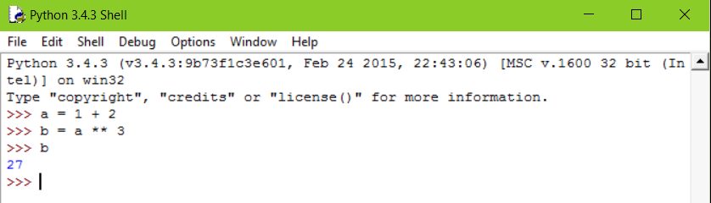Python comes with a default Integrated Development Environment (IDLE); you can open it from the Start Menu. You can type any Python3 code in this interactive console and get a response right away. The Python Shell (IDLE) is going to be your friend. If you are not sure whether a certain command would work or not, you can always test it here first.

Installation of PyGame - Windows

If you are working with a computer that already has PyGame set up on it, feel free to skip this step, but if you want to set up (Python and) PyGame on your own Windows computer, don't worry. It is very easy.

We choose to use Python3.4 and PyGame1.9.2, even though the latest version of Python is 3.5.

It is possible to get PyGame working with Python3.5, but is more involved. If you really want to use Python3.5 with PyGame, you can ask one of the assistants for help.

1. Download the PyGame installer from <http://programarcadegames.com/pygame-1.9.2a0.win32-py3.4.msi>
2. Run the PyGame installer you downloaded by double-clicking it.
   1. When asked to “**Select Python Installations**”, select the first one “**Python 3.4 from Registry**” and PyGame will be installed in the default Python3.4 directory.
   2. If you installed Python3.4 in a different location, choose the second option “**Python from another location**” and provide the folder in which you installed Python3.4.
3. 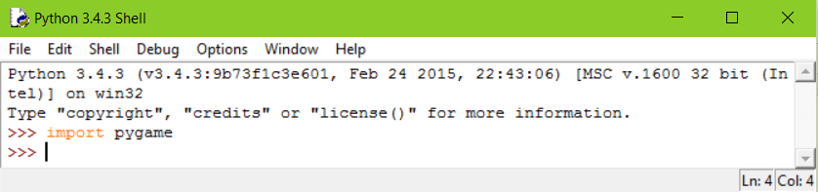 To verify that PyGame is installed correctly, you can run import pygame in a Python Shell (IDLE). You can open it up from the Start Menu. If it does not shout at you, congratulations, you have PyGame ready to go.

Installation of Visual Studio Code – Windows

(a development environment)

Visual Studio Code (a.k.a.VS Code) is a lightweight developer tool (or code editor).

Make sure you have already installed Python

1. Download and run Visual Code installer from <http://code.visualstudio.com/Download>.
2. In the following window, check “**Add to PATH**” and “**Register Code as an editor for supported file types**”. You can decide on the rest of the options according to your preferences. If Visual Studio Code is added to the PATH, you can type “code + <folder_name>” in the **Command Prompt** to launch Visual Studio Code.

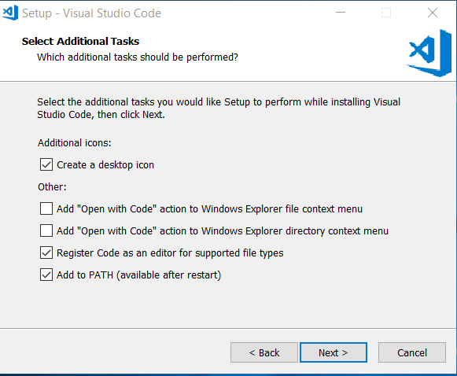

1. To maximize your Python productivity you should install [Don Jayamanne’s Python extension](https://marketplace.visualstudio.com/items?itemName=donjayamanne.python). You install the extension by launching VS Code, opening up the **Command Palette** (Control + Shift + P) and entering ext install in it, then pressing ENTER. Type python to see a list of Python extensions. Be sure to choose the correct one. This will give you access to features like Python-aware Intellisense, 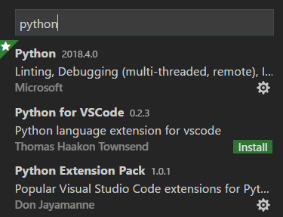auto-completion, hover tooltips to view function and method signatures, error checking, code formatting, snippets, and more.
2. Now, let’s configure your workspace (namely, some folder in which you put all your code).
   1. Click File->Open Folder. Then create and select a folder you would like to use for all your code. This folder is now called the **workspace**.
   2. 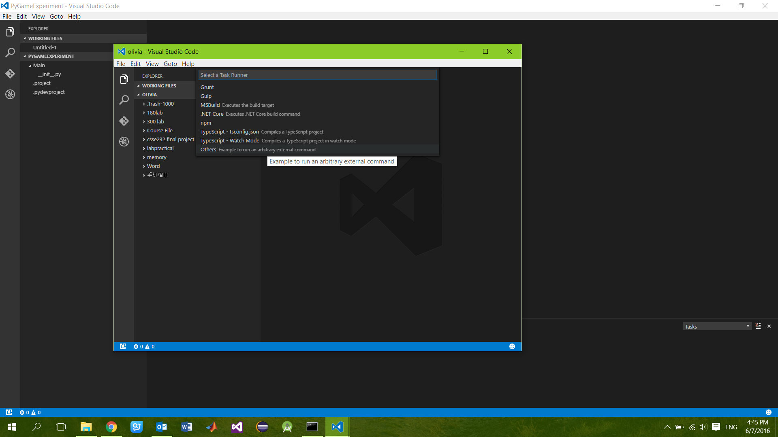You can configure a build task in each workspace you have. A build task is a collection of instructions for your PC to run a program that you open in VS Code from your workspace.
3. To configure the build task in the current workspace, press Control + Shift + P to reach the Command Palette, then type “task” and select the “Tasks: Configure Default Build Task” option. The first time you configure your workspace, the following menu will show up. VS Code supports many build tools, but we aren’t going to use them. Choose “**Others Example to run an arbitrary external command**”.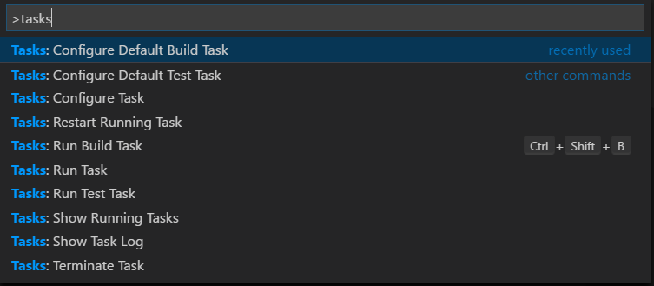
4. Now, let’s replace the contents of **tasks.json** with the snippet below and save the modified file. To run the Python program you are editing, you press **Control + Shift + B**. Once you have this, you probably won’t need to modify “tasks.json” again because the task will work for the whole workspace (anywhere within the folder)

{

"version": "0.1.0",

"command": "py",

"isShellCommand": true,

"args": ["-3.4", "${file}"],

"showOutput": "always"

}

1. 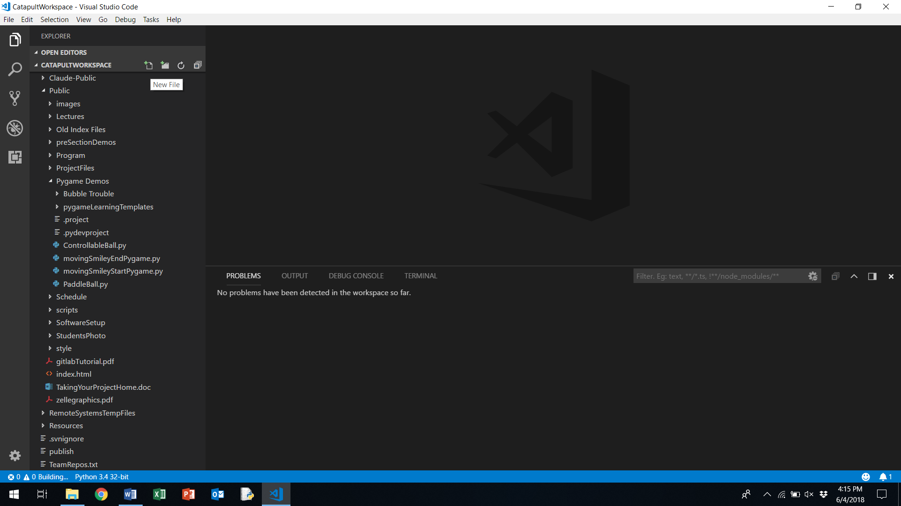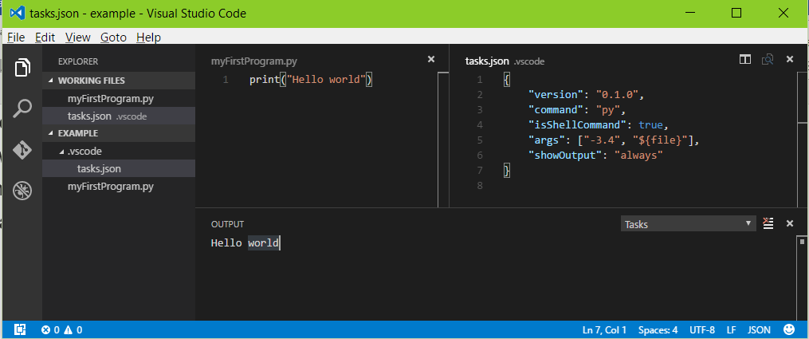Let’s go ahead and write a simple “Hello World” program in your workspace, and use the shortcut to run your program. To create your “Hello World” program, click the New File button that shows up when you hover over the workspace title. If you see the correct output, you have successfully configured your working environment. Enjoy your programming journey!!