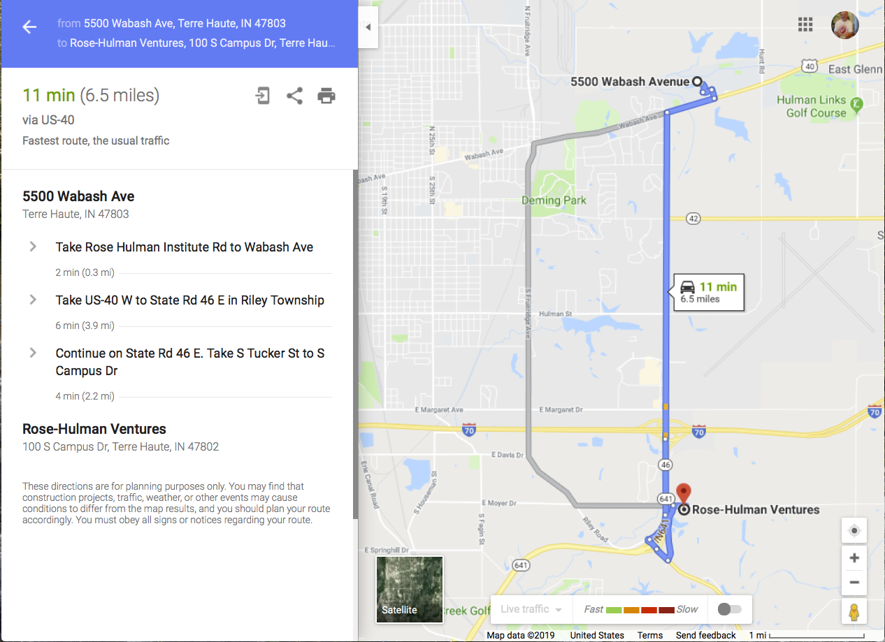

Route to Rose-Hulman Ventures. Due at 10 AM. Meet in front lobby.

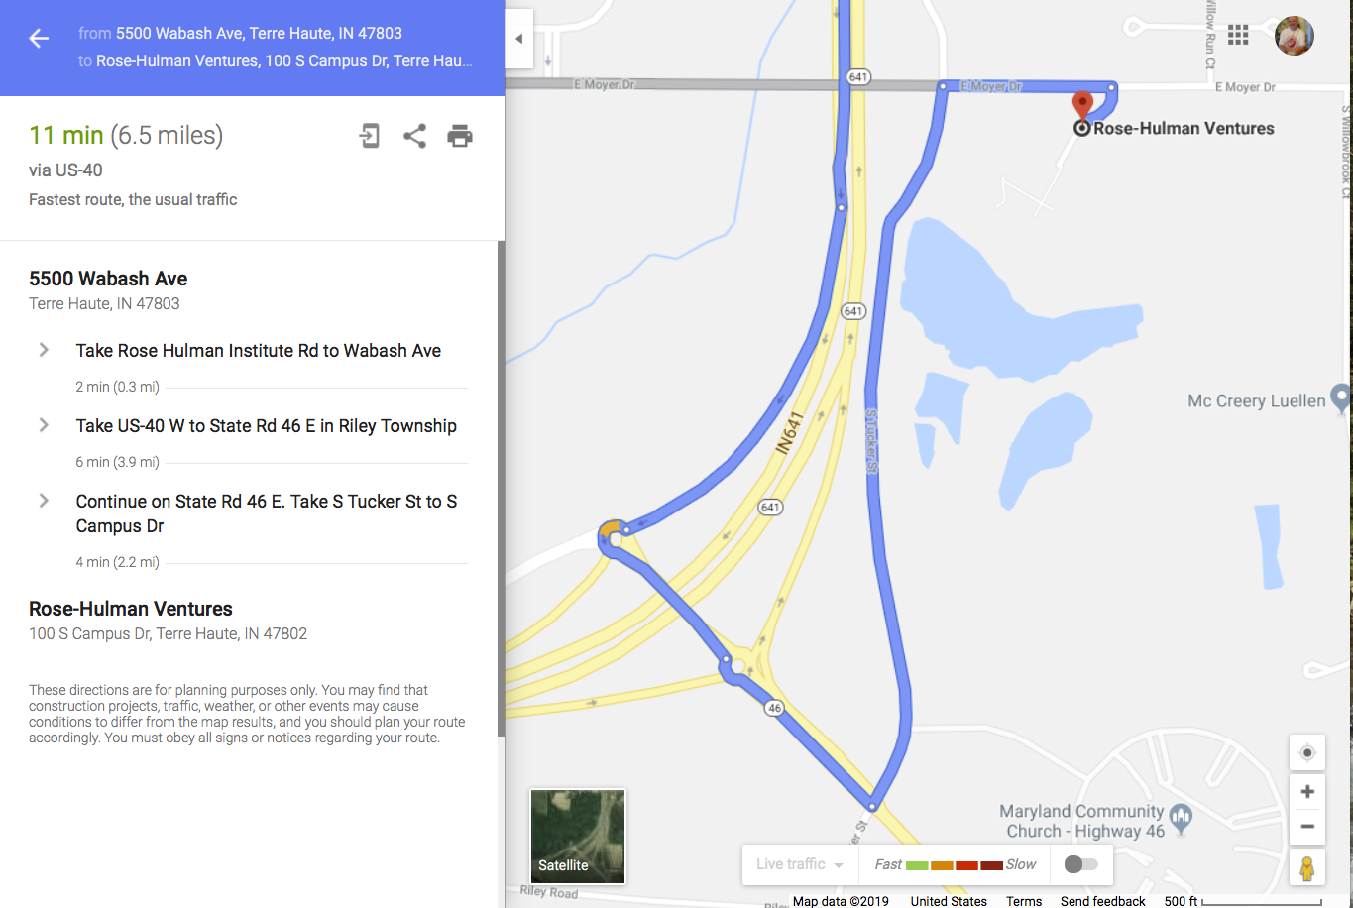

Steve Chenoweth's cell phone is 937-657-3885