Installation of Python – Windows

If you already have Python installed on your computer, please check its version.

We will be using Python3. There are many major differences between Python2.x and Python3.x. For the purpose of learning Python on your own time, feel free to use whatever version your heart desires. However, it is best to get **Python3.7** working so we can work with PyGame.

1. The latest version (as of August 1st, 2019) is Python 3.7.4, which is the version you will probably want to use. Follow this link to download the 64-bit Python installer - <https://github.com/RHIT-CSSE/catapult/raw/master/InstallationExecutables/Windows/python-3.7.4-amd64.exe>. The only difference between the installer you see above and the images below should be that you see Python 3.7.4 instead of Python 3.7.3.
2. Run the Python installer you downloaded by double-clicking it.
3. You should see a screen that looks like this:

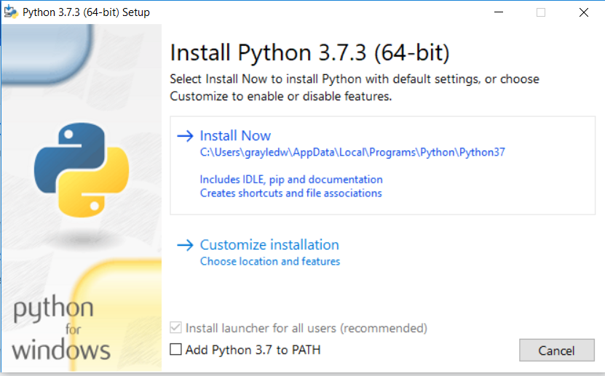

1. Select install now. Make note of the location where Python is being installed on your machine (this is the C:\Users\.... business you see in the screenshot from 2a). We may need this later if we need to add Python to your Environment Variables.
2. Once you’ve selected install now you should see a screen like this:

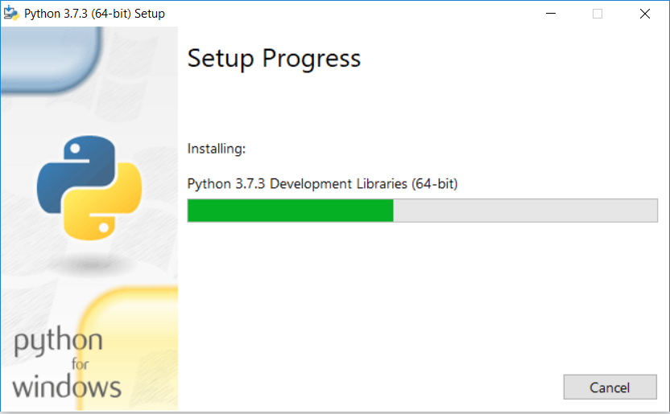

1. If everything goes as planned, once installation is completed a screen like this should appear to you:

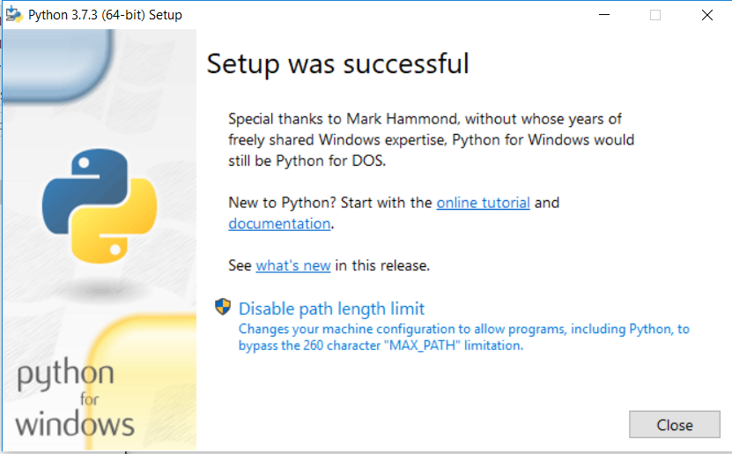

1. If you encountered any issues going through this process, don’t hesitate to get ahold of one of your teaching assistants to get some help. ‘

Testing your Python Installation

1. Let’s make sure that our Python installation works. First, click on your search button in the bottom left hand corner of your screen.
2. Type “Idle”. You should see IDLE (Python 3.7 64-bit) as one of your results. You should open this now.
3. IDLE should look like this:
4. On the first line type, “print(‘I’ve successfully installed Python!’)”, and you should see this result:
5. You’re good to go! Keep this open, we’ll use it again later.

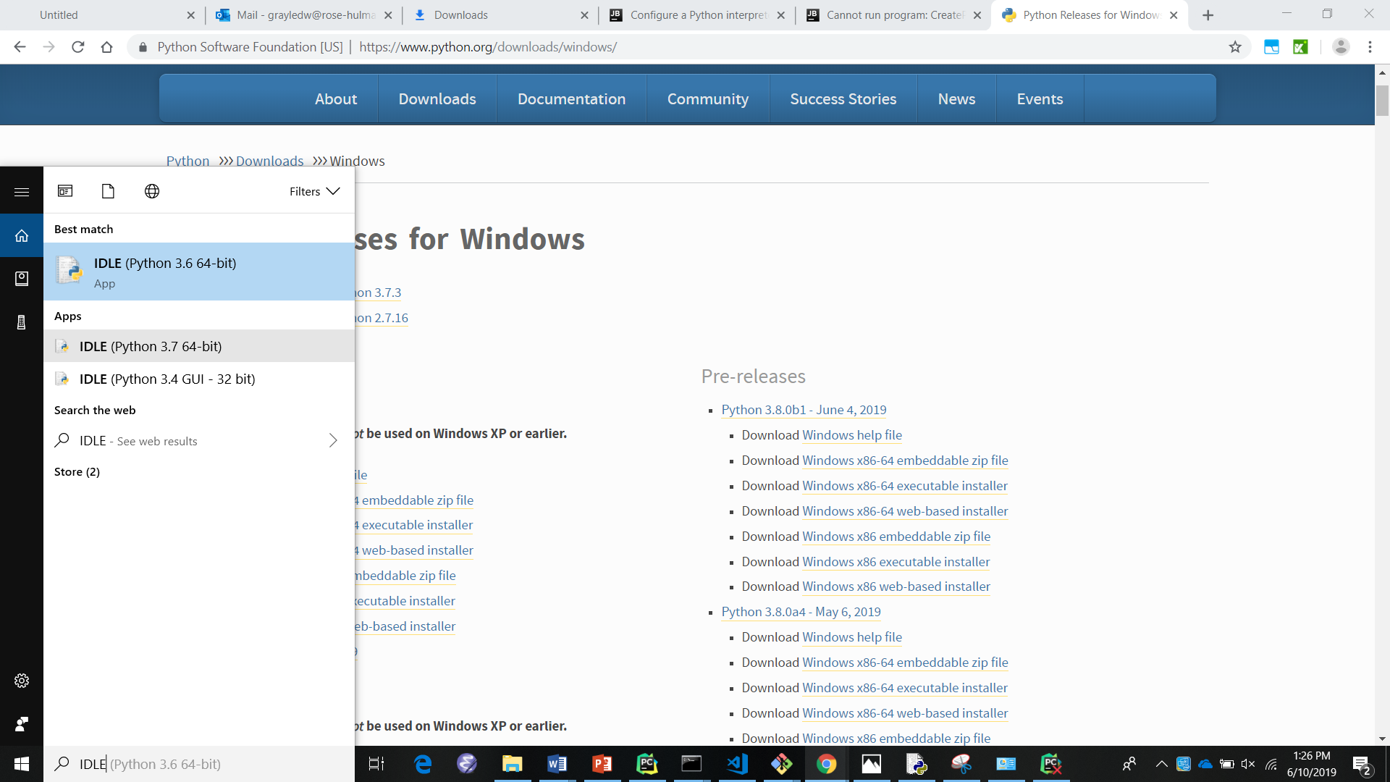

Installation of Git – Windows

Git is a widely used VCS (Version Control System) that will allow us to manage and organize our code throughout the upcoming session with ease.

1. Download the Git Installer here: <https://github.com/RHIT-CSSE/catapult/raw/master/InstallationExecutables/Windows/Git-2.22.0-64-bit.exe>.
2. Once you have opened the installer, click through the installation by accepting all of the defaults on each new question by clicking “Next”. On the final question, click “Install”. The installer window should look something like the picture below with the “Next” button being located in the bottom

Installation of PyCharm and PyGame – Windows

PyCharm is the development environment we will be using throughout the course of Operation Catapult. This is where all the magic will happen, and you will begin to write your very own Python programs!

1. Visit this link: <https://www.jetbrains.com/pycharm/download/download-thanks.html?platform=windows&code=PCC>.
2. We are going to want to install the free, open-source Community version of PyCharm. When you click on the above link you should see a Thank You screen like the one below, and your installer should appear in the lower left hand corner of your screen. If not check under “Downloads” in your browser, and you should be able to find it there.

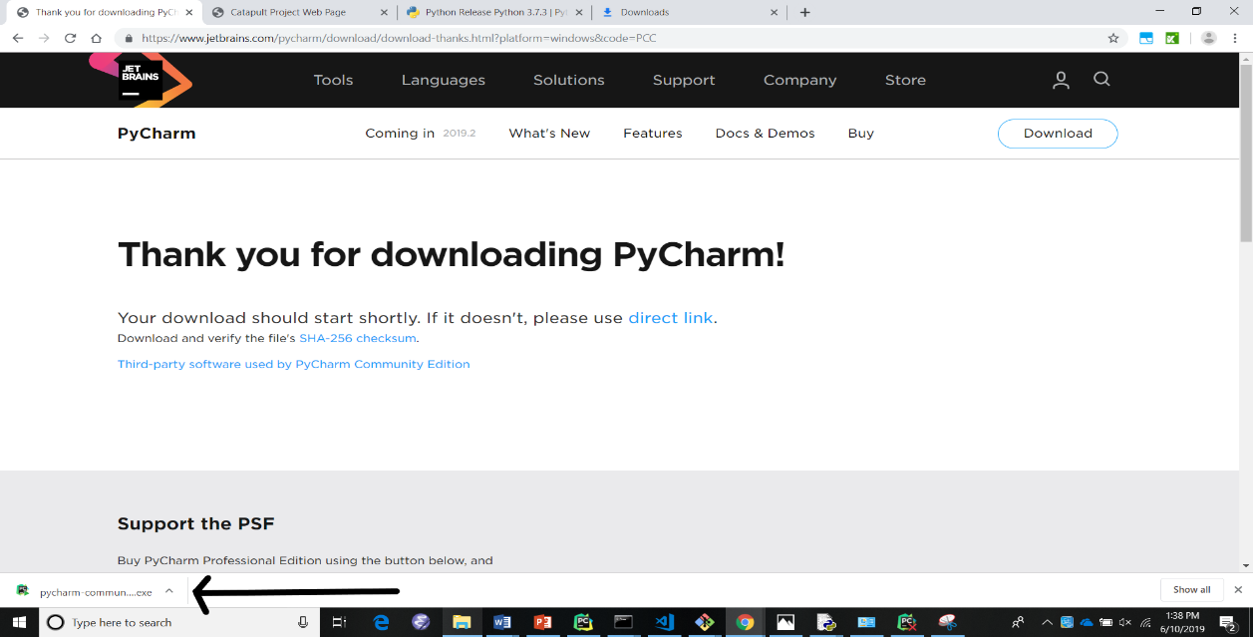

1. Click on the installer to get started. You should see this screen. Click ‘Next’.

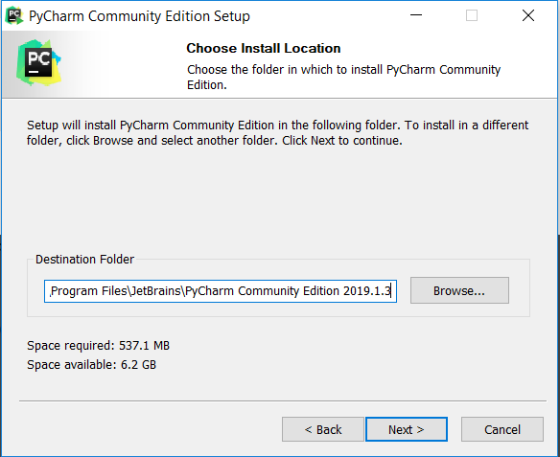

1. On the following screen it will ask where you would like to keep your PyCharm installation. Accept the default. Click ‘Next’.

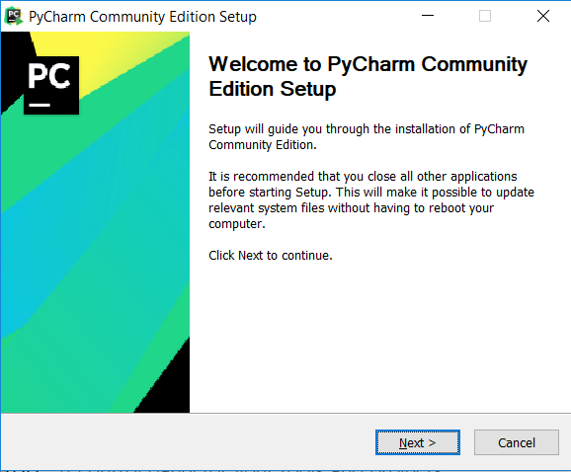

1. Next you’ll be asked to configure your installation. Check the checkboxes next to “64-bit launcher”, “Add “Open Folder as Project””, and “.py” text. Click “Next”.

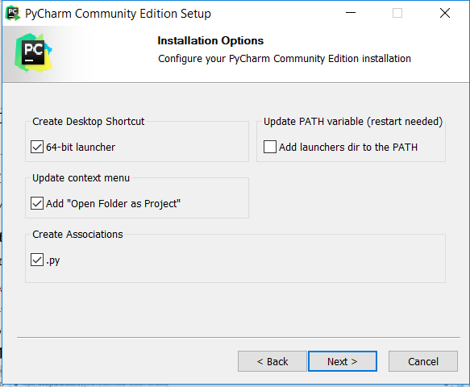

1. The next screen you will see will be “Choose Start Menu Folder”. Accept the default of “JetBrains” and click Install.

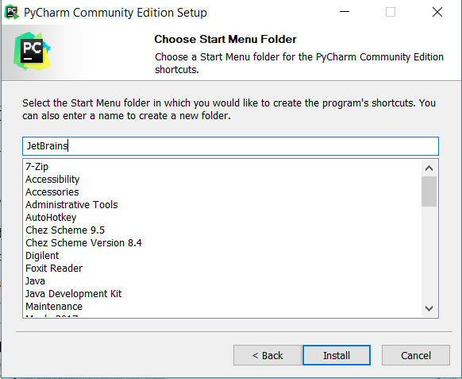

1. Your installation is now in progress. You should see a screen with a green bar that looks like this:

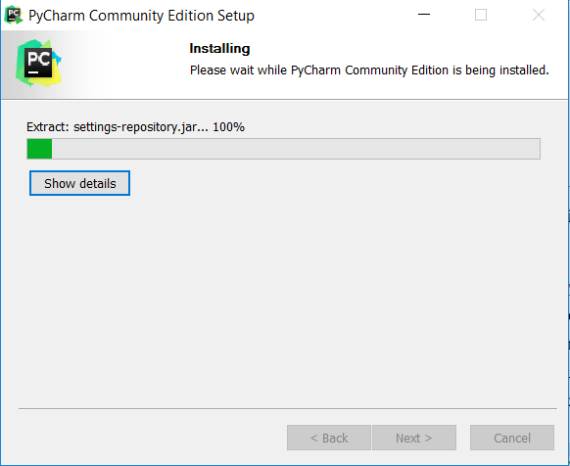

1. Upon completing installation, you should see the following screen:

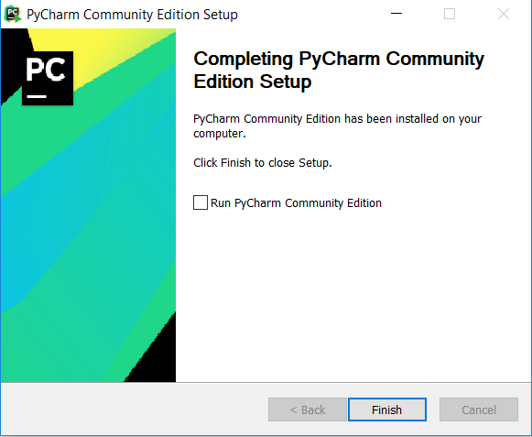

1. Now let’s open up PyCharm. From your desktop’s home screen, look for the PyCharm shortcut. Click on the shortcut and PyCharm should begin to open. You’ll see something like this:

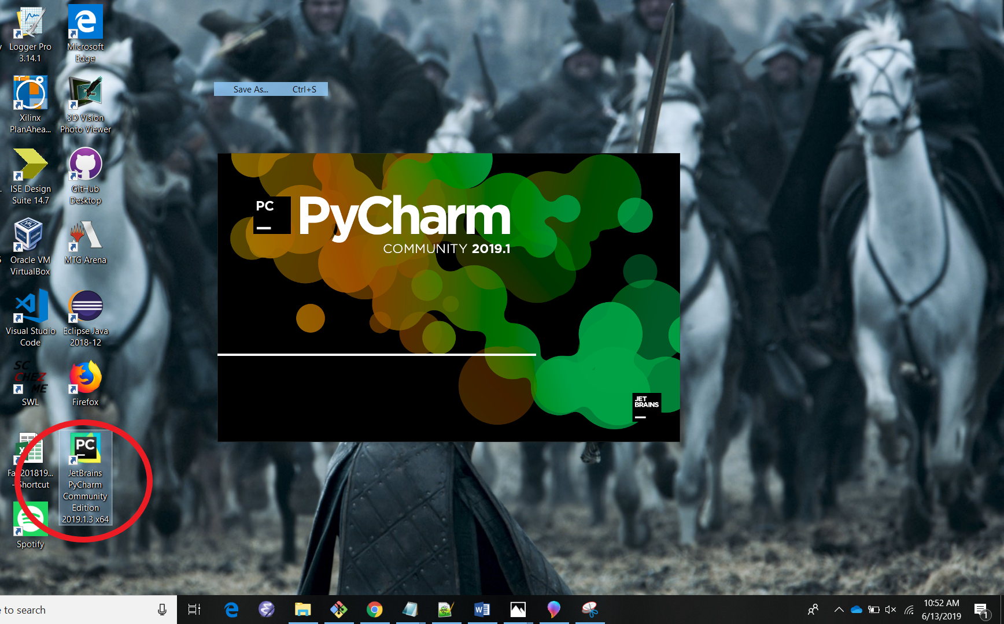

1. 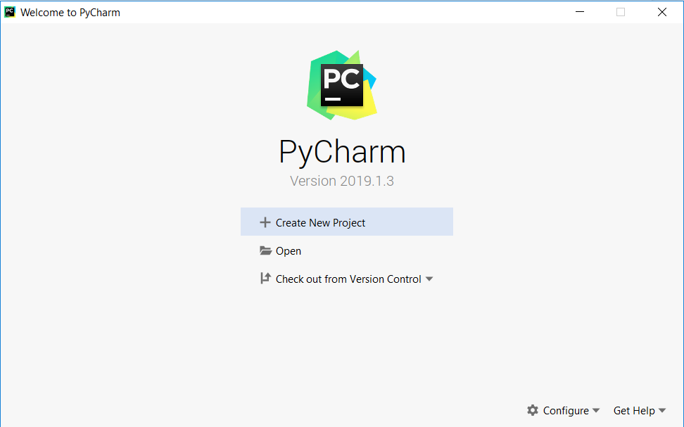When PyCharm opens, you’ll see a start screen that looks like the first picture below. Select the “Check out from Version Control” option. In the drop-down menu that appears, select Git.
2. In the “Clone Repository” window, you’ll now be asked where you want to clone the repository you’re checking out. The repository is full of all of the code you’ll need throughout Operation Catapult. First, make a folder where you want to store all of your code throughout the course of Catapult. Then enter that folder’s path in the “Directory” text box. For example in the image below, the path to my folder is “C:\Users\grayledw\Documents\2019OperationCatapultPyCharmSetupTest\catapult”. Next, copy this link and paste it into the “URL” textbox - **https://github.com/RHIT-CSSE/catapult.git**. Your window should look like the one shown below. Once you’ve done all of these things, click “Clone”.

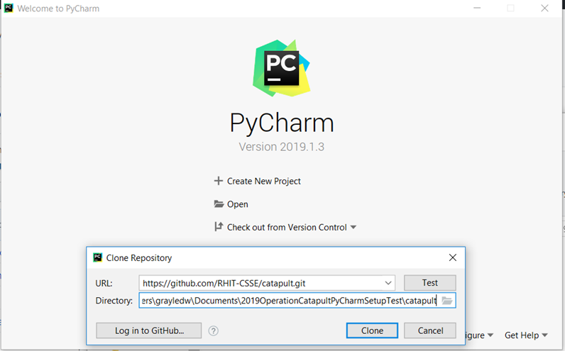

1. You should now be inside of PyCharm. On the left of your screen, you should see a folder. Expand the folder and take a peek inside. We’ll tell you more about finding what you need later. Next go to “File -> Settings”:

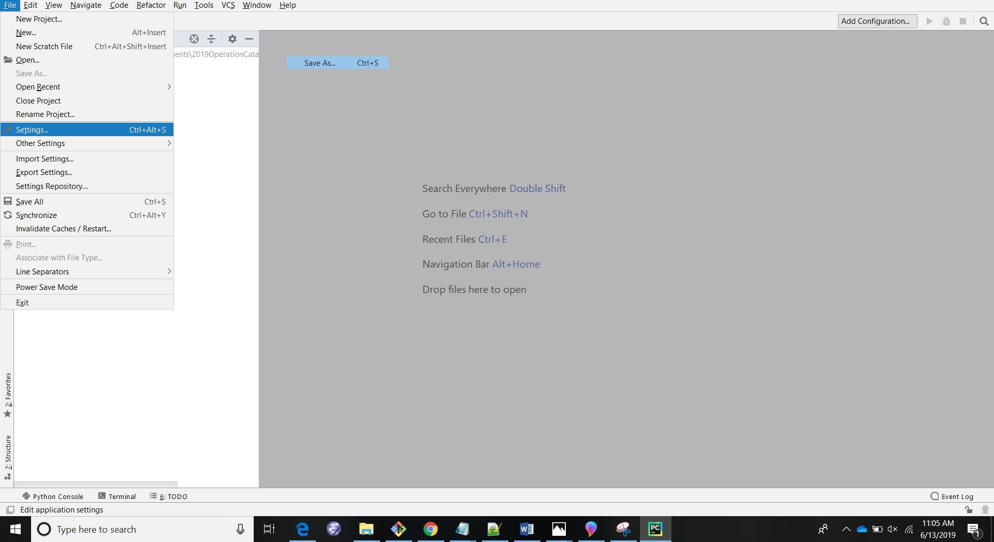

1. You should now be on the settings page. On the left side, expand the section titled – Project: (YOUR PROJECT NAME HERE), and select “Project Interpreter”. You should see a screen that looks like this:

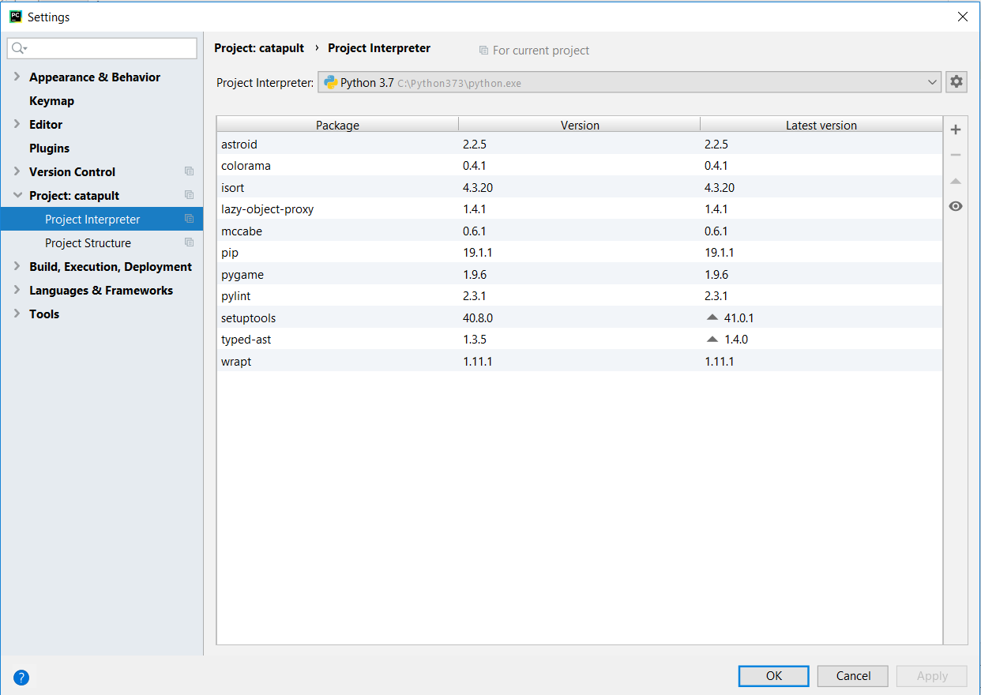

1. Make sure the drop-down menu next to “Python Interpreter” is set to Python 3.7. If not select the drop-down arrow, and select Python 3.7. If Python 3.7 is not one of the available options, please call over a TA and we’ll come help you out. Things should look like the image under step 13) if everything is done correctly.
2. 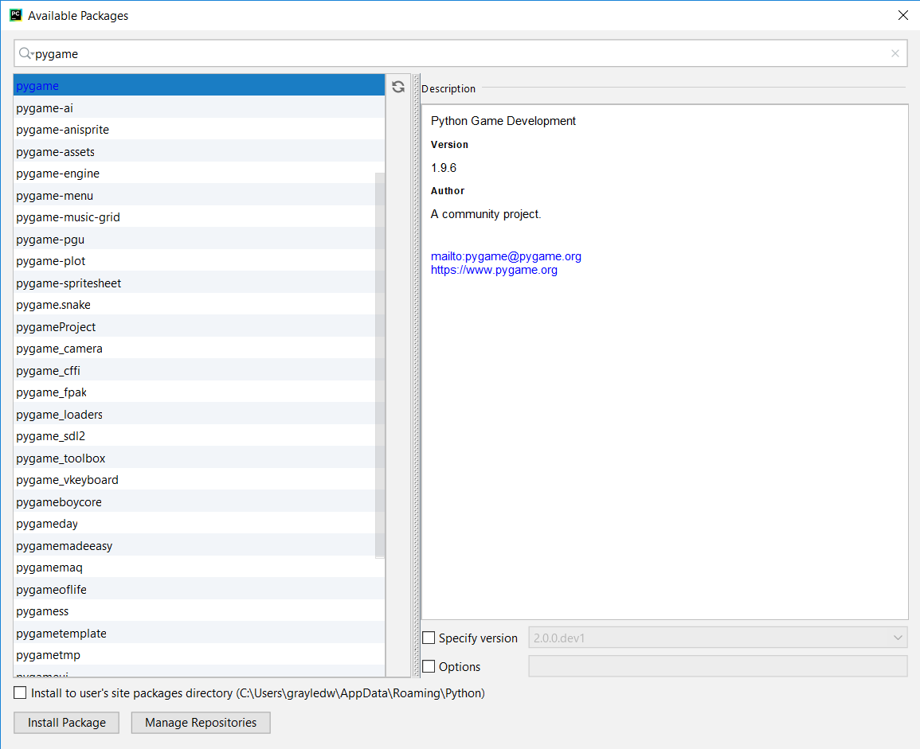Next click the “+” on the right side of your screen, next to the toolbar “Latest version”. A window titled “Available Packages” should appear. In the search bar at the top of the screen, type “pygame”. The top result should be “pygame”. Click on it, and verify on the “Description” that it is “Version” 1.9.6. If so, at the bottom of your screen click “Install Package”. Your “Available Packages” screen should look something like this:
3. 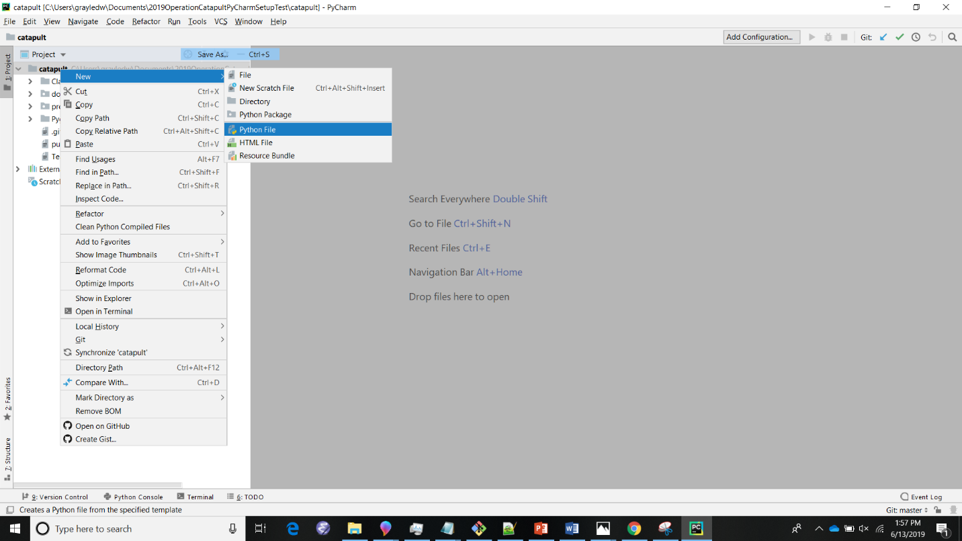You should now be back at the same screen from step 12). Right click on the repository you checkout out earlier, and select “New -> Python File”. Things should look like this:
4. When asked what you want to name your file, name it something like “test.py”. In the window that appears, copy the code (import pygame and print(‘Hello World!)) you see in the image below. In the upper right hand corner of the screen there is a green play button. Select it once you have finished typing in the code. If your results in the console at the bottom of your screen match what you see in the image below, you’ve successfully installed your software successfully! Sit tight while everyone else finishes, but feel free to play around some more in the Python file you created and see what you can get to happen. If you’ve run into any issues, call over one of the TAs and we’ll come and help you out.

