**Questions that students frequently ask on Test 1**

1. **I have a *red* dot to the left of my code. What do I do?**

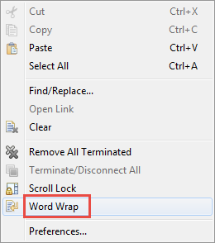Answer: Hover over the dot and read the error message. Remember that the problem is often on the preceding line (perhaps a missing parenthesis). You can put the cursor beside a parenthesis to see its match highlighted in red.

1. **My code produced *red* in the Console when it ran. What do I do?**

Answer:

* 1. First, ***right-click*** in the Console and select ***Word Wrap*** to make the messages more easily read.
  2. Read the ***red*** error message. Sometimes it makes sense, sometimes not.
  3. Look at the ***BOTTOM blue line***. If that line is a line in YOUR module, then ***click on that blue line*** to go straight to the line in your code that broke.

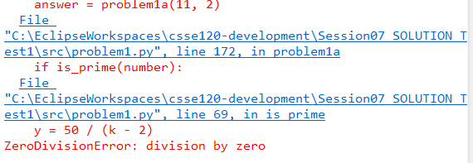

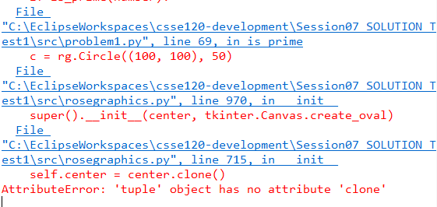On the other hand, if the bottom blue line is in ***rosegraphics.py***, as in the example below, work your way UP until you reach a blue line that is in YOUR module. Then ***click on the blue line*** that leads to YOUR module.

* 1. The message in the example above (***tuple object has no attribute clone***) often occurs when you send an object of the wrong type when constructing an object, e.g.:

WRONG = rg.Circle((100, 100), 50)

RIGHT = rg.Circle(rg.Point(100, 100), 50)

* 1. One message that appears frequently is:

AttributeError: 'BLAHType' object has no attribute 'FOO'

where BLAH and FOO are some particular type and name.

That means that the statement that broke had a line of the form:

**... thing.foo ...**

where ***thing*** is an object of type ***BLAH***. Check that ***thing*** is what you think it is. Check that ***foo*** is spelled right. If you don’t see the problem, ***print*** ***thing*** just before the line that broke to see what it is.

1. **My code is failing tests. What do I do?**

First, re-read the green specification. Make especially sure that you understand the first example in it and WHY the answer is what is given.

If that does not help, then PRINT IS YOUR FRIEND. Put print statements where they will help you understand what is going on, and then work through the example (or test that is failing) until you see why YOUR code is behaving differently than the example indicates that it should. For example, in the following code that HAS AN ERROR, I put the PRINT statement to try to figure out what is going on. I looked at the output and saw that it was not what I expected, and that helped me fix my error.

count = 0

for k in range(n):

**print(k, n, count)**

if is_prime(k):

count = count + 1

return count

1. **Nothing in showing up in my graphics window. What do I do?**

Did you remember to attach your objects to the window? To render the window?

1. **I called a function but it just did not do anything. What do I do?**

Did you write something like:

y = foo

when you meant:

y = foo()

1. **I have a loop that was supposed to make a bunch of objects show up, but only one is appearing. What do I do?**

Might they all be on top of each other? Or off the screen? PRINT the objects to find out.

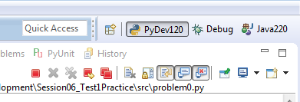Also, it is fine to use move_by, but if you are seeing only one object show up where you expected many, you may be misusing move_by. Replace your move_by by equivalent code and see if that helps.

1. **My program is not printing all the tests. What should I do?**

See if there are RED DOTS above the Console window. If so, your program is probably in an INFINITE LOOP.