**Test 3 – *SOLUTION* to Practice Problems for the Paper-and-Pencil portion**

**Note:**  These practice problems relate very directly to what you can expect to see on the Paper-and-Pencil portion of Test 3. **Do these problems carefully** and **check your answers via the online Solution to these problems**.

Many of these problems are similar to problems that you saw on the Paper-and-Pencil portion of Test ***2***.

Each problem has a ***time estimate*** that indicates how long the problem might take (at most) for a well-prepared student who had no prior experience in software development before this course. ***If you are taking much longer than the time estimates, work with your instructo***r to learn techniques to solve them more quickly.

A well-prepared student should be able to complete **all these problems** in **under about 2 hours**.

**Be forewarned that the Paper-and-Pencil portion of Test 3 may not be as generous regarding partial credit as was Test 2.** ***If you are not 100% clear on ALL parts of ALL of these problems, meet with your instructor,*** a course assistant, or another equally qualified person to become solid in your understanding of the concepts that these problems assess:

* Problem 1: **Scope** of variables, flow of control through function calls and object construction, arguments and parameters.
* Problems 2, 7 and 27: **Mutation via *function calls*** (when the arguments are mutable), **box-and-pointer diagrams**, references, mutation versus reassignment.
* Problem 6: **Mutation via *assignment*** of the insides of container objects, **box-and-pointer diagrams**, references, aliases, mutation versus reassignment.
* Problems 3 and 5: **Object construction**, **aliases** (two names for the same object).
* Problem 4: **Tracing function calls** by hand, returning values, order of operations, ***return*** really ***leaves*** the function.
* Problems 8, 9 and 10: **Tracing loops within loops** by hand, with #10 featuring sequences inside sequences.
* Problem 11: **Tracing *while* loops** by hand.
* Problems 12, 25 and 26: **Implementing** by hand a function that requires **loops within loops** (#12), the **MAX/MIN pattern** (#25), and the **FIND pattern** (#26).
* Problem 13: **Implementing a simple class** by hand.
* Problems 14 through 24: References and mutation.

1. [A well-prepared student should not require more than about **10 minutes** to complete this problem.]

Consider the code on the next page. Arrange so that you can see both this page and the next page at the same time. (Un-staple as needed.) On the test, you will receive the code for any problem like this one on a separate page.

The code is a contrived example with poor style but will run without errors. In this problem, you will trace the execution of the code. ***As each location is encountered during the run:***

1. ***CIRCLE* each variable** that is ***defined*** at that location.
2. ***WRITE t***he ***VALUE*** of each variable that you ***circled*** directly ***BELOW*** the circle.

For example, the run starts in ***main***, as usual. The first of the seven locations **to be encountered** is **Location 6**. At Location 6, the only variables defined are ***a*** and ***z***, with values ***5*** and ***3*** at that point of the program’s run. So, on the row for Location 6, I have circled ***a*** and ***z*** and written their values at Location 6 directly below them.

Note that you fill out the table in the order that the locations are encountered, ***NOT from top to bottom. ASK FOR HELP IF YOU DO NOT UNDERSTAND WHAT THIS PROBLEM ASKS YOU TO DO.***

|  |  |  |  |  |  |  |  |
| --- | --- | --- | --- | --- | --- | --- | --- |
| **Location 1** the 1st time that it is encountered | a  **5** | w  **7** | z | self.w | cat.w | dog.w | cat.a |
| **Location 1** the 2nd time that it is encountered | a  **1** | w  **9** | z | self.w | cat.w | dog.w | cat.a |
| **Location 2** the 1st time that it is encountered | a  **10** | w  **7** | z | self.w  **70** | cat.w | dog.w | cat.a |
| **Location 2** the 2nd time that it is encountered | a  **10** | w  **9** | z | self.w  **90** | cat.w | dog.w | cat.a |
| **Location 3** | a  **3** | w  **4** | z  **5** | self.w | cat.w | dog.w | cat.a |
| **Location 4** | a  **3** | w  **4** | z  **5** | self.w | cat.w | dog.w  **70** | cat.a |
| **Location 5** | a  **3** | w  **4** | z  **5** | self.w | cat.w  **90** | dog.w  **80** | cat.a |
| **Location 6** | a  **5** | w | z  **3** | self.w | cat.w | dog.w | cat.a |
| **Location 7** | a  **5** | w | z  **3** | self.w | cat.w | dog.w  **90** | cat.a |

***Code for Problem 1:***

class **Animal**(object):

def **__init__**(*self*, w, a):

**#### Location 1**

a = 10

*self*.w = a * w # MULTIPLY, not add

**#### Location 2**

def **eat**(*self*, w):

self.w = self.w + (2 * w)

def **make_animals**(z, a, w):

**#### Location 3**

dog = Animal(w + a, z)

**#### Location 4**

cat = Animal(w + z, 1)

dog.eat(5)

**#### Location 5**

return cat

def **main**():

a = 5

z = 3

**#### Location 6**

dog = make_animals(a, z, z + 1)

**#### Location 7**

Arrange so that you can see this code and the problem itself at the same time. (Un-staple as needed.)

The arrows are there to help you see where the seven Locations are in the code.

1. [A well-prepared student should not require more than about **15 minutes** to complete this problem.]

Consider the code on the next page. Arrange so that you can see both this page and the next page at the same time. (Un-staple as needed.) On the test, you will receive the code for any problem like this one on a separate page.

The code is a contrived example with poor style but will run without errors. Trace the code’s execution and **draw a box-and-pointer diagram on a separate sheet of paper** as you trace the code’s execution**.**

As you draw the box-and-pointer diagram, write (in the box below) what gets printed when ***main*** runs. Write Point objects as in this example: **(100, 150)**.

**Reminder:**

**You must *draw*** (on a separate page) a

**\*\* *box-and-pointer \*\****

***diagram*** for this problem.

***NOTE: The solution for the box-and-pointer diagram appears two pages after this page.***

**Output:** (I have put extra blank lines in this solution to make it more readable.)

**Beta 1: 33**

**Beta 2: 100**

**Beta 3: (600, 99)**

**Beta 4: [100, 200, 300]**

**Main 1: 70**

**Main 2: (678, 150)**

**Main 3: (678, 150)**

**Main 4: [444, 100, (678, 150), 222]**

**Main 5: 300**

***Code for Problem 2:***

def **main**():

    radius = 70

    center = Point(100, 150)

    p = center

    seq = [radius, center.x, p, 10]

    ans = beta(radius, center.x, p, seq)

    print(*'Main 1:'*, radius)

    print(*'Main 2:'*, center)

    print(*'Main 3:'*, p)

    print(*'Main 4:'*, seq)

    print(*'Main 5:'*, ans)

def **beta**(radius, x, p, seq):

    radius = 33

    p.x = 678

    seq[0] = 444

    seq[3] = 222

    seq = [100, 200, 300]

    p = Point(600, 700)

    p.y = 99

    print(*'Beta 1:'*, radius)

    print(*'Beta 2:'*, x)

    print(*'Beta 3:'*, p)

    print(*'Beta 4:'*, seq)

    return seq[2]

main()

Arrange so that you can see this code and the problem itself at the same time. (Un-staple as needed.)

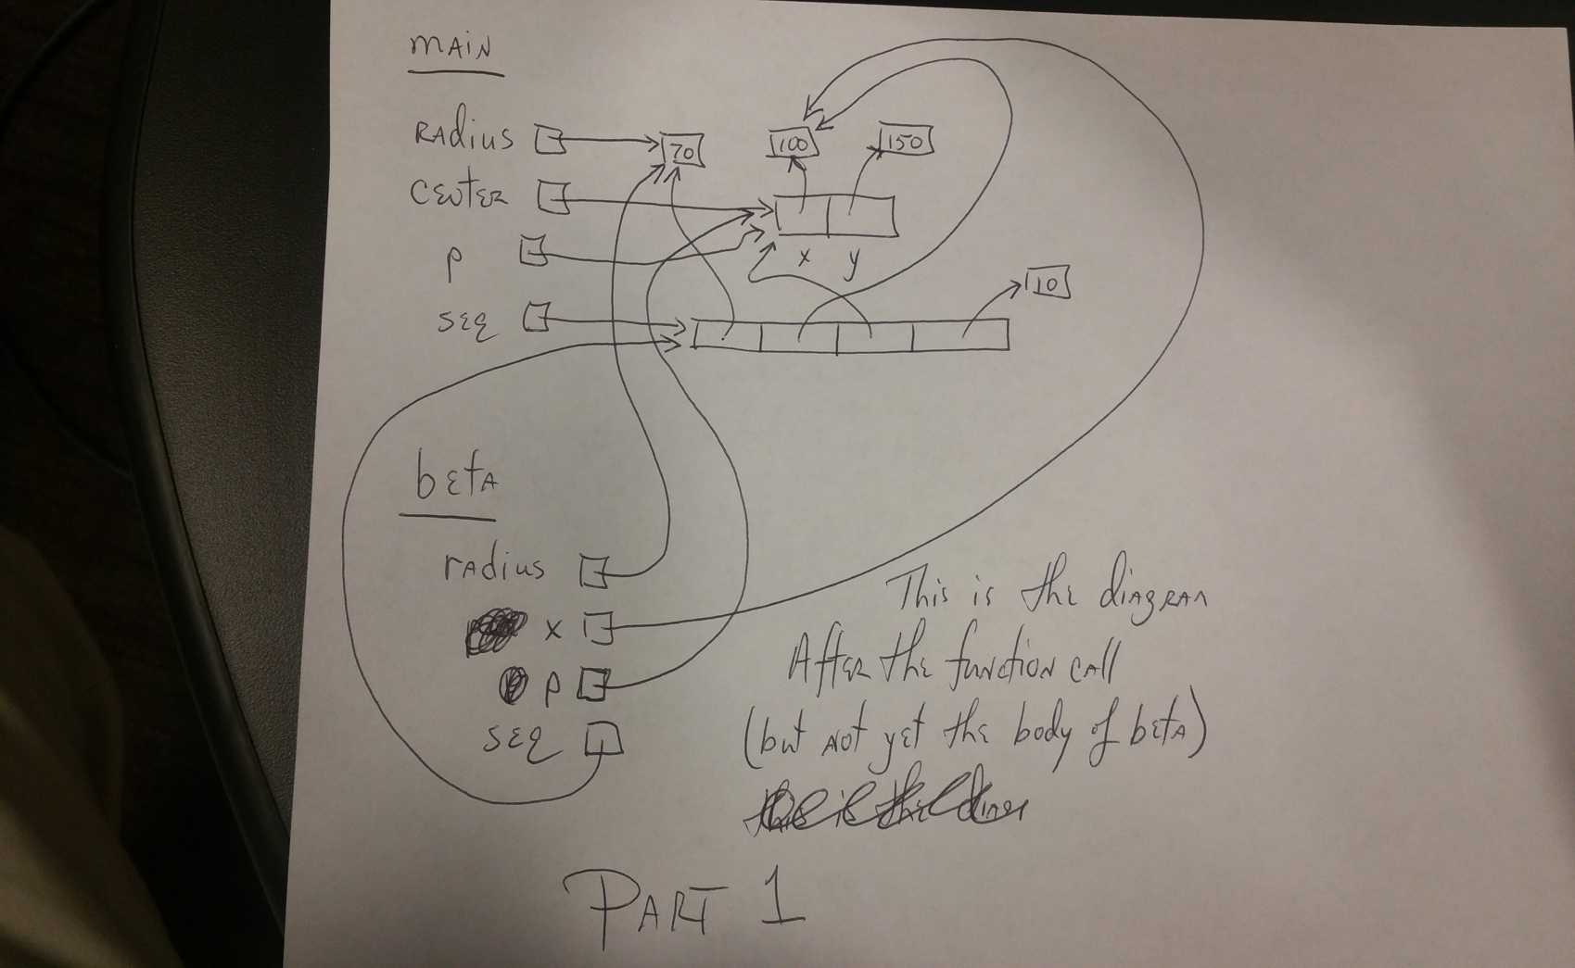

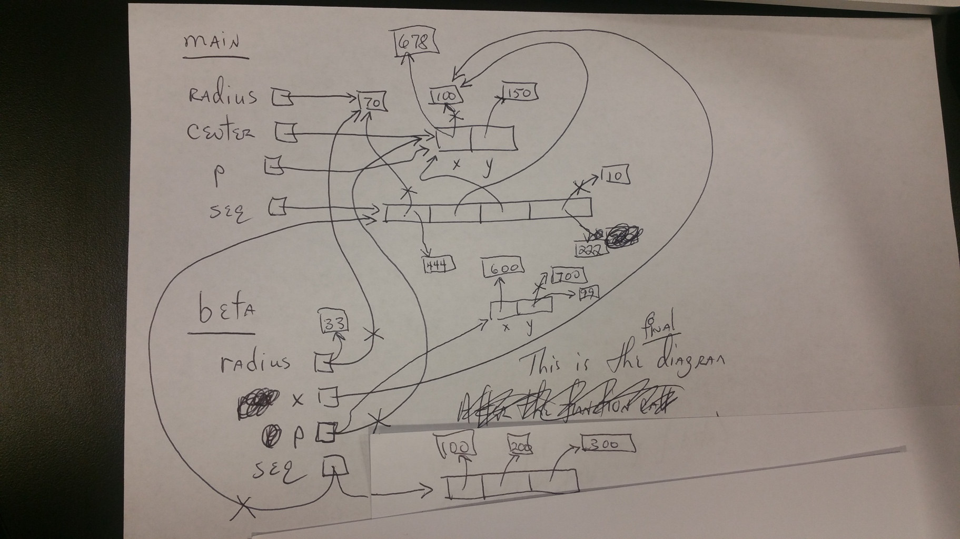

1. [A well-prepared student should not require more than about **1 minute** to complete this problem.]

When the code in the previous problem runs: (circle your choice for each of the following)

1. How many ***Point*** objects are constructed in ***main***? **0 1 2 3 4**
2. How many ***Point*** objects are constructed in ***beta***? **0 1 2 3 4**
3. [A well-prepared student should not require more than about **7 minutes** to complete this problem.]

Consider the code snippet below. It is a contrived example with poor style, but it will run without errors. What does it print when it runs?

Write your answer in the box to the right of the code.

**def main**():

print('Main:', three())

**def three**():

print('*Three 1:*', one(7))

return two(10) + (100 * one(5))

print('*Three 2:*')

**def two**(y):

answer = one(2 * y)

print('*Two:*', y, answer)

return (5 + answer)

**def one**(x):

print('*One:*', x)

return (3 * x)

**main()**

**Output:**

**One: 7**

**Three 1: 21**

**One: 20**

**Two: 10 60**

**One: 5**

**Main: 1565**

1. [A well-prepared student should not require more than about **1 minute** to complete this problem.]

Consider the following four statements:

**p1 = rg.Point(4, 5)**

**p2 = rg.Point(p1.x, p1.y)**

**p3 = p1**

**p4 = p2**

At this point, how many ***rg.Point*** objects have been constructed? **1 2 3 4** (circle your choice)

1. [A well-prepared student should not require more than about **7 minutes** to complete this problem.]

Consider the code snippet to the right. Trace the execution of the code snippet and **draw a box-and-pointer diagram on a separate sheet of paper** as you trace the code’s execution**.**

After the code snippet is executed, what are the values of the variables? (Write your answer in the spaces provided below.)

***p1.x* = ____________ 99**

**p1 = rg.Point(4, 5)**

**p2 = rg.Point(p1.x, p1.y)**

**p3 = p1**

**p4 = p2**

**p3.x = 99**

**p4.y = 600**

**p4 = rg.Point(42, 42)**

***p1.y = ____________* 5**

***p2.x* = ___________ 4**

***p2.y =* ___________ 600**

***p3.x* = ___________ 99**

+

+

4

5

99

42

42

600

***p3.y =* ___________ 5**

**x**

**y**

**x**

**y**

**p1**

**p2**

**p3**

**p4**

***p4.x* = ___________ 42**

***p4.y =* ___________ 42**

+

Inthe ***box-and-pointer diagram*** to the right, arrows in ***purple*** show the effects of the last 3 lines of code.

**x**

**y**

1. [A well-prepared student should not require more than about **12 minutes** to complete this problem.]

Recall that our Point class has instance variables **x** and **y** for its x and y coordinates.

Consider the code snippets below. They are contrived examples with poor style but will run without errors. For each code snippet:

1. Trace the code snippet’s execution when ***main*** runs and **draw a box-and-pointer diagram on a separate sheet of paper** as you trace the code snippet’s execution**.**
2. Write below what the code snippet prints.

(Each code snippet is an independent problem.)

def **main**():

a = [1, 2, 3]

b = [100, 200, 300]

c = foofoo(a, b)

print(a)

print(b)

print(c)

def **foofoo**(a, b):

a = [11, 22, 33]

a[0] = 777

b[0] = 888

x = [a[1], b[1]]

return x

def **main**():

p1 = Point(11, 12)

p2 = Point(77, 88)

p3 = foo(p1, p2)

print(p1.x, p1.y)

print(p2.x, p2.y)

print(p3.x, p3.y)

def **foo**(p1, p2):

p1 = Point(0, 0)

p1.x = 100

p2.y = 200

p3 = Point(p2.x, p1.y)

return p3

***Prints:* 11 12 *Prints:* [1, 2, 3]**

**77 200 [888, 200, 300]**

**77 0** **[22, 200]**

**Reminder: You must *draw*** (on a separate page) ***TWO* ** *box-and-pointer diagrams* \*\*** for this problem. ***See the next page for these.***

**For the problem on the LEFT-hand-side**:

**Main’s namespace Foo’s namespace**

100

0

0

+

12

11

+

**p1**

**x**

**y**

**x**

**y**

**p1**

200

77

88

**x**

**y**

**p2**

**p3**

**x**

**y**

**p2**

+

**p3**

The **bright red** happens, then the **blue**, then the **purple**, then the **green**, then the **dark red**.

**For the problem on the RIGHT-hand-side**:

The picture is the same as the above except:

* Each Point becomes a list of length 3, with its boxes labeled 0, 1, and 2, instead of x and y.
* The third value of the lists stays unchanged in each list.
* The first two values inside list a in main (that corresponds to point p1 in its main) are 1 and 2 instead of 11 and 12.
* The first two values inside list b in main (that corresponds to point p2 in its main) are 100 and 200 instead of 77 and 88.
* a[0] in foofoo (which corresponds to p1.x in its main) changed to 777 instead of 100.
* b[0] in foofoo (which corresponds to p2.x in its main) changed to 88, where p2.y changed to 200.
* The returned value x to which c is reassigned reverses the behavior of p1 and p2 in the left-hand-side problem.

1. [A well-prepared student should not require more than about **10 minutes** to complete this and the next problem, combined.]

Consider the code snippet below. It is a contrived example with poor style, but it will run without errors. What does it print when ***main*** runs?

def **main**():

for j in range(5):

for k in range(j):

print(j, k)

**Output:** (I have put extra blank lines in this solution to make it more readable.)

**1 0**

**2 0**

**2 1**

**3 0**

**3 1**

**3 2**

**4 0**

**4 1**

**4 2**

**4 3**

Write your answer in the box to the right.

**Output:** (I have put extra blank lines in this solution to make it more readable.)

**here**

**there**

**here**

**there**

**here**

**there**

**2 2**

**here**

**3 1**

**there**

**3 2**

**3 3**

**here**

**4 1**

**4 2**

**there**

**4 2**

**4 3**

**4 4**

1. Consider the code snippet below. It is a contrived example with poor style, but it will run without errors. What does it print when ***main*** runs?

Write your answer in the box to the left.

def **main**():

for j in range(5):

print(*'here'*)

for k in range(1, j - 1):

print(j, k)

print(*'there'*)

for k in range(2, j + 1):

print(j, k)

1. Consider the code snippet in the box below. It is a contrived example with poor style, but it will run without errors. What does it print when ***main*** runs?

**Output:**

(I have put extra blank spaces and lines in this solution to make it more readable.)

**0 0**

**1 0**

**2 0**

**three 5**

**3 0**

**four 4**

**0 1**

**five 4**

**1 1**

**2 1**

**seven 5**

**0 2**

**eight 5**

**1 2**

**nine 4**

**2 2**

**0 3**

**is this ok? 11**

**0 5**

**123456 6**

**1 5**

**1234 4**

Write your answer in the box shown to the right of the code.

def **main**():

seq = [(*'one'*, *'two'*, *'three'*, *'four'*),

(*'five'*, *'six'*, *'seven'*),

(*'eight'*, *'nine'*, *'ten'*),

[*'is this ok?'*],

(),

(*'123456'*, *'1234'*)]

for k in range(len(seq)):

for j in range(len(seq[k])):

print(j, k)

if len(seq[k][j]) > 3:

print(seq[k][j],

len(seq[k][j]))

1. [A well-prepared student should not require more than about **5 minutes** to complete this and the next problem, combined.]

Consider the code snippet below. It is a contrived example with poor style, but it will run without errors. What does it print when it runs?

Note: The expression:

while BLAH:

...

makes the body of the ***while*** expression keep running “while” BLAH is true. For example:

while x > 20:

...

makes the body (that is, indented part) of the ***while*** expression keep running while ***x*** is greater than 20. (And presumably ***x*** is decreasing inside the body of the loop, so eventually ***x*** is less than or equal to **20** and the loop then exits.)

Write your answer in the box.

x = 2

while x < 9:

print(x)

x = x + 3

print('One', x)

y = 2

while True:

print(y)

if y > 9:

break

y = y + 3

print('Two', y)

**Output:**

(I have put extra blank spaces and lines in this solution to make it more readable.)

**2**

**5**

**8**

**One 11**

**2**

**5**

**8**

**11**

**Two 11**

1. In the space below, write an implementation for the function whose specification is shown in the following box. Do NOT use your computer for this (or for any other of these paper-and-pencil problems).

def **shape**(r):

*"""*

*Prints shapes per the following examples:*

*When r = 5: When r = 3*

*\*\*\*\*\*5 ***3*

*\*\*\*\*54 **32*

*\*\*\*543 *321*

*\*\*5432*

*\*54321*

*Precondition: r is a non-negative integer.*

*For purposes of "lining up", assume r is a single digit.*

*"""*

***One answer:***

for k in range(r):

for j in range(r - k):

print(*'*'*, end=*''*)

for j in range(k + 1):

print(r - j, end=*''*)

print()

1. [A well-prepared student should not require more than about **8 minutes** to complete this problem.]

Consider the Blah class shown below. Implement the three methods per their specifications.

class **Blah**(object):

def **__init__**(*self*, a, b):

*""" Sets instance variables names color and size*

*to the given arguments. """*

**self.color = a**

**self.size = b**

def **multiply_me**(*self*):

*""" Sets this Blah object's size to 10 times*

*what its value is when this method is called. """*

**self.size = self.size * 10**

def **make_child**(*self*, another_blah):

*""" Returns a new Blah object whose color is*

*the same as this Blah's color and whose size is*

*the same as the given argument's size. """*

**return Blah(self.color, another_blah.size)**

[A well-prepared student should not require more than about **5 minutes** to complete all of the problems on this page.]

1. True or false: ***Variables are REFERENCES to objects***. **True** **False** (circle your choice)
2. True or false: ***Assignment*** (e.g. **x = 100**)  
   causes a variable to refer to an object. **True** **False** (circle your choice)
3. True or false: ***Function calls*** (e.g. **foo(54, x)**)  
   also cause variables to refer to objects. **True** **False** (circle your choice)
4. Give one example of an object that is a ***container*** object:

**Here are several examples: a *list*, a *tuple*, a rg.Circle, a Point,  
an rg.*RoseWindow.***

1. Give one example of an object that is ***NOT*** a ***container*** object:

**Here are several examples: an *integer*, a *float*, None, True, False.**

1. True or false: *W*hen an object is mutated, it no longer refers  
   to the same object to which it referred prior to the mutating. **True** **False**  
    (circle your choice)
2. Consider the following statements:

**c1 = rg.Circle(rg.Point(200, 200), 25)**

**c2 = c1**

At this point, how many ***rg.Circle*** objects have been constructed? **1 2** (circle your choice)

1. Continuing the previous problem, consider an additional statement that follows the preceding two statements:

**c1.radius = 77**

True or False: After the above statement executes, the variable ***c1*** refers to the same object to which it referred prior to this statement. **True** **False**  
 (circle your choice)

1. Continuing the previous problems:
   * + What is the value of ***c1***’s radius after the  
       statement in the previous problem executes? **25 77** (circle your choice)
     + What is the value of ***c2***’s radius after the  
       statement in the previous problem executes? **25 77** (circle your choice)
2. Mutable objects are good because:

They allow for efficient use of space and hence time – passing a mutable object to a function allows the function to change the “insides” of the object without having to take the space and time to make a copy of the object. As such, it is an efficient way to send information back to the caller.

1. Explain briefly why mutable objects are dangerous.

When the caller sends an object to a function, the caller may not expect the function to modify the object in any way. If the function does an unexpected mutation, that may cause the caller to fail. If the object is immutable, no such danger exists – the caller can be certain that the object is unchanged when the function returns control to the caller.

1. [A well-prepared student should not require more than about **10 minutes** to complete both this and the next problem.]

def smallest_number(seq):

index = 0

for k in range(1, len(seq)):

if seq[k] < seq[index]:

index = k

return seq[index]

In the space to the right, write a complete implementation, ***including the header (def) line***, for a function that takes a non-empty sequence of numbers and returns the smallest number in the sequence.

Do NOT use your computer for this (or for any other of these paper-and-pencil problems)

1. In the space to the right, write a complete implementation, ***including the header (def) line***, for a function that takes a sequence of numbers and returns the index of the first number that is less than **99**, or **-1** if the sequence contains no numbers less than **99**.

def first_less_than_99(seq):

for k in range(len(seq)):

if seq[k] < 99:

return k

return -1

Do NOT use your computer for this (or for any other of these paper-and-pencil problems)

A well-prepared student should not require more than about **10 minutes** to complete all of the problem on this page (and continuing to the next page.]

1. In Session 9, you implemented a ***Point*** class. Recall that a ***Point*** object has instance variables ***x*** and ***y*** for its x and y coordinates.

Consider the code in the box below. On the **next** page, draw the ***box-and-pointer diagram*** for what happens when ***main*** runs. Also on the next page, show what the code would ***print*** when ***main*** runs.

def **main**():

point1 = Point(8, 10)

point2 = Point(20, 30)

x = 405

y = 33

print(*'Before:'*, point1, point2, x, y)

**z = change(point1, point2, x, y)**

print(*'After:'*, point1, point2, x, y, z)

def **change**(point1, point2, x, a):

print(*'Within 1:'*, point1, point2, x, a)

point2.x = point1.x

point2 = Point(5, 6)

point1.y = point2.y

x = 99

point1.x = x

a = 77

print(*'Within 2:'*, point1, point2, x, a)

return a

**Draw your box-and-pointer diagram on the next page:**

**x**

20

30

**x**

8

10

**point1**

**point2**

**x**

**y**

**z**

**x**

**y**

**x**

**x**

**y**

405

,***main***

33

5

6

**point1**

**point2**

**x**

**a**

**x**

**y**

**x**

99

,***change***

**x**

**What prints when *main* runs?** Assume that ***Point*** objects get printed as per this example: **Point(8, 10)**.

77

**x**

**Before:** The ***RED*** lines reflect the execution of the lines in ***main*** before the call to function ***change***. Therefore, what gets printed BEFORE the call to ***change*** is:

**Point(8, 10) Point(20, 30) 405 33**

**Within:** The ***GREEN*** lines reflect the execution of the call to function ***change***. Thus  
what gets printed at ***Within 1:*** is **Point(8, 10) Point(20, 30) 405 33**

The ***PURPLE*** lines reflect the execution of the lines in ***change***. Therefore, what gets printed WITHIN the call to ***change*** (at the end of that function, i.e., when ***Within 2:*** is printed) is:

**Point(99, 6) Point(5, 6) 99 77**

**After:** The ***BLUE*** line reflects the execution of the return from ***change*** and the assignment to ***z*** in function ***main***. Therefore, what gets printed AFTER the call to ***change*** is:

**Point(99, 6) Point(8, 30) 405 33 77**

**From the picture on the previous page, we see that:**

**What prints when *main* runs?**Assume that ***Point*** objects get printed as per this example: **Point(8, 10)**.

**Before: Point(8, 10) Point(20, 30) 405 33**

**Within 1: Point(8, 10) Point(20, 30) 405 33**

**Within 2: Point(99, 6) Point(5, 6) 99 77**

**After: Point(99, 6) Point(8, 30) 405 33 77**