Help Resources - CSSE 220

Being stuck on a homework assignment or feeling lost can be overwhelming but remember that you are not alone! Here are several resources to help you succeed that can be accessed from Moodle’s “Useful 220 Links” section:

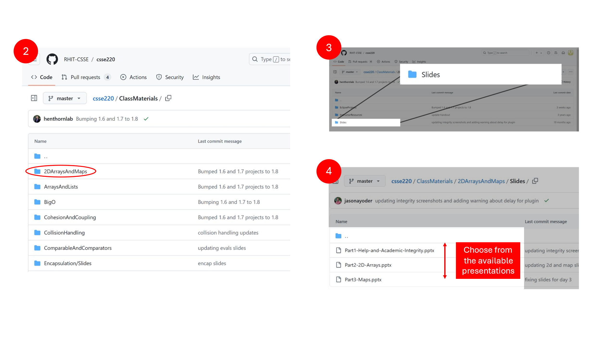**Slides** from each class are available for review and are a great way to revisit lecture material. You can access them both online ([https://github.com/RHIT-CSSE/csse220/tree/master/ClassMaterials](https://github.com/RHIT-CSSE/csse220/tree/master/ClassMaterials/2DArraysAndMaps/Slides)) and locally.

**To access the slides online:**

1. First, go to [GitHub - Class Materials](https://github.com/RHIT-CSSE/csse220/tree/master/ClassMaterials) folder
2. Open the folder corresponding to the topic

you’re studying

1. Navigate to the “Slides” folder
2. Download the PowerPoint presentations

**To access them locally, first open Eclipse on your cloned course repository folder**

### 1. Right click on the desired topic on your

### Package Explorer, then select

### 2. Show In > System Explorer

3. Next, follow the same path to find

the Slides folder with PPT files (1->2->3->4)

*(This usually requires you to go “UP” one level*

*In the file explorer to see the “Slides” folder)*

### In-class solutions

In Eclipse, inside the class repository, you an always find solutions

to the problems discussed during lecture. Their location might vary

according to how your Eclipse workspace was set up.

### TA Help Hours

Teaching Assistants (TAs) are available to help you during their scheduled hours. You can check the TASchedule by navigating to the link on the course Moodle page or by visiting the MS Teams channel for updates on TA availability. Use Teams to message or video call/screen share with a TA.

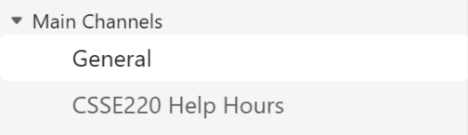

### Piazza

Piazza is an interactive Q&A platform where you can post questions and get answers quickly from both classmates and instructors. It can be accessed from the course Moodle page.

* 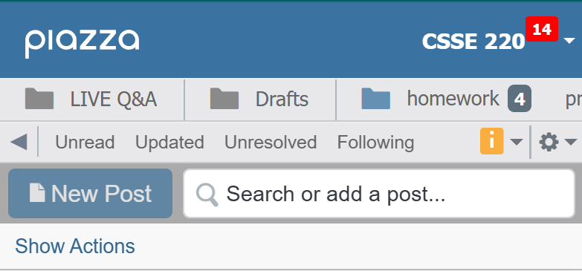**Ask Questions:** Post questions on Piazza instead of emailing instructors. This allows everyone to benefit from the answers, and classmates can often provide support.
* **Collaborate:** Use Piazza’s edits to improve answers collaboratively. Follow-up questions can spark great discussions.



* **Post Anonymously:** If you prefer, you can post questions anonymously.
* A screenshot of a computer

  Description automatically generatedIf your question requires sharing code, you can use the “Instructors Only” option to keep it private. Before you make a post, you can always select who can view it.



### Panopto Videos

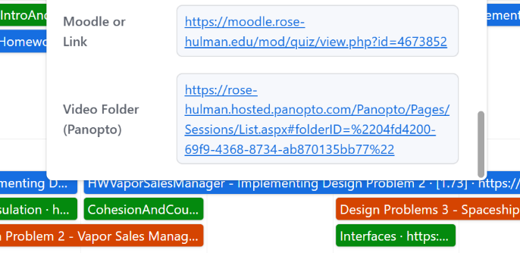

Videos of each lecture are available to help you review material or catch up if you missed a class.

1. Open the “Panopto Video Folder” link from the course Moodle Page
2. Find the topic you want to review (similar to slides)
3. Watch and revisit sections

Alternatively, you can use the topic placeholders in Moodle’s Airtable to navigate directly to the relevant video folder.



### Topic Summaries

By right clicking on a topic placeholder in Moodle’s Airtable, you can access the topic summaries, which can be helpful to clarify definitions, and provide sample examples.

Be careful to follow Academic Integrity guidelines when getting help from others in the class

No matter what sort of help you get, ALWAYS make sure you cite it in your assignment.