How to Get Help

# TA Help Hours

Great for individualized help on assignments!

Linked from Moodle

Click on links in sheet

Opens MS Team Channel

Send message, then video call/screen share with TA

# Questions on Piazza

Extremely quick way to get general/collaborative questions

answered

For public questions, please do not post code from

assignments

Please post questions and look to help *provide hints* to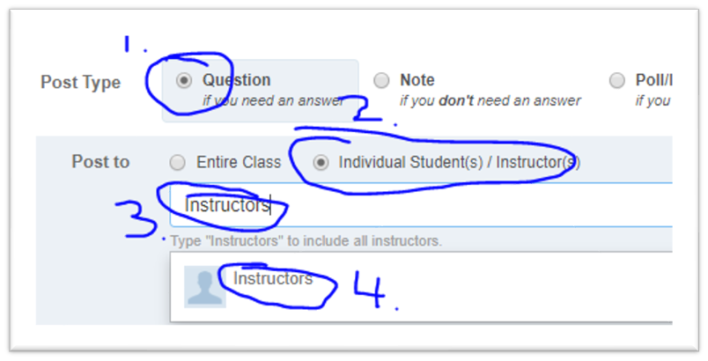

public questions from other students

For questions about homework, or when you need to

post code from assignments:

Share your posts privately to Instructors only

# Panopto ViScreenshot 2024-12-01 at 1.55.50 PM.pngdeos

Great way to review content covered in class

Videos may cover the content slightly differently than in class

# Remember

220 is difficult! Needing periodic help is not a bad thing!

If you are stuck on an assignment and have not made progress in 20 minutes or

more, you should seek help!

Your instructor is happy to help when possible, but the above ways can often be more

immediate sources for help

Be careful to follow Academic Integrity guidelines when getting help from others in the

class

No matter what sort of help you get, ALWAYS make sure you cite it in your assignment