**DP1 Name: ___________________________________ CM: _______**

***Online quiz***: In an online quiz system, teachers write quizzes and students take them. The same quiz question can appear in multiple quizzes. If a teacher updates a quiz question, it's important that all quizzes reflect that change.

**Solution A**

[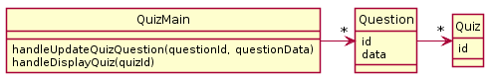](http://www.plantuml.com/plantuml/img/JOun3i8m34LtdyBgH15SeLEN3WmTE83LHAf56aAT30tAtN55YLYiBty__oyFze5MMb3YvgpEbQUO5WSmEHB1CN6-4NjymqpUE7iFXgBTrsEo4ldfJwz33EQ2FzrJfFP0UfRWQDiPlUKyc1OGIqtu4fg0o4Q71X2Klm9ggL6Wbhbss9oRYaBzKGtEy040)

**Solution B**

[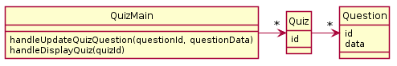](http://www.plantuml.com/plantuml/img/JKwx3eCm3Dpz5HOJLEqlCB4mT63e1rWaKgs6DCN905N-lUPHskLqklFvJXxi0uqqeCJ9MSMH-vW61z0x4i4kyNmbzlY6EtdZx2qOYdQHksGbyjENhvsqvenVtb2aQeyqBC7Hj6JqbkVML82OZuOjeGs8R1IqW23_3L1BZGp7c4kDnQbOlLNy2Til-000)

Both designs have the worst kind of problem: **they don’t function**. For each, please identify the problems with each one (by number, for example: Principle 1a, 1b, or 1c) and explain how it violates that principle. Then propose a new design of your own that works correctly.

***Problems With A***

* OO Design Principle(s) violated: _________________________________
* Your explanation:

***Problems With B***

* OO Design Principle(s) violated: _________________________________
* Your explanation:

***Your Solution***

* Include UML diagram and an explanation of how it functions