**DP3 Name: ___________________________________ CM: _______**

***Spaceship*:** In a single player spaceship racing game, the mechanics surrounding ships are particularly important. Each ship has its own current position, rotation, and velocity. Rotation and velocity can be increased or decreased by the player’s controller - this is how the ship is steered. When a ship or multiple ships are computer controlled there are 4 different flying strategies that control how the ship moves in the game. When the player controls his/her ship, the ship gets input from the player’s controller which sets rotation and velocity. There are two commands to consider: *updatePlayerInput* which is called when a player presses a key on the controller and *moveAllShips* which updates the position of all ships in the game based on their current settings.

**Solution A**

[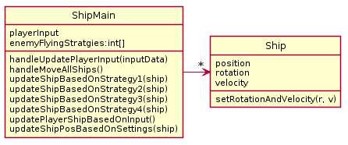](http://www.plantuml.com/plantuml/img/XL5DImD13BtFhnXwseeUj3rv42eYU2WMIxs8Xx0Rji7Pp339BWp5_-xiXxLwi9VmalVoXhoH3-804HehcXpc6gdKjd76b0v4x7PFOGt4zc2i3GuInYSEhUOE6Plqw19nlTK8MXFABR6-lMTo3rmvt8KA53S_QmNrzG4KvaVHsdUuSgv_IOf-t0vRVNyFWjKp3_POf-j2yl1VoSrvoUAyPFb7Cbvm8XoF-UsnyV9jWwev5PbSpET9c6EGNaZ9SuRHAqomG-TBqfIXeBvCn8ghruaeugNjvjdE7B_bwixEBcQ3ynS0)

**Solution B**

[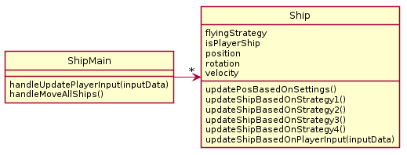](http://www.plantuml.com/plantuml/img/VP1D2y8m38Rl_HLb9nKy-74M52yUH67u0y9Mjs3MbYOJXlZVRVqO7dINaFP9dvINBsWz16WqIqScre25j0qfLH0mwxn6lmUq-gQqhi6MP4w-1357Wiw4dVMjZ33LBGYC-w6zkverKNhEex6wV-cUgZDrQAjSGbHLNRn0VXdJH3nwnoZeR6o34tYtLqEkG4dpxUiNZZV0fZpOt8X4OrhsWKdreUz5is4y7yQBORpyZVya5JDHVRhJbSucsJEU1m00)

Explain the problems with each Solution provided above (and give the number of the OO Principles violated)

***Problems With A***

* OO Design Principle(s) violated: _________________________________
* Your explanation:

***Problems With B***

* OO Design Principle(s) violated: _________________________________
* Your explanation:

***Your Solution***

* Include UML diagram and an explanation of how it functions