**DP5 Name: __________________________________________ CM: _______**

***Internet Sudoku:*** A particular program allows people to solve hard sudoku puzzles while spectators watch over the internet. When a user enters a new number, the program must both update the board and ensure it was a legal move. Then the program must broadcast the move to via an internet channel. The internet connection must first be setup with a network configuration. If there are network connectivity problems, they are placed in an error log that is stored in a file and can be displayed with a command. An error log message includes a message, an error code, and a timestamp. The error display command displays the message and timestamp of the most recently recorded error. The error dump command dumps the complete error log to a datafile with the given name.

**Solution A**

[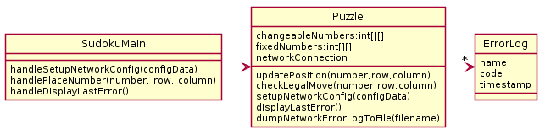](http://www.plantuml.com/plantuml/img/XP7FJiCm3CRlUOfefmwD5-30XS6fcogDsxI3bxXTr2IEyeUn8TwTf6ex92PniQNFN-oVdT0hwy23uI5UDERebOZ9QCQ4XX3uBadgqmQKvL-CynDOgN67CRajnZFv_eLigxfA36aD4PQphT4WS9lC4NrbXxJYdiuhBaWdOs_6jGfEmwM645-z9r-LqlT8qAJhDPELwIBREuIZ7hk69sNZ_h0_v5ghFb7-bUrCQL54HJPhoKc8s51GHPZG2jaDJ9nGz3Lse3VqWVSzuRypo7jxoMIcHuDOK_TERqfZrUPWmU2IJRjFXc7xKYfa94kAoc28O5msir-_zFWyNeoDXyl2uc4nj_e1)

**Solution B**

[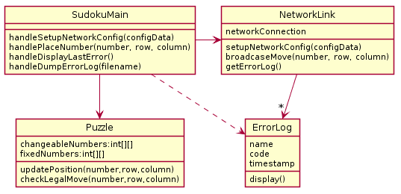](http://www.plantuml.com/plantuml/img/XP7BRi8m44Nt-GgBLLf1Fw0BDgMxW2AnH2mczYHOyKj-b4BLVw_pjX1IDvdepeplzR5hkJ9WGHBdRmBZrtBgWnHPHWKuHuw1wJRiWIloan5o0SK47j47Sq1_rRRzqAhcJKxxiWCFB_DOAO3Y8SWARQxwiYPMNzU4QX6aMWPtt1a1jmAS_xHMspnf1MbwhT1DNdE12YHsxTynO1dkznYy2qVZIeDGYT7KlNFbJ-VJEVPg_etiKOvwC0mybjfnpxMQOdOfbv3qWhGji06nrr_uR6OACp8fk6hxH6fcf91s1b5p_y6hh0P6mM7gzWYkGJzZMVmdQJ2FfBhqcdN5SudEWpJndmsy-yNaWTyss_c4LDz4VS2SfHUCwkfrzNnZcwBu0m00)

**\*\*HINT\*\***: in Solution B, the code in *handleDisplayLastError()* looks like this:

{networkLink.getErrorLog().get(0).display();}

Explain the problems with each Solution provided above (and give the number of the OO Principles violated)

***Problems With A***

* OO Design Principle(s) violated: _________________________________
* Your explanation:

***Problems With B***

* OO Design Principle(s) violated: _________________________________
* Your explanation:

***Your Solution***

* Include UML diagram and an explanation of how it functions