# CSSE 220---Object-Oriented Software Development

## Exam 1 -- Part 2, September 26, 2019

**Allowed Resources on Part 2**. Open book, open notes, and computer. Limited network access. You may use the network only to access your own files, the course Moodle and Piazza sites (but obviously do not post on Piazza) and web pages, the textbook’s site, Oracle’s Java website, and Logan Library’s online books. You may only use a search engine (like Google) to search within Oracle’s Java website - all others uses or accessing websites other than those mentioned above are not allowed.

**Instructions.** You must disable Microsoft Lync, IM, email, and other such communication programs before beginning part 2 of the exam. Any communication with anyone other than the instructor or a TA during the exam may result in a failing grade for the course.

You must actually get these problems working on your computer. Almost all of the credit for the problems will be for code that actually works. If you get every part working, comments are not required. If you do not get a method to work, comments may help me to understand enough so that you can earn (possibly a small amount of) partial credit.

Submit all modified files via Moodle.

Problem Descriptions

**Part C1: Small Problems (18 points)**

Implement the code for the 3 functions in SmallProblems.java. Instructions are included in the comments of each function. Unit tests are included in SmallProblemsTest.java.

**Part C2: Map and 2D Array Problems (20 points)**

Implement the code for both of the functions in MapAnd2dArray.java -- each problem is worth 10 points. Instructions are included in the comments of each function. Unit tests are included in MapAnd2DArrayTest.java.

**Part C3: Test this Class (7 points)**

Implement a unit test for the function in TestThisClass.java. You will add a file TestThisClassTest.java that will contain your test. Your test should have 3 assertions that test a variety of cases, but need not be exhaustive.

**Part C4 on the next page.**

**Part C4: Graphics Problem (20 points)**

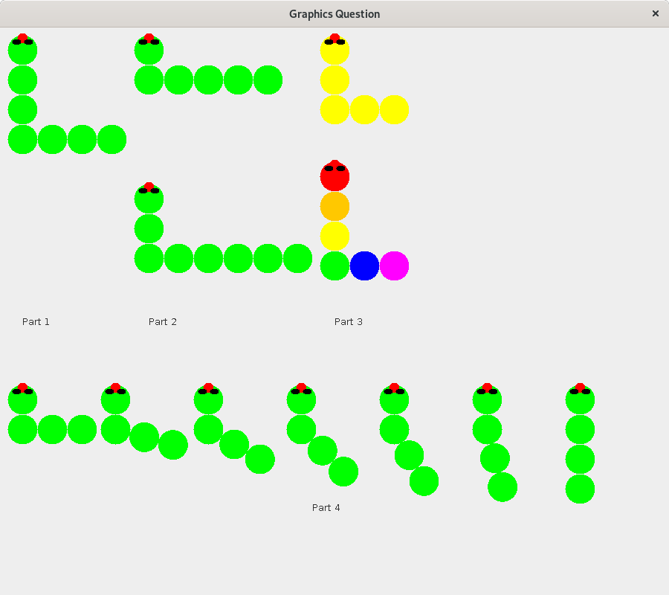

Read over all these instructions carefully. Make sure you understand completely what functionality you have to implement before you start coding. Ask questions if anything is unclear.

*Phase 1* *(5 points)*

When constructed with with no parameters, Centipede should draw a Centipede as above starting at DEFAULT_HEAD_X and DEFAULT_HEAD_Y (that’s the center of the head circle). The head drawing code is included to get you started. The default centipede should have 4 “down” segments and 4 “right” segments (note that that’s only 7 total segments because one segment counts as both). Be sure you get the count right before moving on to the next step!

*Phase 2 (5 points)*

Add a new constructor for the centipede class that takes x y for the center of the head and then down and right for how many down segments and how many right segments. This will require new fields and changes to drawOn. Ensure the Phase 1 code keeps working.

*Phase 3 (5 points)*

Add a setcolor(color, segment_num) method that lets you set the background color of a specific segment. This will require new fields and changes to drawOn.

*Phase 4 (5 points)*

Add a setRotation(rotationDegrees) method that lets you set the angle between the two parts of the centipede. 90 degrees corresponds to the default rotation that all the old centipedes draw at. 0 degrees corresponds to a completely vertical centipede. The above image shows centipedes between 90 (left) and 0 (right).