# CSSE 220---Object-Oriented Software Development

## Exam 2 -- Part 1, October 20, 2018

This exam consists of two parts. Part 1 is to be solved on these pages. If you need more space, please ask your instructor for blank paper.

*Allowed Resources on Part 1*: You may use a single sheet of 8.5” x 11” inch paper with notes on both sides. You can also use your “UML Cheatsheet” and your “Design Principles” handouts if you brought them. Your computer must be closed the entire time you are completing Part 1.

**You will have two back-to-back class periods to complete Part 1.**

**Part 2 will be completed in the next class.**

Please, begin by writing your name on every page of the exam. We encourage you to skim the

entire exam before answering any questions.

|  |  |  |
| --- | --- | --- |
| **Problem** | **Points**  **Possible** | **Earned** |
| 1 | 6 | _______ |
| 2 | 8 | _______ |
| 3 | 10 | _______ |
| 4 | 5 | _______ |
| 5 | 15 | _______ |
| **Paper Part Subtotal** | 44 | _______ |
|  |  |  |
| **Computer Part Subtotal** | 56 | _______ |
|  |  |  |
| **Total** | 100 | _______ |

1. (6 points) A UML diagram for a simple drawing system similar to the Scene assignment is shown below.

In this diagram, PictureMain constructs Rock, Flower, and Butterfly objects and adds them to PictureComponent. The paintComponent method of PictureComponent loops through all rocks, flowers, and butterflies in three loops and calls draw on each of them.

[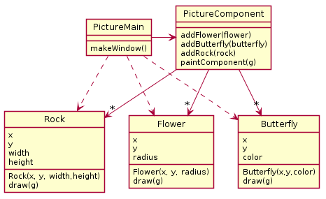](http://www.plantuml.com/plantuml/img/TL7BRiCW4BplLw2Se7Bo2JcqKc-LgbnwfeR4o1WimB9Hb7yFhrB7KIuBEpixioos5sgaXWx8EYzvY4QqRXeaG2kfjUWxfeP_KQ7G5GRQyn-Xc9un0OHk6zQ77aQjk7A1YX1bx5FgcHjyJWV9sFla73TdwV7ltwrKJhhjiGaXvcDmT5KGNmZSYbca1OF4NXha6pGBvhgcu-BIEG8BU4W8P0IOeVDQ84yL92BJK2Oc2sNIh9SniceidNNsqjnggGtylsXfV9EmXzwdxUptHxHxsvL1NjUhy6jAt0AiFodWM_93_N0uRdmh_6HNAydb3W00)

1. (2 points) There is a problem with this design. Which of Encapsulation, Coupling, or Cohesion does the problem with this design seem related? In one sentence, explain what in the diagram suggests this problem exists.
2. (4 points) Now, fix the problem you identified in the previous part with the introduction of an interface. Please do include all relevant dependency lines in your diagrams. To make your diagram shorter, feel free to just draw a rectangle with a Class Name and nothing else only if the class’s fields and methods are unchanged from the original diagram above.

2. (8 points)

A particular system is designed to produce data reports for a company. A data report consists of an id, title, and some text followed by a series of pie graphs and scatter graphs. Each pie graph and scatter graph has its own data. For pie graphs, the data consists of a list of category names and values (e.g., “Misc expenses”, 300.57). For scatter graphs, the data consists of pairs of x y coordinates. To produce a final data report, each graph must be rendered to a PNG image file and then the PNGs and the title/text must be combined into a final PDF file.

Here are 2 possible solutions. You can assume both of these designs function correctly (that

is, exclude principle 1 from your consideration).

Solution A

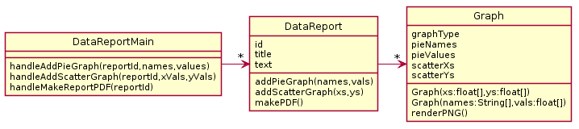

Solution B

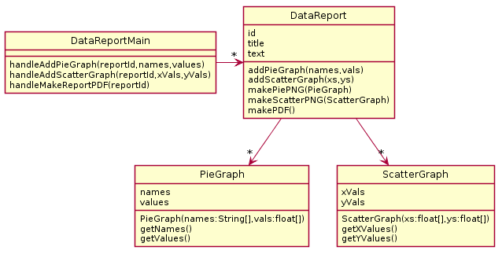

1. (2 points) Explain the problems with Solution A using your design principles.
2. (2 points) Explain the problem with Solution B using your design principles.
3. (4 points) Make a UML diagram of your proposed solution to the problem. For your solution we have provided a DataReportMain to get you started. Feel free to omit any regular getter methods in your solution diagram as well.

[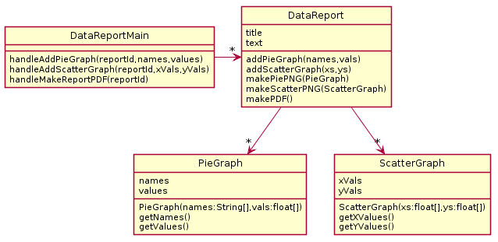](http://www.plantuml.com/plantuml/img/RP71QeD048RlynHBJbhC2-HGA8I67X8aWT0ISXXqcaXM8xkJOYXvzuwhQrVRowxwpp__DwEz55MD1ajb-Qv9JbDaV2irGARHMhL4nYtLLyDhB2hr3MUiSaqlUPuMj39OdoFZvBSygR0actoXlf6DVmjt6JAJcHGtUzGskRUdhrtZXRgiTFawLCQWrEClZg0enGLhQczgM2uCg0OO6tVA2AEHQ2UKaYcUTBEAlDL_xWsj57e7bp36yEZ1l5cmN39qQu0nps8d-wrEXwC3MtpgA_BX6CE9UDFgaNlSEwjhtdSFyoN1xGxSxc0obkyfuutQlmzDvUKZJ9ZyuVcpcZtDWaK71MhUgtwg_xGG27u0)

3. (10 Points)

For this problem, determine the output from this program by tracing the call to operation *fun* which appears on line 2.

|  |  |
| --- | --- |
| 1 **public** **static** **void** main(String[] args) {  2 System.out.println(fun("AXB","CCX"));  3 }  4  5 **public** **static** String fun(String one, String two) {  6 **if**(one.isEmpty()) **return** "";  7 String rest = fun(one.substring(1), two.substring(1));  8 **if**(one.charAt(0) == 'X')  9 **return** rest + two.charAt(0);  10 **else**  11 **return** rest + one.charAt(0);  12 } |  |

4. (5 points)

Write what this code outputs.

|  |
| --- |
| **class** Q {  **public** **static** **double** getPercentage(double one, double two) {  **if**(two == 0)  **throw** **new** IllegalArgumentException();  **if**(one > two)  **throw** **new** ArithmeticException();  **return** (one/two)*100;  }    **public** **static** **void** printPercentage(double one, double two) {  **try** {  double result = -1;  result = getPercentage(one, two);  System.out.println("Percentage was " + result);  } **catch** (IllegalArgumentException e) {  System.out.println("IA error solved");  }  System.out.println("print done");  }    **public** **static** **void** someCode() {  printPercentage(1, 0);  printPercentage(2, 1);  printPercentage(1, 2);    System.out.println("code done");  }  **public** **static** **void** main(String[] args) {  **try** {  someCode();  } **catch** (ArithmeticException e) {  System.out.println("AE error solved");  }  }  } |

Write your answer here:

5. (15 Points)

|  |
| --- |
| **public** interface Plastic {  **void** methodA();  }    **public** **class** Gold **implements** Plastic {  **public** **void** methodA() {  System.out.println("GoldA");  }  **public** **void** methodC() {  System.out.println("GoldC");  }  }  **public** **class** Silver **extends** Gold {  **public** **void** methodA() {  System.out.println("SilverA");  methodB();  }  **public** **void** methodB() {  System.out.println("SilverB");  }  }  **public** **class** Bronze **extends** Silver {  **private** Plastic plastic;  **public** **void** methodB() {  System.out.println("BronzeB");  }  } |

a. (4 points) Draw a UML diagram to represent the given interface and classes. Include all

methods, but when writing subclass methods, only show a method on the subclass if the

subclass method overrides the parent class’s method, or if the method is specific only to

the subclass. In places where lines representing fields are appropriate, use lines and do

NOT re–list the same field in the field list.

b. (11 points) For each line of code below, if the line results in an error, circle the appropriate error; otherwise, provide the output in the provided blank. If the code works but does not print anything, write “nothing”. Consider each line of code separately. That is, if a line would give an error, then assume that line doesn’t affect any others. If the result would print on multiple lines, remove the newline from your result and show it on a single line.

**Code Either circle the error or provide the output**

Gold x = **new** Silver();

Silver x2 = **new** Bronze();

1. Plastic p1 = **new** Plastic(); runtime error compiler error _______________

2. Plastic p2 = **new** Gold(); runtime error compiler error _______________

3. x.methodA(); runtime error compiler error _______________

4. x.methodB(); runtime error compiler error _______________

5. ((Silver) x).methodB(); runtime error compiler error _______________

6. Silver y = x; runtime error compiler error _______________

7. x2.methodC(); runtime error compiler error _______________

8. ((Bronze) x).methodB(); runtime error compiler error _______________

9. ((Silver) x2).methodB(); runtime error compiler error _______________

10. x2.methodA(); runtime error compiler error _______________

11. Silver y2 = x2; runtime error compiler error _______________