**Environments and Closures summary**

Environment:

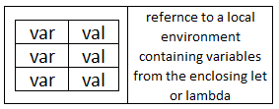

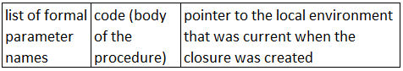

Closure:

**Create a procedure:**

A user-defined procedure (a.k.a. **closure**) is created when a lambda expression is evaluated. The body of the procedure is not evaluated at this time.

**Apply a closure (user-defined procedure):**

1. The expressions for the procedure and its arguments are evaluated.
2. A new local environment is created.
   1. Each variable from the procedure's formal parameter list is bound to the corresponding value from the actual argument list.
   2. The new environment's "pointer to an enclosing environment" is set to be a copy of the local environment pointer **that is the third part of the closure**.
3. The body of the procedure is evaluated, using this new local environment. If a variable is not found in this local environment or something it points to, look in the global environment. If not in global environment either, it is an error.

**Evaluate a let expression:**

1. Evaluate (in the current environment) the expressions to get the values to be assigned to the let variables.
2. Create a new local environment that has bindings for the let variables. The "enclosing environment" pointer points to the current environment.
3. Evaluate the body of the let in this new environment, as in 3 above.

**Evaluate a letrec expression:**

1. Create a new local environment, similar to a let environment, except that:
   1. The "saved environment" pointers of any closures that are bound to the letrec variables point to the new letrec environment, not the enclosing environment.
2. Evaluate the body of the letrec in this new environment, as in 3 above.