**CSSE 304 Exam #2 E&C Jan 17, 2019 (day 23) Name______________________ Section:** 01(9:00) 02(9:55) 03(10:50)

(25 points) Draw the environments and closures created during the execution of the following code segment. Include a sequence number for each environment or closure that you create and for each new entry in the global environment

Be sure to show any changes made to the global environment, and put a sequence number on every environment, closure, and assignment to the global environment.

Value returned by the (f 2 1) expression: ___________

|  |
| --- |
| (define f  (lambda (a b)  (let ([a (let ([b (+ a b)])  (+ a b))]  [g (lambda (x) (* a b x))])  (g (g a)))))  (f 2 1) |

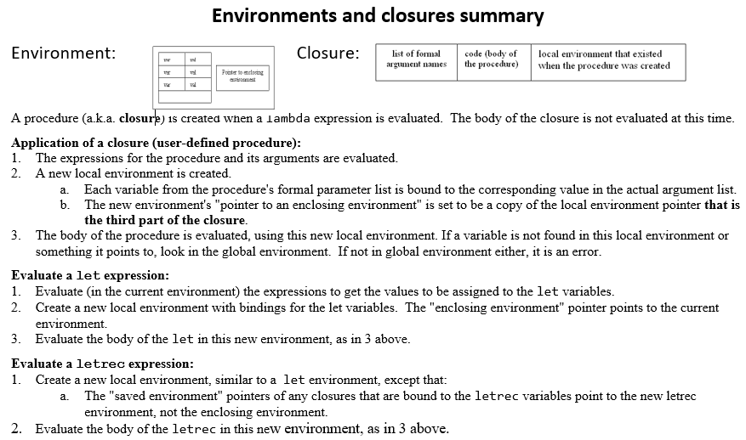

**CSSE 304 Exam #2 E&C Jan 17, 2019 (day 23) Name______________________ Section:** 01(9:00) 02(9:55) 03(10:50)

**This space is here in case you need to start over in order to avoid having a messy diagram.** If you want me to grade this side, place a bog X through your work on the other side.

Value returned by the (f 2 1) expression: ___________

|  |
| --- |
| (define f  (lambda (a b)  (let ([a (let ([b (+ a b)])  (+ a b))]  [g (lambda (x) (* a b x))])  (g (g a)))))  (f 2 1) |

