**CSSE 304 Exam #2 E&C Oct 17, 2019 (day 23) Name______________________ Section:** 01(9:00) 02(10:00) 03(11:00)

(20 points) Draw the environments and closures created during the execution of the following code segment. Include a sequence number for each environment or closure that you create.

If you need to start over, use the back, and put a big X through what you

Value returned by the expression: ___________

|  |
| --- |
| (letrec ([g (lambda (x) (+ x 3))]  [map1 (lambda (f L)  (if (null? L)  '()  (let ([fcar (f (car L))])  (cons fcar (map1 f (cdr L))))))])  (map1 (lambda (y) (g (g y))) '(5))) |

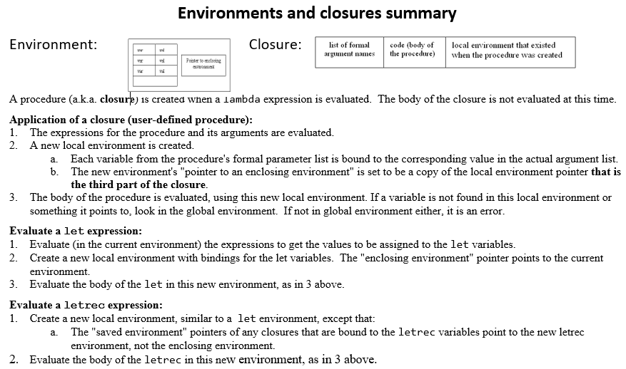

**CSSE 304 Exam #2 E&C Oct 17, 2019 (day 23) Name______________________ Section:** 01(9:00) 02(10:00) 03(11:00)

(20 points) Draw the environments and closures created during the execution of the following code segment. Include a sequence number for each environment or closure that you create.

If you need to start over, use the back, and put a big X through what you

Value returned by the expression: ___________

|  |
| --- |
| (letrec ([g (lambda (x) (+ x 3))]  [map1 (lambda (f L)  (if (null? L)  '()  (let ([fcar (f (car L))])  (cons fcar (map1 f (cdr L))))))])  (map1 (lambda (y) (g (g y))) '(5))) |

