**CSSE 304 Exam #2 E&C Jan 20, 2020 (day 21) Name______________________ Section:** 01(1000) 02(11:00) 03(1200)

(20 points) Draw the environments and closures created during the execution of the code segment below. Include a sequence number for each environment or closure that you create and whenever something is added to the global environment.

If you need to start over, use the back of this page, and put a big X through what you wrote here.

Assume that zero?, cons, reverse, -, and * are bound in the global env. To leave more room for your answer, I do not show the values of these. Applying a built-in procedure does NOT cause a new environment to be created.

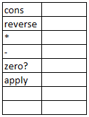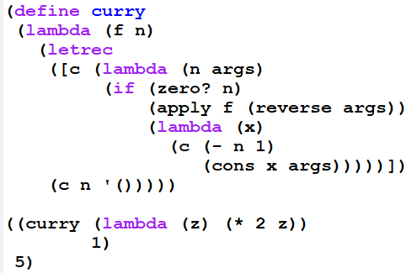

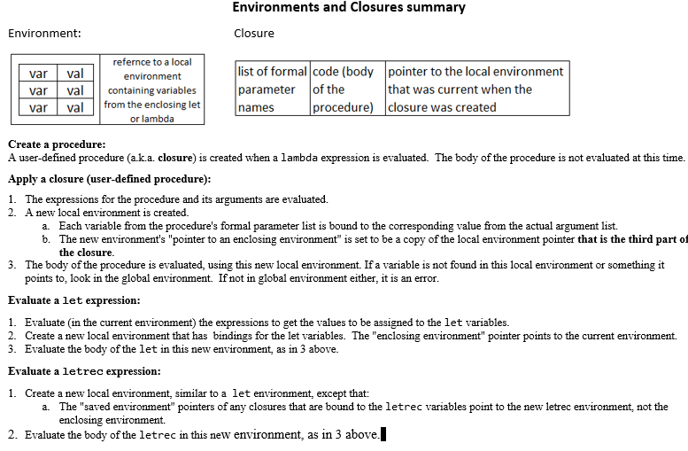

**CSSE 304 Exam #2 E&C Jan 20, 2020 (day 21) Name______________________ Section:** 01(1000) 02(11:00) 03(1200)

(20 points) Draw the environments and closures created during the execution of the code segment below. Include a sequence number for each environment or closure that you create and whenever something is added to the global environment.

If you need to start over, use the back of this page, and put a big X through what you wrote here.

Assume that zero?, cons, reverse, -, and * are bound in the global env. To leave more room for your answer, I do not show the values of these. Applying a built-in procedure does NOT cause a new environment to be created.





