The ORIGINAL Monaco Game Design from 2003

This is the original game design document that I wrote in 2003.  As you can see, it's remarkably similar to the game as it stands today!

*Side Note: PLEASE VOTE FOR MONACO IN THE 2011 INDIE GAMES CHALLENGE, NO REG REQUIRED*

[http://www.indiegamechallenge.com/finalists/monaco/](https://www.indiegamechallenge.com/finalists/monaco/?fbclid=IwAR2b4HD_sjStMGRxPuJrK6tJgB8Slx6DBXoCSLORBA7Vei4VD_8jLZQ0tLI_aem_AbyDB7o_mD9hhRAlLvMmMgNgK4znnZCTfYrL1g6ZePTVq8wRzuEsch3amOPPJR6dOMzGPvTPvgewwarBfbcjKS-v)

Why is this Part 1? For some reason, this doc is missing some of the social features that I remember being in that version.  I actually think this doc must have been revised at some point, as you can see by the reference to Casino Royale.  I'll detail what the missing features were in the next post, and include a revised doc that I made in order to pitch the game in 2008.

THE CONTEXT:

*From Sahara...*

I was working as a programmer for TKO Software, a game dev studio based on Santa Cruz, CA.  I was the lead gameplay programmer on a doomed project: a game based on the movie *Sahara*.  Our management had given us the unrealistic goal of making the game in 9 months (when the movie was supposed to come out) on an unfinished proprietary engine.  Our deadlines slipped, but luckily, so did the movie.  But we eventually ran out of money and the project was cancelled.

*...To Monaco...*

While management scrambled to try to get us paying work, the rest of us essentially sat on our hands.  Being the ambitious little programmer/designer that I was, I brought some designs of mine into the company and suggested that we prototype them.  Management gave me free reign to put together the design docs and then prototype the game, while I made sure that I contractually owned the concepts if TKO decided not to develop the games.

*... To Goldeneye*

One of those designs was *Monaco*.  We only just started making the prototype before word came in that we had picked up contract work on EA's remake of *Goldeneye*.  But I had fallen in love with *Monaco*, and it has been a game I've wanted to make since then.

This is the original game design document.  I may not technically have rights to the document itself, but the company went out of business in 2005 and I do own the concept, so I don't think anyone will complain.

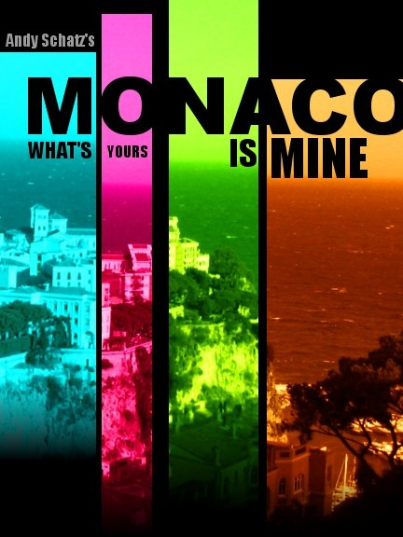

INSTANT SUMMARY

MONACO is a thief game.  Players can go on solo or multiplayer missions to steal jewelry, art, and cars from the compounds of the internationally rich and famous.

LOOK AND FEEL

OCEAN’S 11, CASINO ROYALE, and THE ITALIAN JOB inform the visual style of the game.

GAME DESIGN

MONACO combines the low-level game mechanics of PACMAN married with the stealth features of HITMAN.

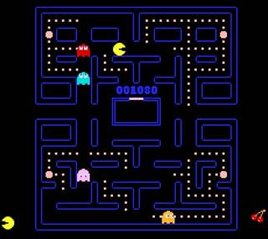

*How does the game derive inspiration from PACMAN?*

MONACO is an ACTIVE stealth game – the player must stay on the move to evade the bad guys

Players are trying to CLEAN OUT an environment of all the minor and major valuable items (just like eating dots in Pacman)

Like the heroes of the best heist movies, players INCAPACITATE guards rather than kill them.  The guards return to action after a short time

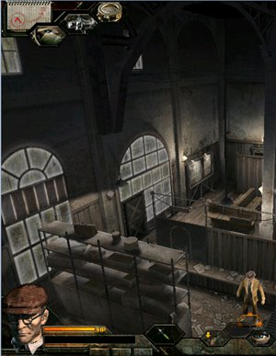

*How is this married to the features of a modern stealth game?*

The player can find DISGUISES around the environment, which, like Pacman’s power pellets, allow them to move freely until they are discovered

Time-based activities, such as PICKING LOCKS and HACKING SECURITY RADAR, increase tension and play a counterpoint to the constant movement and action of the heist

MULTIPLAYER heists create mind games: players can save each other after they are captured – or rat out their teammates to avoid jail time

*NOTE: MONACO employs RPG-style stat-based gameplay and static UI-based interaction to increase the game’s scope without increasing developer workload.*

USER INTERFACE

The following flow chart describes the player’s progression through the user interface.  The three main screens are the TITLE SCREEN, the MANSION, and the MISSION LOBBY.  In the mansion, the player may buy and sell items and make adjustments to their character’s skills.  Once the player reaches the mission lobby, they are “online” and may be connected to other players.

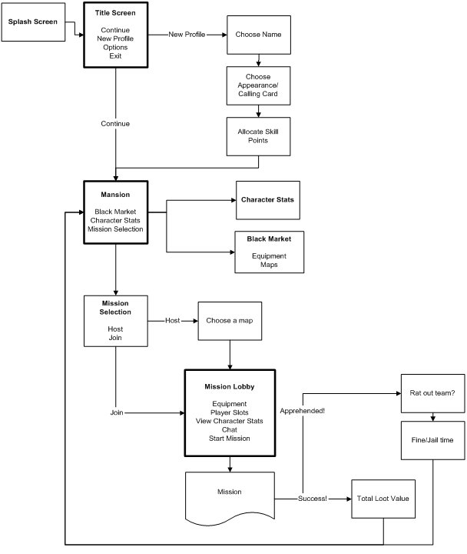

MONACO AS RPG

The missions of MONACO bookended by RPG-inspired gameplay elements.  The player must select an APPEARANCE and a CALLING CARD, BUY and SELL items on the black market, and LEVEL UP after successful missions.



The player leaves behind a calling card when they steal a unique item

CHARACTER CREATION

When creating a character, the player must choose their:

Name

Gender

Portrait

Calling Card (a playing card, a white glove, a flower)

Initial Skills

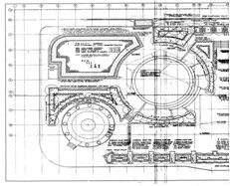

The player must buy a blueprint in order to access a mission

BLACK MARKET

Before missions, players can visit the black market to buy and sell the tools of the thieves’ trade and intelligence on upcoming missions.

Tools: The player may buy and sell lockpicks, laptops, weaponry, and other items

Blueprints: The player must buy a blueprint in order to access a mission.

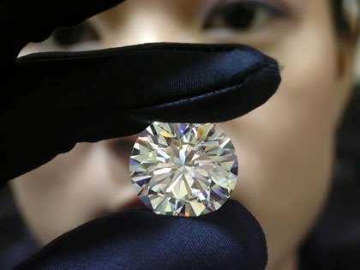

The player’s level, and thus his access to better equipment and more challenging missions, is determined by the total value of unique items the player has stolen

LEVELING UP

The player’s LEVEL is determined by the total value of UNIQUE ITEMS he has stolen.  As the player advances in level, harder mission maps become available on the black market.

When the player advances by a level, they can allocate points to their character’s SKILLS.  In general, these skill points can be raised infinitely, and new maps can be created to be challenging for any level of player.

MISSION FLOW

MAP SELECTION

The player starts a mission by selecting one of the blueprints he has bought from the black market.  The blueprints include:

A humorous description of the fictional owner of the mansion

The owner’s net worth (total value of unique items in the mansion).

The player may also choose to join another mission.

LOBBY

The Lobby allows players to connect to each other before they start the mission.  The host can open slots for up to 3 teammates.  By default the slots have a minimum level of whatever the map default is.  He can kick players out, chat with players, and view their skills and inventory.  All players can equip their characters with items that they have bought.  Each character can only carry a small amount of equipment.

When all players are marked “ready”, the host can start the mission.

MISSION

The players arrive at the mission in their getaway car.  At any point, a player may reenter the getaway car.  They may choose to wait for other players or they can leave their teammates on the scene.  Any players left on the scene are automatically apprehended by the police.

SUCCESS

Players that escape successfully automatically split the value of the loot that they have stolen.  The mission success screen also displays the unique items that were stolen and the player’s progress towards leveling up.

FAILURE

If a player is apprehended and his teammates decide to leave him behind, he will have two options:

Pay a large fine and serve jail time if he incapacitated any guards

Rat out his teammates

If he rats out his teammates, they will all share the total fine, but they will all lose their loot.

image

THE MISSION ITSELF

Missions in MONACO play out in three acts:

Stealth – The guards are unaware that something is happening

Police Countdown – Guards try to catch players while they wait for the police to arrive

Escape – The players attempt to escape unscathed

PLAYER ACTIONS

The player can:

Move about the environment

Use a tranquilizer gun

Interact with an object (locked doors, computers, etc)

Open a container

Change disguises

Enter the getaway car

When the player interacts with an object (for instance, picks a lock), an action bar begins to fill up.  When the bar is full, the action is complete.  These actions are usually skill-dependent.

COMBAT

Security guards are only equipped with a baton, no firearms.  The player can use a tranquilizer gun or hand-to-hand combat to incapacitate guards.  Incapacitated guards will wake up after 5 minutes and call the police from the nearest intercom.

Police are equipped with body armor and pistols and will shoot the player on sight.  Once the police show up, the player must escape as quickly as possible or they will be captured.

When a player is taken out, they are locked in a holding cell near security headquarters.  Teammates can rescue them by picking the lock on their handcuffs.

DISGUISES

The player can find various disguises around the environment.  Guards will attempt to approach players wearing disguises, but they will only become aware of the deception if the player lingers or allows the guards to come too close.

SURVEILLANCE

The player has a minimap available at all times.  When the player hacks into a security system, they are able to see guard positions on the map as well.

CHARACTER CUSTOMIZATION

CALLING CARDS

There are 12 calling cards to choose from.  A calling card is left in place of unique items when they are stolen.  A guard will notice when a unique item is stolen and will call the police.

PORTRAITS

The player may choose between 12 portraits, 6 male and 6 female.  In game, the portrait chosen affects the texture, but not the model, of the character.

SKILLS

As the player levels up, he can allocate skill points which determine the level of equipment he can buy and use.  The player’s speed and effectiveness at various tasks is dependent both upon the quality of the tool used, the player’s skill in that category, and the difficulty of the lock/electronics/enemy he is opposing.

The skills are:

Unarmed Combat (judo)

Mechanics (picking locks)

Electronics (electronic locks)

Software (computers)

Stealth (how quietly the player can move)

Charisma (reduces fines and jail time)

EQUIPMENT

The player may carry a small number of items into a mission.  In general, the player’s items will determine their role in a given mission, as their skills are greatly enhanced by the presence of an appropriate tool.  As the player levels up, higher level tools will become available to them on the black market.

Equipment classes are:

Toolkit (Strength)

Lockpick (Mechanics)

Soldering kit (Electronics)

PDA (Software)

Tranquilzer Gun

Body Armor

ENVIRONMENTS

All of the environments in MONACO are Mediterranean mansions.  MONACO includes 30 UNIQUE MANSION LAYOUTS with randomized lock types and item locations.

STORY

The mansion blueprints each contain a description of a different member of a corrupt Masonic society.  The player will piece together a loosely knit story of crime through these descriptions.



NPC TYPES

All characters operate on the same human animation rig.  Aside from the male and female player models, NPC models include:

Guard

Police Officer

Resident – Male

Resident – Female

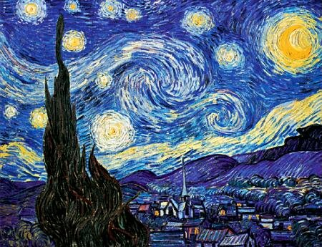

UNIQUE ITEMS

The player will level up based on the value of the “unique” items he steals from a mansion.  When a guard notices that a unique item has been stolen, he will notify the police.  The unique items are:

Jewels

Paintings

Historical Documents

Incriminating Photos

Safety Deposit Keys

Laptop

Valuable Book



VALUABLE ITEMS

Some items are valuable, and will contribute to the total cash value of items at the end of the heist, but do not figure into the player’s unique item score.

Jewelry

Cash

Wine

Perfume

OTHER ASSETS

Aside from basic walls and ground textures, the following is a basic list of environmental objects that need to be completed for a basic version of the game.

Exterior objects

Tree

Hedge

Fountain

Doors

Front Door

Exterior Door

Interior Door

Cellar Door

Window

Stairs

Ladder

Household Objects

Bed

Toilet

Sink

Bathtub

Dining Table

Chair

Containers

Nightstand

Desk

Chest

Safe

Bookshelf

Display Stand

Electronics

Computer

Electronic Lock

Security Camera

Intercom

*NOTE: A media design document will contain an exhaustive list of all of the art assets that need to be created*

TECHNOLOGY

There are two areas that will require significant technical development.

ARTIFICIAL INTELLIGENCE

Artificial Intelligence for Guards, Residents, and Police will require both scripted and dynamic behavior.  However, the behavior does not need to be incredibly complex, as predictable AI actually is more conducive to puzzle-solving.

MAP CREATION

Mansions will be created with a CUSTOM TILE EDITOR that allows the map creator to paint floors, draw walls, place objects, and place/route NPCs.