ECE 300 Lab 2: Review of LTI Systems

## Objective

The purpose of this lab is to become familiar with the Signals Exploration Board (SEB) by reviewing the concepts of linearity, time-invariance, and impulse response. When using the frequency domain to analyze systems, we are starting with the assumption that the system is linear and time-invariant (LTI) It is crucial to know if the SEB behaves this way or under which circumstances it behaves this way. We will also see that the impulse response of the system is directly related to frequency response. You will start by measuring the steady-state input-output relationship for the system to determine the bounds on the input and output in order for the system to behave linearly. Then you will use the system to understand mathematical combinations of signals in the context of linearity. Finally you will explore the concept of time-invariance of the system.

## Prelab

1. Solve the differential equation of a first-order system,, and derive the step and impulse response for this system. Show that the impulse response is the derivative of the step response. Provide a sketch of both the step and impulse response. You must show your work to get credit.

## Background

### LTI Systems

For a system to be strictly linear it must be both homogeneous and additive. Recall that a homogeneous system satisfies the property that “if the input is doubled the output will also double but otherwise remain unchanged”. Mathematically, homogeneity can be written as:

If then , where *m* is any scaling factor

A system is additive if it produces the same output regardless of whether two different inputs are added together before being applied to the system or if the corresponding outputs from each individual input are added together. Mathematically this can be written as:

If  and  then .



Fig 1: The input-output relationship of two different systems. The system on the left is truly linear. The system on the right is linear in a certain operating region, but has saturating nonlinearities.

Memoryless linear time-invariant (LTI) systems have an input-output relationship that is a line passing through the origin and extending to infinity. Real-world continuous-time systems cannot produce infinite outputs and we cannot provide infinite inputs. Therefore, these limitations create saturating nonlinearities as shown in Fig. 1. As long as the input remains within the bounds of the dashed lines shown in the figure, the system will appear to be linear. However, if the input goes outside of these bounds then the system will behave nonlinearly.

### Testing a system model for linearity

Recall that we can determine if a system is linear by comparing the results of two different tests on the system. In the first test, we sum two different signals, then input that combination to the system, and look at the output

. (1)

In the second test, we input each signal separately to the system, look at each output, and then sum the outputs

 (2)

We know that the system is linear if both tests yield the same results, i.e. .

### Testing a system model for time-invariance

Recall that the definition of time-invariance is that “a time delay of the input signal will yield the same time delay in the output signal, but not produce any other change in the output.” Mathematically, this is tested by

1. Find the output of the system to a delayed input signal



1. Using an un-delayed input signal, just delay the output signal



1. If then the system is said to be time invariant (TI)

# Settings and Parts Used

Other Equipment:

Memory Stick to get data from scope

Laptop with MATLAB running

## Part 1: Linearity of the SEB

In this part of the lab you will try to understand under what conditions the SEB behaves like a linear system. Because this board is made with electronic components it is actually a nonlinear system. However, if we make certain restrictions, the board will behave as if it were a linear system. As you are looking at the scope you should be able to determine the restrictions that are necessary on the input and output signals for the board to behave linearly.

1. FG Ch1=SIG: HighZ output, Ramp, 8Vpp, 500Hz, 50% symmetry via Ramp Parameter Menu  
   Connect scope Ch1 = SIG  
   Connect scope Ch2 = V_OUT

Set Scope: Horiz-TimeMode = Normal

Set Scope: Adjust horizontal scale so that you can see 2-3 periods

Set Scope: Adjust vertical scale so that both input and output waveforms fill screen without clipping

1. Adjust the three switches and two jumpers on the board so that the input signal on the SIG terminal has a gain of 1 and passes through the board to the output without being filtered.
2. Compare the input and output signals on the scope. ***Provide a mathematical expression for the system model (i.e. y(t)=?, where y is the system output). Show that this mathematical model of the system is homogeneous and therefore linear.***
3. Now switch the horizontal mode on the scope to be XY mode (Set Scope: Horiz-TimeMode = XY). This mode makes the x-axis of the scope screen be the signal on Ch1 (SIG input) instead of time. The y-axis of the scope screen is now controlled by Ch2, which is connected to the output of the system. For every instant of time, the scope is making the value on Ch1 be the x-coordinate on the screen and the value of Ch2 be the y-coordinate. If the signal is periodic it will continually retrace the same coordinates on the screen and give you a steady-state curve. The scope screen should now show you a diagonal line, which is the input-output relationship of the system.
4. Adjust the Gain switch on the board so that the multiplying signal can be set with the potentiometer to create a variable gain. Play with the potentiometer by turning it in the positive and negative directions, while observing what happens on the scope. Make sure you see what happens as you turn the potentiometer all the way in both the positive and negative directions.
5. **Your Experiment:** 
   1. Adjust the potentiometer to have a gain of -2.5V/V and increase the input signal amplitude so that the output saturates.
   2. Record at what output voltages the curve saturates, and at what input voltages the output becomes saturated.
   3. Adjust the mathematical model from Part (c) to represent the gain of the system. Include saturation effects in your model.
6. Without adjusting the gain control knob, change the scope’s setting Horiz-TimeMode=Normal and observe the waveforms. Then change it back to Horiz-TimeMode=XY. Note how the same information is displayed as the system input-output relationship in the XY mode and in the time domain in the Normal mode. **Record the screen of your scope in the normal time domain view showing what the signals look like when the system saturates.**
7. Make sure that the signal has no DC offset. Connect the speaker to the speaker output of the board. Vary the amplitude of the input signal. Listen for higher frequency tones to appear as the system starts to saturate. Later in the quarter, we will have a better understanding of why this happens. Once you hear this, disconnect the speaker.
8. **Your Experiment:** Make sure the speaker is disconnected. Using the definition of homogeneity, create an experiment that will prove that the SEB under saturating conditions is nonlinear.

## Part 2: Mathematical Combinations of Signals

Recall from the board manual that the board can multiply and add signals together where is the signal that the **Inputs Section** produces. You know what it means to add and multiply numbers together, but what does it mean to add and multiply *signals*? When we talk about mathematical combinations of signals, we are referring to the point-by-point combinations of these signals. In other words, take values of each signal at a particular point in time. Then perform the mathematical operation on these values at that point in time to get the resulting signal value at that point in time. Now repeat this operation for all points in time. You will be using the YIN and ZIN pins to add and multiply with the signal that is applied to the SIG input of the board.

1. FG Ch1 to SIG: Ramp, 2Vpp, 500Hz, 50% symmetry  
   FG Ch2 to ZIN: Ramp, 2Vpp, 250Hz, 100% symmetry via Ramp Parameter Menu

Scope Ch1=SIG

Scope Ch2=ZIN

Scope Ch3= V_OUT  
Set scope MATH channel to add SIG + ZIN ( i.e. add Ch1 and Ch2)

1. Adjust the switches and jumpers so that the signal source is the SIG input, the gain is set to 1, and you are adding the ZIN signal to the SIG input (). Make sure that this signal passes through the Sampling and Filtering Sections of the board unaltered.
2. Arrange the signals on the scope screen in an organized fashion. I will explain in detail here, but you will need to do this on your own in the future. Place the SIG signal at the top, the ZIN signal just below it so that they do not overlap, the V_OUT signal at the bottom of the screen so that it also does not overlap, and place the MATH channel directly overlapping the V_OUT signal. Make sure all signals are set to the same amplitude scale, that they have the maximum amplitude scale without overlapping, and that *none of the signals goes off the edge of the screen*.
3. Set up a vertical cursor on the scope at a particular point in time on the x-axis. Then find the values of the input signals ZIN and SIG at this point in time and add those values together. Verify that those values added together produce the value of the output signal at that point in time. Choose another point in time and do the same thing. Make sure you understand how all of the jumps and changes in the output signal are created by the summation of the two input signals.
4. Now play with the parameters of the input signals: amplitude, phase, and frequency. Observe how changes to these parameters affect the output signal.
5. **Your Experiment:** 
   1. Determine a set of signal parameters (frequency, amplitude, and/or phase) that will make the V_OUT signal from the board different from the MATH channel (i.e. they will no longer perfectly overlap at all points in time).
   2. Record the screen and your signal parameters
   3. Explain why the signals do not overlap

### Now you will change the board so that it multiplies instead of adds signals together.

1. Reset the signals to the parameters specified in Step (a) of this part.

Change the MATH channel on the scope to multiply the two signals rather than add.

Adjust the switches and jumpers on the board so that the signal source is the SIG input, the offset switch is set to 0, and you are multiplying the YIN signal to the SIG input ().

Make sure that this signal passes through the Sampling and Filtering Sections of the board unaltered.

1. Set up a vertical cursor on the scope at a particular point in time on the x-axis. Then find the values of the input signals ZIN and SIG at this point in time and multiply those values together. Verify that those values multiplied together produce the value of the output signal at that point in time. Choose another point in time and do the same thing. Make sure you understand why you now get a curved signal when the two input signals are lines.
2. Again play with the parameters of the signals and observe how they change the output. Make sure that you understand how the output changes as a result of changing the parameters. Find parameters that will make the V_OUT and MATH channels not the same for all points of time.
3. **Your Experiment:** Using any signals available from the function generator,determine a pair of input signals for YIN and SIG that, when multiplied together, will produce exactly the signal shown in Figure 2. When you have figured this out, **record the scope screen showing both of the input signals and the output signal.**

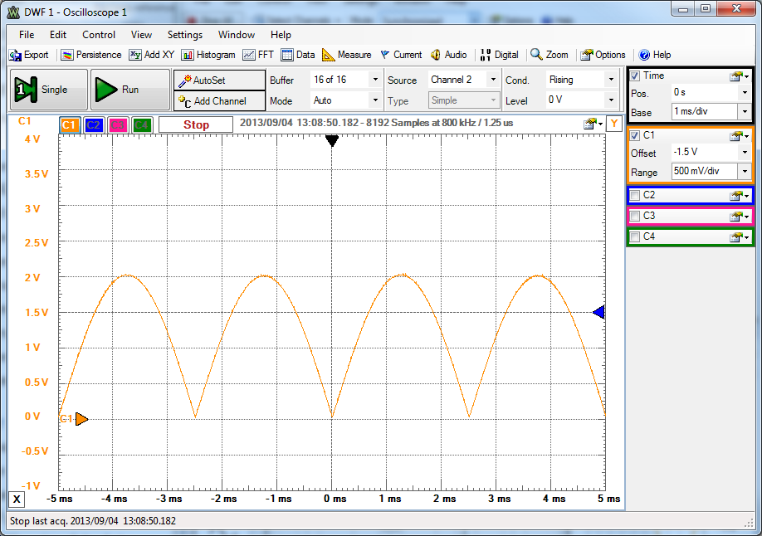

Figure 2: The signal that you should produce by multiplying YIN and SIG

## Part 3: Testing the system for time invariance

Recall the definition of time-invariance “a delay in the input should create a similar delay in the output, otherwise the output should be unchanged.” We will test this by looking at a periodic signal under two different system conditions. In a periodic signal, each period is identical except for a time delay. We can think of each subsequent period as a delayed version of an “initial” signal. If the system is time-invariant, then the output should be the same for every period. If the system is time varying, then the output for each period will be different according to the time at which that period enters the system.

1. FG Ch1=SIG: Pulse, 5Vpp, 1kHz, Offset=2.5V, Duty-Cycle=20%   
   Leave the FG connected to YIN but set the gain switch to 1

FG Ch2=YIN: HighZ output, Sinusoid, 100Hz, 2Vpp  
Scope Ch1=SIG  
Scope Ch3=V_OUT

1. Set the scope to trigger off of SIG (Ch1) and set the trigger mode to Normal. Adjust the timescale and vertical scale of the scope so that approximately 5 pulses are visible.
2. **Your Experiment:**
   1. Using the mathematical test for time invariance that you learned in ECE205, determine if this model represents a time invariant system.
   2. Record the screen of the scope, and explain how your observations of the signals on the oscilloscope are consistent with the results of your hand analysis.
3. Now change the gain control switch to YIN. Note that you are now changing the system definition. Observe what is happening to the system’s output. You should see the pulses changing in amplitude. With regard to time-invariance, remember that the INPUT to the system has not changed it is only being delayed.
4. **Your Experiment:**
   1. Assuming that the system is linear, you should be able to alter your model from Part 3 Step (c) to account for the multiplication of YIN to SIG. Note that this is a change in the system model or definition, not just a change in the signals.
   2. Using the mathematical test for time invariance, determine if this new system is time-invariant.
   3. Record the screen of the scope, and explain how your observations of the signals on the oscilloscope are consistent with your mathematical analysis.Data Memo for Lab 2

Names:

Date:

Section:

### Part 1: Linearity

1. Provide the linear system model with gain=1:_____________________________
2. Show your mathematical analysis to determine if this system is homogenous and therefore linear.
3. Provide the linear system model when the gain was variable:_____________________________
4. Put the 2-scope captures showing saturation here
5. Fill in the table below for the saturation values:

|  |  |  |  |  |
| --- | --- | --- | --- | --- |
| Slope of linear region (V/V) | Vout Saturation Voltage | | Vin Saturation Voltage | |
|  | Positive | Negative | Positive | Negative |
|  |  |  |  |

1. Describe your experiment:
2. Even though the SEB is a nonlinear system, it will behave linearly under certain circumstances. Explain what those circumstances are.

### Part 2: Linearity

1. Put the screen capture of the addition of signals here:
2. As shown in your screen capture, explain why V_OUT and the MATH channel on the scope no longer overlap at all points in time. Explain why and how the quality of the sound changed.
3. Put the screen capture of the signals that multiplied together to get the signal from Figure 2.

### Part 3: Time Invariance with the Impulse Response

1. Show derivation for time-invariance of the system with gain=1.
2. Put the screen capture of the impulse response for system with gain=1 here.
3. Explain how your observations are consistent with your derivation.
4. Provide the system model when the gain=YIN:_______________________________
5. Show the derivation for time invariance of the system with gain=YIN.
6. Put the screen capture of the impulse response for system with gain=YIN here.
7. Explain how your observations are consistent with your derivation.