ECE 300 Lab 4: Systems with Periodic Inputs

## Objective

The objective of this lab is to understand how a signal’s spectrum can be modified by a system, in this case a lowpass filter. In previous courses you measured the filter characteristics by using a single sinusoid for the input and measuring the corresponding change in amplitude and phase of the output as you varied the sinusoid’s frequency. We have seen that any periodic signal can be represented by a series of harmonically related cosines, each having an amplitude and phase that is specified by the corresponding coefficient. The filter then acts on all of the harmonic components of the input simultaneously to change the amplitudes and phases according to the filter’s *frequency response*. The output of the filter is then the sum of the modified harmonic components. In this lab, you will

* characterize a filter using a periodic signal
* Use the filter on a square wave
* Use the filter on both an ideal and realistic ECG waveform
* Observe these signals simultaneously in both the time and frequency domain

## Prelab

1. Find the Fourier Series representation in the form  of the function



and plot the spectrum of the series through the 5th harmonic. Write out the first five terms of the Fourier series of.

1. The following circuit is the filter that you will be using in lab throughout the quarter. Find the frequency response of the circuit. Assume both resistors have the same value, R. Use MATLAB to plot the magnitude and phase of this frequency response for RC=0.00016s and RC=0.0016s. The functions **abs()**and **unwrap(angle())** will be helpful when finding the magnitude and phase. Plot the magnitude in dB and the phase in degrees. The x-axis should be in log scale (see **semilogx()** function) with units of Hz and you only need to show the positive frequency axis from f=10Hz-20kHz.



**HINTS:** Finding the frequency response of an opamp circuit is the same as finding the gain of the circuit, but with each of the elements replaced with its impedance voltage-current relationship. In other words treat every resistor as , capacitor as , and inductor as  and then apply the linear circuit techniques that you learned in ECE203 to find the gain of the opamp circuit. Remember what happens at the input terminals of the opamp if there is negative feedback. Because of the impedances, the frequency response will be a complex-valued function of ω. As such, the frequency response can be written as



where and  are the phasor representations of the output and input voltages. We can express this gain in dB by using the ratio of normalized average power, . As such finding the frequency response (gain of the filter) in dB is equivalent to



1. Understanding ECG signals: Read about ECG signals and gain an understanding of what the QRS parts of the ECG wave mean. Draw a picture of one period of a “typical” ECG signal and label the QRS parts of the wave and how long (in terms of seconds) one period would be.

## Background Theory

One of the reasons for using a Fourier Series representation of a periodic signal instead of a different type of representation is that we get a frequency domain representation of the original signal. If  is a periodic signal with period, , then it has the Fourier series representation where  and . When x(t) is real, the magnitude of the  is even and the phase of theis odd, and we can rewrite the complex Fourier series as a Fourier cosine series



Assume next we have a periodic signal . We can represent this as a phasor . Assume this signal is the input to an LTI system with frequency response. We know we are only interested in the response of the frequency response at the same frequency as the input, so we want . Again we can represent the frequency response as the phasor . The output of the system *in steady state* is then



Going back from phasor notation to the time domain, we have the steady state output is



Now assume we have two inputs to the system at different frequencies



We can represent these two inputs as phasors



For each input, the corresponding output will be



The steady state output due to each input is then



If the input is, then by linearity our output will be



Now assume we have a periodic signal  as the input to an LTI system with frequency response . Since this signal is periodic it has a Fourier series representation:



Extending our analysis above, the steady state output of the system in the time domain will be



We can now get the power spectrum of the output signal from the previous equation. The single-sided power of the kth harmonic is defined as the RMS2 of that harmonic frequency given by



Converting to dBmV we get



This is simply the gain of the filter in dB added to the magnitude spectrum of the input signal, also in dB (dBmV). You will use this result to determine the predicted power levels at the output of the filter.

# Settings and Parts Used

Other Equipment:

2 – 16kΩ resistors

1 each - 10nF cap, 100nF cap, 1F cap

3 ECG adhesive electrodes (keep these for future labs and only use on same person, you won’t get any more)

## Part 1: Filtering an Impulse Train

As shown in the prelab, the impulse train contains every harmonic of the fundamental frequency with equal amplitudes and zero phase relative to the fundamental. If this function is used as the input to a filter, we can very easily determine the filter’s frequency response at many different frequencies by measuring the change in power level of each harmonic at the output of the filter. Use the magnitude plot from Part(b) of the prelab, to determine the predicted values of the change in power level of the spikes displayed in the spectrum.

1. FG Ch1 = SIG: Pulse, 5Vpp, 300Hz, pulseWidth=0.02ms, offset=2.5V

Scope Ch1 = SIG  
Scope Ch2 = V_OUT

Scope MATH channel to be FFT of V_OUT

1. Set up the board so that SIG has a gain of 1 and the signal passes through the board unaltered.
2. Look at the scope and adjust the timescale so that you can clearly see each power peak. All the peaks should have approximately the same power level.
3. Change the amplitude, frequency, and phase of the pulse signal and note how the output signal changes in the time and frequency domains. As you adjust the amplitude, note that you also have to adjust the offset so that the signal amplitude starts at 0V and pulses up to the desired amplitude.
4. Look in the board manual to see how to set up the Filtering Section in order to implement the filter shown in the Prelab section. In this lab you will be using only the 1st order filter on the board. Set up the first-order filter with a 16kΩ resistor from Vin to V-, a 16kΩ resistor from Vout to V-, and the 10nF capacitor from Vout to V-.
5. Reset the SIG parameters back to those shown in Step (a).
6. Adjust the board jumper to flip back and forth between the filtered and unfiltered signal. Observe what is happening in the time and frequency domains. Play the output signal of the board on the speaker for the filtered and unfiltered versions of the signal for different frequencies. The point is to understand what the filter is doing to the signal in both the time and frequency domains.
7. Reset the SIG parameters back to those shown in Step (a).
8. **Your Experiment:**
   1. Vary the fundamental frequency of the input signal until the power of the 5th harmonic component changes by -3dB ± 0.2dB from its unfiltered value.
   2. Record this 5th harmonic and corresponding fundamental frequency in the table in the Data Memo. Also record the oscilloscope screen and place the image in the data memo.
   3. In order to verify that your answer is correct, use the gain equation of the filter from the prelab, , to calculate at what frequency the filter will produce a magnitude gain of -3dB. Verify that this frequency is the same as the 5th harmonic frequency that you measured.
   4. If each of the pulses going into the filter represents an impulse, what should you call the output of the filter?
   5. Will this filter be able to truly eliminate a frequency component of the input signal? Explain.

## Part2: Filtering a square wave

Now you will use the filter on a signal that is a little more complicated (i.e. for which all of the frequency components are not the same). You should use the magnitude of the frequency responses that you computed in Part(b) of the prelab and the unfiltered values shown below to predict what the power levels at the output of the filter should be.

1. FG Ch1 = SigIn: Pulse, 1kHz, 1Vpp, and 50% duty cycle, offset=0V
2. Set the board to have a gain of 1 and pass the signal through unfiltered. Verify that the power levels that you measure are consistent with those shown in this table.

|  |  |  |
| --- | --- | --- |
| Harmonic | Unfiltered Power  (dBV) | Frequency (kHz) |
| 1 | -7 | 1 |
| 2 | --- | 2 |
| 3 | -17 | 3 |
| 4 | --- | 4 |
| 5 | -21 | 5 |

1. Listen to the output signal on the speaker. Adjust the jumpers to change between the unfiltered and filtered signal.
2. Change the capacitor from the 10nF to the 100nF capacitor and switch back and forth again. Note the changes in the time and frequency domain representations of the signal and the change in sound.
3. With the 10nF capacitor in the filter, adjust the fundamental frequency of the input signal to larger and smaller values. Note how the harmonics change in the frequency domain and how the shape of the signal changes in the time domain. At lower fundamental frequencies, the time domain should look more like a square wave, and at higher frequencies it will look more like a shark fin. Understand what is going on here both in the time and frequency domains. Think about what the filter is doing in the frequency domain and what the filter’s time constant is doing in the time domain.
4. **Your Experiment:** Perform the following steps for both the 10nF and 100nF capacitors in the filter:
   1. Vary the fundamental frequency of the square wave until the 5th harmonic of the output signal drops by -3dB ± 0.2dB below its ***unfiltered*** power level.
   2. Record the fundamental and 5th harmonic frequencies, the oscilloscope screen
   3. In order to verify that your answer is correct, use the gain equation of the filter from the prelab, , to calculate at what frequency the filter will produce a magnitude gain of -3dB. Verify that this frequency is the same as the 5th harmonic frequency that you measured.
   4. Explain any similarities to or differences from the frequencies that you measured from your experiment in Part 1.
   5. If the beginning and end of each pulse represents a step input to the filter, what would you call the ouput of the filter?

## Part 3: Application: Filtering your ECG Signal

A measured ECG signal has a clear repeating pattern, but is not truly periodic because of natural fluctuations in the signal, similar to the musical notes that you played in the previous lab. In order to get an idea of what the spectrum for an ideal ECG signal would look like, you will first produce one with the function generator, and then record your own ECG waveform.

### Recording an artificial ECG signal

1. FG Ch1 to SIG: Arb-Arb Waveform Menu-Internal-User 3, f=1kHz, 2Vpp, Offset=750mV

Scope Ch2 = V_OUT

Scope MATH Channel is FFT of V_OUT

1. Set up the 1st order filter using the 10nF capacitor
2. **Your Experiment:** 
   1. Now adjust the board jumper to filter the artificial ECG signal. Start with the 10nF capacitor in the filter, and then insert the 100nF capacitor, and finally the 1F capacitor.
   2. Explain which filter changes the ECG signal the most. To help explain your answer, use MATLAB to produce a plot that shows the magnitude of the frequency response of each filter in dB on the same axes with the y-axis in dB and x-axis in logscale and also label on this plot the fundamental through 5th harmonic of the ECG signal. This plot should be similar to the prelab plot with the additional gain for the filter with the 1F capacitor.

### Recording a real ECG

1. Disconnect the FG from the SIG terminal

Connect the 9V battery to the board using the provided battery connector (it will only connect one way)

Ensure the 10nF capacitor is in the filter but adjust the board jumpers to look at an unfiltered signal   
If working in pairs, only one partner should wear the ECG electrodes. You should rub the skin gently with an alcohol pad in the area where the electrode will go. Place one ECG electrode on each wrist and the third electrode on the right ankle.   
Using alligator-alligator wires connect the electrodes to the appropriate input pins on the board as described in the Signals Exploration Board manual.

1. After the ECG electrodes are connected to the ECG+/- terminals, adjust the board jumpers to use the ECG as the signal source.
2. Adjust the oscilloscope so that you can see ~10 periods of the ECG waveform. Adjust the gain control potentiometer so that the peak-peak amplitude of the waveform is approximately 1-2V. Adjust the vertical scope scale so that the waveform covers approximately 2 vertical divisions.
3. Make sure that you can clearly see both the ECG signal and the MATH FFT of the ECG Signal on the scope screen.
4. When conducting your experiment, the partner with the electrodes will have to sit still, while the other one manipulates the scope and the board. Make sure you have a trace without any major deviations going across the whole screen before recording. The free partner or another student in the class should then freeze the screen by hitting the Run/Stop button before recording the screen.
5. **Your Experiment:** Manipulate the board jumper to flip back and forth between the filtered and unfiltered ECG signal. Do this manipulation while the filter has each of the three different capacitors: 10nF, 100nF, and 1F. Explain which filter best improves the ECG signal in terms of removing noise without affecting the signal. In order to back up your explanation, record the scope screen for the unfiltered case, and then again for each of the filters. Also reproduce the same MATLAB plot with the gain for the three filters and label the first 5 harmonics of your real ECG signal on this plot. Why are the filters able to remove some of the noise from the ECG signal but not the large deviations called “movement artifacts?”

Data Collection Memo for Lab 4

Names: Yang Zhang & Zhang Wen

Section: ECE300-01

Date: September 26, 2016

### Part 1: Filtering an Impulse Train

|  |  |  |
| --- | --- | --- |
|  | **Measured** | **Calculated from filter gain** |
| **Frequency of 5th harmonic** | **1kHz** | **-2.9dB** |
| **Frequency of the fundamental** | **200Hz** | **-0.23dB** |

1. Provide your hand calculations here or on a separate sheet.

At f = 1000Hz, with filter -26.79dB, without filter -24.18dB. The filter gain is approximately -3dB.

1. Provide the oscilloscope screen image here

Filtered:

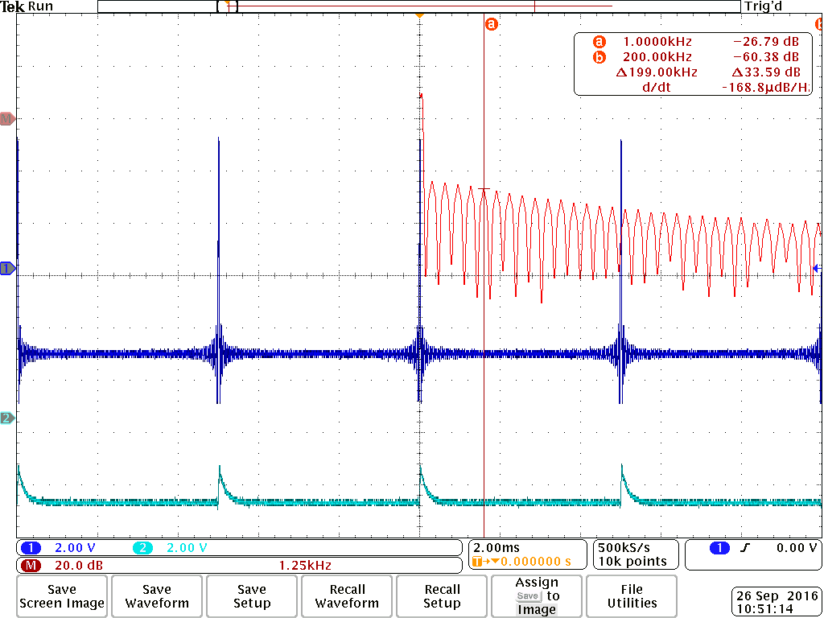

Unfiltered:

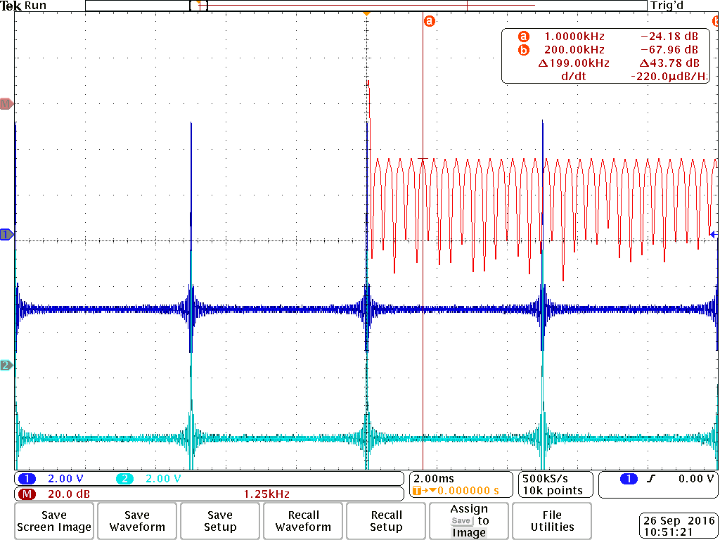

1. Will this filter be able to truly eliminate a frequency component of the input signal? Explain.

No. The gain is not 0 which is just close to 0. However, it will still eliminate the input signal

1. What should you call the output of the filter when the input is an impulse?

The output is the impulse response.

### Part 2: Filtering a square wave

For the filter with the 10nF capacitor

|  |  |  |
| --- | --- | --- |
|  | **Measured** | **Calculated from filter gain** |
| **Frequency of 5th harmonic** | **1kHz** | **-2.91dB** |
| **Frequency of the fundamental** | **200Hz** | **-0.1dB** |

1. Provide your hand calculations here or on a separate sheet.

At f = 1000Hz, with filter -17.68, without filter -14.76. The filter gain is approximately -3 dB.

1. Provide the oscilloscope screen image here

Unfiltered:

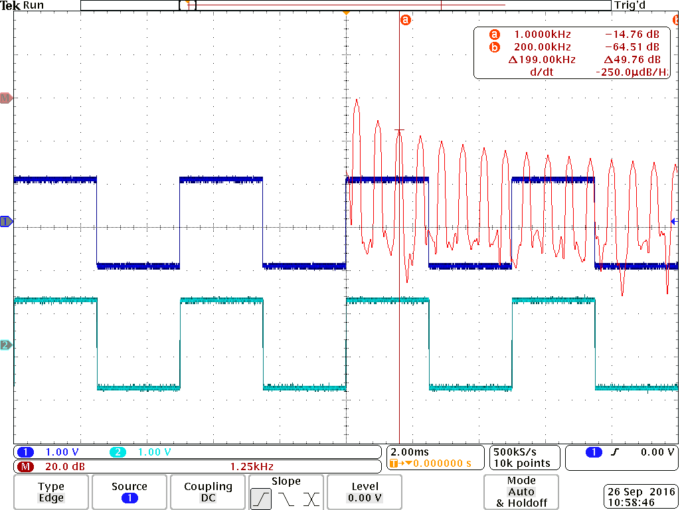

Filtered:

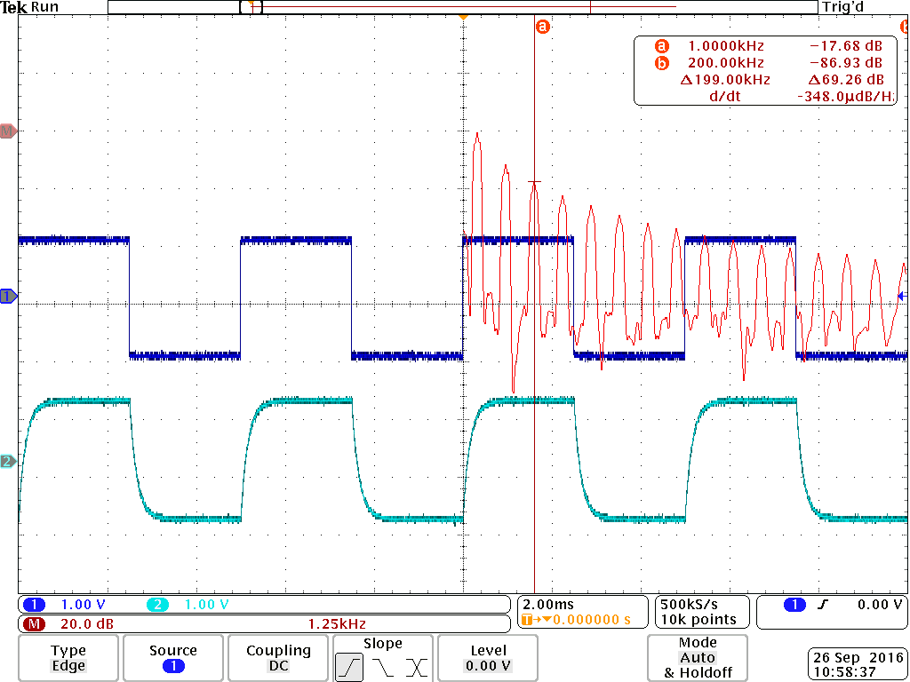

1. Explain any similarities or differences to the frequencies measured in Part 1.

The filter gain is almost identical as what we got in part 1. Since it is a linear system, it would produce the same frequency response for the same frequency, it has the same gain for the same frequency component even if the input waveform is totally different.

1. What should you call the output of the filter when the input is a step?

Unit Step response.

For the filter with the 100nF capacitor

|  |  |  |
| --- | --- | --- |
|  | **Measured** | **Calculated from filter gain** |
| **Frequency of 5th harmonic** | **100Hz** | **-2.98dB** |
| **Frequency of the fundamental** | **20Hz** | **-0.21** |

1. Provide your hand calculations here or on a separate sheet.

At f = 100 Hz, with filter -17.69, without filter -14.74. The filter gain is approximately -3 dB.

1. Provide the oscilloscope screen image here

Unfiltered:

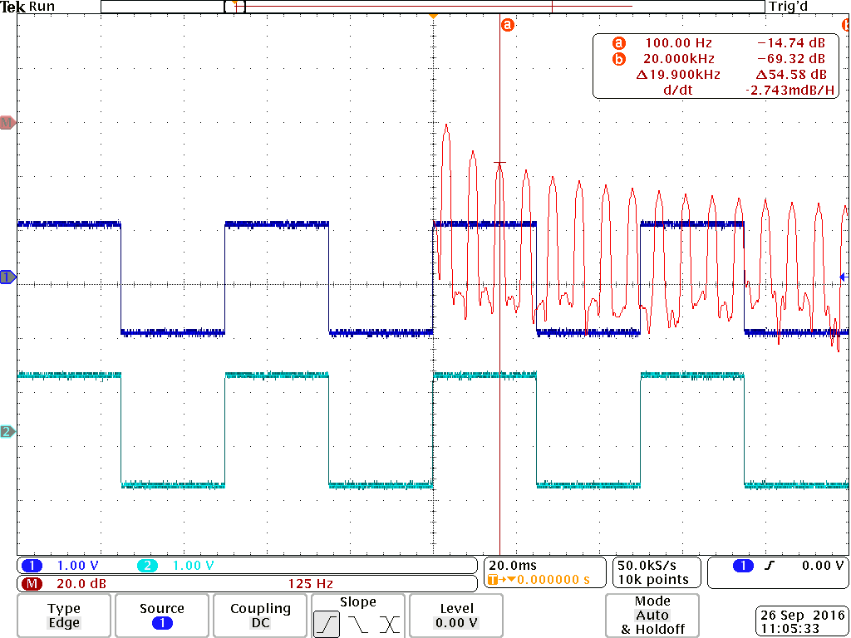

Filtered:

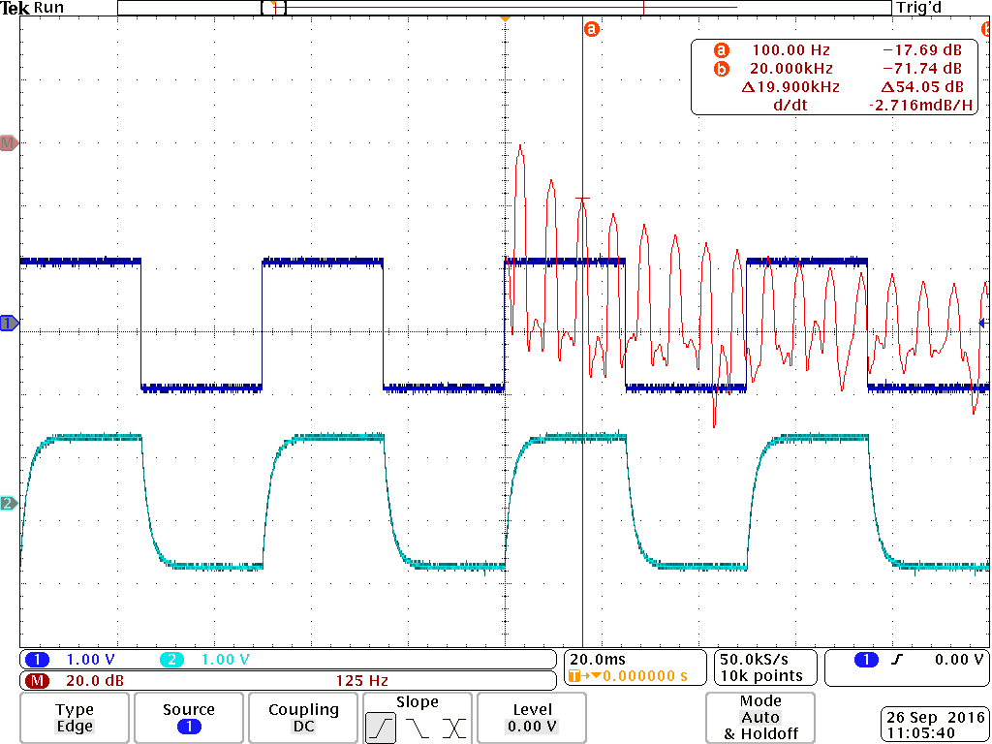

1. Explain any similarities or differences to the frequencies measured in Part 1.

The system has a different frequency response in this part. The tau of the system is 10 times larger than part 1, so the corresponding bandwidth is 1/10. When we divide both frequency by 10, the filter gain gives us similar results. This means that changing the tau in linear system shrink or expand the frequency response by corresponding factor.

### Part 3: Filtering your ECG signal

For the artificial ECG signal

1. Provide the annotated MATLAB plot here



1. Explain which filter changes the artificial ECG signal the most.

The 1uF capacitor change the signal most since we can almost just see the DC component.

For the real ECG signal

|  |  |
| --- | --- |
| Place scope capture of unfiltered ECG signal with FFT here../../../Volumes/Untitled/tek0 | Place the scope capture of the filtered ECG signal with the 10nF capacitor here../../../Volumes/Untitled/tek0 |
| Place the scope capture of the filtered ECG signal with the 100nF capacitor here../../../Volumes/Untitled/tek0 | Place the scope capture of the filtered ECG signal with the 1F capacitor here../../../Volumes/Untitled/tek0 |

1. Provide the annotated MATLAB plot here



1. Explain which filter best improves the ECG signal in terms of removing noise but leaving the ECG signal unaltered.

100 nF did the best job. For the 10 nF. The signal still has a lot of noise. The 1uF one removes almost all the signal except the DC component

1. Using a frequency domain explanation, explain why the filters are able to remove some of the noise from the ECG signal but not the large deviations called “movement artifacts.”

Because the noise exists between the first and the fifth harmonic frequency of the system, the 10nF filter remains 0 in the whole range, and the 100nF filter signal drops after the fifth harmonic. The 1uF signal drops in the second harmonic and get distorted.