# Prelab:

Speech processing and speech recognition begin with understanding where speech sounds come from and what they “look” like.

1. Describe the difference between a voiced versus a voiceless sound. Provide two examples of phonetics that are voiced and two that are unvoiced, for example “f as in farm”.
2. Look up the definition of a spectrogram. Find an example of a birdsong spectrogram and describe in your own words what that birdsong would sound like by looking at the spectrogram.
3. Look up the standards for AMR-WB and AMR-NB for speech coding in telecommunication systems. Provide the bandwidth that is used for each of these codecs.

(a):

The voiced sound will have a much larger amplitude than the voiceless sound. Also, it will have a bigger frequency than the voiceless sound.

(b):

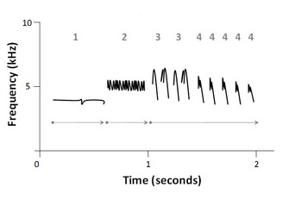

Figure 1: Schematic sound spectrogram of a white-crowned sparrow (Zonotrichia leucophrys) song. Arrows indicate phrase (or motif) and numbers indicate syllables which are made up of notes (or elements), the simplest unit of song. 2010 Nature Education All rights reserved.

The frequency is high and the amplitude is not that big. Therefore, this sound will be a typical bird sound which is alt but not loud.

(c): The bandwidth for AMR-WB is from 50 Hz to 7000 Hz

The bandwidth for AMR-NB is from 300 Hz to 3400 Hz