Yang Zhang PreLab8:

1st order Butterworth with =250Hz:

% 1st order Butterworth with f(-3Db) =250Hz

clc;

clear;

f=logspace(0,4,1000);

w=2*pi*f;

fc=250;

wc=2*pi*fc;

% First Order Filter

[Nbu1,Dbu1]=butter(1,wc,'s');

HwBu1=freqs(Nbu1,Dbu1,w);

figure(1)

subplot(2,2,1), semilogx(f,abs(HwBu1),'LineWidth',2)

axis([1 1e4 0 1.3]);grid on;xlabel('frequency (Hz)');ylabel('|H| (V/V)')

title('Magnitude of H(\omega) in V/V and dB')

subplot(2,2,3), semilogx(f,20*log10(abs(HwBu1)),'LineWidth',2)

axis([1 1e4 -50 5]);grid on;xlabel('frequency (Hz)');ylabel('|H| (dB)')

subplot(2,2,2), semilogx(f,180*unwrap(angle(HwBu1))/pi,'LineWidth',2)

axis([1 1e4 -100 0]);grid on;xlabel('frequency (Hz)');ylabel('\theta_H (deg)')

title('Phase in deg and Time Delay in sec of H(\omega)')

subplot(2,2,4), semilogx(f,unwrap(angle(HwBu1))./w,'LineWidth',2)

axis([1 1e4 -1e-3 0]);grid on;xlabel('frequency (Hz)');ylabel('delay (s)')

figure(2)

sys=tf(Nbu1,Dbu1);

impulse(sys);xlim([-0.0005 0.002])

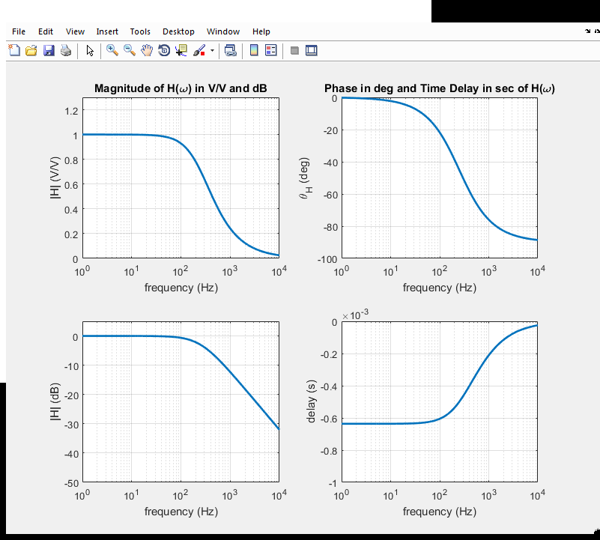

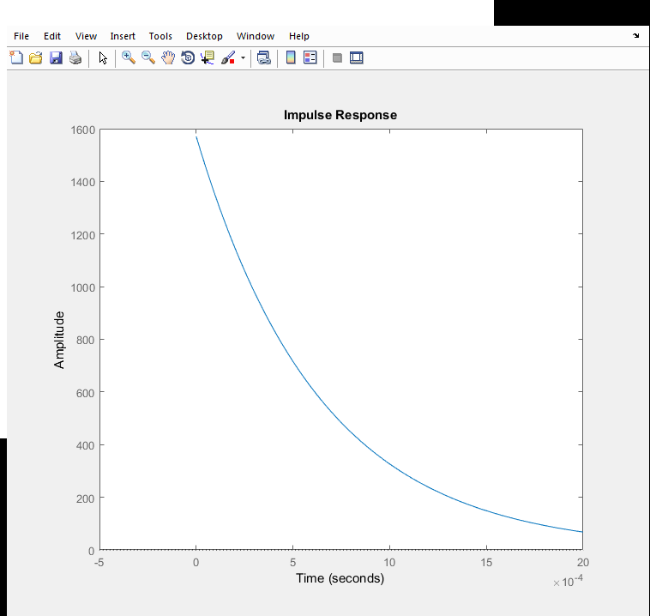

6th order Butterworth with =250Hz:

% 6st order Butterworth with f(-3Db) =250Hz

clc;

clear;

f=logspace(0,4,1000);

w=2*pi*f;

fc=250;

wc=2*pi*fc;

[Nbu1,Dbu1]=butter(6,wc,'s');

HwBu1=freqs(Nbu1,Dbu1,w);

figure(1)

subplot(2,2,1), semilogx(f,abs(HwBu1),'LineWidth',2)

axis([1 1e4 0 1.3]);grid on;xlabel('frequency (Hz)');ylabel('|H| (V/V)')

title('Magnitude of H(\omega) in V/V and dB')

subplot(2,2,3), semilogx(f,20*log10(abs(HwBu1)),'LineWidth',2)

axis([1 1e4 -50 5]);grid on;xlabel('frequency (Hz)');ylabel('|H| (dB)')

subplot(2,2,2), semilogx(f,180*unwrap(angle(HwBu1))/pi,'LineWidth',2)

axis([1 1e4 -100 0]);grid on;xlabel('frequency (Hz)');ylabel('\theta_H (deg)')

title('Phase in deg and Time Delay in sec of H(\omega)')

subplot(2,2,4), semilogx(f,unwrap(angle(HwBu1))./w,'LineWidth',2)

axis([1 1e4 -1e-3 0]);grid on;xlabel('frequency (Hz)');ylabel('delay (s)')

figure(2)

sys=tf(Nbu1,Dbu1);

impulse(sys);

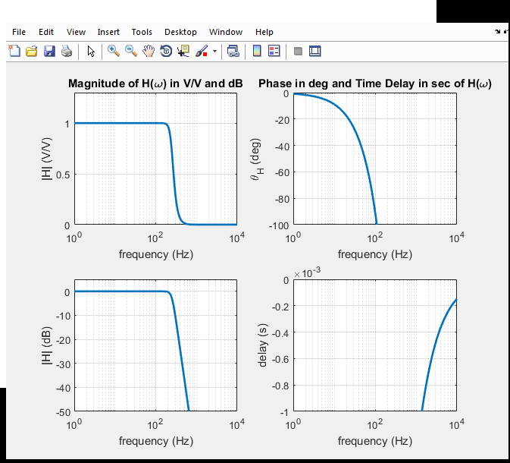

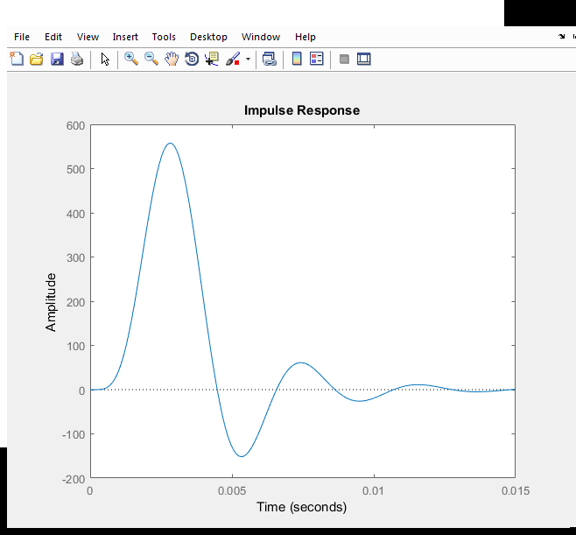

6th order Chebychev Type I with =250Hz and 2dB ripple in the passband:

% 6th order Chebychev Type I with f(-3Db) =250Hz and 2dB ripple in the passband:

clc;

clear;

f=logspace(0,4,1000);

w=2*pi*f;

fc=250;

wc=2*pi*fc;

[Nbu1,Dbu1]=cheby1(6,2,250,'low','s');

Nbu1 = Nbu1 * 10^ (2/20);

HwBu1=freqs(Nbu1,Dbu1,w);

figure(1)

subplot(2,2,1), semilogx(f,abs(HwBu1),'LineWidth',2)

axis([1 1e4 0 1.3]);grid on;xlabel('frequency (Hz)');ylabel('|H| (V/V)')

title('Magnitude of H(\omega) in V/V and dB')

subplot(2,2,3), semilogx(f,20*log10(abs(HwBu1)),'LineWidth',2)

axis([1 1e4 -50 5]);grid on;xlabel('frequency (Hz)');ylabel('|H| (dB)')

subplot(2,2,2), semilogx(f,180*unwrap(angle(HwBu1))/pi,'LineWidth',2)

axis([1 1e4 -100 0]);grid on;xlabel('frequency (Hz)');ylabel('\theta_H (deg)')

title('Phase in deg and Time Delay in sec of H(\omega)')

subplot(2,2,4), semilogx(f,unwrap(angle(HwBu1))./w,'LineWidth',2)

axis([1 1e4 -1e-3 0]);grid on;xlabel('frequency (Hz)');ylabel('delay (s)')

figure(2)

sys=tf(Nbu1,Dbu1);

impulse(sys);

