ECE 300 Lab 3: Power Measurements of Periodic Signals

Objective
The primary purpose of this lab is to give you an initial experience with the frequency domain of signals by observing them in the time and frequency domain simultaneously. Eventually, you need to get to a point where you can look at a signal in the frequency domain and have an idea in your mind of what it looks like in the time domain and vice versa. The Fourier series is the mathematical theory that allows us to describe a signal in the frequency domain. The oscilloscope allows you to measure signals in the time domain and in the frequency domain. However, a novelty that will take some getting used to is that the scope displays its frequency-domain measurements as power levels in dBV. Working with power and dBV takes some practice, but it is the standard “language” for these measurements so it is necessary to learn.

Prelab
- Compute the time-average power of a sinusoid with an amplitude of 0.5V. Express your answer in Watts (50 Ohm reference), dBV (use 1Vrms as the reference voltage), and dBm (50 Ohm reference). Use the dB references on Moodle to help you do this.
- Derive the expression for the Fourier series coefficients of a 20% and 80% duty-cycle square wave.
- Read about DTMF signaling on Wikipedia http://en.wikipedia.org/wiki/Dual-tone_multi-frequency_signaling
If you do not read about this, you will either be lost in lab or waste lab time reading about it.
- Compute the fundamental period of the DTMF tones for the numbers 2 and 3.

Background
Recently we learned to represent a periodic signal by using the Fourier series. In addition to showing the time-domain, the scopes can display the spectrum of a signal in quasi- real time. The power spectrum of a signal is a representation of the average power of the cosine at each frequency component (harmonic) of the signal. The scope displays a “one-sided spectrum” in decibels relative to 1V_{rms} (dBVs) versus frequency. In lab we will observe the spectra of sinusoids, square, and other waves, but first we must learn how to convert the Fourier series coefficients that we calculate to the dB values displayed by the scope.
We know that the complex Fourier Series of a signal x(t) is given by
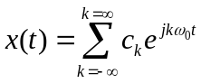
where
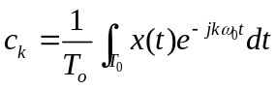 .
Whenever 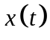 is real-valued we know that 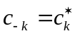, which yields a sum of cosine functions in addition to the DC offset term, 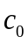. The Fourier Series can then be rewritten as
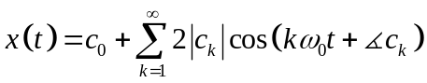.
From our study of power signals, we know that for the periodic power signal
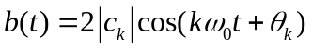
the average power is 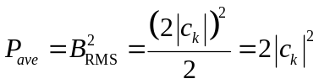
From the cosine form of the complex Fourier series representation, we then know
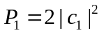is the average power of 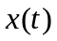at frequency 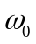
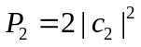is the average power of at frequency 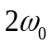
and in general, for 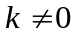
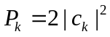is the average power of at frequency 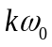
For 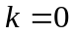 the average power is 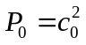.
We can make a plot of the average power in each frequency, which is called a single sided (or one sided) power spectrum. The scope displays the one-sided spectrum of a signal, but instead of showing the value of 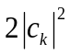 at each frequency, the spectrum analyzer shows average power in decibels with respect to a reference. For the sinusoid at frequency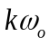, the average power in decibels is given by
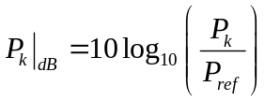,
where the power P_{k} represents the power spectrum coefficient. If the reference, P_{ref} , is a 1V_{RMS} sinusoid applied to a 1Ω resistor, we have
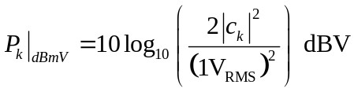.
The units “dBV” indicate that the reference for the decibels is a one volt RMS sinusoid.* If however the reference, P_{ref} , is simply 1mW, then we get
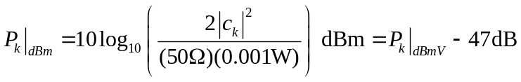
Note that when adding or subtracting the units of the offset are always dB whether you’re working with dBmV or dBm. When finding the error between a predicted and measured value, the error is found as the simple subtraction between the two values, error=measured-predicted (not the percentage difference), and it is always expressed in dB regardless of the power reference. For example, if the predicted value is -10dBV and the measured value is -12dBV, then the error is -12dBV-(-10dBV)=-2dB.
Note: Because it is showing a power spectrum, the scope does not measure or display the phase angles,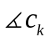.
* Further information on working with dBs is available in the document called “Guide to dBs” available on the class webpage. It is suggested you read this before lab.

Settings and Parts Used
Other Equipment:
DTMF touchtone generator
Memory Stick to get data from scope
Laptop

Part 1: Observing sinusoids in both time and frequency
In this part of the lab you will learn to use the spectrum analyzer by observing sinusoids in both the time and frequency domain. You should clearly understand the difference between time and frequency domain measurements and how they relate to each other. If I ask you the question, “what is the frequency and amplitude of the sinusoid?” you should be able to answer by looking at either the time or frequency domain.

Single Sinusoid
- FG Ch1 = SIG: Sinusoid, 1Vpp, 1kHz
Scope Ch1 = SIG
Scope Ch3 = V_OUT
Set Scope Math: Source=Ch3, function = FFT (FFT stands for fast Fourier transform. This will cause the scope to display the power spectrum of whatever channel is set as the source)

- You can use the FFT MATH function to display the power spectrum of a signal on the oscilloscope. The x-axis for the FFT is frequency and you can set the center frequency and span in order to zoom in on a particular bandwidth (Math->More FFT button). The lower frequency limit is always 0Hz and the upper frequency limit is limited by the horizontal time scale for the input channels of the scope.
The y-axis for the FFT has units of dBV. You can adjust the scale of the y-axis but you cannot change the units. Also, the reference level of the scope is the center line. You can use the cursors to measure the peak levels of the power spectrum or you can use the dV/div to estimate the power level relative to the center.
- Set the switches and jumpers on the board to use the SIG source with a gain of 1 and 0 offset. The signal should pass through the Sampling and Filter Sections unaltered.
- With the scope set up correctly, you should be able to see the input and output signals in the time domain and a spike at 1kHz in the frequency domain that represents your sinusoid. Use the cursors on the scope to measure the power at the peak of the spike (make sure the cursors are measuring the MATH channel). You should measure a stable peak at 1kHz within ±1dB of your prelab calculations. Do not go on until you get this verified by the instructor.
- Adjust the phase, frequency, and amplitude of the sinusoid and note how it changes in both the oscilloscope and spectrum analyzer.
- Connect a speaker to the speaker driver port on the board. Note the sound. This is the sound of a pure sinusoidal tone. All sounds are made up of such tones with different frequencies, amplitudes, and phases. Increase the amplitude of the sinusoid until the board no longer behaves linearly. Observe how the sound quality changes.
- Your Experiment: Record the scope screen. When you put in in the lab memo, label as many of the parameters of the sinusoid (frequency (period), amplitude, and phase) as possible in both the time and frequency domain and explain how these parameters relate to the sound from the speaker.

Sums of sinusoids
- FG Ch2 = ZIN
Scope Ch2= ZIN
FG Ch2 = ZIN: Sine, 1kHz, 1Vpp, align the phases of the two sinusoids
- Arrange the switches on the board in order to sum ZIN and SIG (i.e. 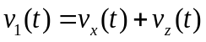) and pass through the Sampling and Filtering Sections of the board unaltered.
- Arrange the signals on the scope screen so that you can clearly see both input signals and the output signal and the spectrum of the output signal. With both sinusoids at the same frequency, they should add to a single sinusoid of the same frequency but with different amplitude and phase. Note that the spectrum is only showing the power spectrum for the resulting sum, not each of the inputs. Now adjust the phase of ZIN. As the two sinusoids phase shift, they will create a single sinusoid that changes in amplitude and phase. As the amplitude of the sum changes, the power spectrum will change because the amplitude of the sum will change.
- Your Experiment: Determine the relative phase shift(s) between the sinusoids that will produce the maximum and minimum output power. Explain your results.
- While keeping the SIG input signal constant, change the amplitude, frequency, and phase of the ZIN signal. Make sure that you understand how each parameter is represented in the time and frequency domain measurements.
- Your Experiment:
  - Make ZIN have the same amplitude as SIG and again do not change the parameter of SIG from those shown in Step (a) above.
  - Determine frequencies for ZIN that are greater than 1kHz for which the sum of ZIN and SIG will have a fundamental period of 5ms, 1ms, and be aperiodic. Verify mathematically that the period of the sum of the two signals is the same as your experimental value.
  - Take a screen capture of the scope for the 1ms and aperiodic case. Explain why, for the aperiodic case, the time domain is unstable but the frequency domain is stable.

Application: Looking at a DTMF signal
- Disconnect the FG from SIG and ZIN
Scope CH3 = V_OUT
Set the 6V section of the power supply on the bench to produce +5V. Connect the red and black wires from the DTMF touchpad to the +6V red and black terminals on the power supply.
Connect the white wire on the DTMF touchpad to SIG
Connect a speaker to the speaker driver output

- Dual-tone multi-frequency (DTMF) signals are how older touch-tone phones sent telephone numbers over the phone lines. Push the number “1” on the touch tone generator. While holding the button down, look at the board’s output voltage in both the time and frequency domain on the scope and listen to the tones that are generated. Can you hear the two different tones? Can you correlate the sounds to the frequencies that are displayed on the spectrum analyzer?
- Question: Why do all of the buttons appear to produce an aperiodic signal on the scope?

Part2: Measuring the spectrum of a square wave
As we have or will see in class, even non-sinusoidal signals are made up of different sinusoidal components. The scope can “see” each of these components separately. Now you will use the FFT function on the scope to see the different sinusoidal components of a square wave.
- FG Ch1 = SIG: Pulse, 500Hz, 1Vpp, 50% DutyCycle
Scope Ch1 = SIG
Scope CH3 = V_OUT
- Now observe the power spectrum on the scope. Verify that you are within 1dB of the predicted powers for the fundamental and third harmonic frequencies. Note that the error for dB values is always the difference of MEASURED-PREDICTED and never the percentage error. The units of the error are always dB regardless of whether you are working with dBmV, dBm, dBc, etc.
Harmonic | Predicted power  (dBV) | Measured Power  (dBV) | Error (dB) | Frequency (kHz)
1 | -7 |  |  | 0.5
2 | --- |  |  | 1
3 | -17 |  |  | 1.5

- Change the timescale on the scope. Note how it changes the “sharpness” of the peaks in the spectrum. To get the best data, your peaks should be as “sharp” as possible. However, this may not give you the best time domain picture of the signal. Finding a balance between the best spectrum and time domain measurements could be a challenge for the rest of the labs this quarter.
- Connect the speaker to the speaker driver. Change the duty cycle of the square wave and note what happens to the power spectrum. Note which harmonics appear and which disappear. See if you can hear those harmonics changing. Note the envelope shape that outlines the spikes in the spectrum. You should be able to name and describe this shape.
- Your Experiment:
  - Make sure the square wave is set back to 50% duty cycle
  - Change the frequency of the square wave by 100 Hz. Measure the frequency of the fundamental frequency, the 3rd harmonic, and the 5th harmonic. Explain why the fundamental frequency changes by 100Hz but the harmonics change by more than 100Hz.
  - Set the frequency back to 500Hz. Change the duty cycle to 80% and then to 20%. Record the scope and spectrum analyzer screens for each duty cycle. Explain why the two different signals sound the same for each of these duty cycles even though the signals are different in the time domain.

Part 3: Application: Measuring the spectrum of musical notes
In this part of the lab, you will look at the harmonics of signals from musical instruments. You will use the microphone input of the board while producing notes from different instruments on your laptop. Using IE go to the following website to start a virtual keyboard http://www.bgfl.org/custom/resources_ftp/client_ftp/ks2/music/piano/guitar.htm. Because you cannot hold the note indefinitely, you will need to freeze the screen of the spectrum analyzer and scope so that you can take the measurements. Make sure that no one else is playing at the same time that you are recording. The microphones are very sensitive and you will get interference.
- Set the signal source jumper to MIC.
Connect scope Ch3 = V_OUT
Scope MATH to be FFT of V_OUT
Change the scope triggering mode from AUTO to NORMAL

- Taking this data will require some practice to capture it correctly. The first thing you should do is pick an instrument and play some notes on the keyboard and see what you get on the scope. Once you have an idea of how this will fit together, here is what you need to do…
  - Adjust the scope triggering level, timescale, and amplitude scale so that when you press a note, you can clearly see the periodic nature of the signal and it is as large as possible on the screen as shown in Figure 1 below. You should also have a relatively consistent signal with approximately 5-10 periods all the way across the screen. In other words, you don’t want to see the signal start and stop or change much in amplitude. It should just look like a periodic signal
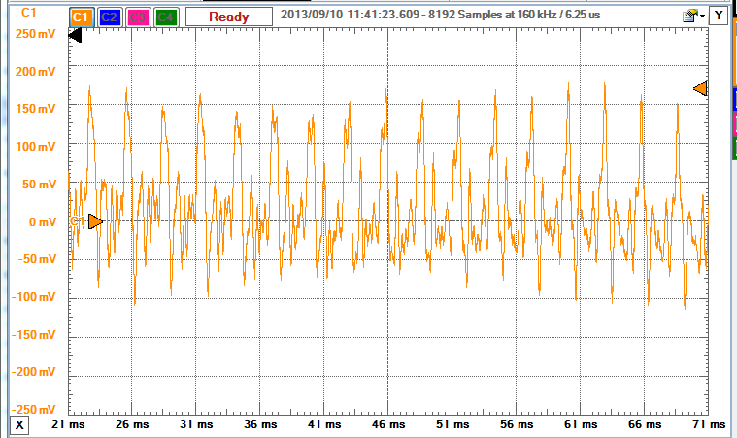
Figure 1: What the scaling of your signal should look like on the scope.
  - Once you can repeatedly get a signal. Play the note and then when the screen is stable, push the run/stop button on the scope in order to keep the scope screen from updating.
- Your Experiment: Capture the scope screen with both the time and frequency domain of
  - The saxophone at two different notes, be sure to record the note that you played
  - The piano at one of the same notes as the saxophone
For each of the three plots, annotate the screen captures to verify that the fundamental frequency of the note corresponds to the table shown in Figure 2 at the end of the Data Section.

Looking at both the time and frequency domain data that you recorded, explain the similarities and differences between two different notes that are played on the same instrument. Then explain the similarities and differences between the same note that is played on two different instruments.

Data Memo for Lab 3
Names:
Date:
Section Number:

Part 1: Single Sinusoid
- Put the scope capture of a single sinusoid here and then annotate it
- Explain how frequency, amplitude, and phase relate to the sound that you hear.

Part 1: Sums of Sinusoids
- Phase Shift that produces the maximum power (deg):_____________ Power of sum (dBmV):_______________
Phase shift that produces the minimum power (deg):_____________ Power of sum (dBmV):________________
Explain your results:
- Fill in the following table for SIG at 1kHz but changing the frequency of ZIN:
Period of the Sum | ZIN Freq (Hz) | Explanation
5ms
1ms
aperiodic

2 - Screen captures.
Scope of 1ms case here

Scope of aperiodic case here

Questions:
- Explain why, for the aperiodic case, that the time domain jumps around a lot but the spectrum is stable. For the time domain, this has something to do with how the scope triggers a signal.
- For the 5ms and 1ms case, the fundamental frequency is different from each input signal’s frequency. Explain mathematically how a signal can have a fundamental frequency that is not present in the signal.

Part 1: Application: Looking at a DTMF signal
- Explain mathematically why the buttons on the DTMF tone generator produce aperiodic signals.

Part 2: Data from square wave
- Recording the frequencies of components in the square wave
Harmonic | Frequencies of 500Hz square wave (kHz) | Frequencies of 600Hz square wave (kHz)
1 | 0.5
2 | ---
3 | 1.5
4 | ---
5 | 2.5

- Recording of the screen captures for the different duty cycles
4 - Screen captures.
Scope of 80% duty cycle

Scope of 20% duty cycle

Questions:
1. When you changed the fundamental frequency by 100Hz, explain why the harmonic frequencies change by more than 100 Hz.
2. Explain why the 80% and 20% duty-cycle square wave signals sound the same even though they look different in the time domain. Your answer should be based on the frequency domain data.

Part 3: Application: Measuring the spectra of musical notes
- Capture the scope screens for the different notes and instruments as described in the procedure. Annotate each to verify the fundamental frequencies.
3 - Screen captures.
Scope capture of note played on keyboard | Note Played | Fund Freq
Scope of Saxophone at Note 1

Scope of Saxophone at Note 2

Scope of Piano at Note 1

Questions:
- Looking at both the time and frequency domain data that you recorded, explain the similarities and differences between two different notes that are played on the same instrument.
- Then explain the similarities and differences between the same note that is played on two different instruments.

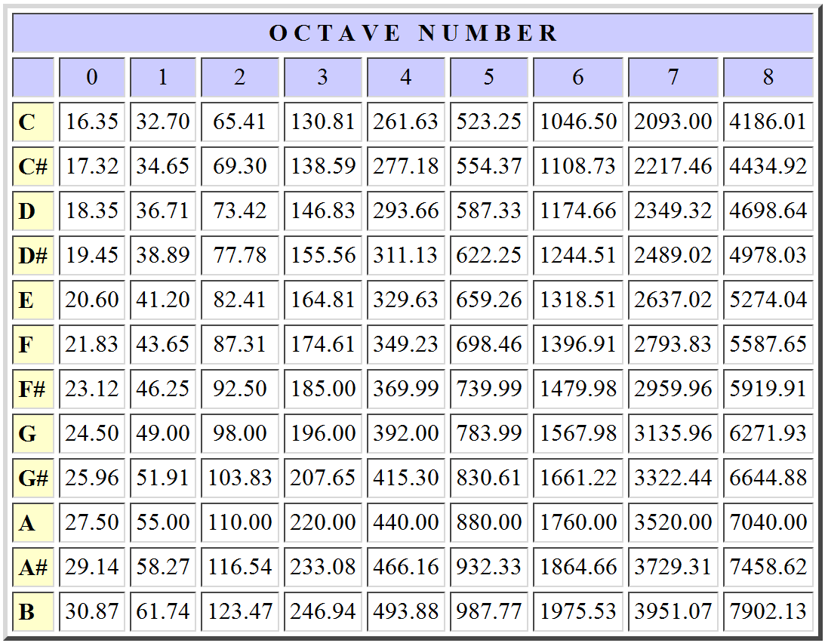
Figure 2: Table of fundamental frequencies for the notes in the octaves of the Chromatic Scale (piano keys)

