Data Memo for Lab 8
Names: Yang Zhang & Zhang Wen
Date: October 31
Section: ECE300-01

Data for the 1st Order Filter
Using the Impulse Response
-3dB Frequency Measurement | -40dB frequency Measurement | Transition Bandwidth
275HZ | 11.92kHz | 11.645kHz

Insert Scope Capture of Impulse Response and Frequency Response Here:
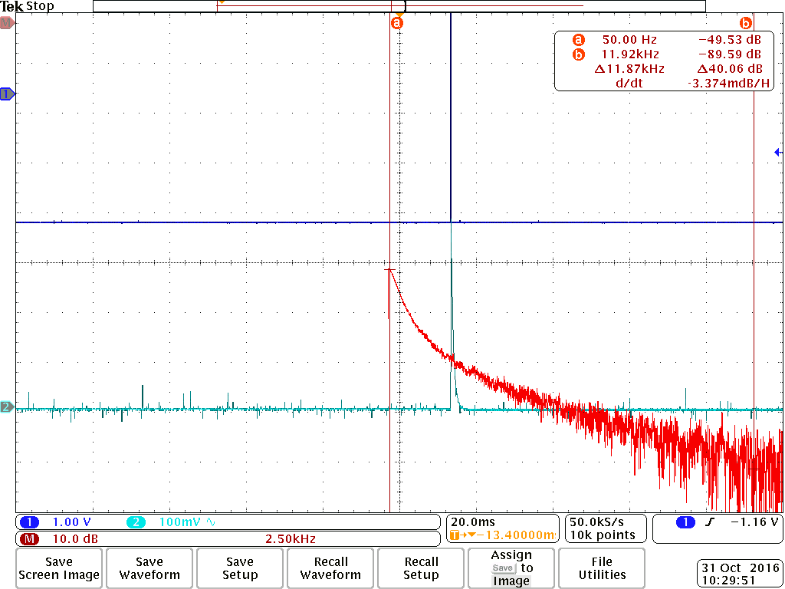
Measurements Based on the Sinusoid Input
 | Passband |  |  | 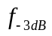 | Transition |  |  | 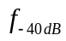
Freq | 10 | 50 | 100 | 250 | 500 | 2000 | 10000 | 20000
Amp (Vpp) | 6.8 | 6.8 | 6.4 | 4.48 | 3.04 | 0.81 | 0.202 | 0.108
Gain (dB) | 1 | 1 | 0.941 | 0.709 | 0.481 | 0.131 | 0.033 | 0.018
Delay (ms) | 1.3ms | -0.4 | -0.64 | -0.485 | -0.338 | 0.385 | -0.026 | -0.014
Phase (deg) | 2.1 | -7.2 | -18.84 | -42.57 | -61.67 | -82.71 | -96.7 | -105.8

Insert Matlab plots of 1st order filter characteristics here:
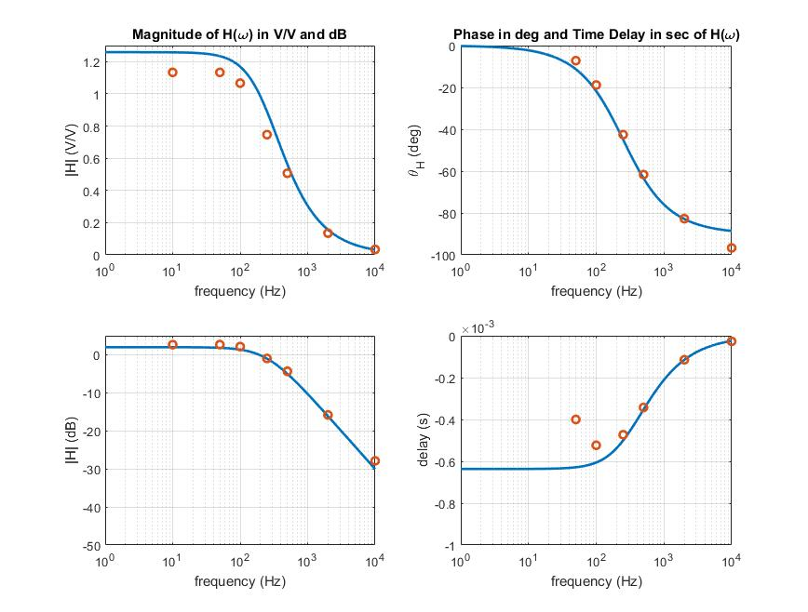

Data for the 6th Order Butterworth Filter
Using the Impulse Response
-3dB Frequency Measurement | -40dB frequency Measurement | Transition Bandwidth
250Hz | 580Hz | 330Hz

Insert Scope Capture of Impulse Response and Frequency Response Here:
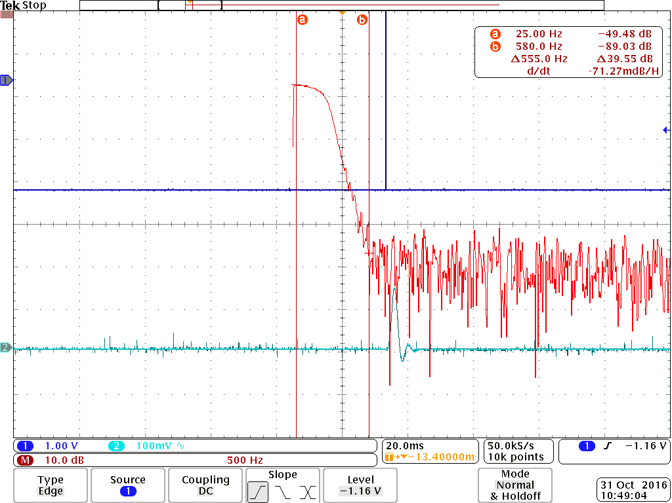
Measurements Based on the Sinusoid Input
 | Passband |  |  |  | Transition
Freq | 50 | 100 | 200 | 250 | 300 | 350 | 400 | 500
Amp (Vpp) | 7.18 | 6.81 | 4.961 | 3.948 | 2.294 | 1.095 | 0.535 | 0.173
Gain (dB) | 1 | 0.937 | 0.802 | 0.637 | 0.37 | 0.177 | 0.086 | 0.028
Delay (ms) | -2.545 | -2.545 | 3.319 | 1.223 | 0.479 | 0.075 | -0.124 | -0.306
Phase (deg) | -45.35 | -92.71 | 168.0 | 110.4 | 54.48 | 12.42 | -16.82 | -51.73

Insert Matlab plots of Butterworth filter characteristics here:
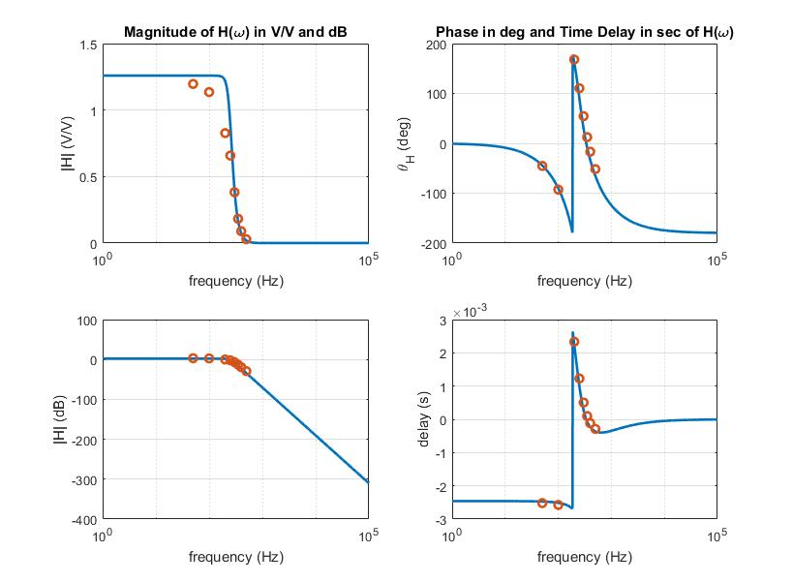

Data for the 6th Order Chebychev Filter
Using the Impulse Response
-3dB Frequency Measurement | -40dB frequency Measurement | Transition Bandwidth
252.5 | 477.5 | 225

Insert Scope Capture of Impulse Response and Frequency Response Here:
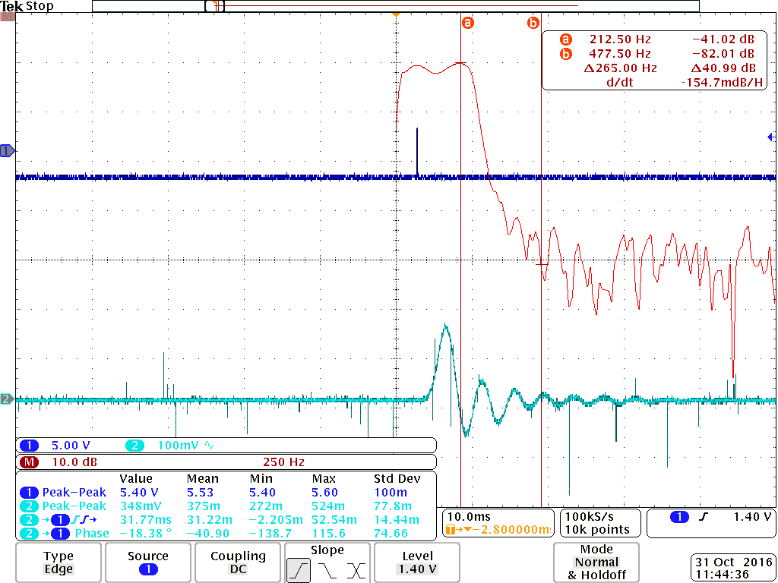
Measurements Based on the Sinusoid Input
 | Pass  Peak | Pass  Trough | Pass  Mid |  | Transition
Freq | 10 | 100 | 200 | 250 | 280 | 310 | 350 | 400
Amp (Vpp) | 6.3 | 6.1 | 7.55 | 6.6 | 1.68 | 0.640 | 0.212 | 0.072
Gain (dB) | 1.219 | 1.107 | 1.297 | 1.04 | 0.266 | 0.193 | 0.0344 | 0.012
Delay (ms) | -3.06 | 6.39 | 1.278 | -0.498 | 2.583 | -1.076 | -1.071 | 1.522
Phase (deg) | -9.14 | -131.5 | 93.27 | -43.06 | -100.5 | -121.6 | -132.5 | -141.3

The amount of ripple measured in the passband is:_______3dB________
Insert Matlab plots of Chebychev filter characteristics here:
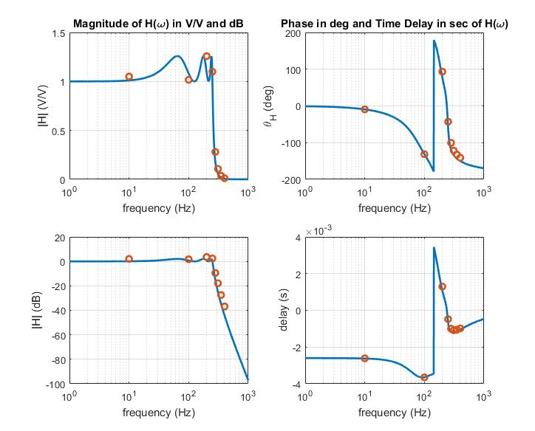

Questions/Data Analysis:
- Relate the transition bandwidths between the three filters. Explicitly state which filter has the largest and smallest transition bandwidths and why.
1st order butterworth has largest bandwidth because the order is the smallest. 6th order chebychev has the smallest bandwidth since it has the largest order and has ripple to achieve higher transition slope
- Provide a rationale for choosing to use a 1st order filter instead of one of the 6th order filters.
1st order is cheaper and easier to build
- Use your data to justify the statement that the filters have approximately linear phase in their passbands.
The time delay of two butterworth filter is flat. All frequency has phase delay proportional to the frequency.

