ECE 300 Lab 9: Sampling

Objective
The objective of this lab is to observe the three forms of sampling in both the time and frequency domain. Very short duration pulses will be used to approximate impulses. The impulse sampling and square wave sampling will be done with the AD633 multiplier chip on the board, which will actually multiply the input signal by the sampling signal in the time domain. The ZOH sampling will be done with the switch in the “Sampling” section of the board. The switch is opened and closed in a periodic fashion according to the clock signal. When the clock is “high” the switch will be closed and the input signal will pass to the output. When the clock is “low”, the switch is open and the input signal is disconnected from the output. If a very short duration pulse is used for the clock, it will sample the input signal at a specific point in time. While the switch is “open” the voltage will be “stored” on a capacitor on the output side of the switch. This is called a “sample and hold” circuit.

Settings and Parts Used
Bag of passive components for 1st order filter and 6th order Butterworth filters

Part 1: Impulse Sampling
We will start exploring with the simplest case using a bandlimited signal with pseudo-impulse sampling. Recall that an ideal impulse has an amplitude of infinity with an area of one. We will be using very-low duty cycle pulses, which have a much smaller amplitude and area, to approximate an impulse. The bandlimited signal is the COS4 signal that we used in previous labs. In this part of the lab, you should gain a better understanding of aliasing, the Nyquist rate, and being able to identify copies of the input-signal’s spectrum in the spectrum of the sampled signal.
- FG Ch1 to SIG = Arb Wform User1 (COS4), 5 Vpp, offset=1.5V, 50Hz
FG Ch2 to YIN = Pulse, 1kHz, pulse width=100μs, 1Vpp, offset=500mV
Connect scope Ch1 = SIG
Connect scope Ch2 = V_OUT
Set the MATH channel to take the FFT of V_OUT
Set the scope timescale = 10ms/div
Set Acquire=normal (Do NOT use averaging in this lab)

- Place the passive components on the board for the 1st order filter and 6th order Butterworth filter.
- Set the board jumpers so that the signal is passed through the board unfiltered but multiplied by YIN, which is acting like a pseudo impulse train.
- As you look at the scope screen, adjust the signals so that you see the output signal superimposed on top of the input signal. You should see the samples of the output signal line up with the “outline” of the input signal. Place the frequency domain FFT signal where you can clearly see it on the screen. Note that the input signal in time is made of 4 harmonically related cosine functions. In the frequency domain, the input signal is represented with spikes at ±50Hz, ±100Hz, ±150Hz, and ±200Hz each with the same power level. When this signal is sampled, the spectrum of the sampled signal has copies of this spectrum at every harmonic of the sampling frequency. Make sure that you can identify these copies of 8 spikes that are centered at 1kHz, 2kHz, and so on and that each copy is identical.
- Once you think you understand everything on the scope screen, play around with the sampling frequency. Get an intuition about what happens in the time and frequency domain as you change the sampling frequency.
- Your Experiment:
  - Set the sampling frequency to be at the Nyquist rate, which is twice the highest frequency in the signal.
  - Vary the phase of the input signal and note what happens to the spectrum and time domain of the output signal. Adjust the phase until the peaks at the boundaries of the copies are at a maximum.
  - Get a screen capture of the scope for the unfiltered case and then again using the 1st and 6th order recovery filters for a total of three screen captures.
  - Set the sampling frequency to be 2.5 times the Nyquist rate. Get a screen capture of the scope for the unfiltered case and then again using the 1st and 6th order recovery filters for a total of three more screen captures.
  - Why does the phase affect the power spectrum when sampling at less than the Nyquist rate?

Part 2: Symmetric Square-Wave (Pulse) Sampling
In this part of the lab, we will still be looking at a bandlimited signal. The focus will be to understand what happens when a 50% duty-cycle square wave is used to “sample” the input signal. You should be able to identify and understand the differences in the time and frequency domains between pulse sampling and impulse sampling. Because we are still doing sampling by multiplying two signals together, the only thing we have to change is the sampling signal, which is applied at YIN.
- FG Ch1 to SIG = Arb Wform User1 (COS4), 5Vpp, offset=1.5V, 50Hz
FG Ch2 to YIN = pulse, 1kHz, 1Vpp, offset=500mV, 50% duty cycle

- Set the board jumpers so that the signal is passed through the board unfiltered but multiplied by YIN, which is acting like a pseudo impulse train.
- Once you think you understand everything on the scope screen, play around with the sampling frequency. Get an intuition about what happens in the time and frequency domain as you change the sampling frequency. Verify that the copies look like scaled versions of the input signal’s spectrum and that the scale factors are consistent with the sinc(k/2) function.
- Your Experiment:
  - Set the sampling frequency to be at the Nyquist rate, which is twice the highest frequency in the signal. Get a screen capture of the scope for the unfiltered case and then again using the 1st and 6th order recovery filters for a total of three screen captures.
  - Set the sampling frequency to be 2.5 times the Nyquist rate. Get a screen capture of the scope for the unfiltered case and then again using the 1st and 6th order recovery filters for a total of three more screen captures.

Part 3: ZOH Sampling
In this part of the lab, we will still be using a bandlimited signal. The focus will be to understand how ZOH sampling changes the signal in the time and frequency domains. To implement ZOH sampling requires more than just multiplying by a sampling signal as we discussed in class. The circuit used to implement this type of sampling is called a “sample and hold” circuit, which consists of a switch and a capacitor. The switch is changed from the open to closed and back to the open state very quickly which causes the voltage of the input signal at that moment in time to be stored on the capacitor. Because there is nowhere for the charge on the capacitor to go, it then holds this voltage until the next sample is taken. A pulse signal is used to control the transistor switch and you have to insert an extra capacitor to store the voltage.
- FG Ch1 to SIG = Arb Wform User1 (COS4), HighZ, 5Vpp, offset=1.5V, 50Hz
Move FG Ch2 from YIN to CLK = pulse, 1kHz, 100μs, 18Vpp, offset=0V
Place a 10nF (103 code) cap in the round white socket that is next to the sampling switch
- Set the board jumpers and switches so that the input signal is passed through the board unfiltered, with a gain of 1, offset of 0, and the sampling switch is moved from SHORT to SAMPLE, which connects the sampling clock to the transistor switch.
- Once you think you understand everything on the scope screen, play around with the sampling frequency. Get an intuition about what happens in the time and frequency domain as you change the sampling frequency. Verify that the copies are all distorted according to the sinc(ω/ω_{sa}) function.
- Your Experiment:
  - Set the sampling frequency to be at the Nyquist rate, which is twice the highest frequency in the signal. Get a screen capture of the scope for the unfiltered case and then again using the 1st and 6th order recovery filters for a total of three screen captures.
  - Set the sampling frequency to be 2.5 times the Nyquist rate. Get a screen capture of the scope for the unfiltered case and then again using the 1st and 6th order recovery filters for a total of three more screen captures.

Part 4: Sampling realistic periodic and aperiodic signals
In this part of the lab, we will use the three forms of sampling on realistic signals, both periodic and aperiodic. The main problem with sampling these signals is that their bandwidth is unknown. At least the periodic signal will have a regular pattern, but the aperiodic signal will change over time. It will be your job to choose a minimum sampling frequency that still reduces aliasing to an unnoticeable level. The scope has trouble producing the FFT spectrum of these signals when impulse sampling is used because the pulses are so narrow. You will sample these signals using only square wave and ZOH sampling.
- FG Ch1 to SIG = ArbWvf-User3 (ECG), Amp =5Vpp, Offset=1.8V, freq=10Hz
Set up the board to do square wave sampling without filtering the signal as shown in Parts 1(a) and (c)

- Adjust the sampling frequency up and down from the 1kHz that you started with. See if you can observe aliasing in the time and frequency domains. Switch back and forth between the different recovery filters and the unfiltered case as you adjust the sampling frequency. Make sure you understand what you are observing.
- Switch to ZOH sampling (Parts 3(a) and (b)) of this signal each with the different recovery filters and again observe what is happening in the time and frequency domain for each case.
- Your Experiment:
Determine the type of sampling and the minimum sampling frequency that will reduce aliasing below the noise floor when using the 6th order recovery filter. Take a scope capture of this case.

- FG Ch1 to SIG = ArbWvfm THESE signal (User2), 5 Vpp, 400mV offset, 0.5Hz
Set up the board to do square wave sampling without filtering the signal as shown in Parts 1(a) and (c)
- Adjust the sampling frequency up and down from the 1kHz that you started with. See if you can observe aliasing in the time and frequency domains. Switch back and forth between the different recovery filters and the unfiltered case as you adjust the sampling frequency. Make sure you understand what you are observing.
- Switch to ZOH sampling (Parts 3(a) and (b)) of this signal each with the different recovery filters and again observe what is happening in the time and frequency domain for each case.
- Your Experiment:
Determine the type of sampling and the minimum sampling frequency that will reduce aliasing below the noise floor when using the 1st order recovery filter. Take a scope capture of this case.
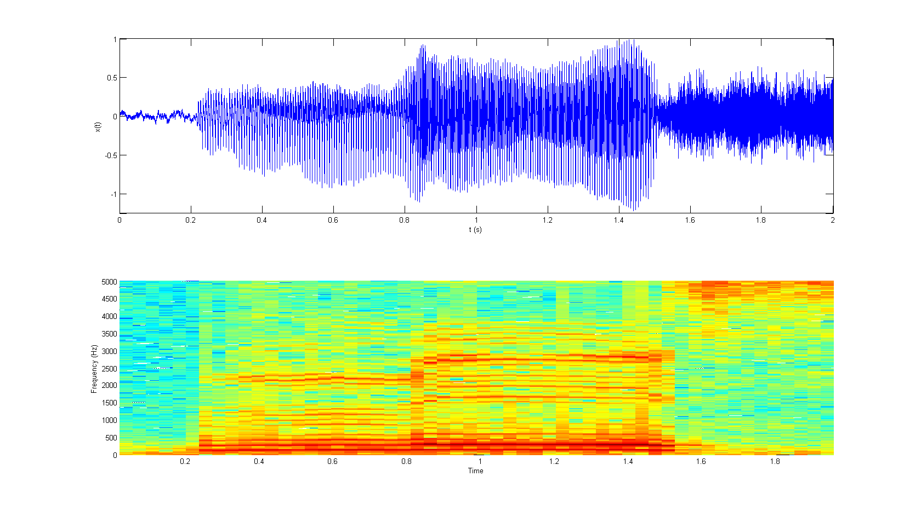
Figure 1: Spectrogram of the THESE waveform that is stored on the function generator provided here in order to help you choose the correct sampling frequency.
Data Memo for Lab 9
Name:
Section:
Date:

Part 1: Impulse Sampling Scope Captures
Nyquist Rate with no recovery filter | 2.5 times the Nyquist Rate with no recovery filter
Nyquist Rate with 1st order recovery filter | 2.5 times the Nyquist Rate with 1st order recovery filter
Nyquist Rate with 6th order recovery filter | 2.5 times the Nyquist Rate with 6th order recovery filter

Part 2: Pulse Sampling Scope Captures
Nyquist Rate with no recovery filter | 2.5 times the Nyquist Rate with no recovery filter
Nyquist Rate with 1st order recovery filter | 2.5 times the Nyquist Rate with 1st order recovery filter
Nyquist Rate with 6th order recovery filter | 2.5 times the Nyquist Rate with 6th order recovery filter

Part 3: ZOH Sampling Scope Captures
Nyquist Rate with no recovery filter | 2.5 times the Nyquist Rate with no recovery filter
Nyquist Rate with 1st order recovery filter | 2.5 times the Nyquist Rate with 1st order recovery filter
Nyquist Rate with 6th order recovery filter | 2.5 times the Nyquist Rate with 6th order recovery filter

Questions/Data Analysis:
- Explain why sampling at frequencies just slightly above the Nyquist rate is insufficient to eliminate aliasing.
- Explain why the 1st order filter produced an output with less aliasing for the ZOH sampling than for the Impulse and Pulse sampling cases.
- Explain why changing the phase alters the power spectrum when sampling below the Nyquist rate.

Part 4: Sampling of realistic signals
Scope Capture of the ECG Signal | Scope Capture of the “these” signal

Questions/Data Analysis:
- Explain your choice of sampling frequency and sampling type for the ECG signal.
- Explain your choice of sampling frequency and sampling type for the “these” signal.

