Yang Zhang

CM677

ECE380

Mini Project 1

Part 2.2:

Front Panel:

1: Cosine wave

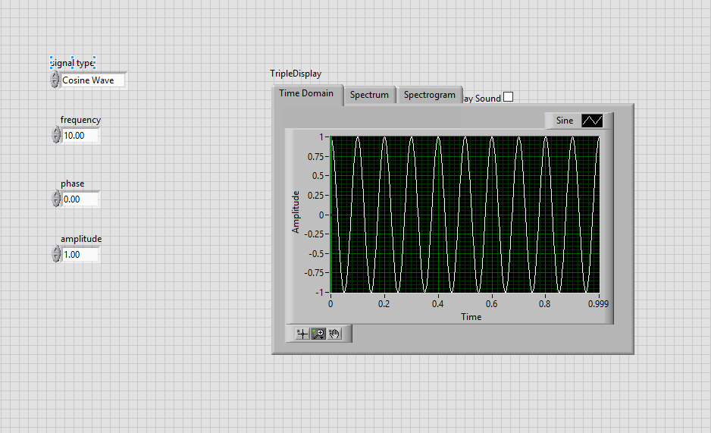

2: Square Wave:

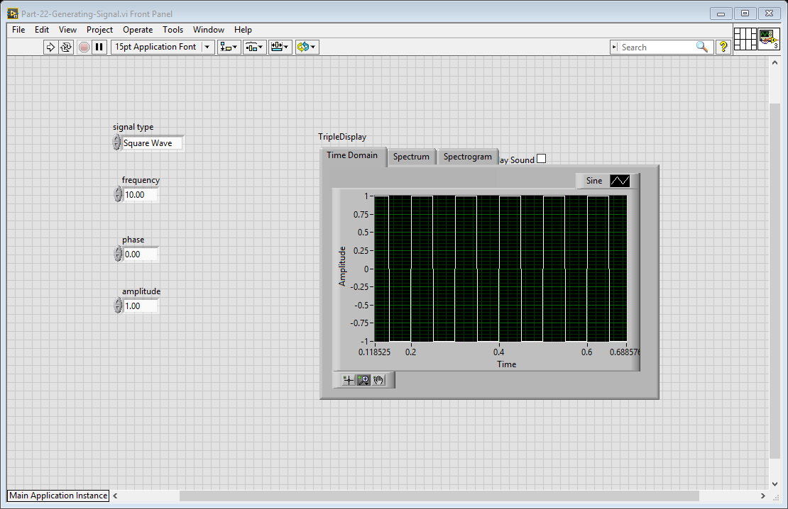

Block Diagram:

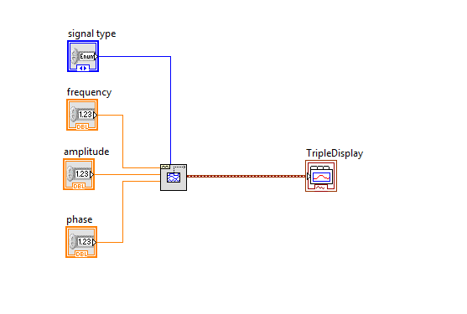

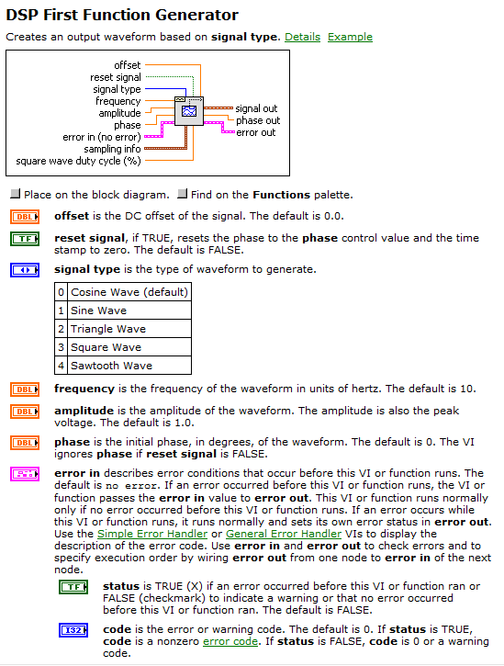

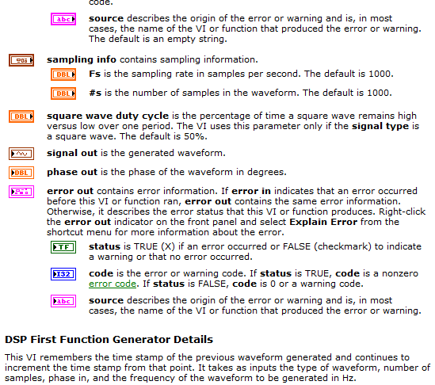

Part 2.3:

Front Panel:

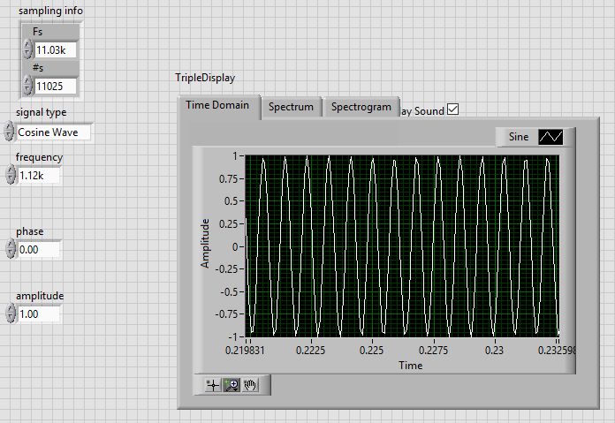

Block Diagram:

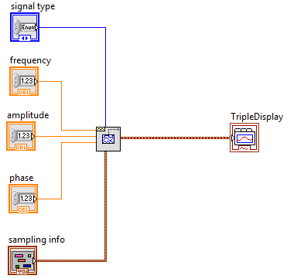

Part 3:

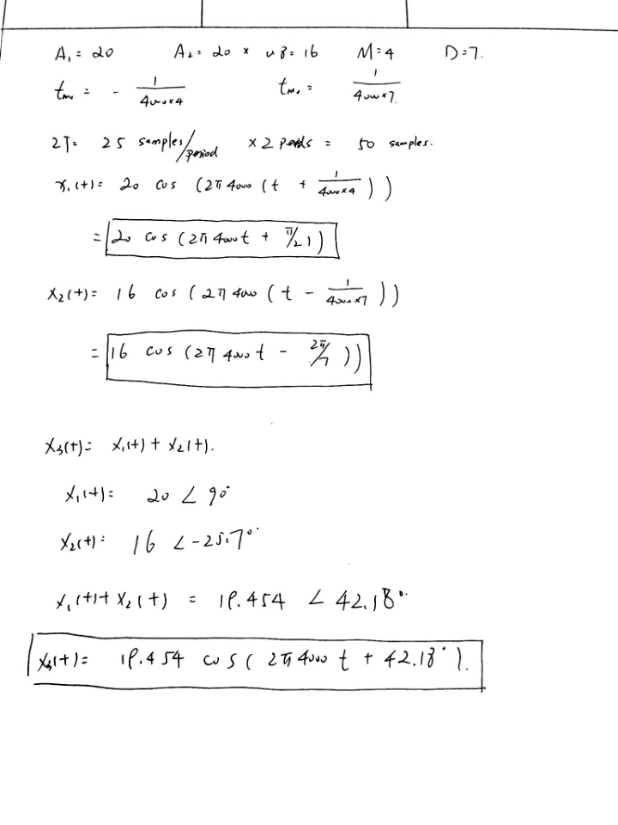

Front Panel:

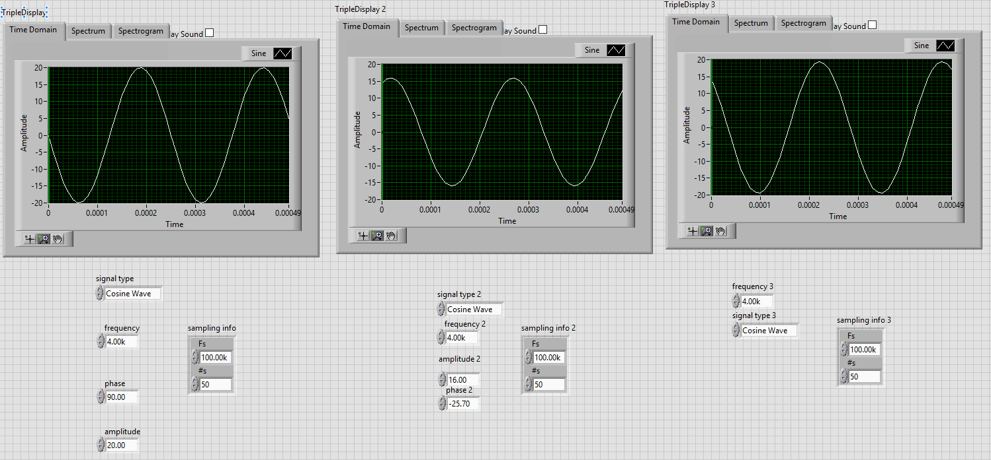

Block Diagram:

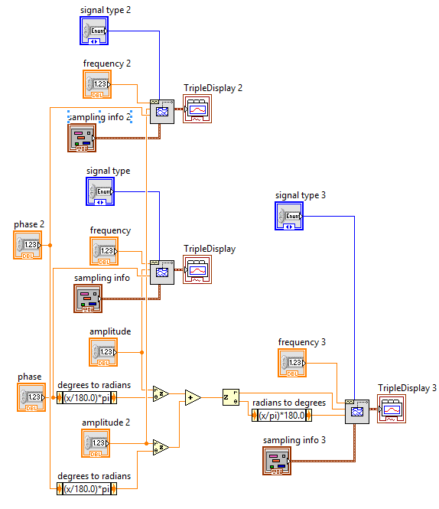

Figure 1: x1(t)

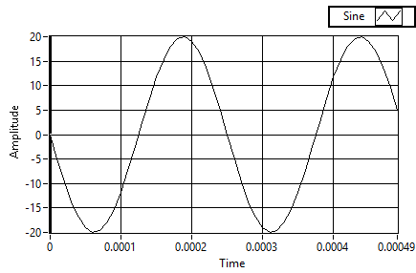

x1(t) = 20*cos(2*pi*4000*t+90degree)

Figure 2: x2(t)

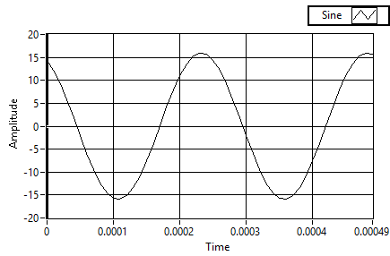

X2(t) = 16*cos(2*pi*4000*t+25.7degree)

Figure 3: x3(t)

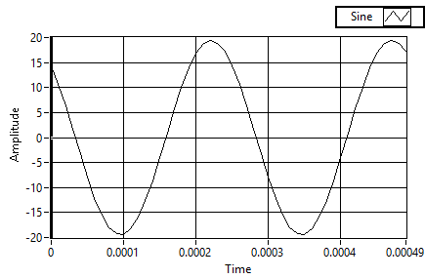

x3(t) = x1(t) + x2(t)

Part 3.1:

Figure 1: x1 peak

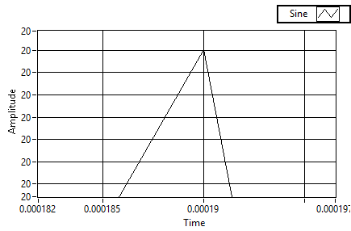

The first peak for $x_{1}\left(t\right)= 20\cos\left(2π4000t+90°\right)$, $t_{m_{1}}=0.00019s$

$$ϕ_{1}=-2π4000*t_{m_{1}}= -2π4000*0.00019=86.40°$$

$A_{1}=20$

Figure 2: x2 peak

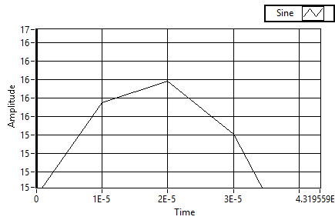

$x_{2}\left(t\right)= 16\cos\left(2π4000t+25.7°\right)$, $t_{m_{2}}=2E-5s$

$$ϕ_{2}=-2π4000*t_{m_{2}}= -2π4000*2*{10}^{-5}=-28.8°$$

$A_{2}=16$

Figure 3: x3 peak

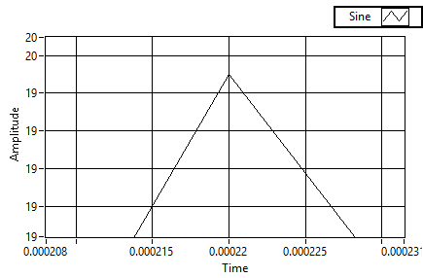

$x_{3}\left(t\right)= x1\left(t\right)+x2(t)$, $t_{m3}=0.00022s$

$$ϕ_{3}=-2π4000*t_{m_{3}}= -2π4000*0.00022=43.2°$$

$A_{3}=19.5$

Compare Table:

|  |  |  |  |
| --- | --- | --- | --- |
| Name | Meatured | Calculated | Error |
| |x1(t)| | 20 | 20 | 0 |
| ∠x1(t) | 86.4 | 90 | 3.6 |
| |x2(t)| | 16 | 16 | 0 |
| ∠x2(t) | -28.8 | -25.7 | 3.1 |
| |x3(t)| | 19.5 | 19.454 | -0.046 |
| ∠x3(t) | 43.2 | 42.18 | -1.02 |