Yang Zhang

ECE380

Mini-Project 2

Due December 16, 2016

Mini Project 2

Part 2.5: Preparation

By hand Part:

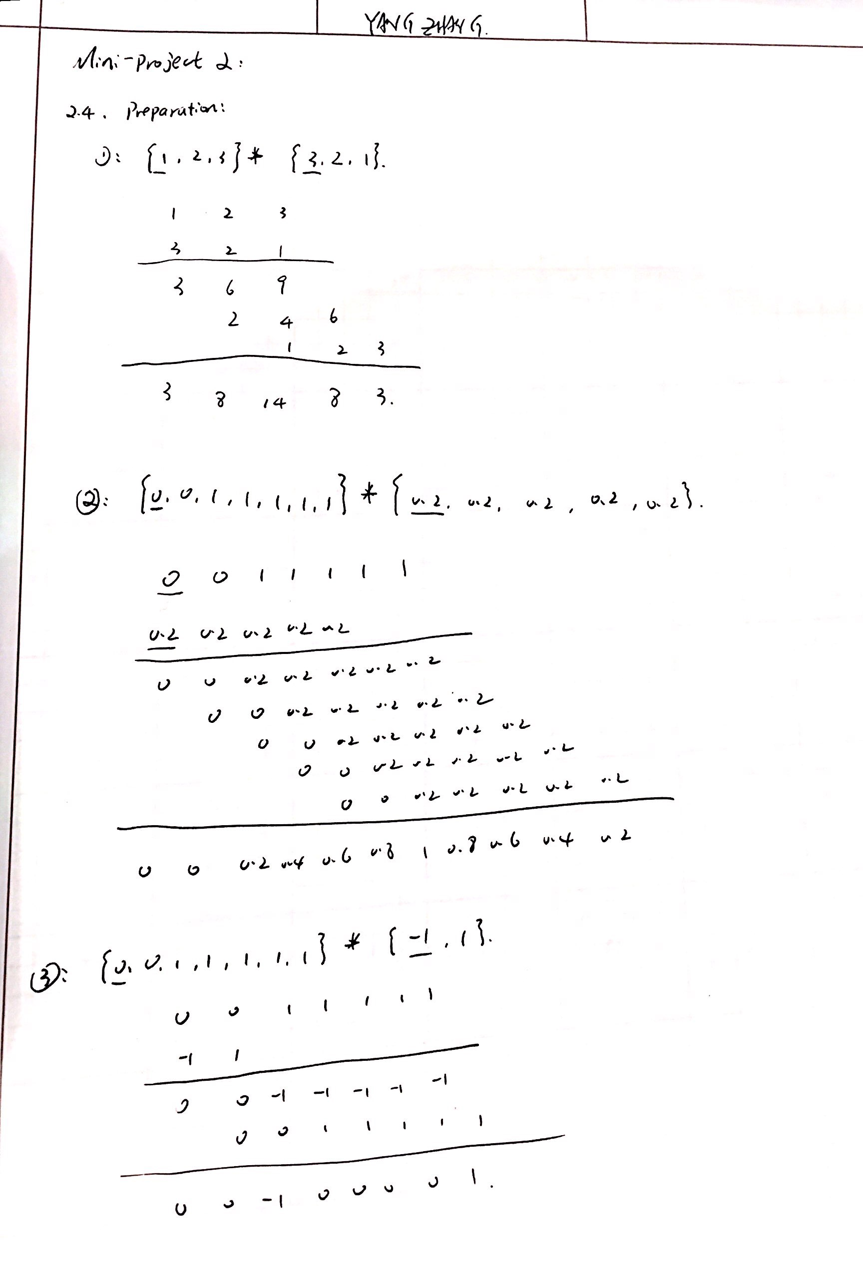

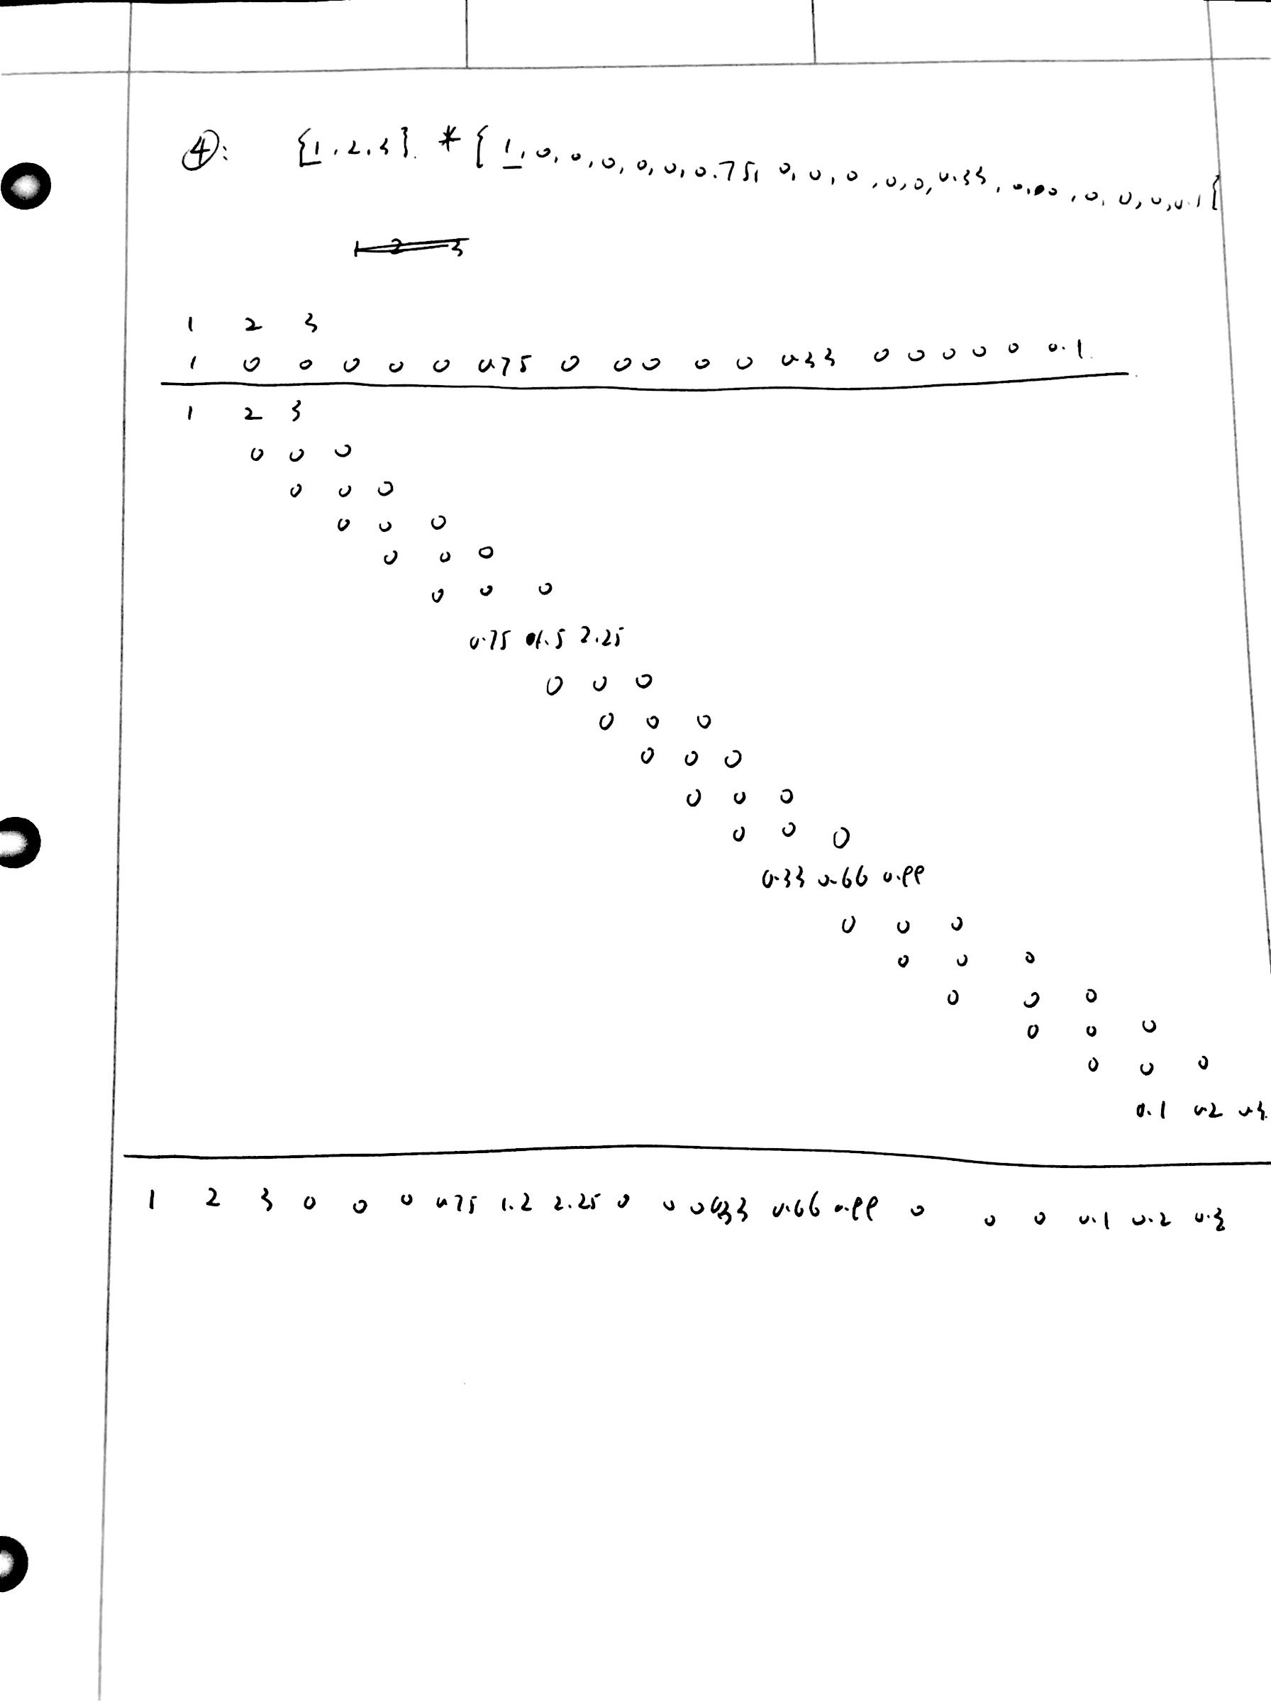

5 LabView verification:

(1):

Block Diagram

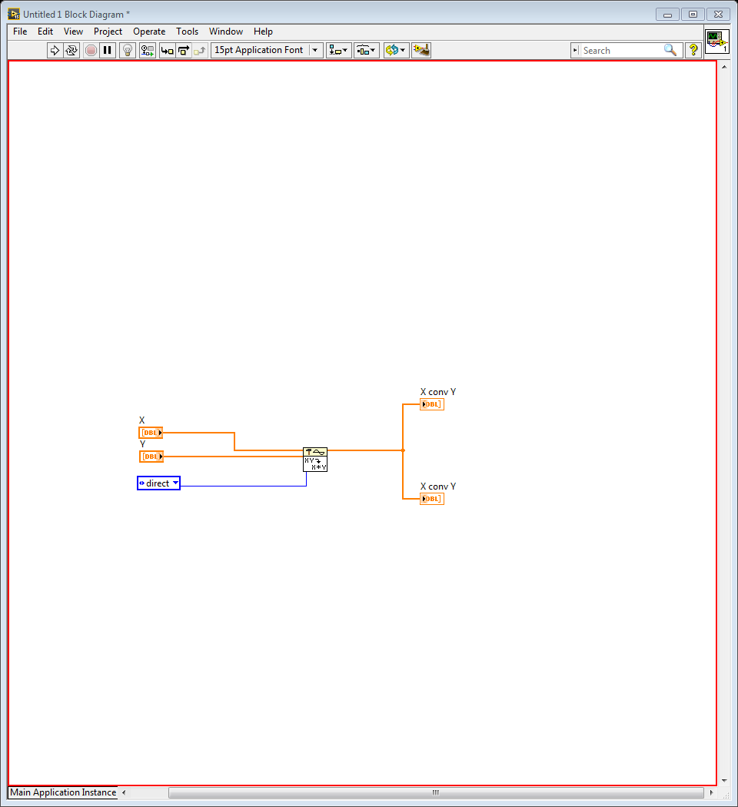

Front Panel:

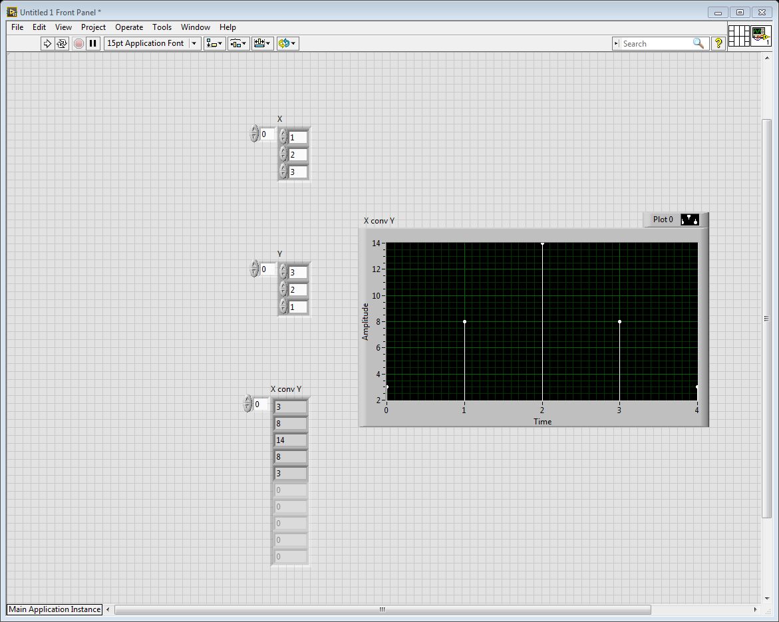

Part 2:

Front Panel:

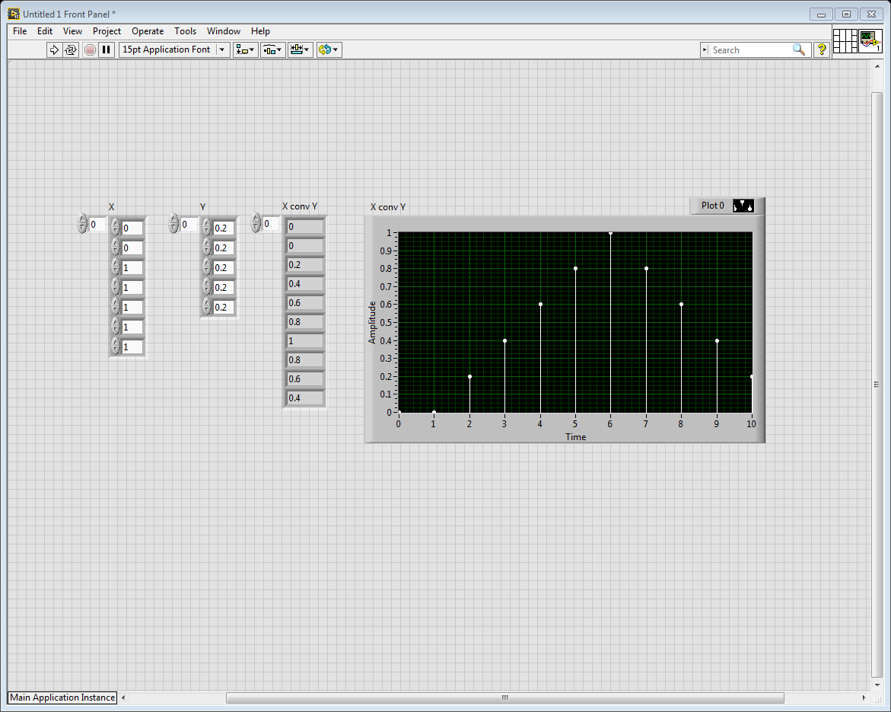

Part 3:

Front Panel:

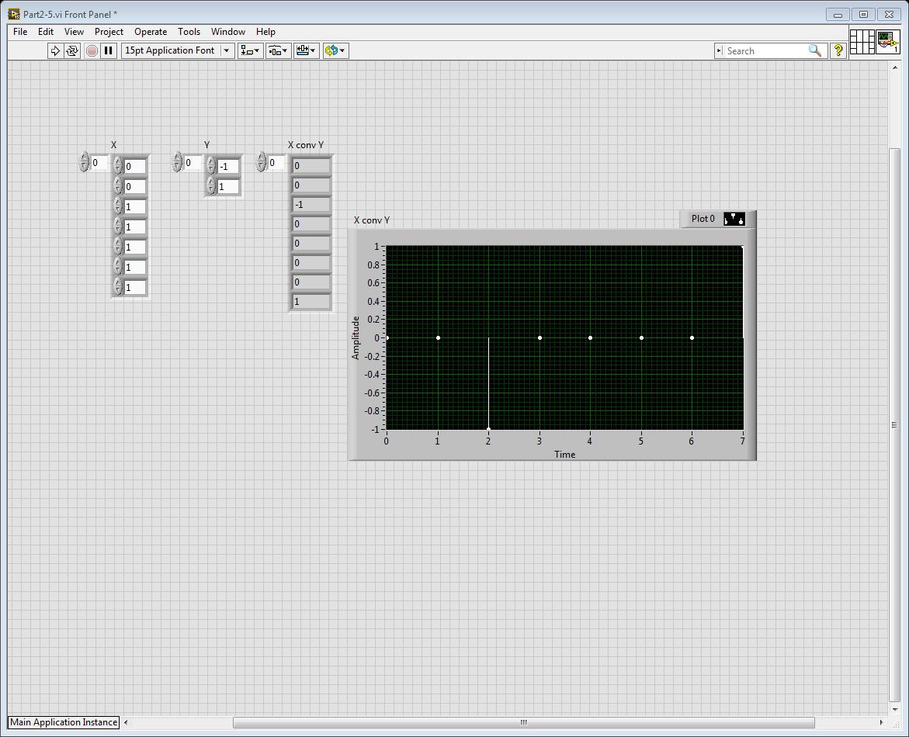

Part 4:

Front Panel:

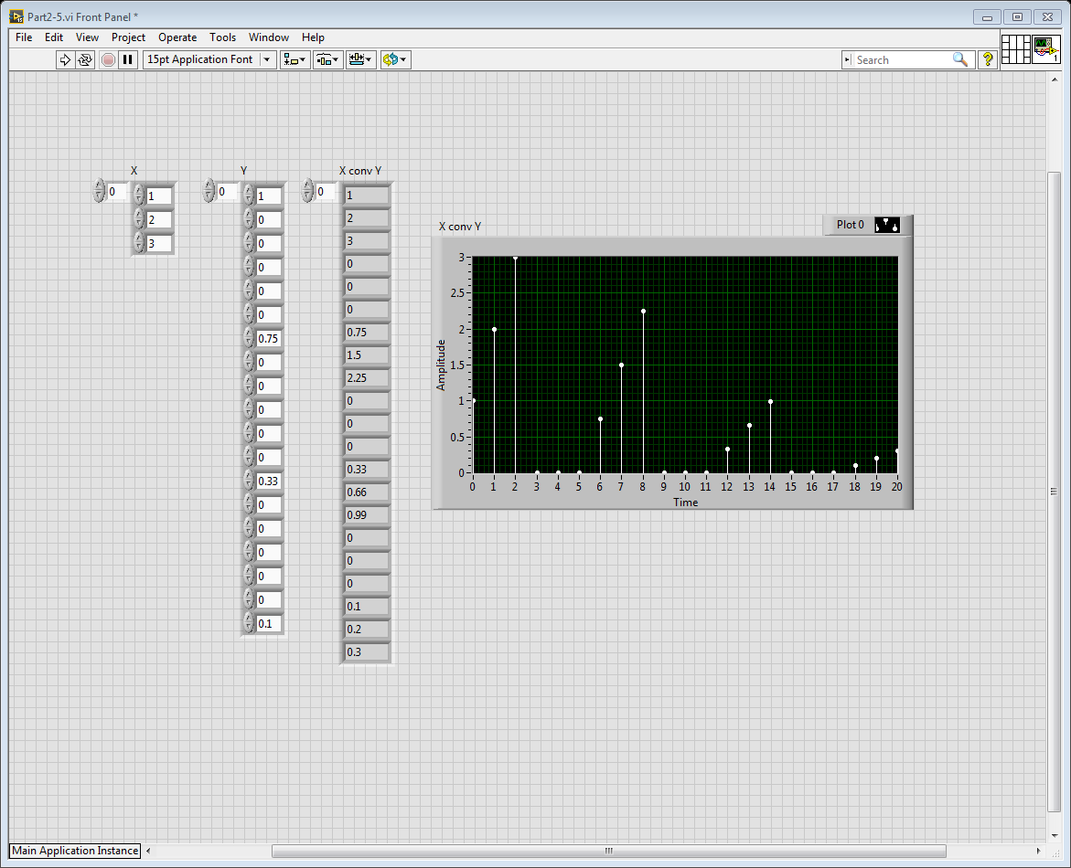

Part 2.6

6:

Block Diagram

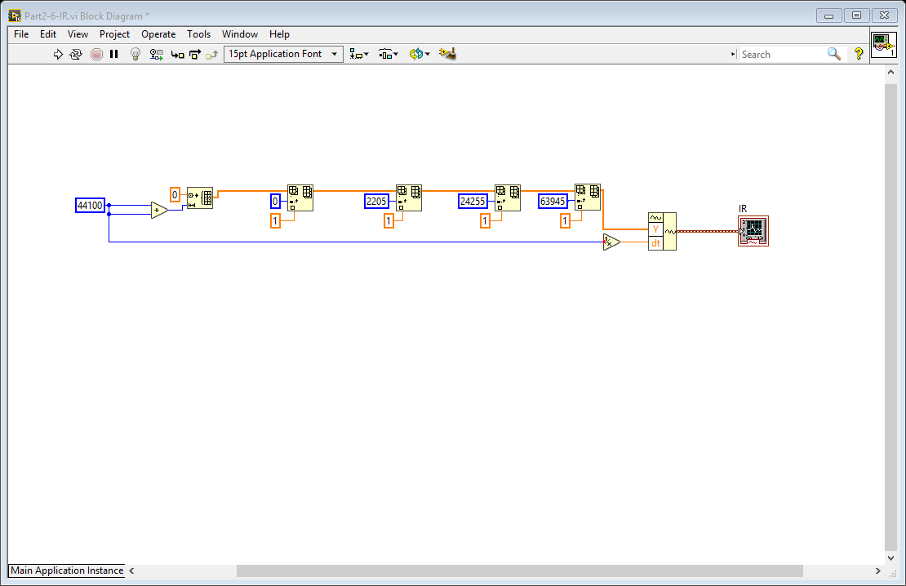

Front Panel: (Waveform)

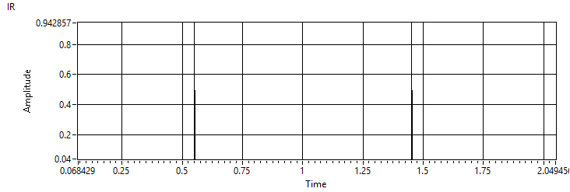

7:

Block Diagram:

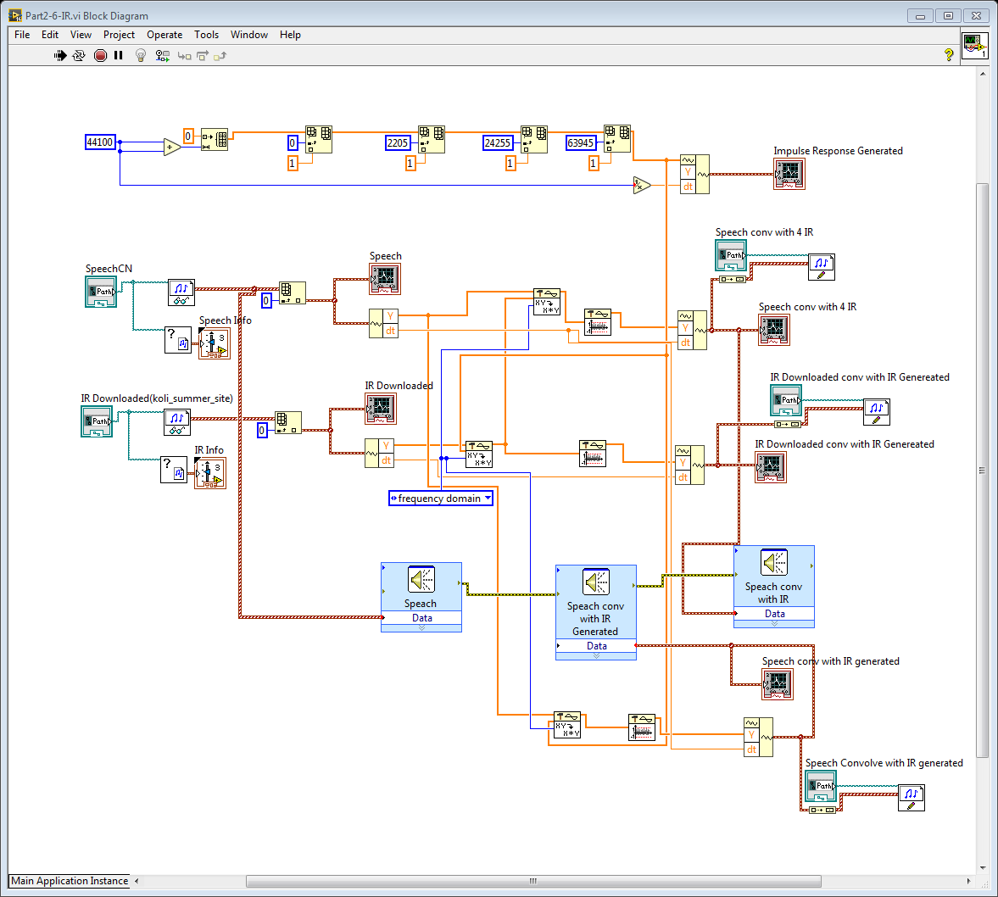

Front Panel with waveforms:

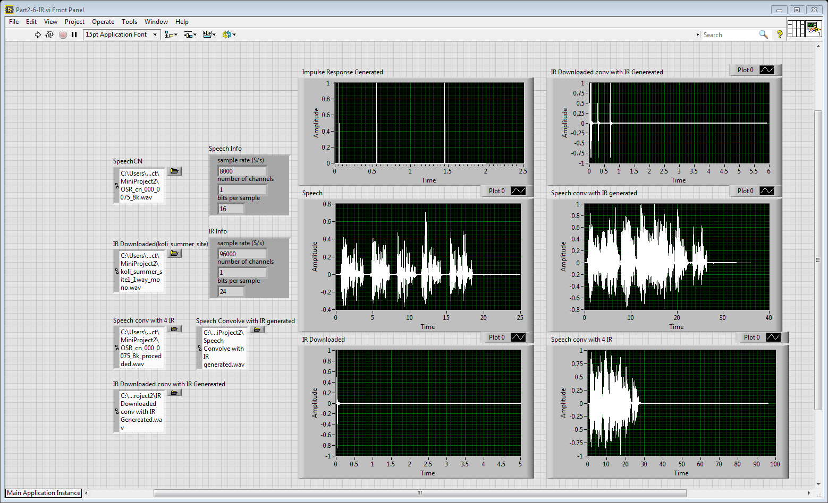

8:

When the speech is convolved with the impulse response that generated, it just echoed. The last pair looks most similar to this case.

9:

It feels the speaker is giving the speech in the open air with echoes. Echoes and some noise can be heard.