Yang Zhang

ECE380

CM677

Due: January 13, 2017

Mini Project 2:

Part 3.5: Preparation

Block Diagram

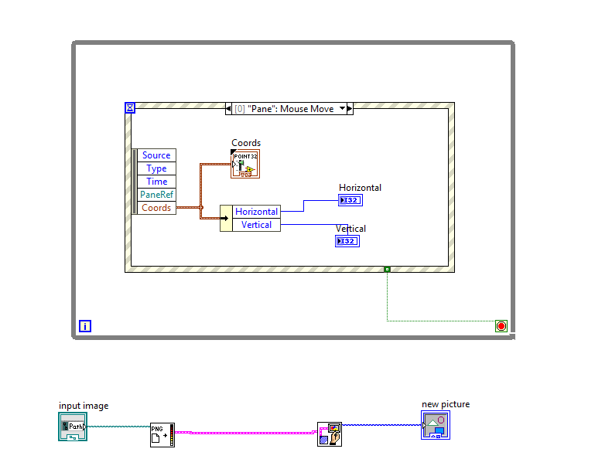

Front Panel:

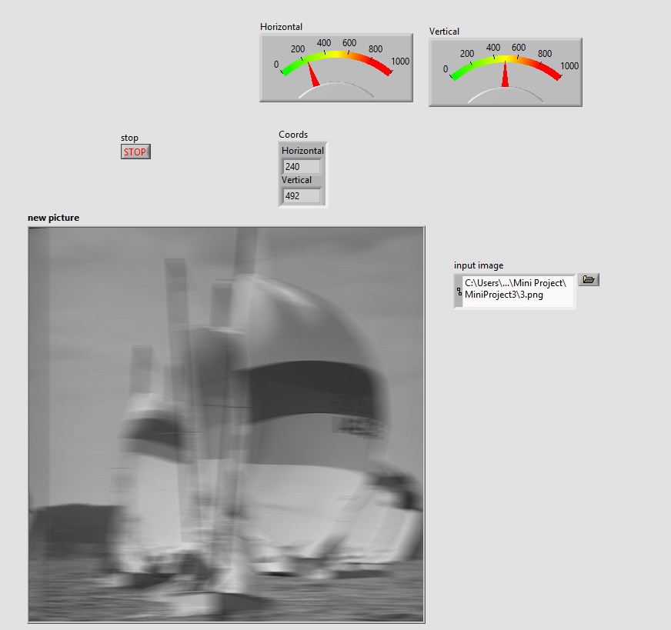

Calculated D:

D = 265-240 = 25

Part 3.6:

By hand part:

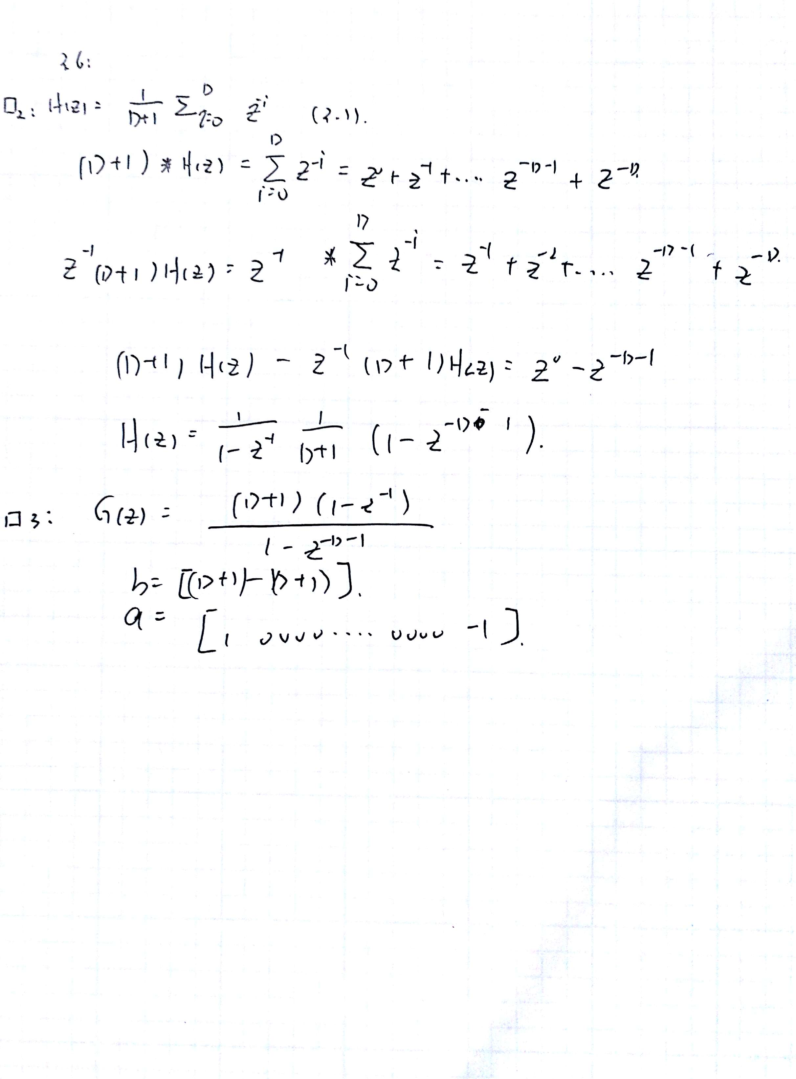

pole zero and frequency response for G(z):

front panel:

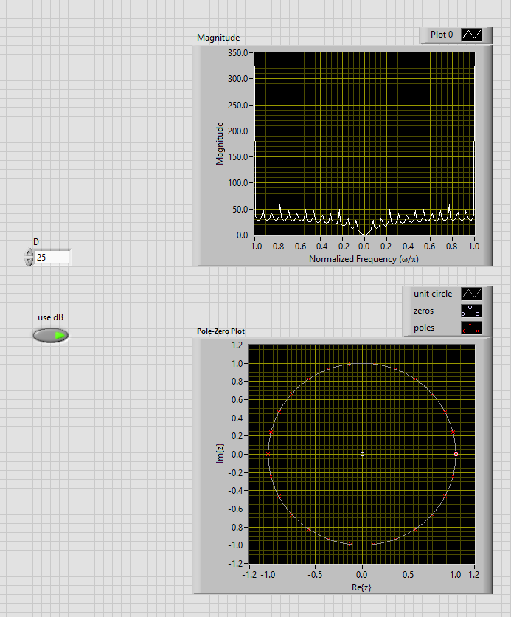

Block diagram:

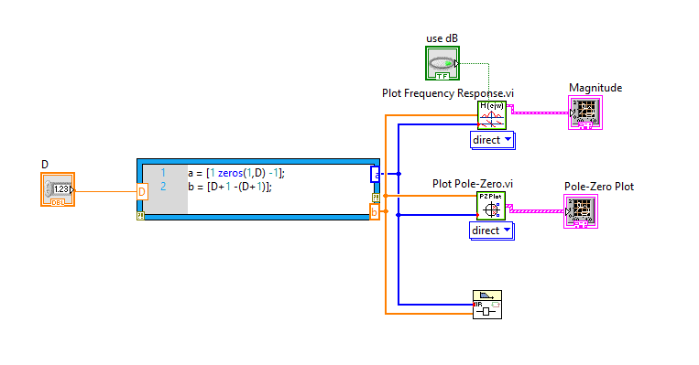

Problem:

Where are the poles of G(z) located in the pole-zero diagram? How do these pole locations manifest themselves in the frequency response plot?

Answer: Poles are located on the unit circle. Number of poles is the D number. Zeros are located on (1,0) and (0,0)

Stable Inverse Filter:

By hand part:

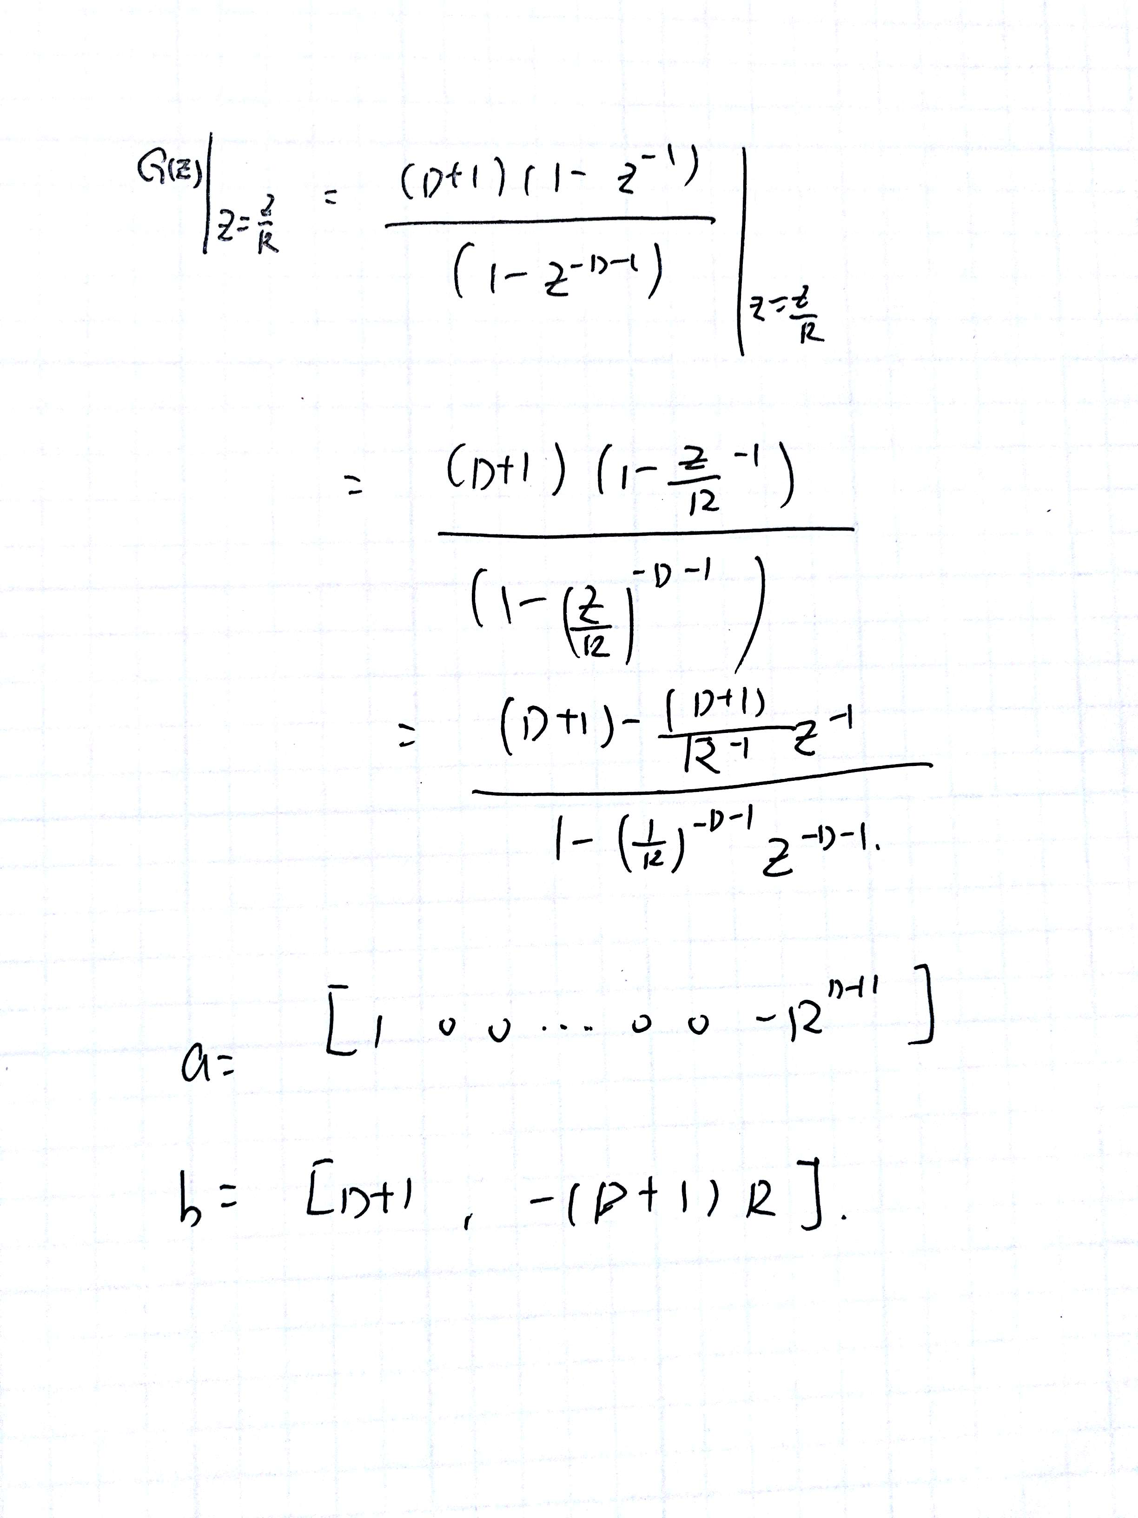

Pole Zero diagram: (front panel)

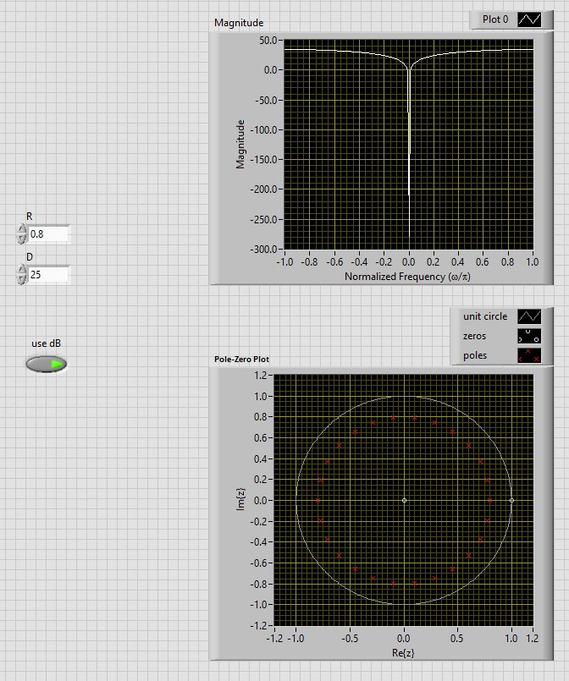

When R increase, it will get closer to unit circle. If R decrease, It will get closer to origin

Block diagram:

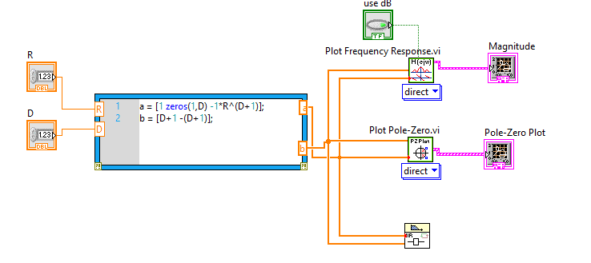

Unit DC gain:

By hand Part:

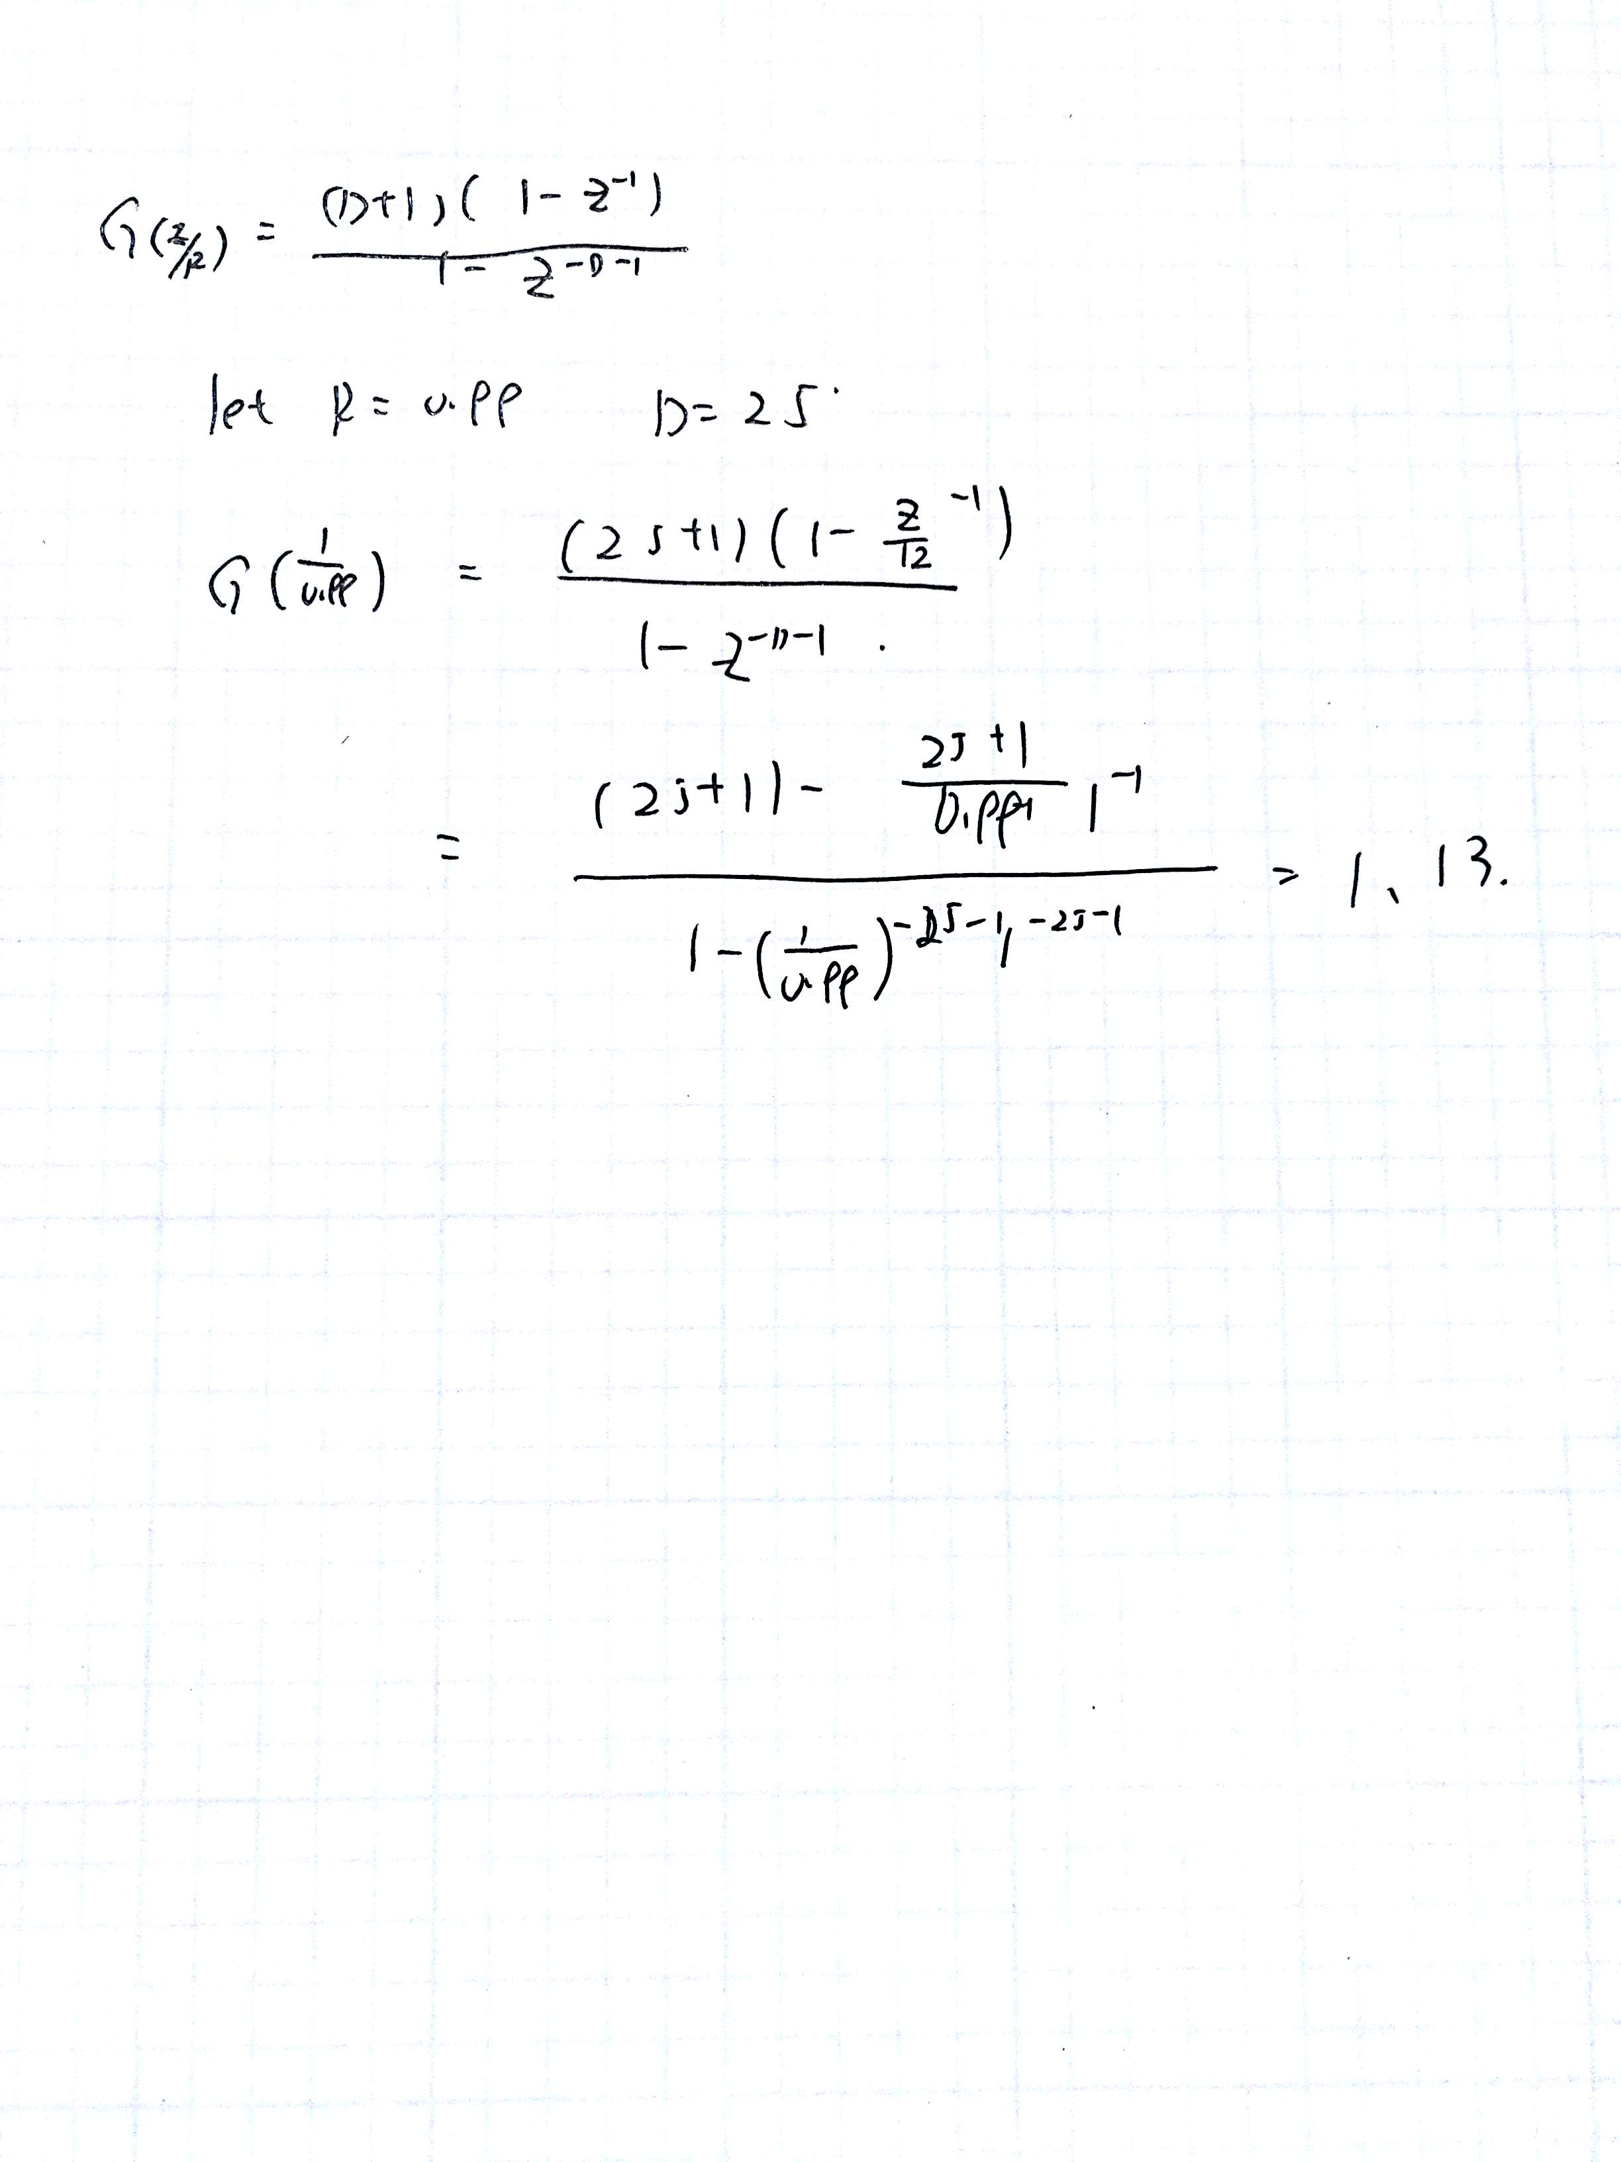

Part 3.7:

D = 24, R=0.95



Front Panel:

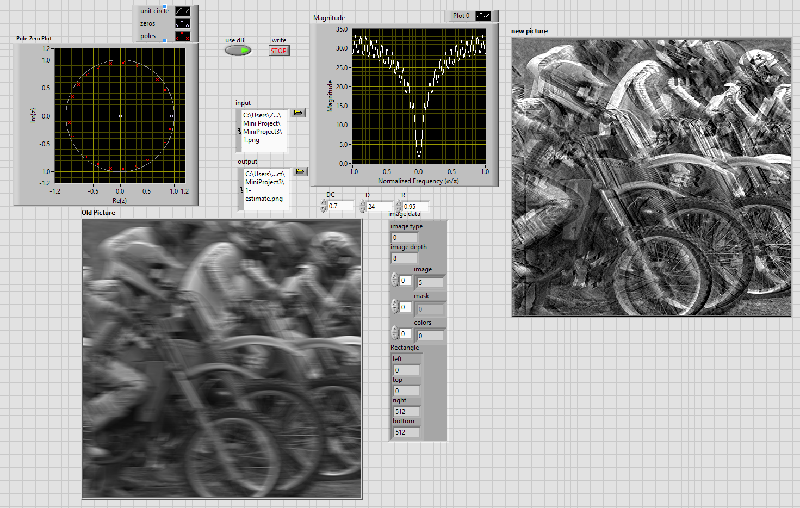

Block Diagram:

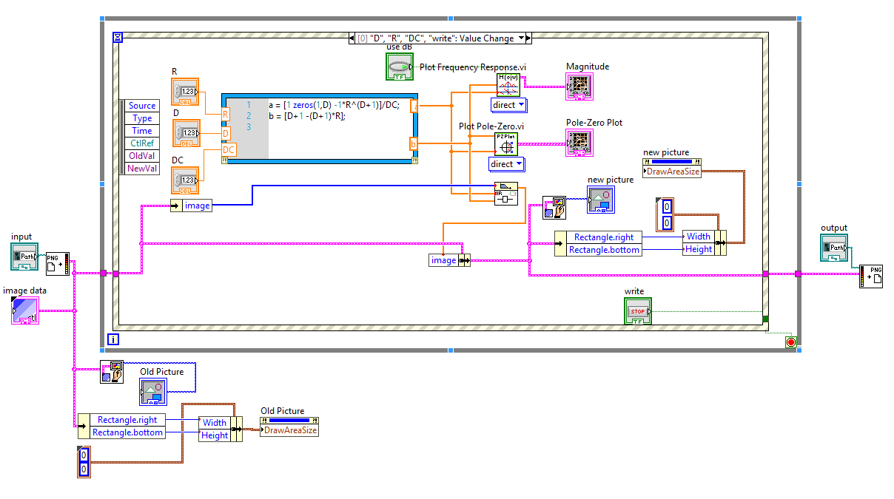

3.8:

(a) choose R=0.95 and change D:

D=24:



D=30:



Picture will shift if we change the D value.

(b): set D to 24 and change R:

R = 0.8:



R = 0.99:



Seems like R is to change the contrast ratio of the picture.