Yang Zhang

CM677

ECE380

Mini Project 4

4.5-1:

“Quindar” is used to contact the people in the space

4.5-2:

Quindar tone can travel along with the human voice

4.5-3:

They are both sine waves

4.5-4:

First one: 2525Hz, 250ms duration

Second one: 2475Hz, 250ms duration

4.5-5:

<https://en.wikipedia.org/wiki/Quindar_tones>

4.6:

Figure 1:

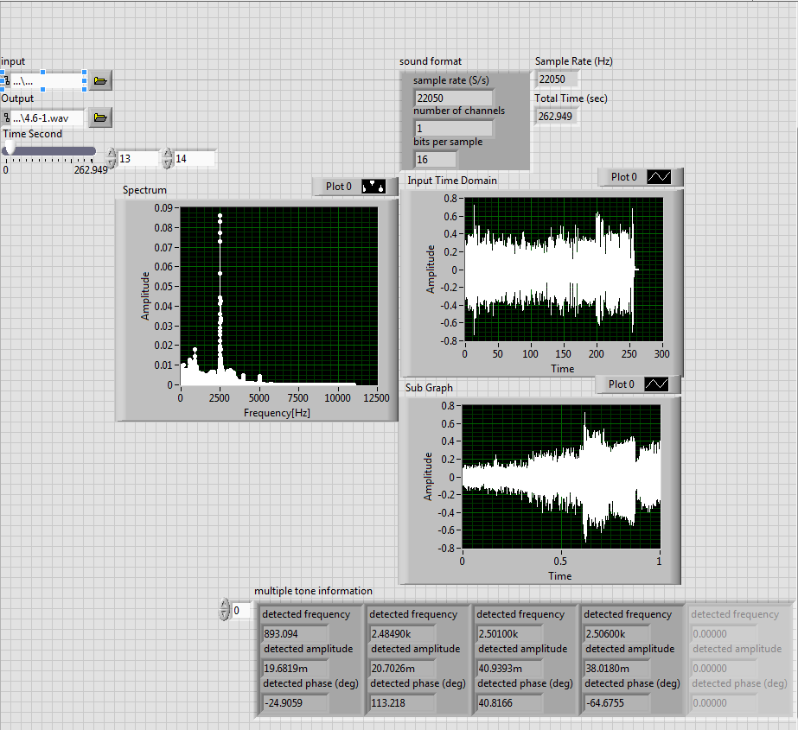

The first tone is found at about 13.5 sec. The frequency is about 2.506 kHz

Figure 2:

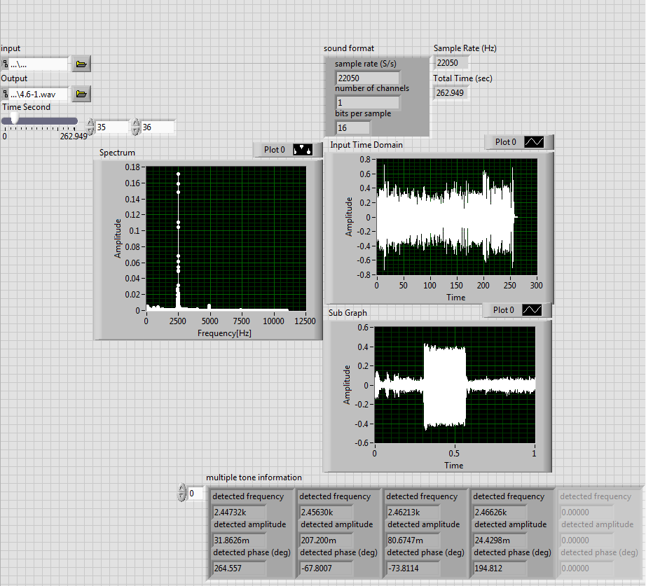

The second tone is found at about 35.5 sec. The frequency is about 2.456 kHz

Block Diagram:

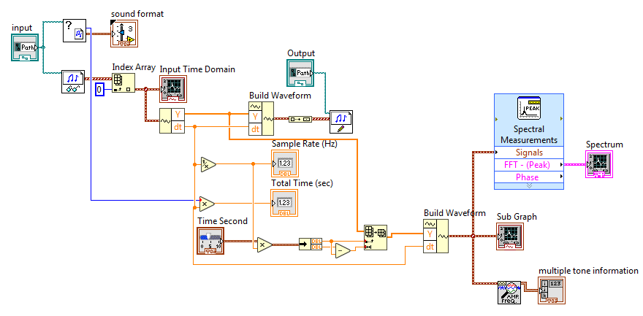

Percentage difference:

At 13 .5 secs:

At 35.5 secs:

Because the signal is transmitted through a really long distance. There will be some data that are lost. Therefore, the actual frequency is will be slightly different than the original one. For the first tone, choose 2506 Hz and 2456 Hz for the second.

4.7:

Hand calculation for the notch filters:

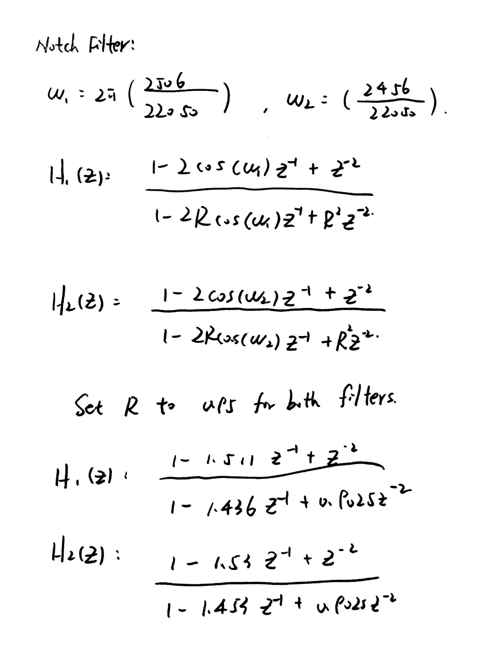

Cascade two filters into one:

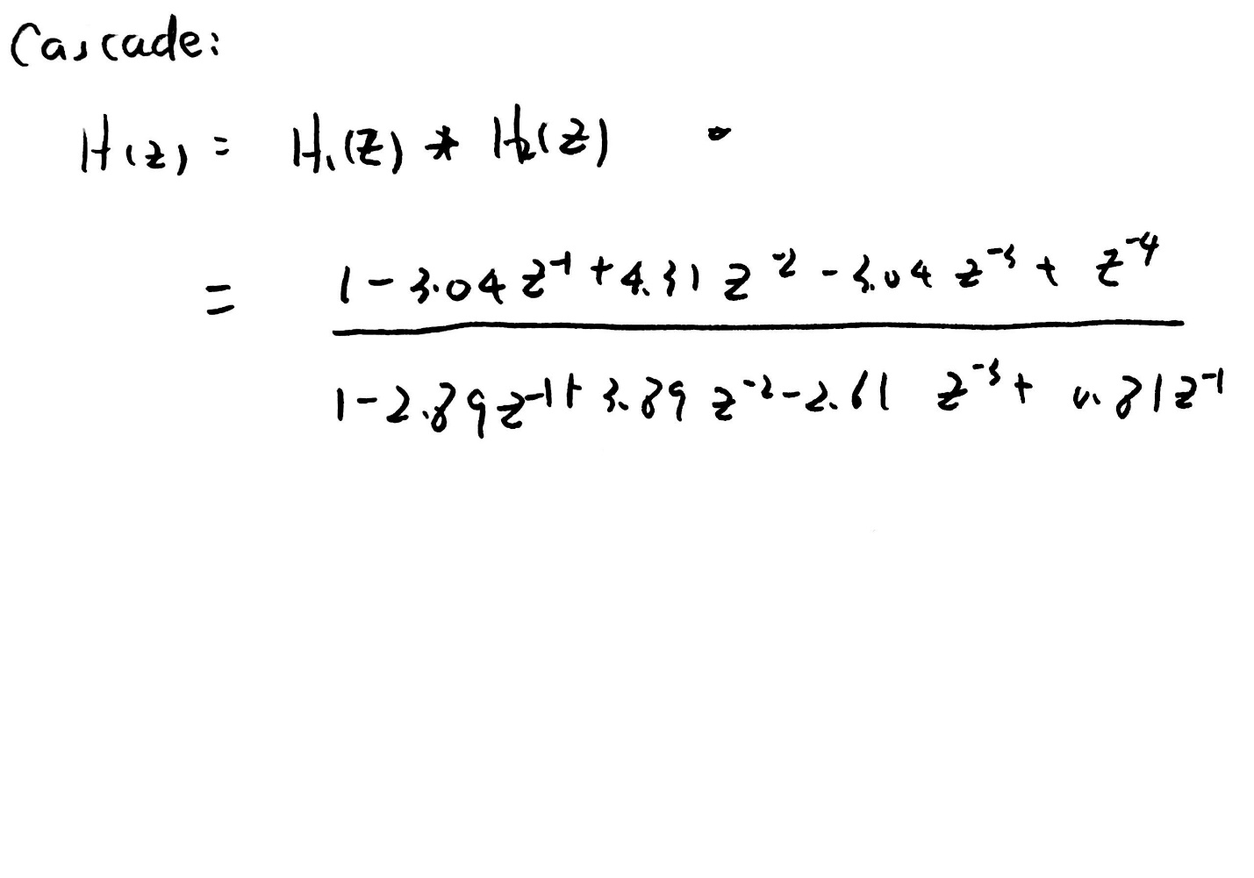

Pole Zero plot for the notch filter:

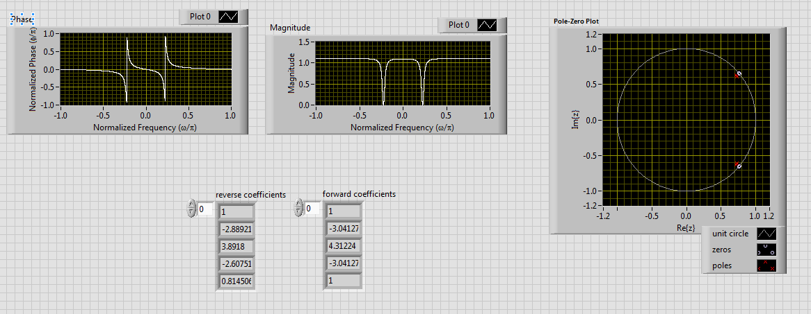

Block Diagram:

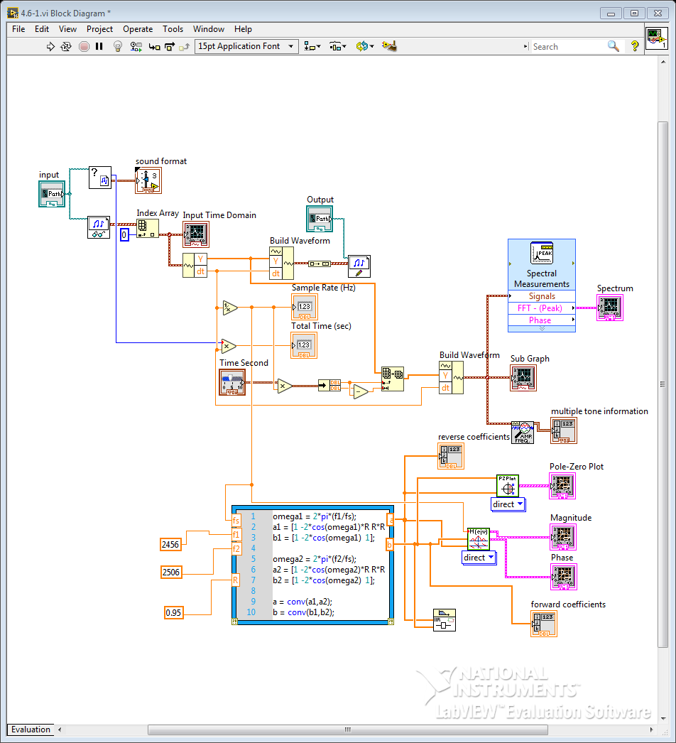

Connect the original signal to the notch filter:

At 35.5 sec:

When the filter is off:

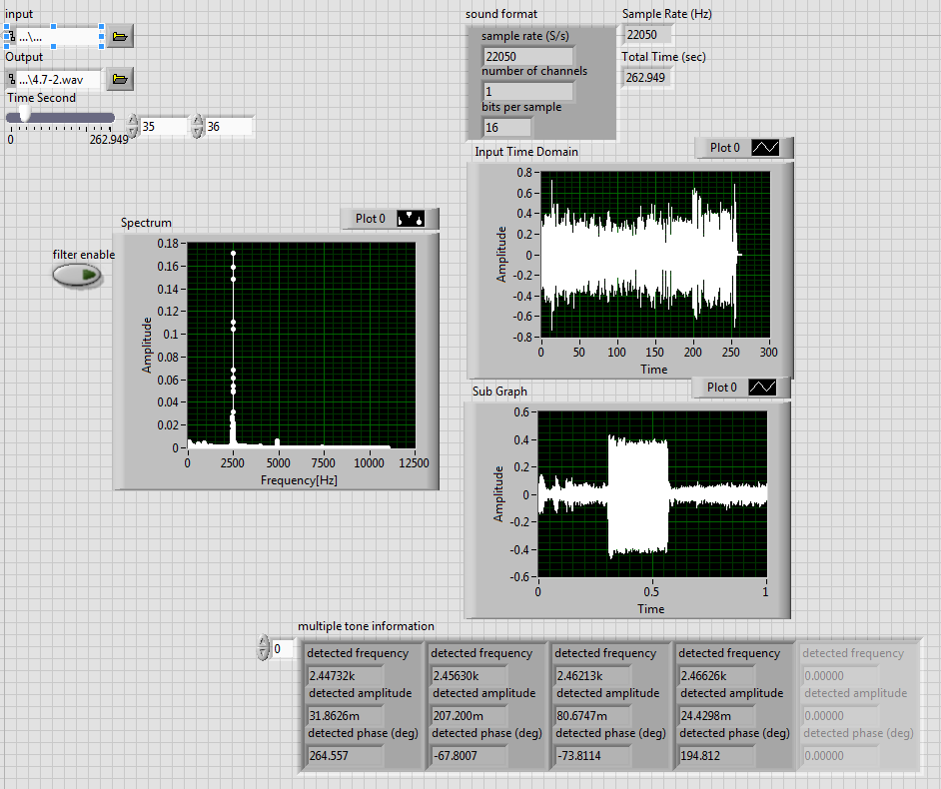

When the filter is on:

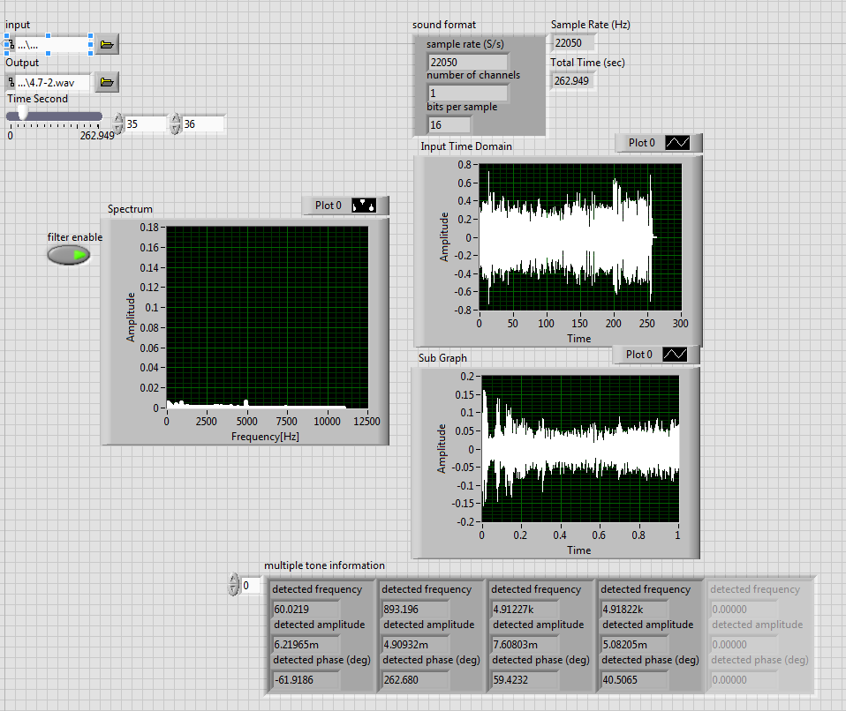

We can clearly see that the impulse at 2.456kHz is filtered out.

At 13.5 secs:

When the filter is off:

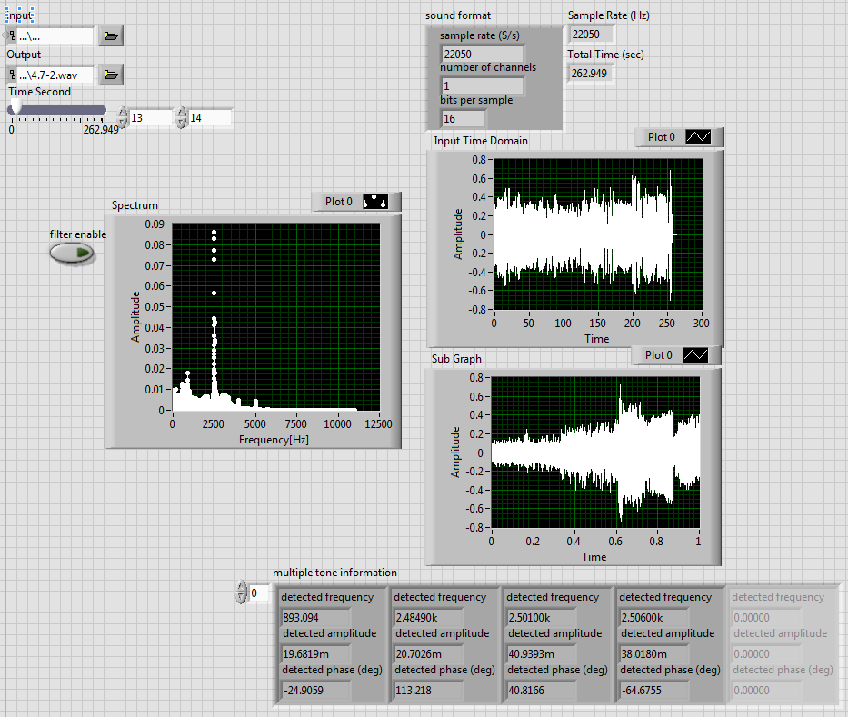

When the filter is on:  
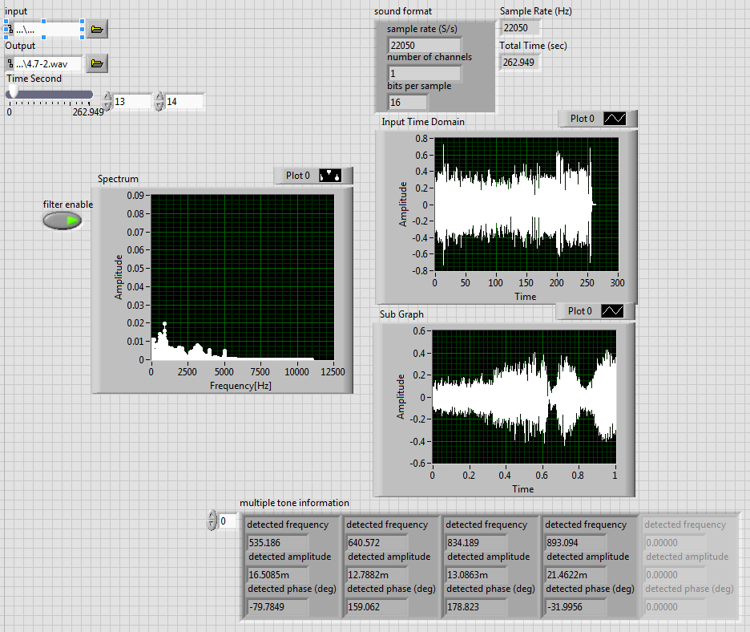

We can also see that the impulse at 2.506kHz is filtered out.

Block Diagram:

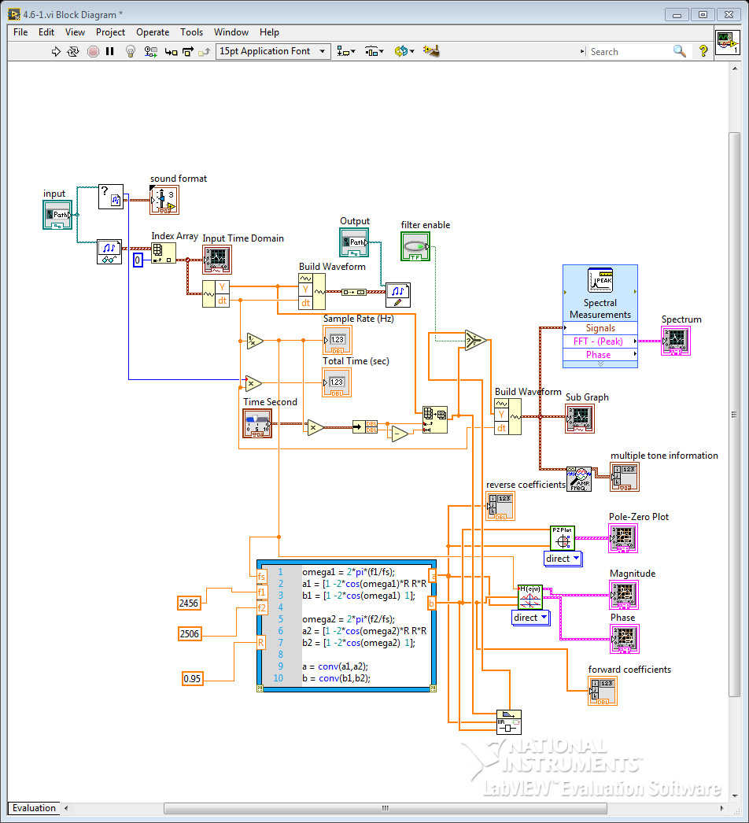

For a longer time period:

I choose time 20 secs to 36 secs:

With filter:

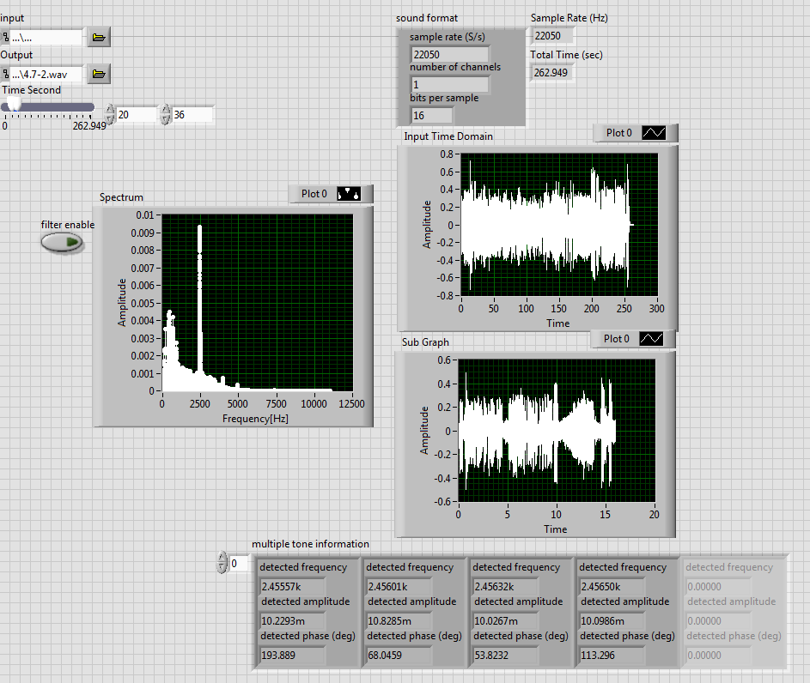

Without filter:

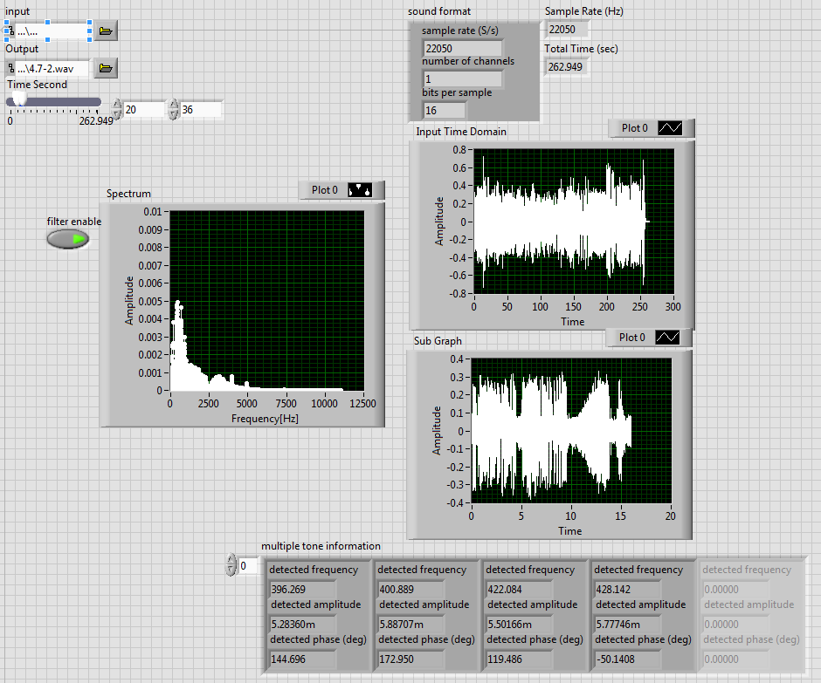

The impulse at about 2kHz is filtered out.

4.8:

For the 2nd harmonic:

Without filter: With filter:

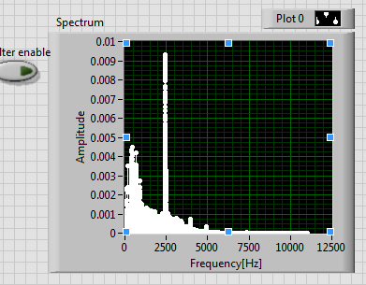 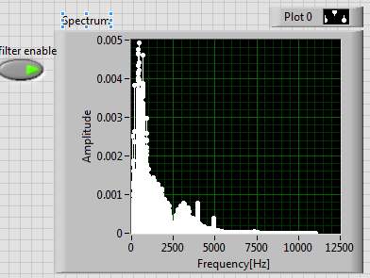

At 2500 HZ, the amplitude is about 0.0095, at the second harmonic which is 5000 Hz, the amplitude is 0.0005.

The percentage of the fundamental’s amplitude is

Block diagram with sub VI replaced:

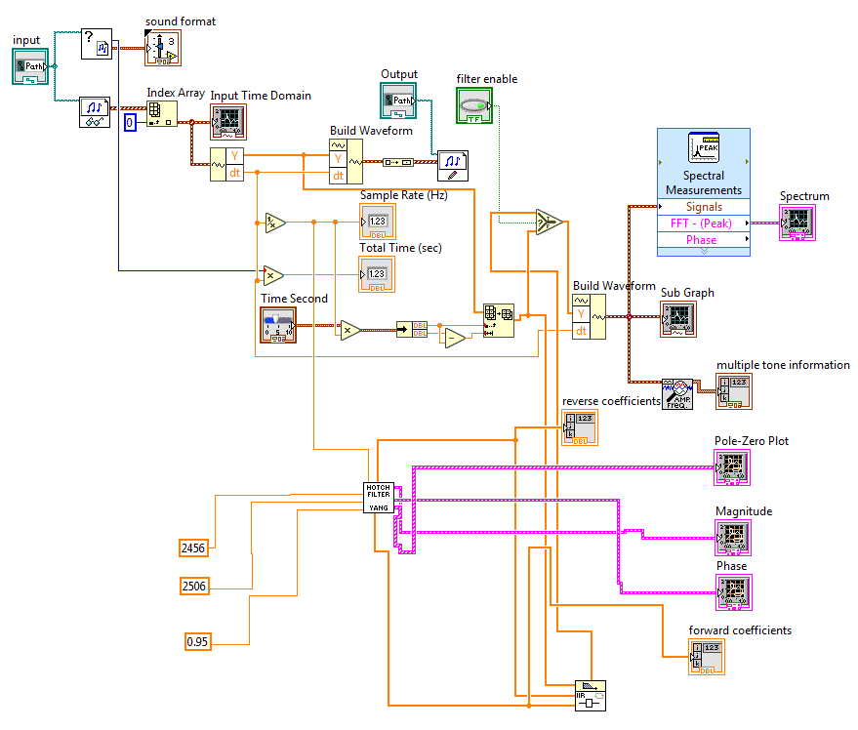

Notch Filter Sub VI:

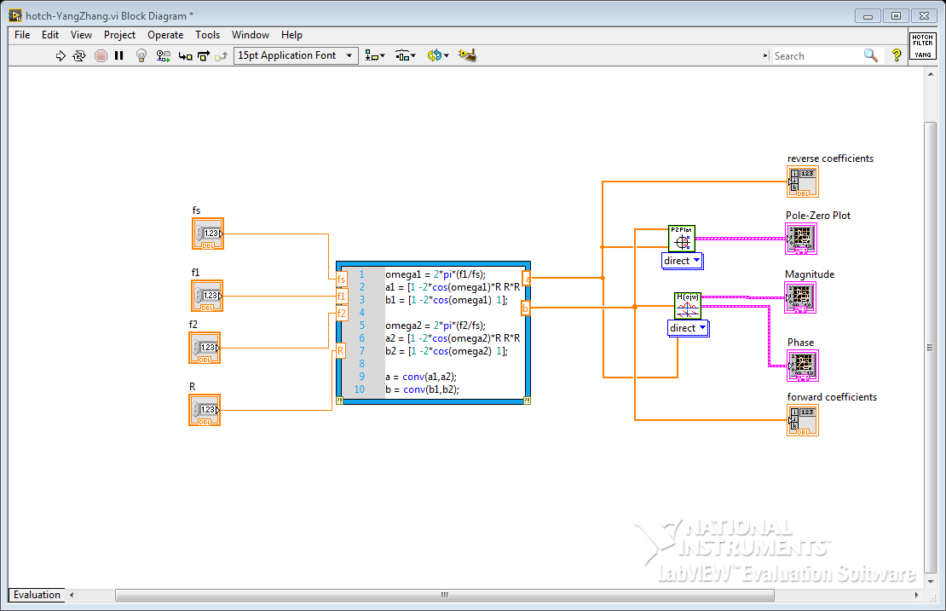

Whole block diagram for Comb filter:

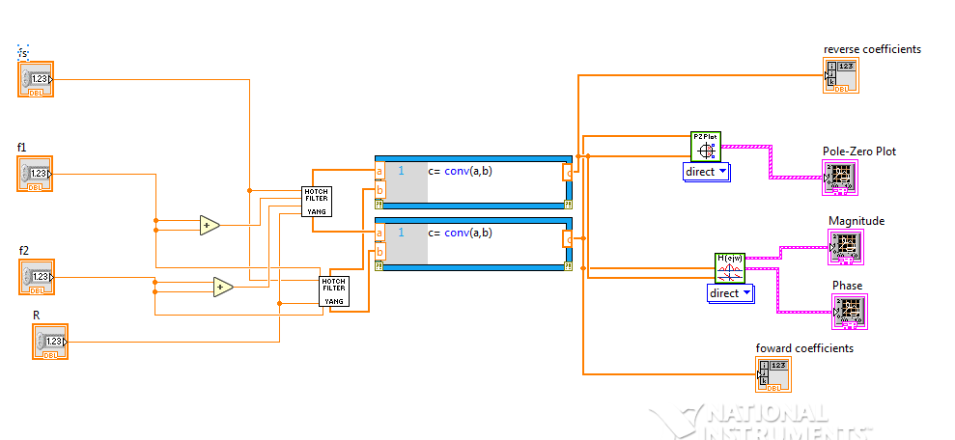

Whole program block diagram (replace notch filter by comb filter)

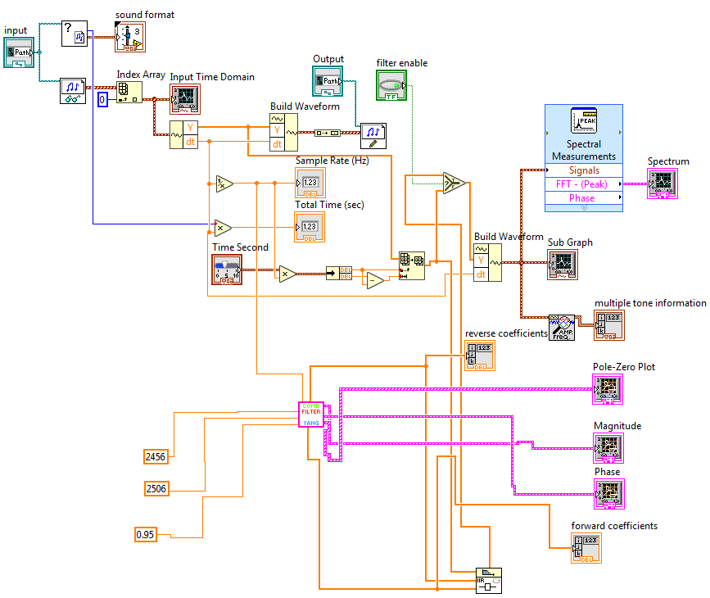

With filter on:

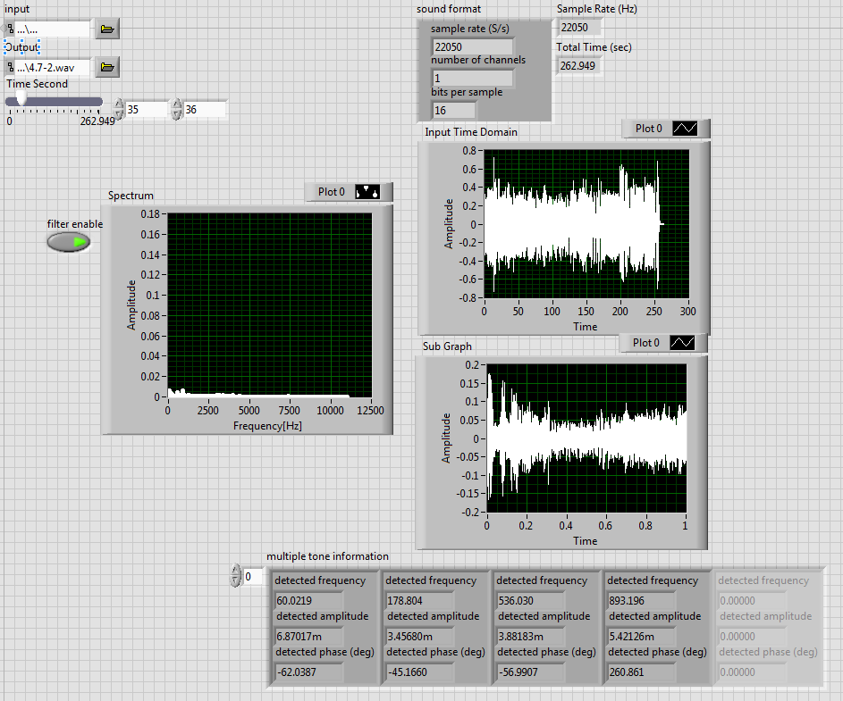

I think it is much better than the notch filter. From the spectrum, we can clearly see that the amplitude at frequency 2000 Hz is less than that of the notch filter. I tried to make the R value lower, but then the human voice sounds strange. But if we make the R value higher, the Quindar tunes appear again.

4.9 Discuss:

The comb filter is better than notch filter.

Overall block diagram:

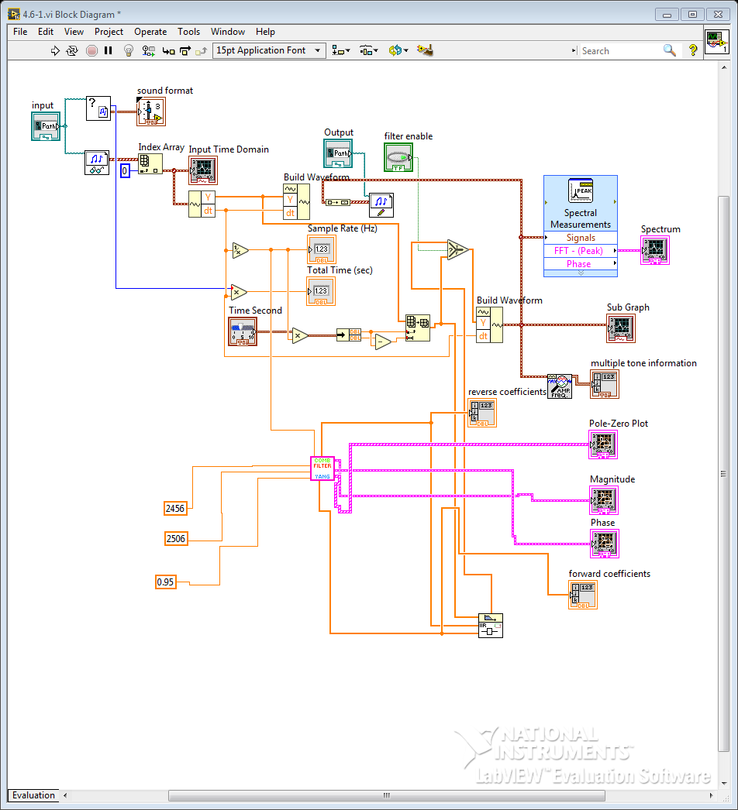

Overall Front Panel

