Yang Zhang

CM677

Mini-Project 5

ECE380

5.5-1:

1: DTFM is dual tone multi frequency. It is the signal to the phone company that we generate when we press the telephone’s touch keys

Source: [*http://searchnetworking.techtarget.com/definition/DTMF*](http://searchnetworking.techtarget.com/definition/DTMF)

2: Starting in 1963

Source: [*https://en.wikipedia.org/wiki/Dual-tone_multi-frequency_signaling*](https://en.wikipedia.org/wiki/Dual-tone_multi-frequency_signaling)

3: 123A456B789C * 0#D

Source: [*https://en.wikipedia.org/wiki/Dual-tone_multi-frequency_signaling*](https://en.wikipedia.org/wiki/Dual-tone_multi-frequency_signaling)

4 and 5:

|  |  |  |
| --- | --- | --- |
| Key | Low Freq(Hz) | High Freq(Hz) |
| 1 | 697 | 1209 |
| 2 | 697 | 1336 |
| 3 | 697 | 1477 |
| A | 697 | 1633 |
| 4 | 770 | 1209 |
| 5 | 770 | 1336 |
| 6 | 770 | 1477 |
| B | 770 | 1633 |
| 7 | 852 | 1209 |
| 8 | 852 | 1336 |
| 9 | 852 | 1477 |
| C | 852 | 1633 |
| * | 941 | 1209 |
| 0 | 941 | 1336 |
| # | 941 | 1477 |
| D | 941 | 1633 |

Source: [*https://en.wikipedia.org/wiki/Dual-tone_multi-frequency_signaling*](https://en.wikipedia.org/wiki/Dual-tone_multi-frequency_signaling)

Rows: 697Hz, 770Hz, 852Hz, 941 Hz

Columns: 1209Hz, 1336Hz, 1477Hz, 1633Hz

5.6-1

Subrange length = 128, the last DTMF tone, without hamming window

Front Panel:

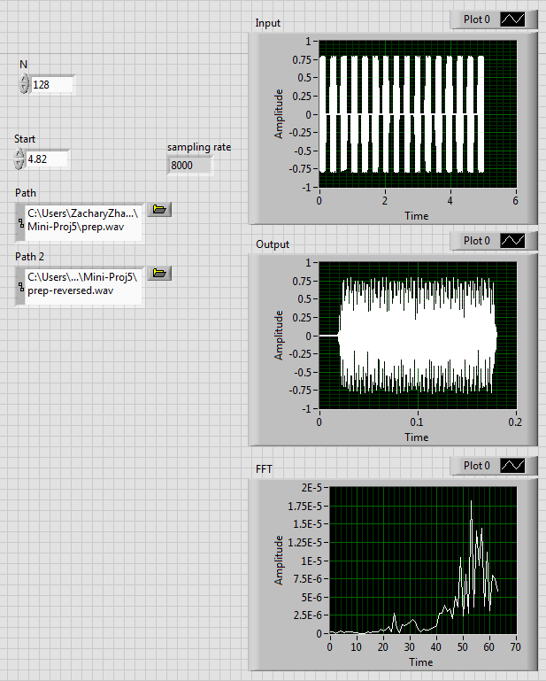

Block Diagram:

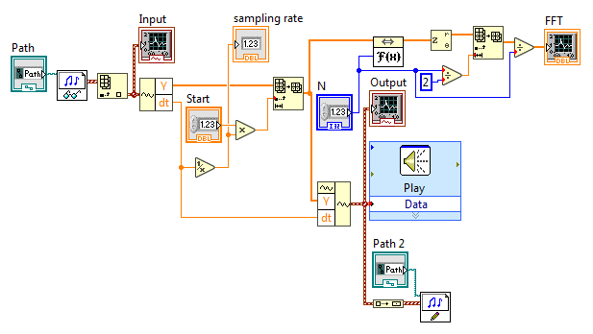

When the FFT length increase, the FFT become narrower which looks like impulses:

Length = 1024:

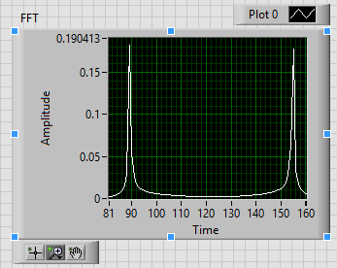

Calculated Bin Number:

The frequency bins of the two high spikes are at about 89 and 155

Using Hamming Window:

Front Panel:

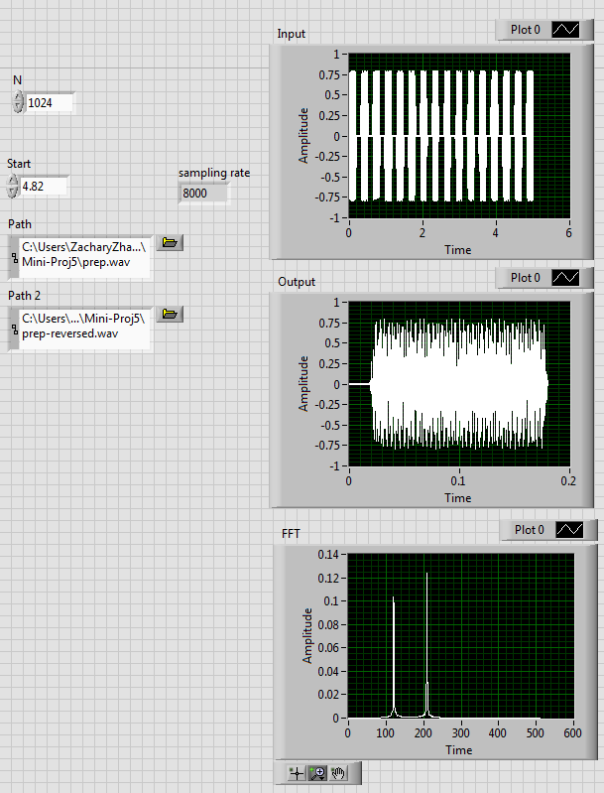

Block Diagram:

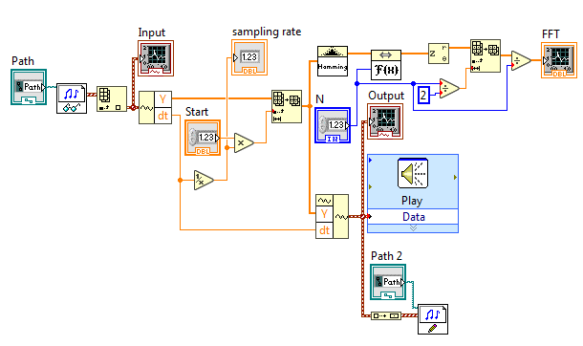

The leakage for the Hamming window is much less than that without window, we can see the comparison as the following:

With Hamming: Without Hamming:

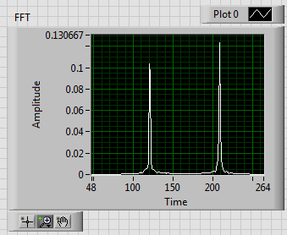 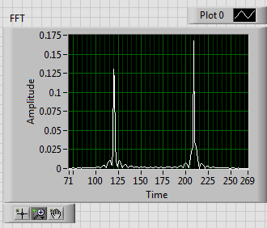

5.7-1:

1: Envelope detector output with cutoff frequency = 30Hz

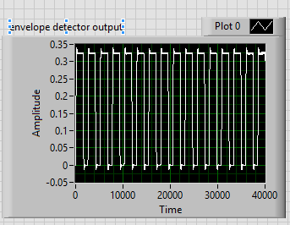

2: Camparator with threshold 0.2:

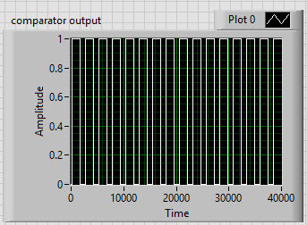

3: Differential output:

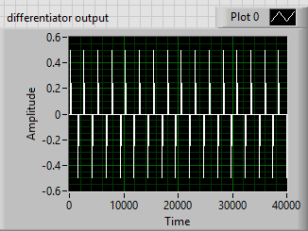

4: Decoder:

Front Panel for each tone and key of the mystery DTFM:

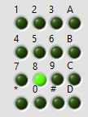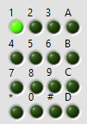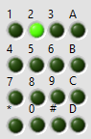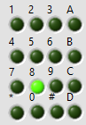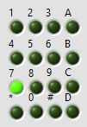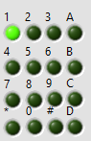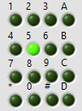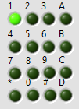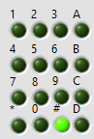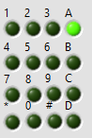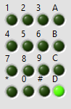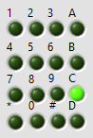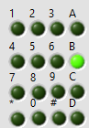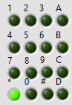

The decoded DTMF sequence is : 8-1-2-8-7-7-1-5-1-1-#-A-D-C-B-*

Front Panel:

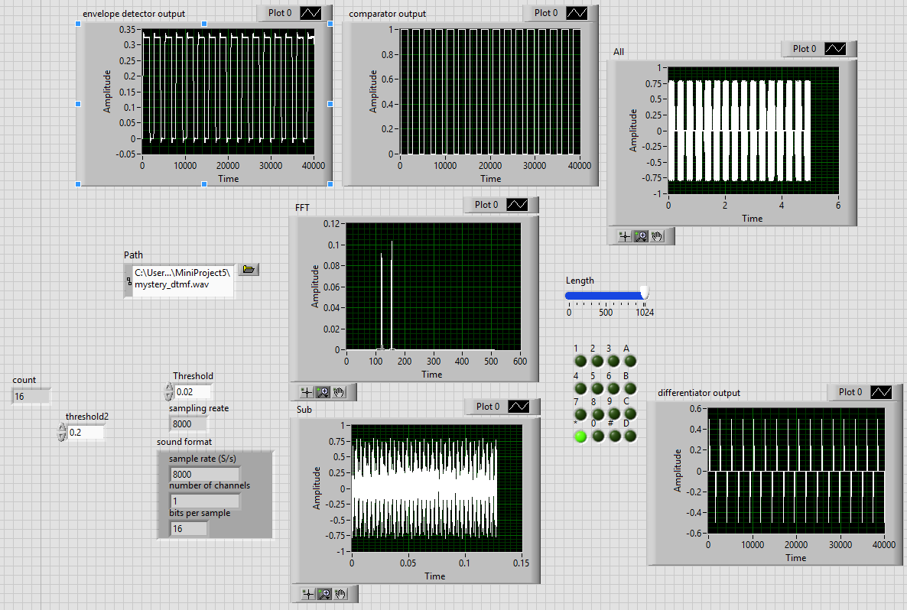

Block Diagram:

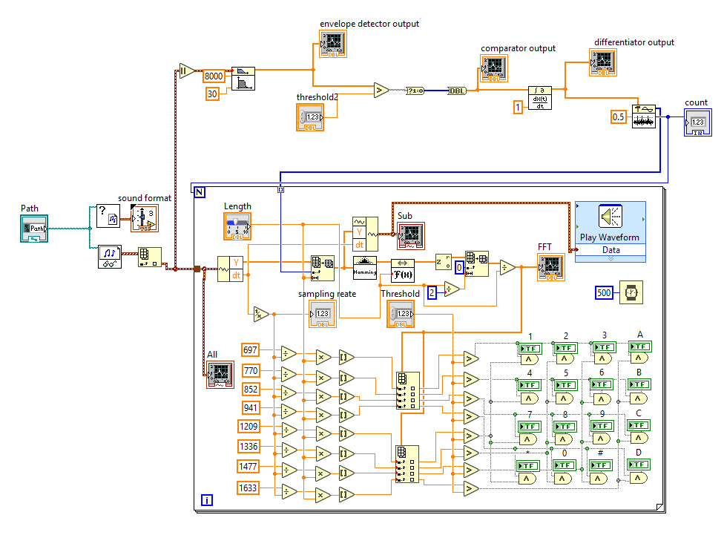

5.9-1:

The decoder system works pretty good! It can detect the DTMF audo and give me the feedback keypad. Really Interesting!