Week-2
Develop an application that receives user‟s name, contact and city and displays the same using Layout Managers and Event Listeners.
Android app in Java using Android Studio that receives the user’s name, contact, and city via EditText fields and displays them in a TextView when a button is clicked.
Using LinearLayout as the layout manager and implement an OnClickListener for the button. activity_main.xml
layout with 3 EditTexts, a Button, and a TextView to display the result.
<?xml version="1.0" encoding="utf-8"?>
<LinearLayout xmlns:android="http://schemas.android.com/apk/res/android" android:layout_width="match_parent"
android:layout_height="match_parent"
android:padding="16dp"
android:orientation="vertical">
<EditText
android:id="@+id/n"
android:layout_width="match_parent"
android:layout_height="wrap_content"
android:hint="Enter Name"
android:inputType="textPersonName" />
<EditText
android:id="@+id/ph"
android:layout_width="match_parent" android:layout_height="wrap_content" android:hint="Enter Contact"
android:inputType="phone" />
<EditText
android:id="@+id/ct"
android:layout_width="match_parent" android:layout_height="wrap_content" android:hint="Enter City"
android:inputType="text" />
<Button
android:id="@+id/b"
android:layout_width="wrap_content" android:layout_height="wrap_content" android:text="Submit"
android:layout_marginTop="16dp" />
<TextView
android:id="@+id/tv" android:layout_width="match_parent" android:layout_height="wrap_content" android:text=""
android:textSize="18sp"
android:layout_marginTop="24dp" />
</LinearLayout>
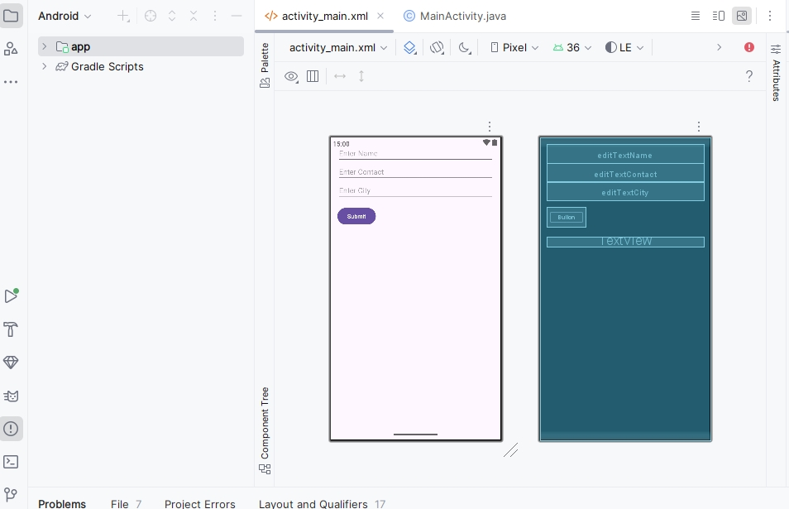
MainActivity.java
package com.example.userinputapp;
import androidx.appcompat.app.AppCompatActivity;
import android.os.Bundle; import android.view.View; import android.widget.Button; import android.widget.EditText; import android.widget.TextView;
public class MainActivity extends AppCompatActivity {
EditText n, ph, ct; Button b;
TextView tv;
@Override
protected void onCreate(Bundle bd) { super.onCreate(bd);
setContentView(R.layout.activity_main);
// Initialize views
n = findViewById(R.id.n); ph = findViewById(R.id.ph); ct = findViewById(R.id.ct); b = findViewById(R.id.b); tv = findViewById(R.id.tv);
// Set listener for button
b.setOnClickListener(new View.OnClickListener() { @Override
public void onClick(View v) {
// Get input values
String nm = n.getText().toString().trim();
String con = ph.getText().toString().trim(); String cty = ct.getText().toString().trim();
// Display the values
String msg = "Name: " + nm + "\nContact: " + con + "\nCity: " + cty; tv.setText(msg);
}
});
}
}
Output:
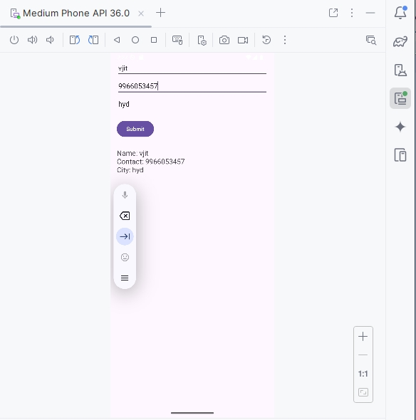
Explanation:
- Layout Manager: LinearLayout arranges the views vertically.
- Event Listener: b.setOnClickListener listens for the button click.
- When the button is clicked, it fetches the input values and shows them in the TextView.

Develop an application that shows names as a list and on selecting a name it should show the details of the candidate on the next screen with a “Back” button.

create a simple two-screen Android app in Java using Android Studio.

activity_main.xml
<?xml version="1.0" encoding="utf-8"?>
<LinearLayout xmlns:android="http://schemas.android.com/apk/res/android"
android:orientation="vertical"
android:padding="16dp"
android:layout_width="match_parent"
android:layout_height="match_parent">

<ListView
android:id="@+id/lv"
android:layout_width="match_parent"
android:layout_height="match_parent" />

</LinearLayout>

activity_detail.xml

<?xml version="1.0" encoding="utf-8"?>
<LinearLayout xmlns:android="http://schemas.android.com/apk/res/android"
android:orientation="vertical"
android:padding="16dp"
android:gravity="center_horizontal"
android:layout_width="match_parent"
android:layout_height="match_parent">

<TextView
android:id="@+id/tv"
android:layout_width="wrap_content"
android:layout_height="wrap_content"
android:textSize="20sp"
android:text="Details will appear here" />

<Button
android:id="@+id/b"
android:layout_width="wrap_content"
android:layout_height="wrap_content"
android:text="Back"
android:layout_marginTop="24dp" />

</LinearLayout>
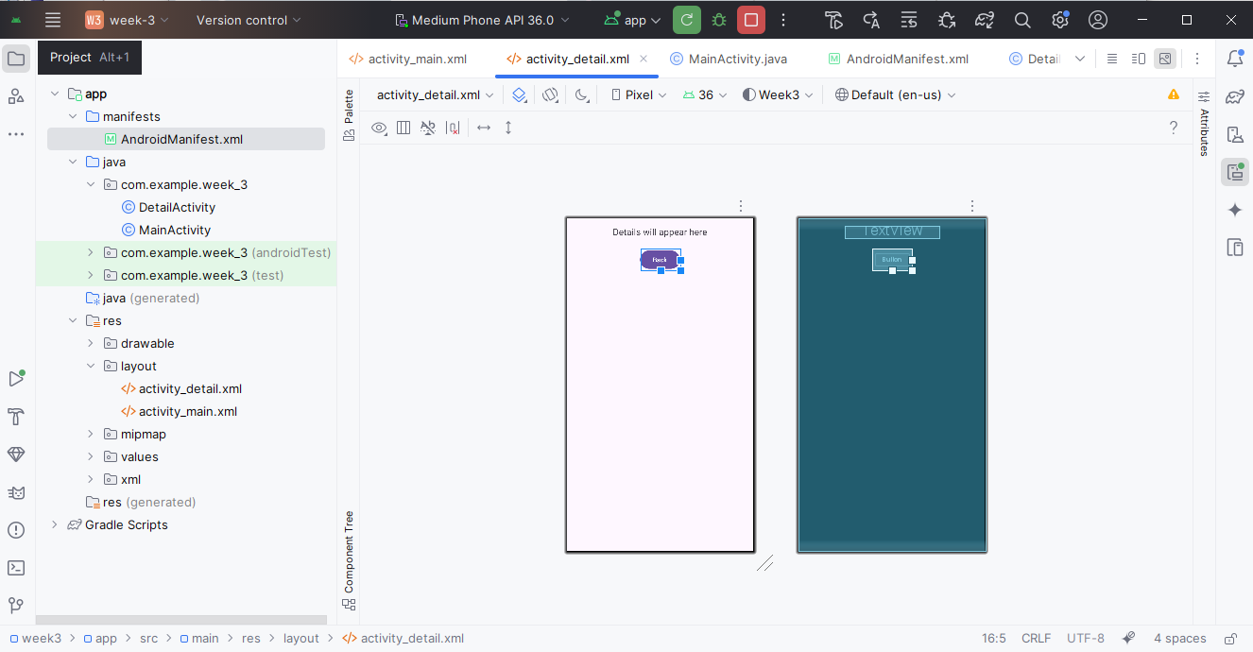
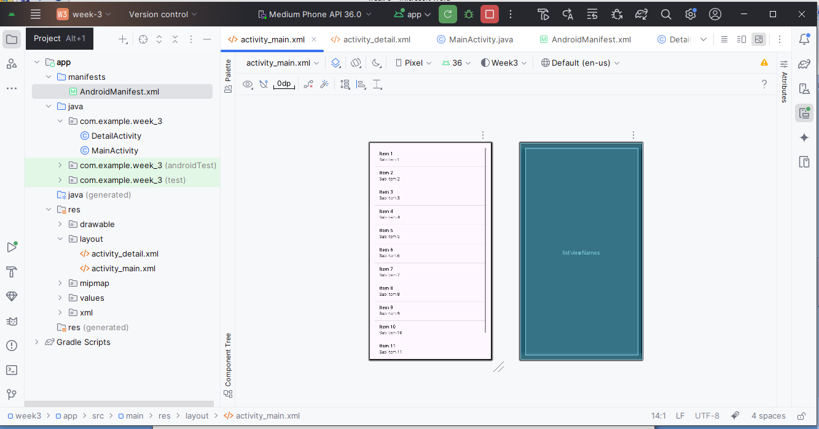

MainActivity.java
java
CopyEdit
package com.example.nameapp;

import androidx.appcompat.app.AppCompatActivity;
import android.content.Intent;
import android.os.Bundle;
import android.widget.AdapterView;
import android.widget.ArrayAdapter;
import android.widget.ListView;

public class MainActivity extends AppCompatActivity {

ListView lv;
String[] nm = {"Alice", "Bob", "Charlie", "David"};
String[] dt = {
"Alice - Android Developer from NYC",
"Bob - Data Scientist from LA",
"Charlie - UX Designer from Chicago",
"David - QA Engineer from Seattle"
};

@Override
protected void onCreate(Bundle bd) {
super.onCreate(bd);
setContentView(R.layout.activity_main);

lv = findViewById(R.id.lv);
ArrayAdapter<String> ad = new ArrayAdapter<>(this, android.R.layout.simple_list_item_1, nm);
lv.setAdapter(ad);

lv.setOnItemClickListener((p, v, pos, id) -> {
Intent i = new Intent(MainActivity.this, DetailActivity.class);
i.putExtra("details", dt[pos]);
startActivity(i);
});
}
}

DetailActivity.java
java
CopyEdit
package com.example.nameapp;

import androidx.appcompat.app.AppCompatActivity;
import android.os.Bundle;
import android.widget.Button;
import android.widget.TextView;

public class DetailActivity extends AppCompatActivity {

TextView tv;
Button b;

@Override
protected void onCreate(Bundle bd) {
super.onCreate(bd);
setContentView(R.layout.activity_detail);

tv = findViewById(R.id.tv);
b = findViewById(R.id.b);

// Get passed details from Intent
String d = getIntent().getStringExtra("details");
tv.setText(d);

b.setOnClickListener(v -> finish()); // Go back to previous screen
}
}

AndroidManifest.xml
xml
CopyEdit
<application
... >

<activity android:name=".DetailActivity" />
<activity android:name=".MainActivity">
<intent-filter>
<action android:name="android.intent.action.MAIN" />
<category android:name="android.intent.category.LAUNCHER" />
</intent-filter>
</activity>

</application>

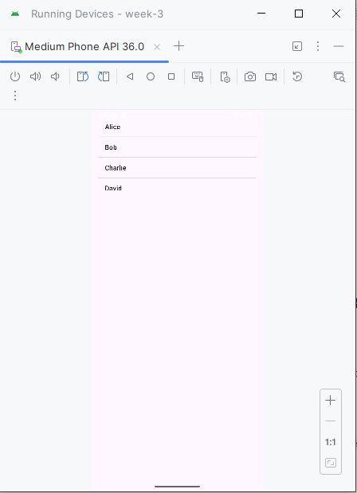
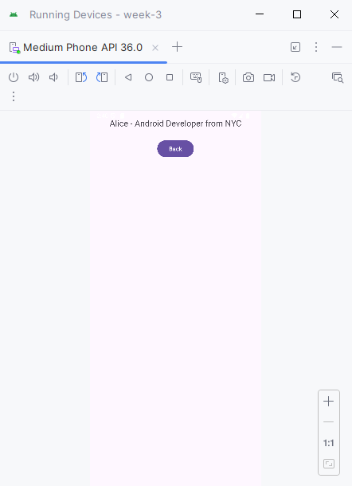
Week-4
Create a native calculator application.
activity_main.xml
<?xml version="1.0" encoding="utf-8"?>
<LinearLayout xmlns:android="http://schemas.android.com/apk/res/android" android:layout_width="match_parent"
android:layout_height="match_parent"
android:orientation="vertical"
android:padding="16dp"
android:gravity="center">
<EditText
android:id="@+id/e1"
android:layout_width="match_parent" android:layout_height="wrap_content" android:hint="Enter first number"
android:inputType="numberDecimal" />
<EditText
android:id="@+id/e2"
android:layout_width="match_parent" android:layout_height="wrap_content" android:hint="Enter second number"
android:inputType="numberDecimal"
android:layout_marginTop="8dp" />
<LinearLayout
android:layout_width="match_parent" android:layout_height="wrap_content" android:orientation="horizontal"
android:layout_marginTop="16dp" android:gravity="center">
<Button
android:id="@+id/b1"
android:layout_width="wrap_content" android:layout_height="wrap_content" android:text="+" />
<Button
android:id="@+id/b2"
android:layout_width="wrap_content" android:layout_height="wrap_content" android:text="-"
android:layout_marginStart="8dp" />
<Button
android:id="@+id/b3"
android:layout_width="wrap_content" android:layout_height="wrap_content" android:text="×"
android:layout_marginStart="8dp" />
<Button
android:id="@+id/b4"
android:layout_width="wrap_content" android:layout_height="wrap_content" android:text="÷"
android:layout_marginStart="8dp" />
</LinearLayout>
<TextView
android:id="@+id/tv"
android:layout_width="match_parent" android:layout_height="wrap_content" android:text="Result: "
android:textSize="18sp"
android:layout_marginTop="24dp" />
</LinearLayout>
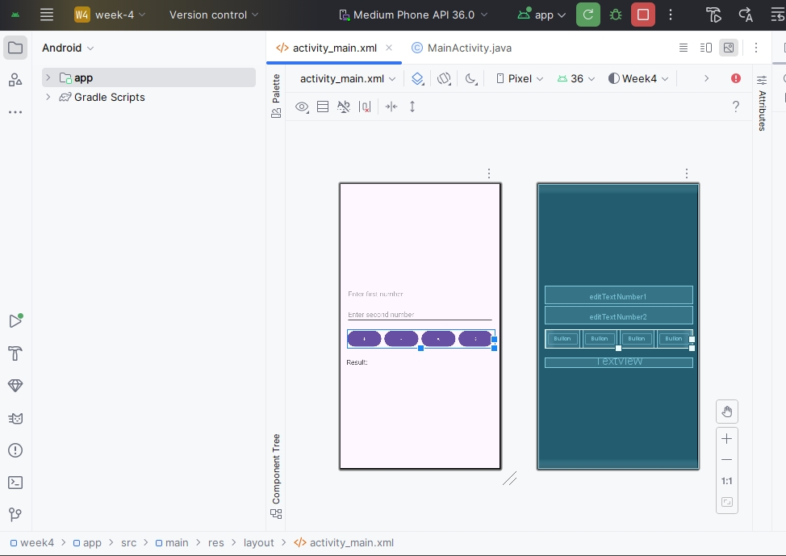
MainActivity.java
package com.example.calculatorapp;
import androidx.appcompat.app.AppCompatActivity; import android.os.Bundle;
import android.view.View; import android.widget.*;
public class MainActivity extends AppCompatActivity {
EditText e1, e2; Button b1, b2, b3, b4; TextView tv;
@Override
protected void onCreate(Bundle bd) { super.onCreate(bd);
setContentView(R.layout.activity_main);
e1 = findViewById(R.id.e1); e2 = findViewById(R.id.e2); b1 = findViewById(R.id.b1);
b2 = findViewById(R.id.b2); b3 = findViewById(R.id.b3);
b4 = findViewById(R.id.b4);
tv = findViewById(R.id.tv);
b1.setOnClickListener(v -> calc('+'));
b2.setOnClickListener(v -> calc('-')); b3.setOnClickListener(v -> calc('*')); b4.setOnClickListener(v -> calc('/'));
}
private void calc(char op) {
String s1 = e1.getText().toString(); String s2 = e2.getText().toString();
if (s1.isEmpty() || s2.isEmpty()) {
tv.setText("Please enter both numbers"); return;
}
double n1 = Double.parseDouble(s1); double n2 = Double.parseDouble(s2); double res = 0;
switch (op) {
case '+':
res = n1 + n2;
break;
case '-':
res = n1 - n2;
break;
case '*':
res = n1 * n2;
break;
case '/':
if (n2 == 0) {
tv.setText("Cannot divide by zero"); return;
}
res = n1 / n2;
break;
}
tv.setText("Result: " + res); }
}
Output:
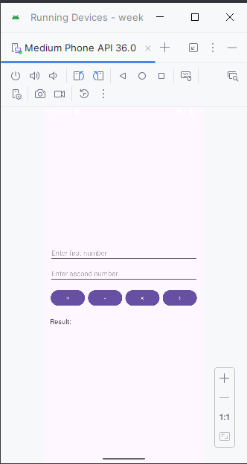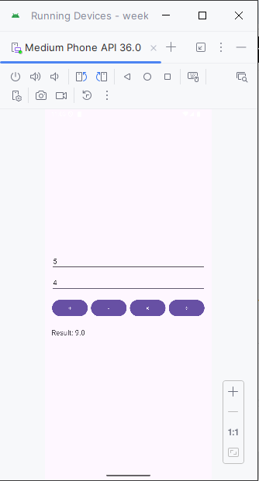

Week-5
Create an application that saves user information like name, age, gender etc. in shared preference and retrieves them when the program restarts.
Functionality
- User enters name, age, and gender.
- Info is saved using SharedPreferences.
- When the app restarts, data is automatically loaded from preferences.
activity_main.xml (UI Layout)
<?xml version="1.0" encoding="utf-8"?>
<LinearLayout
xmlns:android="http://schemas.android.com/apk/res/android" android:layout_width="match_parent"
android:layout_height="match_parent"
android:orientation="vertical"
android:padding="20dp">
<EditText
android:id="@+id/n"
android:layout_width="match_parent" android:layout_height="wrap_content" android:hint="Name" />
<EditText
android:id="@+id/a"
android:layout_width="match_parent" android:layout_height="wrap_content" android:inputType="number"
android:hint="Age" />
<EditText
android:id="@+id/g"
android:layout_width="match_parent"
android:layout_height="wrap_content" android:hint="Gender" />
<Button
android:id="@+id/b"
android:layout_width="match_parent" android:layout_height="wrap_content" android:text="Save Info" />
<TextView
android:id="@+id/tv"
android:layout_width="match_parent"
android:layout_height="wrap_content"
android:paddingTop="20dp"
android:text="User Info Will Be Displayed Here" /> </LinearLayout>
MainActivity.java
import android.content.SharedPreferences;
import android.os.Bundle;
import android.widget.*;
import androidx.appcompat.app.AppCompatActivity;
public class MainActivity extends AppCompatActivity {
EditText n, a, g; Button b;
TextView tv;
SharedPreferences sp;
public static final String PN = "UserInfo";
@Override
protected void onCreate(Bundle bd) { super.onCreate(bd);
setContentView(R.layout.activity_main);
n = findViewById(R.id.n);
a = findViewById(R.id.a);
g = findViewById(R.id.g); b = findViewById(R.id.b);
tv = findViewById(R.id.tv);
sp = getSharedPreferences(PN, MODE_PRIVATE); load();
b.setOnClickListener(v -> { save();
});
}
private void save() {
String nm = n.getText().toString();
String ag = a.getText().toString();
String gen = g.getText().toString();
SharedPreferences.Editor ed = sp.edit(); ed.putString("Name", nm);
ed.putString("Age", ag);
ed.putString("Gender", gen);
ed.apply();
tv.setText("Saved: " + nm + ", " + ag + ", " + gen); }
private void load() {
String nm = sp.getString("Name", "Not set");
String ag = sp.getString("Age", "Not set");
String gen = sp.getString("Gender", "Not set");
tv.setText("Loaded: " + nm + ", " + ag + ", " + gen); }
}
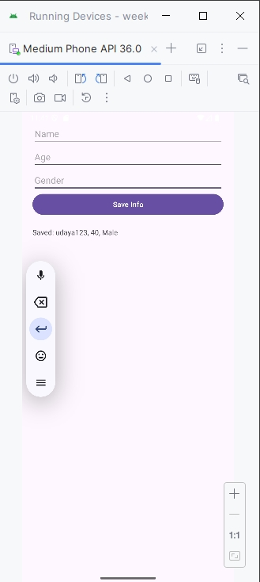

Week-6
Develop a Registration and Login application that makes use of database.
The SQlite database as its name suggests, is a lightweight database which is used to store the data locally in your Android mobile devices. One can create a simple login and register app using SQlite which can also work as test bench or platform for launching the app for web servers.
Let us first create a Database helper class which extends the properties of SQliteOpenHelperClass.
The code snippet for DB Helper class "DBHelper.class" is as follows:
package com.learnandroid.loginsqlite;
import android.content.ContentValues;
import android.content.Context;
import android.database.Cursor;
import android.database.sqlite.SQLiteDatabase; import android.database.sqlite.SQLiteOpenHelper; import androidx.annotation.Nullable;
public class DBHelper extends SQLiteOpenHelper { public static final String DBN = "Login.db"; public DBHelper(Context c) {
super(c, "Login.db", null, 1); }
@Override
public void onCreate(SQLiteDatabase db) {
db.execSQL("create Table users(username TEXT primary key, password TEXT)");
}
@Override
public void onUpgrade(SQLiteDatabase db, int i, int i1) { db.execSQL("drop Table if exists users");
}
public Boolean ins(String u, String p){ SQLiteDatabase db = this.getWritableDatabase();
ContentValues cv= new ContentValues();
cv.put("username", u);
cv.put("password", p); long res = db.insert("users", null, cv); if(res==-1) return false;
else
return true;
}
public Boolean chkU(String u) {
SQLiteDatabase db = this.getWritableDatabase();
Cursor cur = db.rawQuery("Select * from users where username = ?", new String[]{u});
if (cur.getCount() > 0)
return true;
else
return false;
}
public Boolean chkLogin(String u, String p){
SQLiteDatabase db = this.getWritableDatabase();
Cursor cur = db.rawQuery("Select * from users where username = ? and password = ?", new String[] {u,p});
if(cur.getCount()>0)
return true;
else
return false;
}
}
Let us first create main_activity.xml which serves as the register page. This page will have three edit text boxes, username, password and retype password. The code snippet for main_activity.xml is as follows.
<?xml version="1.0" encoding="utf-8"?>
<RelativeLayout xmlns:android="http://schemas.android.com/apk/res/android" xmlns:app="http://schemas.android.com/apk/res-auto"
xmlns:tools="http://schemas.android.com/tools"
android:layout_width="match_parent"
android:layout_height="match_parent"
android:padding="10dp"
tools:context=".MainActivity">
<EditText
android:id="@+id/u"
android:layout_width="match_parent" android:layout_height="wrap_content" android:hint="User Name"
android:layout_marginTop="50dp"/>
<EditText
android:id="@+id/p"
android:layout_width="match_parent"
android:layout_height="wrap_content"
android:hint="Password"
android:layout_marginTop="50dp"
android:layout_below="@+id/u"/>
<EditText
android:id="@+id/rp"
android:layout_width="match_parent"
android:layout_height="wrap_content"
android:hint="Retype Password"
android:layout_marginTop="50dp"
android:layout_below="@+id/p"/>
<Button
android:id="@+id/su"
android:layout_width="match_parent"
android:layout_height="wrap_content"
android:text="Register"
android:layout_marginTop="50dp"
android:layout_below="@+id/rp"/>
<Button
android:id="@+id/si"
android:layout_width="match_parent"
android:layout_height="wrap_content"
android:text="Existing user! Go to Sign in page" android:layout_marginTop="50dp"
android:layout_below="@+id/su"/>
</RelativeLayout>
The code snippet for MainActivity.java is as follows.
package com.learnandroid.loginsqlite;
import androidx.appcompat.app.AppCompatActivity; import android.content.Intent;
import android.os.Bundle;
import android.view.View;
import android.widget.Button; import android.widget.EditText; import android.widget.Toast;
public class MainActivity extends AppCompatActivity {
EditText u, p, rp;
Button su, si;
DBHelper db;
@Override
protected void onCreate(Bundle bd) { super.onCreate(bd);
setContentView(R.layout.activity_main);
u = (EditText) findViewById(R.id.u);
p = (EditText) findViewById(R.id.p);
rp = (EditText) findViewById(R.id.rp); su = (Button) findViewById(R.id.su);
si = (Button) findViewById(R.id.si);
db = new DBHelper(this);
su.setOnClickListener(new View.OnClickListener() { @Override
public void onClick(View v) {
String us = u.getText().toString();
String pw = p.getText().toString();
String rpw = rp.getText().toString();
if(us.equals("")||pw.equals("")||rpw.equals("")) Toast.makeText(MainActivity.this, "Please enter all the fields", Toast.LENGTH_SHORT).show();
else{
if(pw.equals(rpw)){
Boolean cu = db.chkU(us);
if(cu==false){
Boolean ins = db.ins(us, pw);
if(ins==true){
Toast.makeText(MainActivity.this, "Registered successfully", Toast.LENGTH_SHORT).show();
Intent i = new Intent(getApplicationContext(),HomeActivity.class);
startActivity(i);
}else{
Toast.makeText(MainActivity.this, "Registration failed", Toast.LENGTH_SHORT).show();
}
}
else{
Toast.makeText(MainActivity.this, "User already exists! please sign in", Toast.LENGTH_SHORT).show();
}
}else{
Toast.makeText(MainActivity.this, "Passwords not matching", Toast.LENGTH_SHORT).show();
}
} }
});
si.setOnClickListener(new View.OnClickListener() {
@Override
public void onClick(View v) {
Intent i = new Intent(getApplicationContext(), LoginActivity.class);
startActivity(i);
}
});
}
}
Now create another activity for Login. The code snippet for activity_login.xml is as follows. <?xml version="1.0" encoding="utf-8"?>
<RelativeLayout xmlns:android="http://schemas.android.com/apk/res/android"
xmlns:app="http://schemas.android.com/apk/res-auto"
xmlns:tools="http://schemas.android.com/tools"
android:layout_width="match_parent"
android:layout_height="match_parent"
android:padding="10dp"
tools:context=".LoginActivity">
<EditText
android:id="@+id/u1"
android:layout_width="match_parent" android:layout_height="wrap_content" android:hint="User Name"
android:layout_marginTop="50dp"/>
<EditText
android:id="@+id/p1"
android:layout_width="match_parent" android:layout_height="wrap_content" android:hint="Password"
android:layout_marginTop="50dp"
android:layout_below="@+id/u1"/>
<Button
android:id="@+id/b"
android:layout_width="match_parent"
android:layout_height="wrap_content"
android:text="Sign in"
android:layout_marginTop="50dp"
android:layout_below="@+id/p1"/> </RelativeLayout>
The code snippet for LoginActivity.java is as follows:
package com.learnandroid.loginsqlite;
import androidx.appcompat.app.AppCompatActivity;
import android.content.Intent; import android.os.Bundle; import android.view.View; import android.widget.Button; import android.widget.EditText; import android.widget.Toast;
public class LoginActivity extends AppCompatActivity {
EditText u, p;
Button b;
DBHelper db;
@Override
protected void onCreate(Bundle bd) { super.onCreate(bd);
setContentView(R.layout.activity_login);
u = (EditText) findViewById(R.id.u1); p = (EditText) findViewById(R.id.p1); b = (Button) findViewById(R.id.b); db = new DBHelper(this);
b.setOnClickListener(new View.OnClickListener() { @Override
public void onClick(View v) {
String us = u.getText().toString(); String pw = p.getText().toString();
if(us.equals("")||pw.equals(""))
Toast.makeText(LoginActivity.this, "Please enter all the fields", Toast.LENGTH_SHORT).show();
else{
Boolean ok = db.chkLogin(us, pw);
if(ok==true){
Toast.makeText(LoginActivity.this, "Sign in successfull", Toast.LENGTH_SHORT).show();
Intent i = new Intent(getApplicationContext(), HomeActivity.class);
startActivity(i);
}else{
Toast.makeText(LoginActivity.this, "Invalid Credentials", Toast.LENGTH_SHORT).show();
}
}
}
});
}
}
Output:
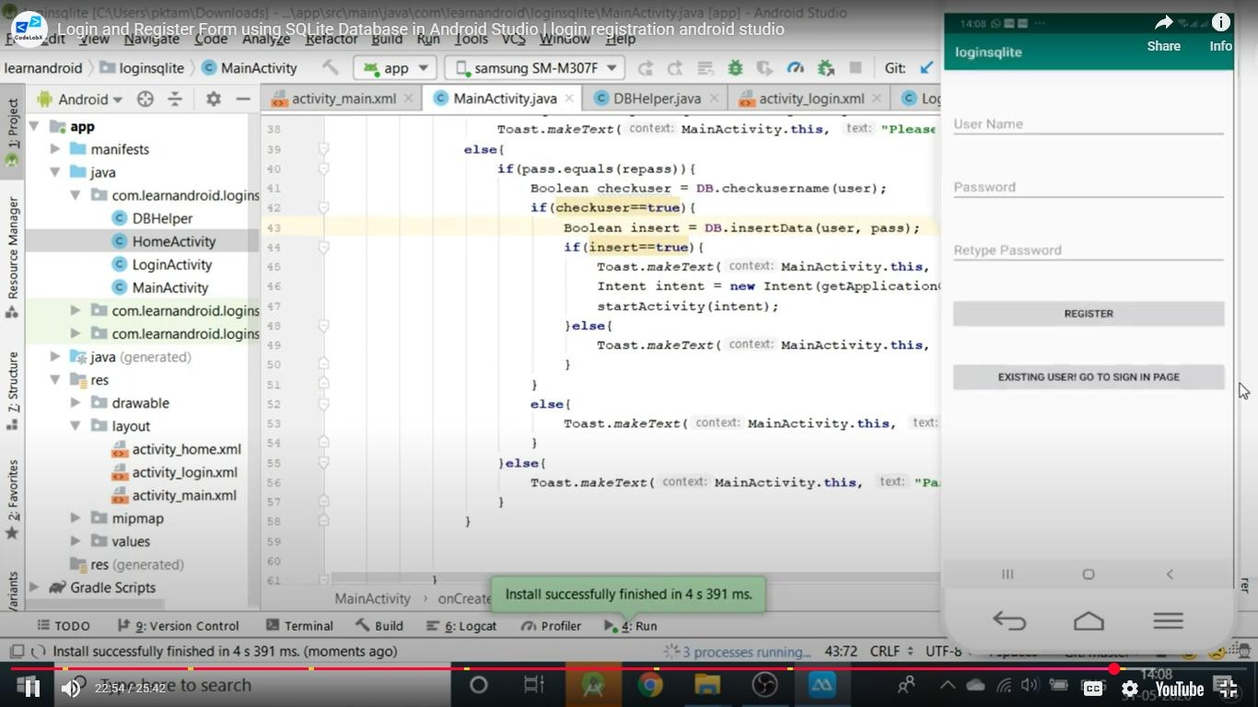
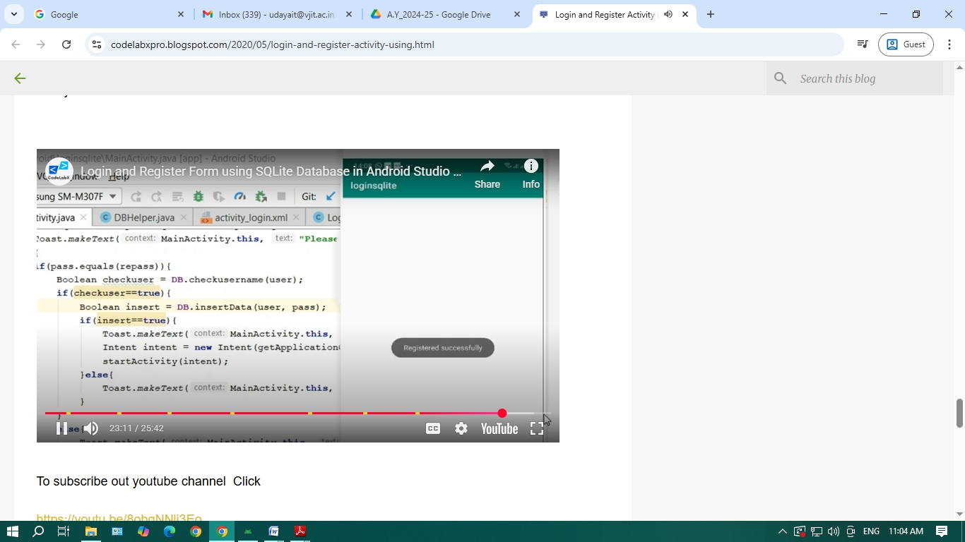
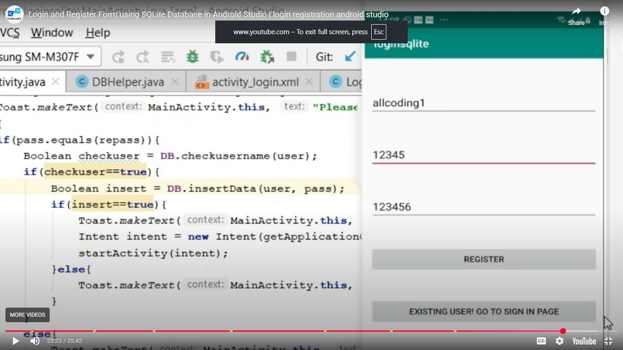
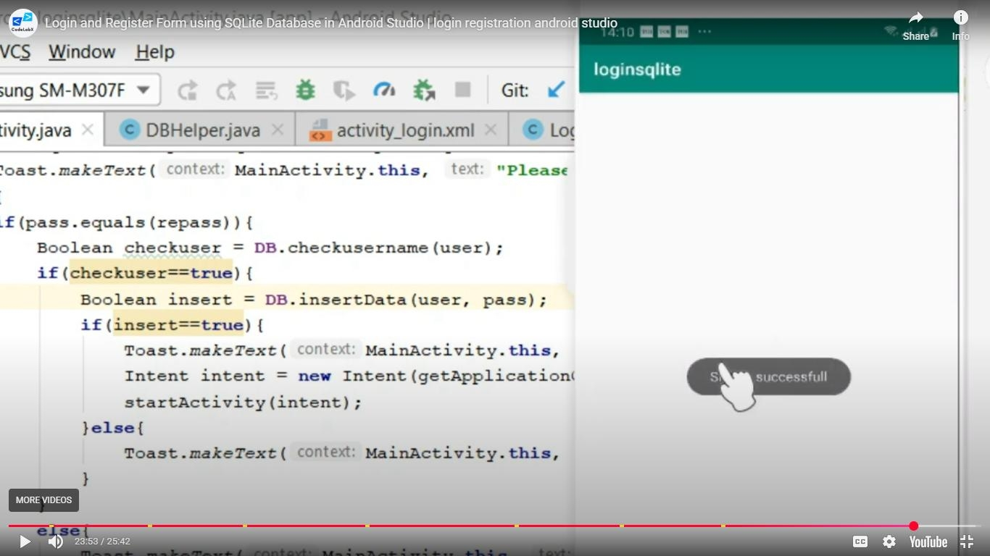
Supporting link is “https://codelabxpro.blogspot.com/2020/05/login-and-register-activity-using.html”

Week 7:
Develop an application that inserts some notifications into Notification area and whenever a notification is inserted, it should show a toast with details of the notification.
Activtity_main.xml
<?xml version="1.0" encoding="utf-8"?> <androidx.constraintlayout.widget.ConstraintLayout xmlns:android="http://schemas.android.com/apk/res/android" xmlns:app="http://schemas.android.com/apk/res-auto"
xmlns:tools="http://schemas.android.com/tools"
android:layout_width="match_parent"
android:layout_height="match_parent"
tools:context=".MainActivity">
<Button
android:id="@+id/b" android:layout_width="wrap_content"
android:layout_height="wrap_content"
android:text="Create Notification"
tools:layout_editor_absoluteX="170dp"
tools:layout_editor_absoluteY="322dp" /> </androidx.constraintlayout.widget.ConstraintLayout>
Mainactivity.java
package com.example.notify;
import androidx.appcompat.app.AppCompatActivity; import androidx.core.app.NotificationCompat;
import android.annotation.SuppressLint; import android.os.Bundle;
/*public class MainActivity extends AppCompatActivity {
@Override
protected void onCreate(Bundle savedInstanceState) { super.onCreate(savedInstanceState);
setContentView(R.layout.activity_main);
}
}*/
import android.app.NotificationChannel ;
import android.app.NotificationManager ;
import android.content.ContentResolver ;
import android.content.Context ;
import android.graphics.Color ;
import android.media.AudioAttributes ;
import android.net.Uri ;
//import android.support.v4.app.NotificationCompat ; //import android.support.v7.app.AppCompatActivity ; //import android.os.Bundle ;
import android.view.View ;
import android.widget.Button ; import java.util.Objects;
public class MainActivity extends AppCompatActivity {
public static final String CID = "10001" ; private final static String ch;
static {
ch = "default"; }
@Override
protected void onCreate (Bundle bd) {
super.onCreate(bd) ;
setContentView(R.layout.activity_main ) ;
@SuppressLint({"MissingInflatedId", "LocalSuppress"}) Button b = findViewById(R.id.b ) ;
b.setOnClickListener( new View.OnClickListener() {
@SuppressLint("NotificationPermission")
@Override
public void onClick (View v) {
Uri s = Uri.parse (ContentResolver.SCHEME_ANDROID_RESOURCE + "://" + getPackageName() + "/raw/quite_impressed.mp3" ) ;
NotificationCompat.Builder nb = new NotificationCompat.Builder(MainActivity.this,
ch )
.setSmallIcon(R.drawable.ic_launcher_foreground )
.setContentTitle( "Test" )
.setSound(s)
.setContentText( "Hello! This is my first push notification" );
NotificationManager nm = (NotificationManager) getSystemService(Context.NOTIFICATION_SERVICE ) ;
if (android.os.Build.VERSION.SDK_INT >= android.os.Build.VERSION_CODES.O ) {
AudioAttributes aa = new AudioAttributes.Builder()
.setContentType(AudioAttributes.CONTENT_TYPE_SONIFICATION )
.setUsage(AudioAttributes.USAGE_ALARM )
.build() ;
int imp = NotificationManager.IMPORTANCE_HIGH ; NotificationChannel nc = new
NotificationChannel( CID , "NOTIFICATION_CHANNEL_NAME" , imp) ;
nc.enableLights( true ) ;
nc.setLightColor(Color.RED ) ;
nc.enableVibration( true ) ;
nc.setVibrationPattern( new long []{ 100 , 200 , 300 , 400 , 500 , 400 , 300 , 200 , 400 }) ;
nc.setSound(s , aa) ; nb.setChannelId( CID ) ;
assert nm != null;
nm.createNotificationChannel(nc) ;
}
Objects.requireNonNull(nm).notify(( int ) System.currentTimeMillis (), nb.build()) ;
}
}) ;
}
}
output:
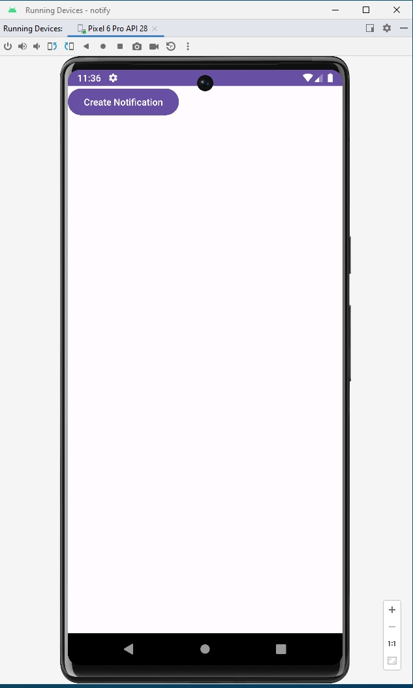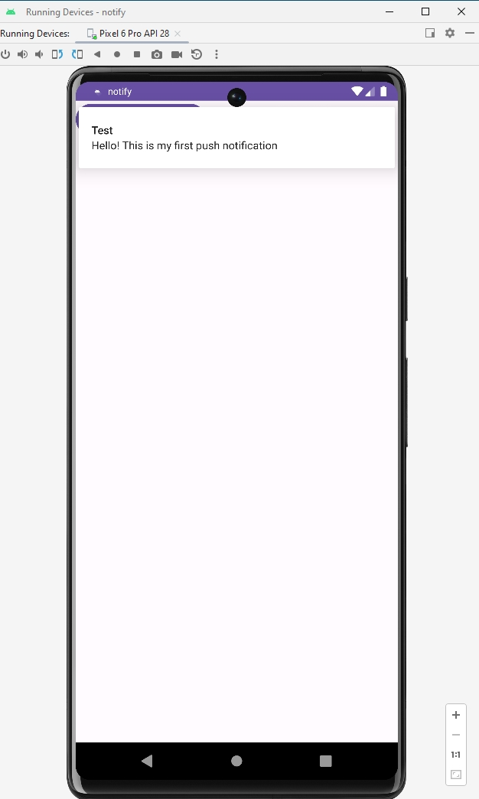

Week-8
Develop an application with three options: dial a phone number, open a website, and send an SMS. Each option uses an Intent.
Step-by-Step Implementation
1. Open Android Studio and create an Empty Views Activity.
2. Enter the project name: IntentMenuApp.
3. Select Java and choose Minimum SDK: API 21 or above.
activity_main.xml
This layout displays the same three buttons: Dial a Number, Open a Website, and Send an SMS.
<?xml version="1.0" encoding="utf-8"?>
<LinearLayout xmlns:android="http://schemas.android.com/apk/res/android"
android:layout_width="match_parent"
android:layout_height="match_parent"
android:orientation="vertical"
android:gravity="center"
android:padding="24dp">

<Button
android:id="@+id/d"
android:layout_width="match_parent"
android:layout_height="wrap_content"
android:text="Dial a Number" />

<Button
android:id="@+id/w"
android:layout_width="match_parent"
android:layout_height="wrap_content"
android:text="Open a Website"
android:layout_marginTop="16dp" />

<Button
android:id="@+id/s"
android:layout_width="match_parent"
android:layout_height="wrap_content"
android:text="Send an SMS"
android:layout_marginTop="16dp" />

</LinearLayout>
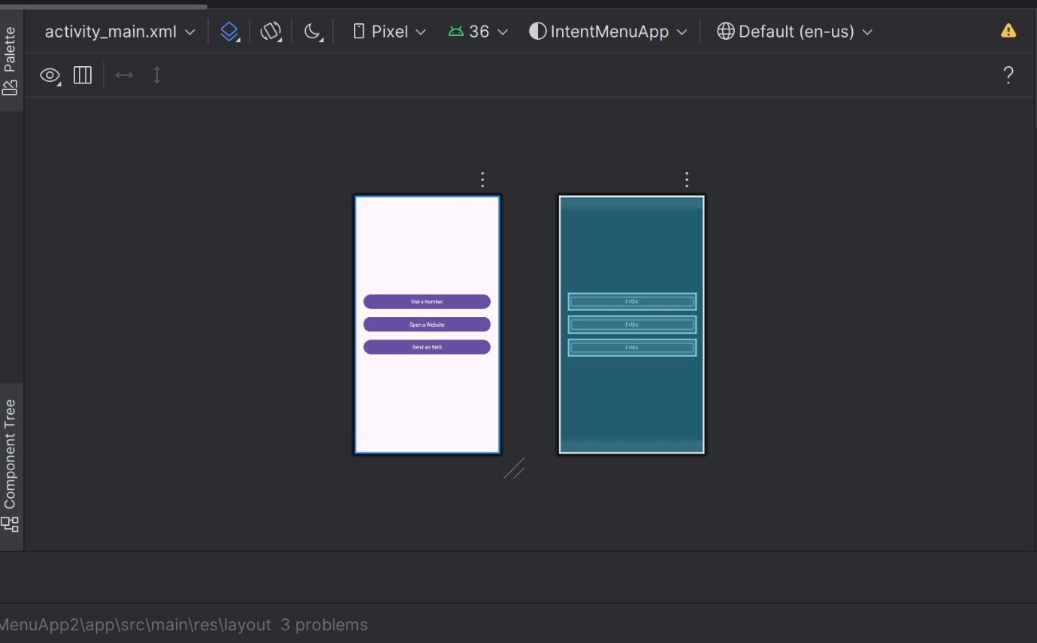
MainActivity.java
The three short click listeners open the dialer, browser, and SMS app.
package com.example.intentmenuapp;

import androidx.appcompat.app.AppCompatActivity;
import android.content.Intent;
import android.net.Uri;
import android.os.Bundle;
import android.widget.Button;
import android.widget.Toast;

public class MainActivity extends AppCompatActivity {
Button d, w, s;

@Override
protected void onCreate(Bundle bd) {
super.onCreate(bd);
setContentView(R.layout.activity_main);

d = findViewById(R.id.d);
w = findViewById(R.id.w);
s = findViewById(R.id.s);

d.setOnClickListener(v -> {
Intent i = new Intent(Intent.ACTION_DIAL,
Uri.parse("tel:1234567890"));
startActivity(i);
});

w.setOnClickListener(v -> {
Intent i = new Intent(Intent.ACTION_VIEW,
Uri.parse("https://www.google.com"));
startActivity(i);
});

s.setOnClickListener(v -> {
Intent i = new Intent(Intent.ACTION_VIEW,
Uri.parse("sms:1234567890"));
i.putExtra("sms_body", "Hello! This is a test message.");
try {
startActivity(i);
} catch (Exception e) {
Toast.makeText(this, "No SMS app found!",
Toast.LENGTH_SHORT).show();
}
});
}
}
AndroidManifest.xml
No extra permissions are required. Keep the default AndroidManifest.xml created by Android Studio.
Output
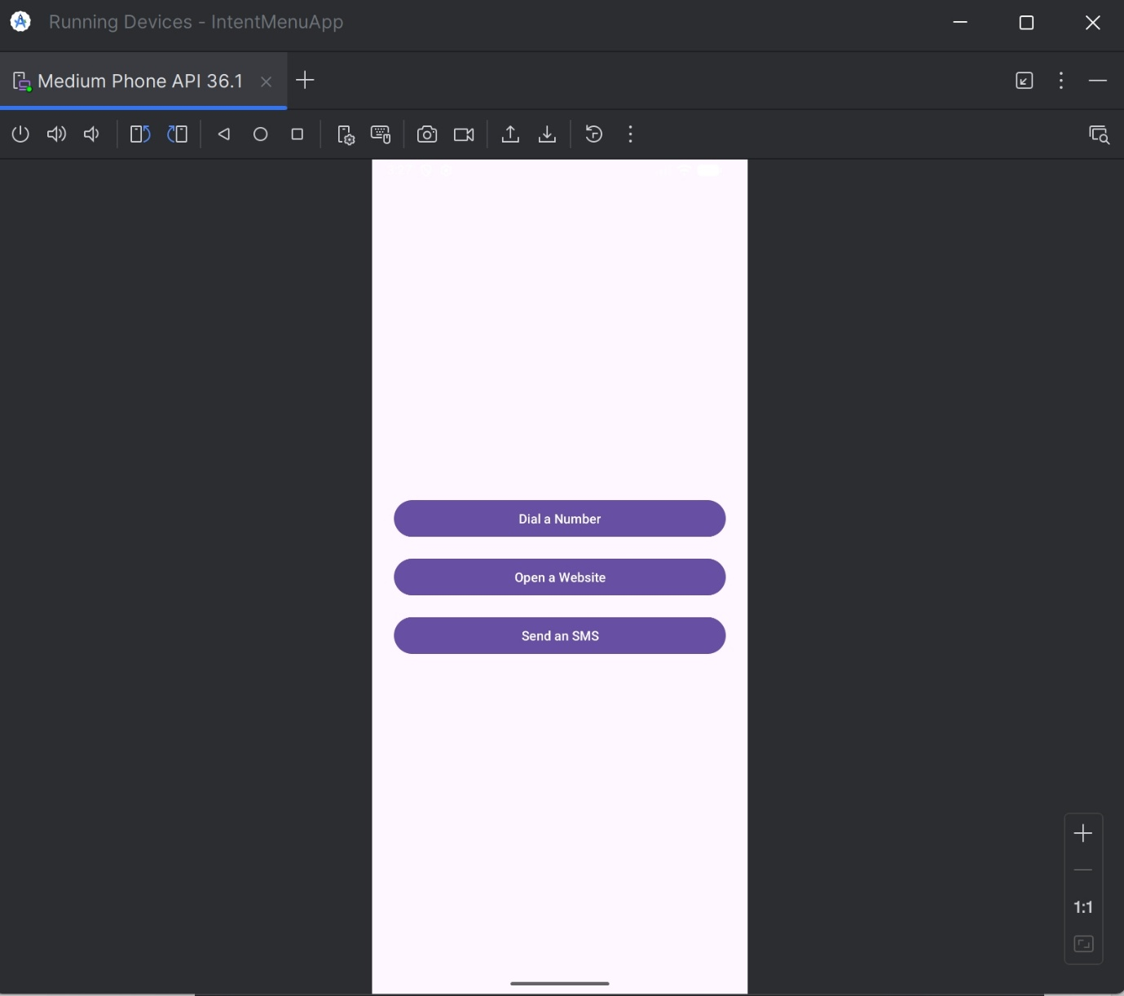
Main Screen: Displays all three buttons.
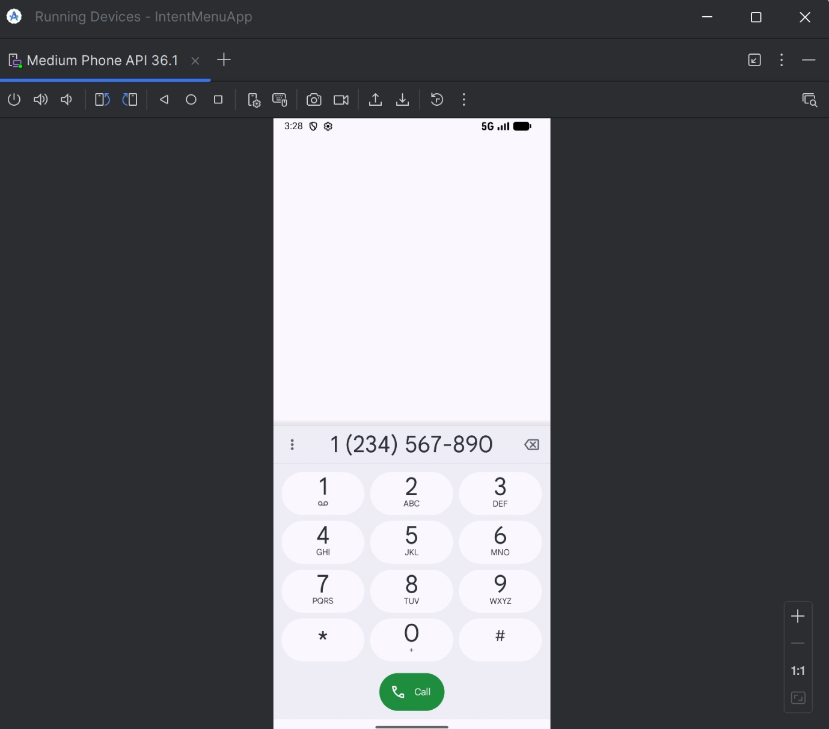
Dial Number: Opens the phone dialer with 1234567890.
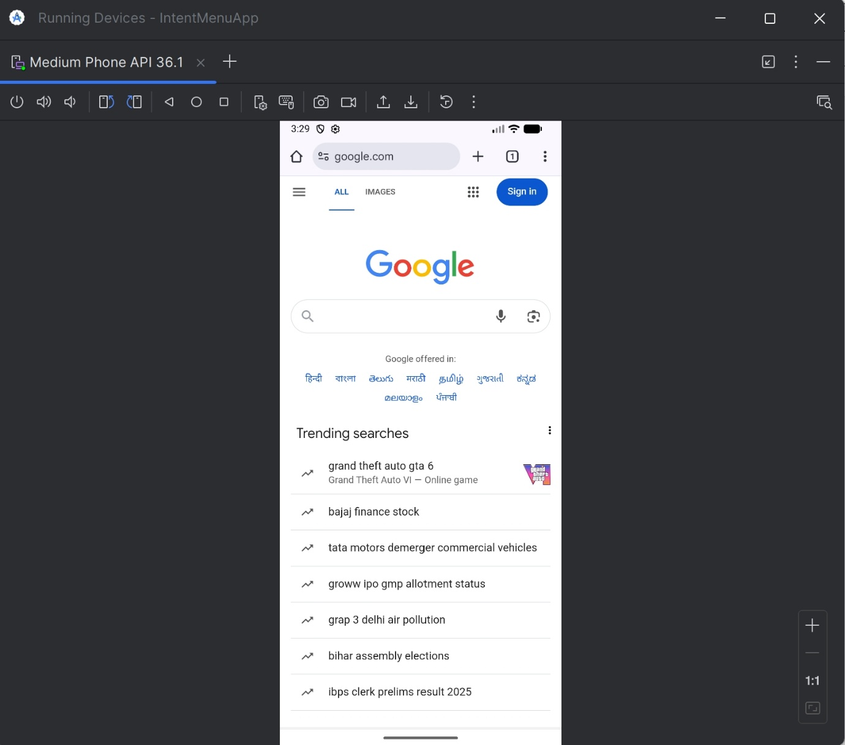
Open Website: Opens https://www.google.com in the browser.
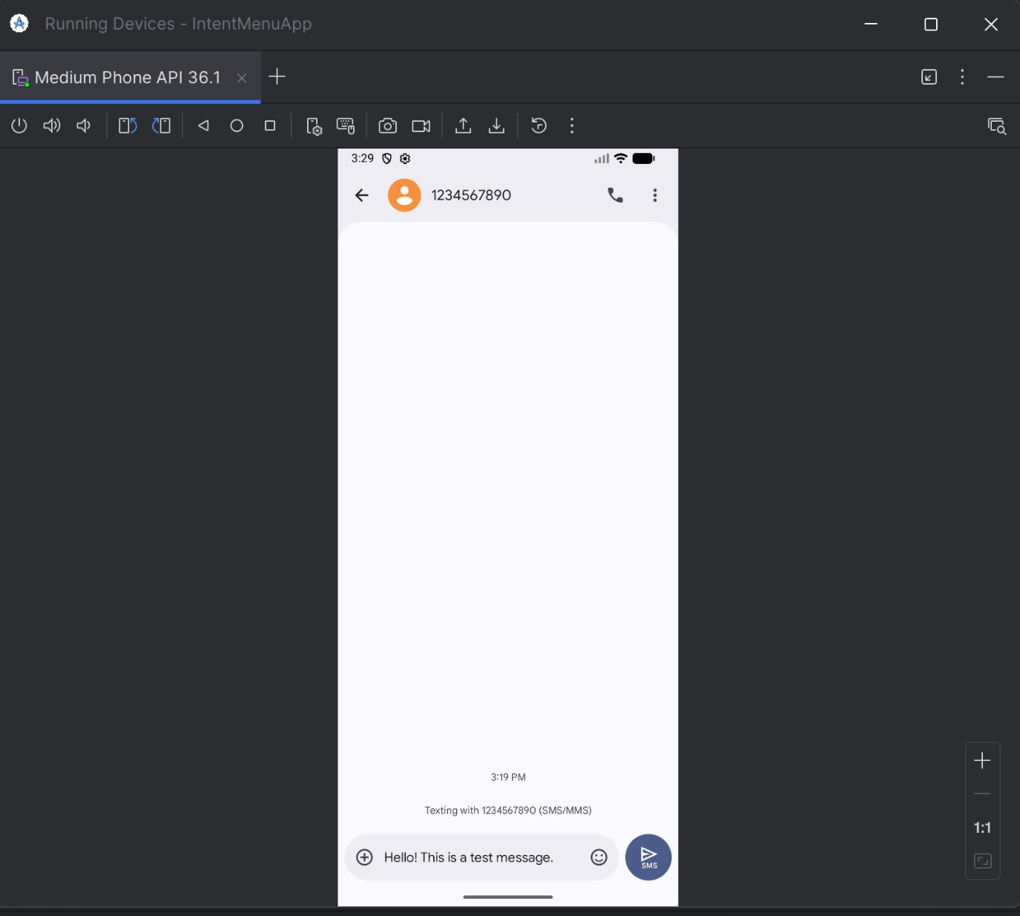
SMS: Opens the SMS app with the sample message already filled in.
Week-9
Create an alarm application using time picker to set alarm time.
Create the Layout (activity_main.xml)
<LinearLayout
xmlns:android="http://schemas.android.com/apk/res/android" android:layout_width="match_parent"
android:layout_height="match_parent"
android:orientation="vertical"
android:padding="16dp">
<Button
android:id="@+id/b"
android:layout_width="match_parent" android:layout_height="wrap_content" android:text="Set Alarm Time" />
<TextView
android:id="@+id/tv"
android:layout_width="match_parent" android:layout_height="wrap_content" android:text="No Alarm Set" />
</LinearLayout>
MainActivity.java
package com.example.alarmapp;
//package com.example.alarmapp;
import android.app.AlarmManager; import android.app.PendingIntent; import android.app.TimePickerDialog; import android.content.Context; import android.content.Intent;
import android.os.Bundle;
import android.widget.Button;
import android.widget.TextView;
import android.widget.TimePicker;
import android.widget.Toast;
import androidx.appcompat.app.AppCompatActivity; import java.util.Calendar;
public class MainActivity extends AppCompatActivity { private TextView tv;
private AlarmManager am;
private PendingIntent pi;
private Calendar cal = Calendar.getInstance();
@Override
protected void onCreate(Bundle bd) { super.onCreate(bd);
setContentView(R.layout.activity_main);
tv = findViewById(R.id.tv);
Button b = findViewById(R.id.b);
am = (AlarmManager) getSystemService(Context.ALARM_SERVICE);
b.setOnClickListener(v -> {
int h = cal.get(Calendar.HOUR_OF_DAY); int m = cal.get(Calendar.MINUTE);
TimePickerDialog dlg = new TimePickerDialog(MainActivity.this, (TimePicker tp, int sh, int sm) -> {
cal.set(Calendar.HOUR_OF_DAY, sh);
cal.set(Calendar.MINUTE, sm);
cal.set(Calendar.SECOND, 0);
tv.setText("Alarm set for: " + sh + ":" + String.format("%02d", sm));
alarm(cal);
}, h, m, true);
dlg.show();
});
}
private void alarm(Calendar c) {
Intent i = new Intent(this, AlarmReceiver.class);
pi = PendingIntent.getBroadcast(this, 0, i,
PendingIntent.FLAG_IMMUTABLE);
am.set(AlarmManager.RTC_WAKEUP, c.getTimeInMillis(), pi);
Toast.makeText(this, "Alarm Scheduled", Toast.LENGTH_SHORT).show(); }
}
AlarmReceiver.java
package com.example.alarmapp;
//package com.example.alarmapp;
import android.content.BroadcastReceiver; import android.content.Context;
import android.content.Intent;
import android.widget.Toast;
public class AlarmReceiver extends BroadcastReceiver {
@Override
public void onReceive(Context ctx, Intent i) {
Toast.makeText(ctx, "Alarm! Wake up!", Toast.LENGTH_LONG).show(); // Can also trigger a notification here
}
}
AndroidManifest.xml
<?xml version="1.0" encoding="utf-8"?>
<manifest xmlns:android="http://schemas.android.com/apk/res/android" xmlns:tools="http://schemas.android.com/tools">
<application
android:allowBackup="true"
android:dataExtractionRules="@xml/data_extraction_rules" android:fullBackupContent="@xml/backup_rules"
android:icon="@mipmap/ic_launcher"
android:label="@string/app_name"
android:roundIcon="@mipmap/ic_launcher_round"
android:supportsRtl="true"
android:theme="@style/Theme.Alarmapp">
<activity
android:name=".MainActivity"
android:exported="true">
<intent-filter>
<action android:name="android.intent.action.MAIN" />
<category android:name="android.intent.category.LAUNCHER" /> </intent -filter>
</activity>
<receiver android:name=".AlarmReceiver"/>
</application>
</manifest> Output:
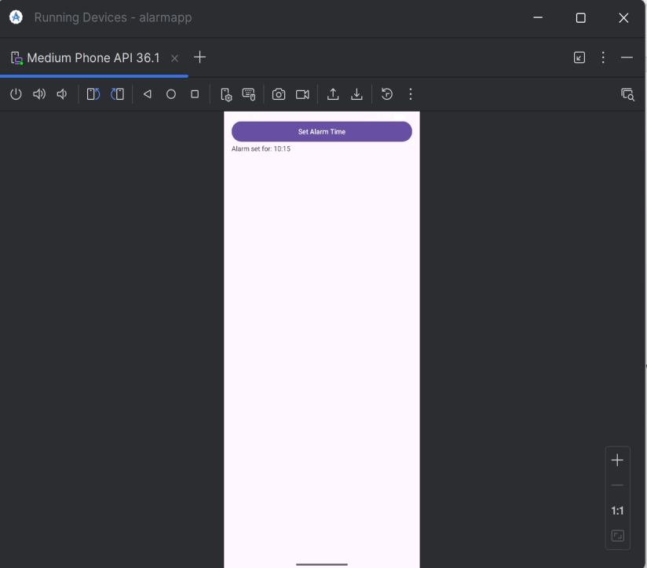
Hours:
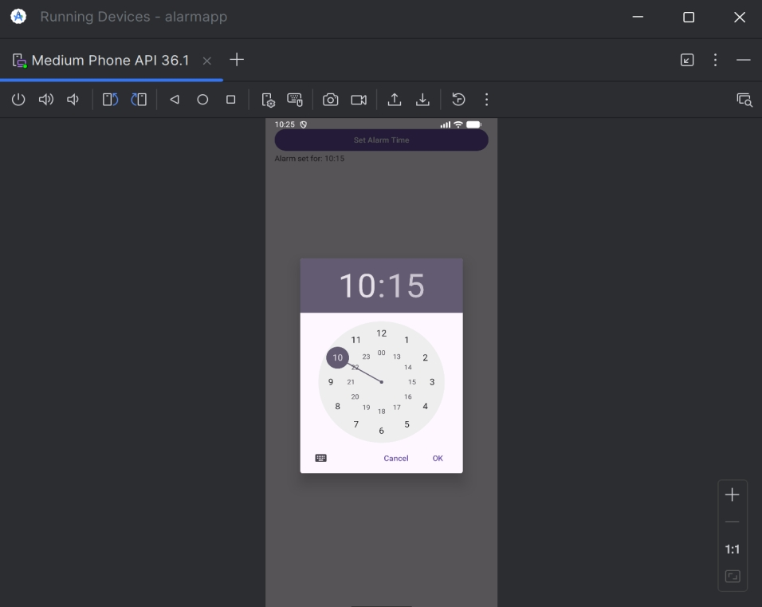
Minitues:
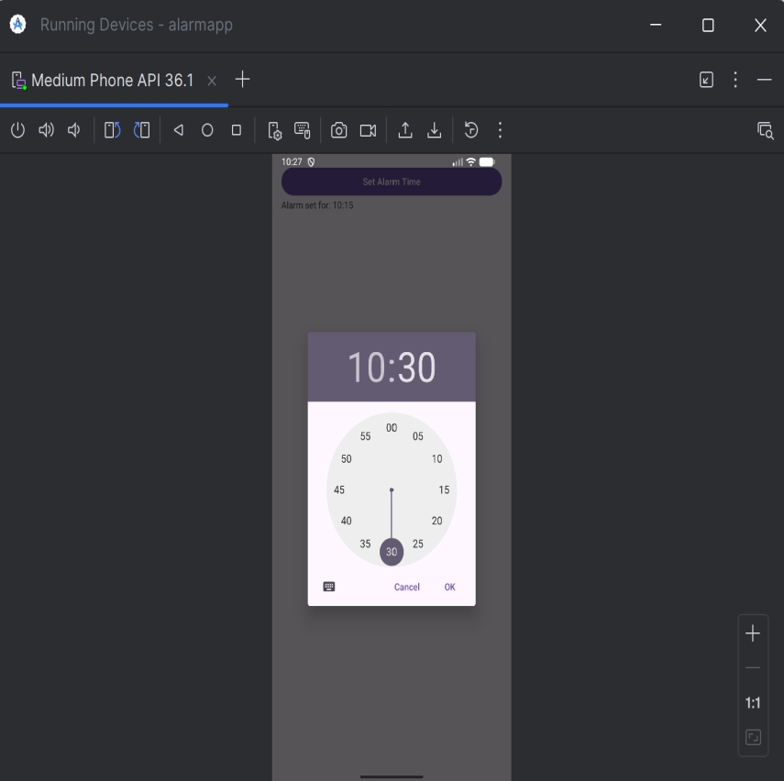
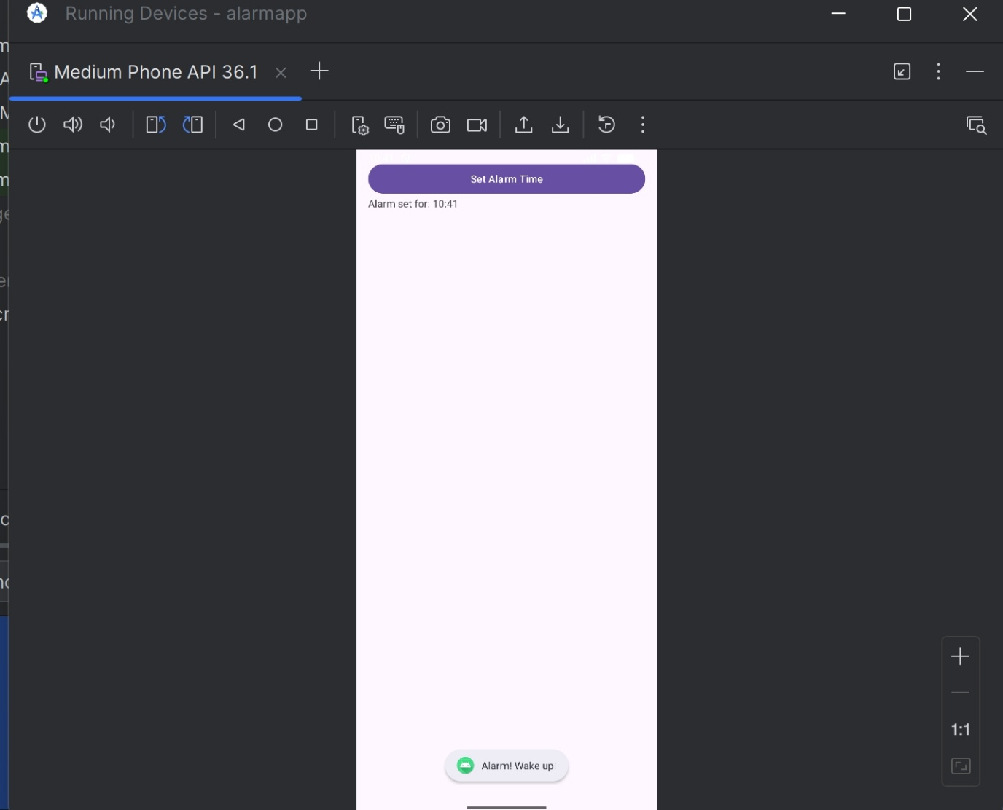

Week-10
Create an application that shows the given URL (from a text field) in a browser
AndroidManifest.xml
<manifest xmlns:android="http://schemas.android.com/apk/res/android" package="com.example.openurlapp">
<application
android:allowBackup="true"
android:label="Open URL App"
android:roundIcon="@mipmap/ic_launcher_round"
android:supportsRtl="true"
android:theme="@style/Theme.AppCompat.Light.NoActionBar">
<activity android:name=".MainActivity">
<intent-filter>
<action android:name="android.intent.action.MAIN"/>
<category android:name="android.intent.category.LAUNCHER"/> </intent -filter>
</activity>
</application> </manifest>
activity_main.xml
<?xml version="1.0" encoding="utf-8"?>
<LinearLayout xmlns:android="http://schemas.android.com/apk/res/android" android:layout_width="match_parent"
android:layout_height="match_parent"
android:orientation ="vertical"
android:padding="24dp"
android:gravity="center">
<EditText
android:id="@+id/et"
android:layout_width ="match_parent"
android:layout_height ="wrap_content"
android:hint="Enter URL (e.g. https://www.google.com)" android:inputType="textUri"
android:layout_marginBottom ="16dp" />
<Button
android:id="@+id/b"
android:layout_width ="wrap_content" android:layout_height ="wrap_content" android:text="Open in Browser"
android:backgroundTint="#4CAF50"
android:textColor="#FFFFFF"
android:padding="10dp" />
</LinearLayout>
MainActivity.java
package com.example.openurlapp;
import androidx.appcompat.app.AppCompatActivity; import android.content.Intent;
import android.net.Uri;
import android.os.Bundle;
import android.widget.Button; import android.widget.EditText; import android.widget.Toast;
public class MainActivity extends AppCompatActivity {
EditText et; Button b;
@Override
protected void onCreate(Bundle bd) { super.onCreate(bd);
setContentView(R.layout.activity_main);
et = findViewById(R.id.et); b = findViewById(R.id.b);
b.setOnClickListener(v -> {
String u = et.getText().toString().trim();
if (u.isEmpty()) {
Toast.makeText(MainActivity.this, "Please enter a URL", Toast.LENGTH_SHORT).show();
return; }
// Add https:// if missing
if (!u.startsWith("http://") && !u.startsWith("https://")) {
u = "https://" + u; }
try {
Intent i = new Intent(Intent.ACTION_VIEW, Uri.parse(u)); startActivity(i);
} catch (Exception e) {
Toast.makeText(MainActivity.this, "Invalid URL!", Toast.LENGTH_SHORT).show();
} }); }
}
Output:
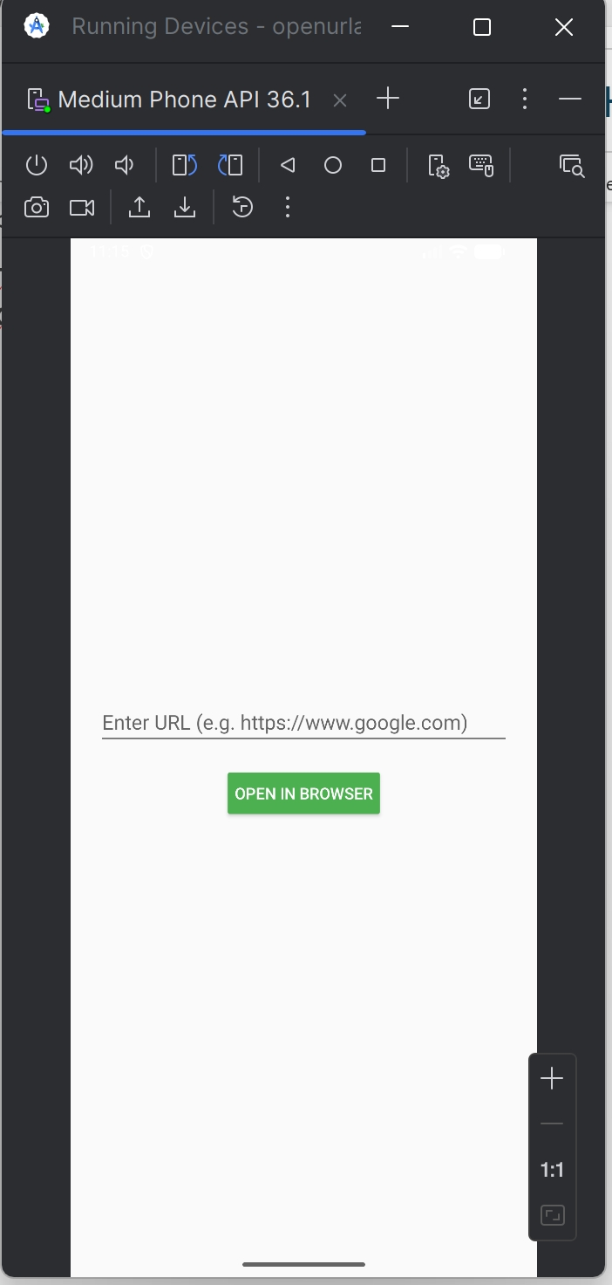
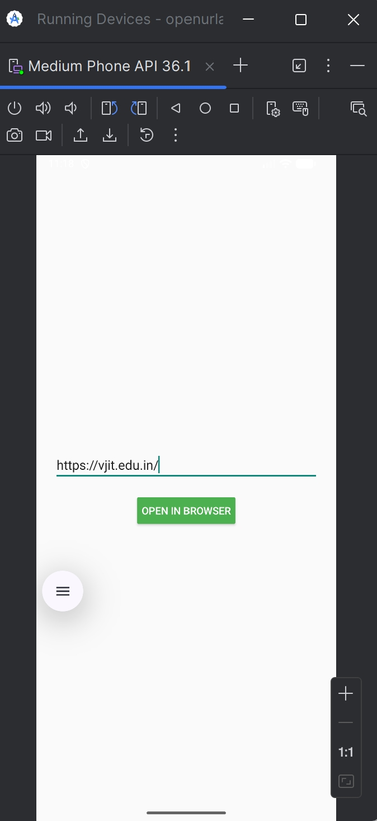
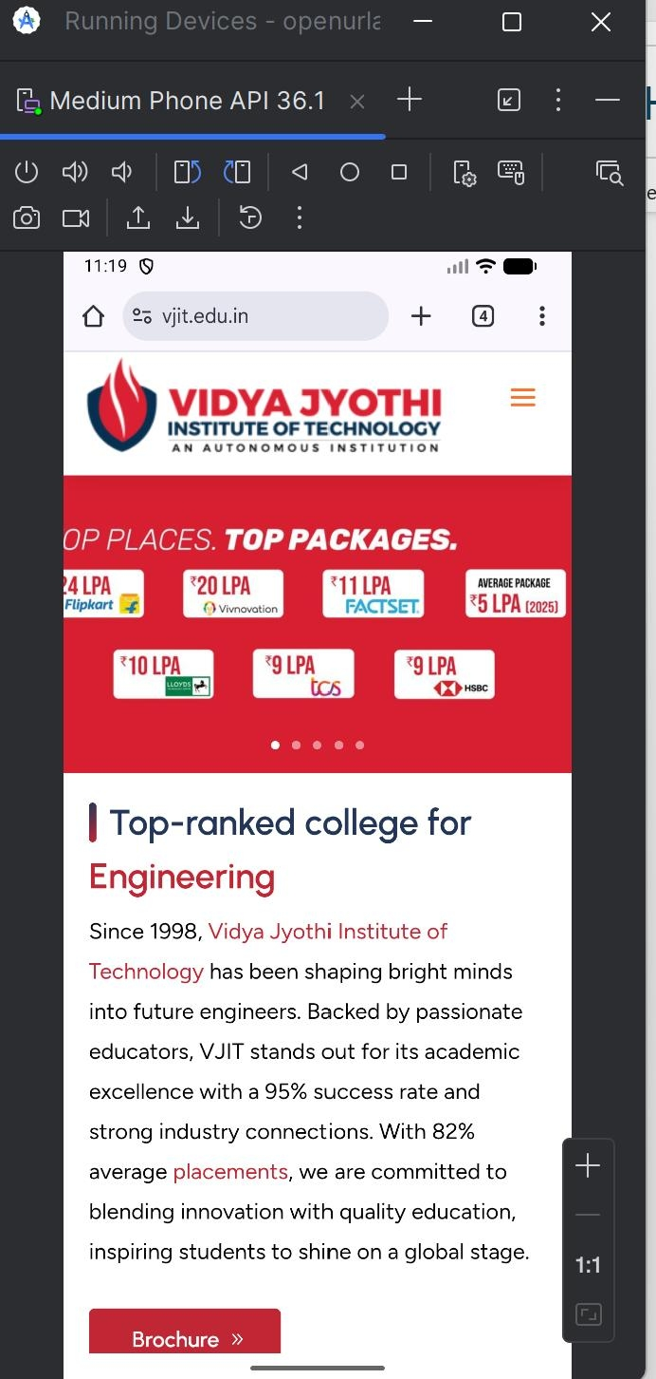

Week-11
Develop a native application that uses GPS location information. activity_main.xml
<LinearLayout xmlns:android="http://schemas.android.com/apk/res/android" android:layout_width="match_parent"
android:layout_height="match_parent"
android:orientation="vertical"
android:padding="16dp">
<Button
android:id="@+id/b"
android:layout_width="match_parent" android:layout_height="wrap_content" android:text="Get Location" />
<TextView
android :id="@+id/tv"
android:layout_width="match_parent"
android:layout_height="wrap_content"
android:text="Location will appear here" android:textSize="18sp"/> </LinearLayout>
MainActivity.java
package com.example.gpslocationapp;
//package com.example.gpslocationapp;
import android.Manifest;
import android.annotation.SuppressLint; import android.content.pm.PackageManager; import android.location.Location;
import android.location.LocationListener; import android.location.LocationManager; import android.os.Bundle;
import android.widget.Button;
import android.widget.TextView;
import android.widget.Toast;
import androidx.annotation.NonNull;
import androidx.appcompat.app.AppCompatActivity; import androidx.core.app.ActivityCompat;
import androidx.core.content.ContextCompat;
public class MainActivity extends AppCompatActivity {
private static final int PC = 100; private LocationManager lm;
private TextView tv ;
@Override
protected void onCreate(Bundle bd) { super.onCreate(bd);
setContentView(R.layout.activity_main);
Button b = findViewById(R.id.b); tv = findViewById(R.id.tv );
b.setOnClickListener(v -> loc()); }
private void loc () {
if (ContextCompat.checkSelfPermission(this, Manifest.permission.ACCESS_FINE_LOCATION) !=
PackageManager.PERMISSION_GRANTED) {
ActivityCompat.requestPermissions(this, new
String[]{Manifest.permission.ACCESS_FINE_LOCATION}, PC);
} else {
lm = (LocationManager) getSystemService(LOCATION_SERVICE); lm.requestLocationUpdates(LocationManager.GPS_PROVIDER, 0, 0, ll);
}
}
private final LocationListener ll = new LocationListener() { @SuppressLint ("SetTextI18n")
@Override
public void onLocationChanged(Location loc1) {
double lat = loc1.getLatitude();
double lon = loc1.getLongitude();
tv.setText("Latitude: " + lat + "\nLongitude: " + lon);
lm.removeUpdates(this); // Optional: remove after first update
}
@Override public void onStatusChanged(String p, int s, Bundle ex) {} @Override public void onProviderEnabled (@NonNull String p) {}
@Override public void onProviderDisabled(@NonNull String p) {
Toast.makeText(MainActivity.this, "Please enable GPS", Toast.LENGTH_LONG).show();
}
};
@Override
public void onRequestPermissionsResult(int rc, @NonNull String[] per, @NonNull int[] gr) {
super.onRequestPermissionsResult(rc, per, gr); if (rc == PC) {
if (gr.length > 0 && gr[0] ==
PackageManager.PERMISSION_GRANTED) {
loc();
} else {
Toast.makeText(this, "Location permission denied", Toast.LENGTH_SHORT).show();
}
}
}
}
AndroidManifest.xml
<?xml version="1.0" encoding="utf-8"?>
<manifest xmlns:android="http://schemas.android.com/apk/res/android" xmlns:tools="http://schemas.android.com/tools">
<uses-permission android:name="android.permission.ACCESS_FINE_LOCATION" /> <uses-permission android:name="android.permission.ACCESS_COARSE_LOCATION" />
<application
android:allowBackup="true"
android:dataExtractionRules="@xml/data_extraction_rules"
android:fullBackupContent="@xml/backup_rules"
android:icon="@mipmap/ic_launcher"
android:label="@string/app_name"
android:roundIcon="@mipmap/ic_launcher_round"
android:supportsRtl="true"
android:theme="@style/Theme.Gpslocationapp">
<activity
android :name =".MainActivity"
android :exported ="true">
<intent -filter>
<action android:name="android.intent.action.MAIN" />
<category android:name="android.intent.category.LAUNCHER" /> </intent -filter>
</activity>
</application>
</manifest> Outputs:


