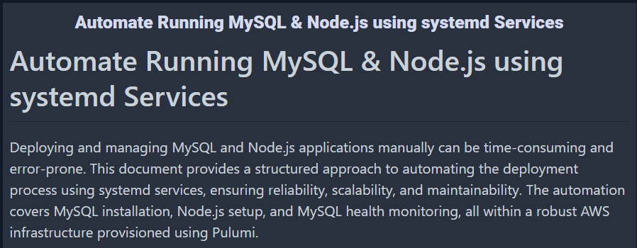

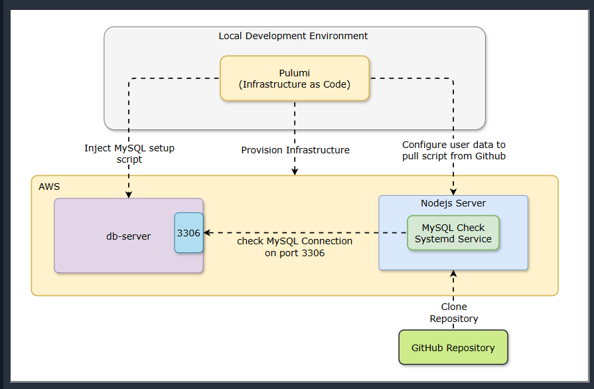

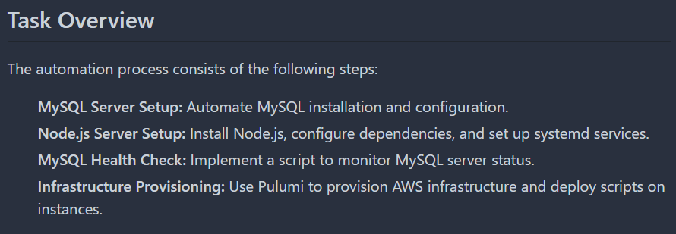

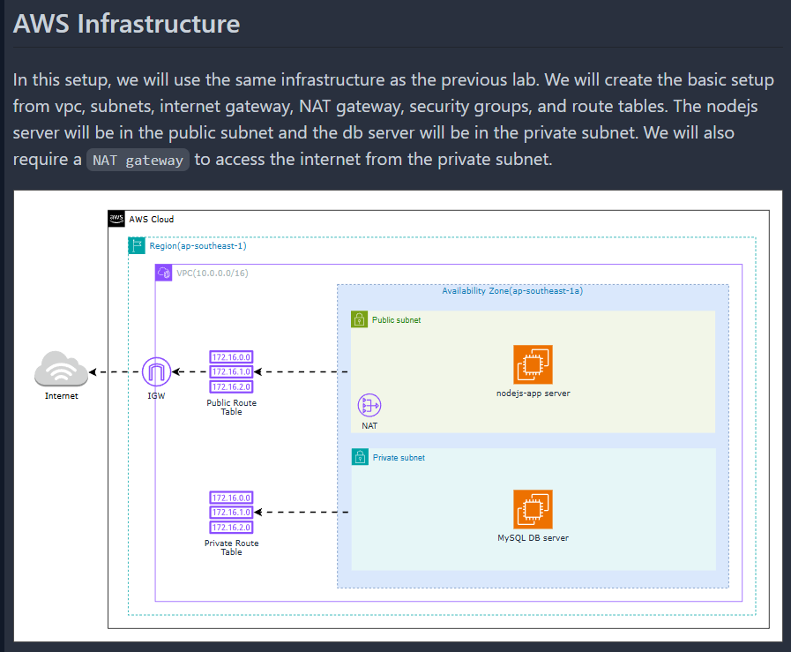

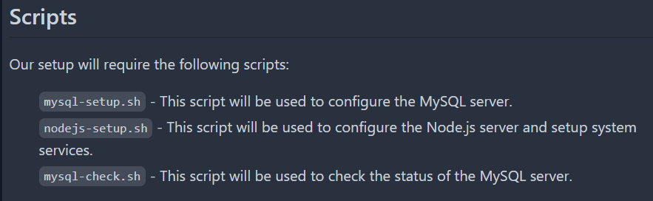

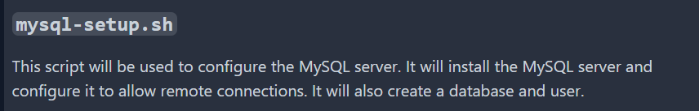

#!/bin/bash

exec > >(tee /var/log/mysql-setup.log) 2>&1

# Update system

apt update

apt upgrade -y

# Install MySQL server

apt-get install -y mysql-server

# Configure MySQL to allow remote connections

sed -i 's/bind-address.*=.*/bind-address = 0.0.0.0/' /etc/mysql/mysql.conf.d/mysqld.cnf

# Create database and user

mysql -e "CREATE DATABASE app_db;"

mysql -e "CREATE USER 'app_user'@'%' IDENTIFIED BY 'app_user';"

mysql -e "GRANT ALL PRIVILEGES ON app_db.* TO 'app_user'@'%';"

mysql -e "FLUSH PRIVILEGES;"

# Restart MySQL

systemctl restart mysql

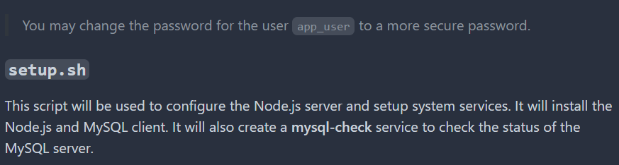

#!/bin/bash

exec > >(tee /var/log/setup.log) 2>&1

# Update system and install dependencies

apt-get update

apt-get upgrade -y

apt-get install -y netcat-openbsd mysql-client

# Install Node.js

curl -fsSL https://deb.nodesource.com/setup_18.x | bash -

apt-get install -y nodejs

# Create script directory

mkdir -p /usr/local/bin

# Copy the MySQL check script to proper location

cd /tmp/scripts

cp check-mysql.sh /usr/local/bin/

chmod +x /usr/local/bin/check-mysql.sh

# Wait for environment variable to be set

max_attempts=30

attempt=0

while [ -z "$DB_PRIVATE_IP" ]; do

if [ $attempt -ge $max_attempts ]; then

echo "Timeout waiting for DB_PRIVATE_IP to be set"

exit 1

fi

echo "Waiting for DB_PRIVATE_IP environment variable..."

attempt=$((attempt + 1))

sleep 10

# Source the environment file only once per iteration

source /etc/environment

done

echo "DB_PRIVATE_IP is set to: $DB_PRIVATE_IP"

# Wait for MySQL server to be ready

echo "Waiting for MySQL server to be ready..."

sleep 120

echo "Creating MySQL Connectivity Check Service"

# Install systemd service

cat > /etc/systemd/system/mysql-check.service << 'EOL'

[Unit]

Description=MySQL Connectivity Check Service

After=network.target

Wants=network.target

[Service]

Type=simple

EnvironmentFile=/etc/environment

ExecStart=/usr/local/bin/check-mysql.sh

Restart=on-failure

RestartSec=30

StandardOutput=append:/var/log/mysql-check.log

StandardError=append:/var/log/mysql-check.log

[Install]

WantedBy=multi-user.target

EOL

# Reload systemd and start service

systemctl daemon-reload

systemctl enable mysql-check

systemctl start mysql-check

echo "MySQL check service has been started. You can check the status with: systemctl status mysql-check"

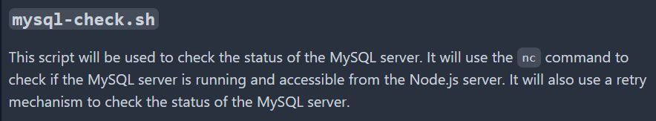

#!/bin/bash

DB_HOST="$DB_PRIVATE_IP"

DB_PORT=3306

MAX_RETRIES=30

RETRY_INTERVAL=10

check_mysql() {

nc -z "$DB_HOST" "$DB_PORT"

return $?

}

retry_count=0

while [ $retry_count -lt $MAX_RETRIES ]; do

if check_mysql; then

echo "Successfully connected to MySQL at $DB_HOST:$DB_PORT"

exit 0

fi

echo "Attempt $((retry_count + 1))/$MAX_RETRIES: Cannot connect to MySQL at $DB_HOST:$DB_PORT. Retrying in $RETRY_INTERVAL seconds..."

sleep $RETRY_INTERVAL

retry_count=$((retry_count + 1))

done

echo "Failed to connect to MySQL after $MAX_RETRIES attempts"

exit 1

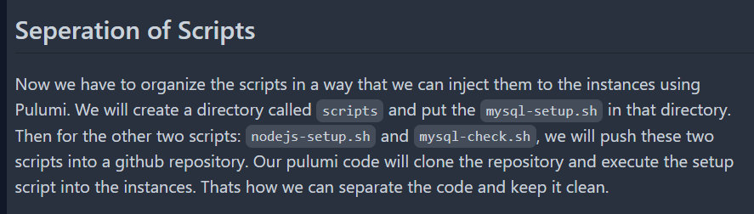

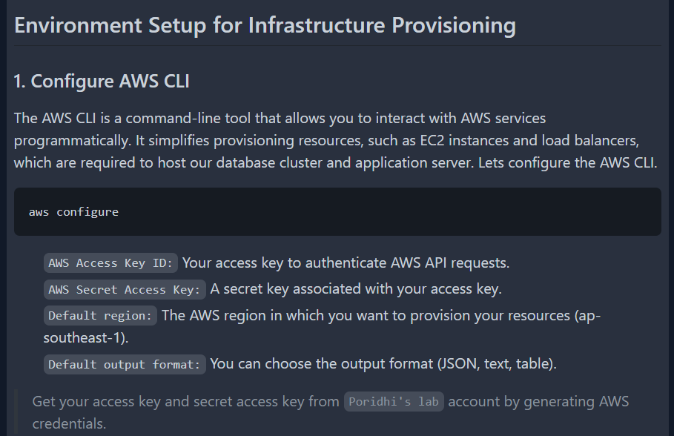

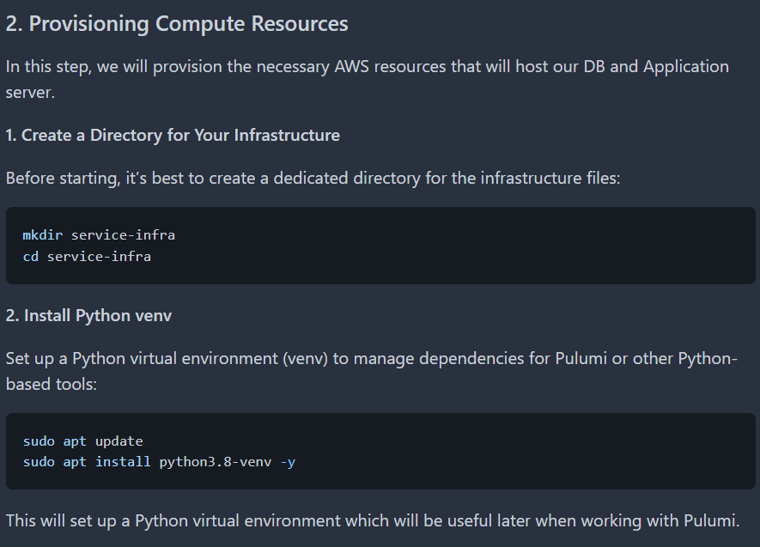

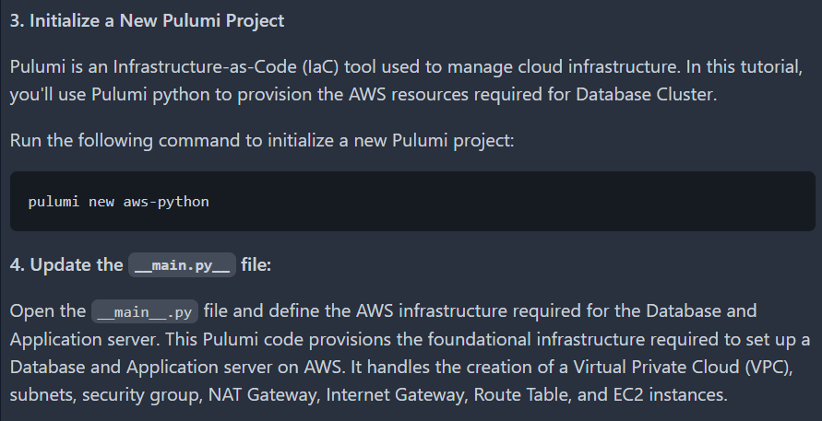

import pulumi

import pulumi_aws as aws

import os

# Create a VPC

vpc = aws.ec2.Vpc(

'nodejs-db-vpc',

cidr_block='10.0.0.0/16',

enable_dns_support=True,

enable_dns_hostnames=True,

tags={'Name': 'nodejs-db-vpc'}

)

# Create public and private subnets

public_subnet = aws.ec2.Subnet(

'nodejs-public-subnet',

vpc_id=vpc.id,

cidr_block='10.0.1.0/24',

map_public_ip_on_launch=True,

availability_zone='ap-southeast-1a',

tags={'Name': 'nodejs-public-subnet'}

)

private_subnet = aws.ec2.Subnet(

'db-private-subnet',

vpc_id=vpc.id,

cidr_block='10.0.2.0/24',

map_public_ip_on_launch=False,

availability_zone='ap-southeast-1a',

tags={'Name': 'db-private-subnet'}

)

# Create an Internet Gateway

internet_gateway = aws.ec2.InternetGateway(

'nodejs-db-internet-gateway',

vpc_id=vpc.id,

tags={'Name': 'nodejs-db-internet-gateway'}

)

# Create NAT Gateway for private subnet

elastic_ip = aws.ec2.Eip('nat-eip')

nat_gateway = aws.ec2.NatGateway(

'nat-gateway',

allocation_id=elastic_ip.id,

subnet_id=public_subnet.id,

tags={'Name': 'nodejs-db-nat-gateway'}

)

# Create public Route Table

public_route_table = aws.ec2.RouteTable(

'public-route-table',

vpc_id=vpc.id,

routes=[

aws.ec2.RouteTableRouteArgs(

cidr_block='0.0.0.0/0',

gateway_id=internet_gateway.id,

)

],

tags={'Name': 'nodejs-public-route-table'}

)

# Create private Route Table

private_route_table = aws.ec2.RouteTable(

'private-route-table',

vpc_id=vpc.id,

routes=[

aws.ec2.RouteTableRouteArgs(

cidr_block='0.0.0.0/0',

nat_gateway_id=nat_gateway.id,

)

],

tags={'Name': 'db-private-route-table'}

)

# Associate route tables with subnets

public_route_table_association = aws.ec2.RouteTableAssociation(

'public-route-table-association',

subnet_id=public_subnet.id,

route_table_id=public_route_table.id

)

private_route_table_association = aws.ec2.RouteTableAssociation(

'private-route-table-association',

subnet_id=private_subnet.id,

route_table_id=private_route_table.id

)

# Create security group for Node.js application

nodejs_security_group = aws.ec2.SecurityGroup(

'nodejs-security-group',

vpc_id=vpc.id,

description="Security group for Node.js application",

ingress=[

# SSH access

aws.ec2.SecurityGroupIngressArgs(

protocol='tcp',

from_port=22,

to_port=22,

cidr_blocks=['0.0.0.0/0'], # Consider restricting to your IP

),

# Node.js application port

aws.ec2.SecurityGroupIngressArgs(

protocol='tcp',

from_port=3000,

to_port=3000,

cidr_blocks=['0.0.0.0/0'],

),

],

egress=[

aws.ec2.SecurityGroupEgressArgs(

protocol='-1',

from_port=0,

to_port=0,

cidr_blocks=['0.0.0.0/0'],

)

],

tags={'Name': 'nodejs-security-group'}

)

# Create security group for MySQL database

db_security_group = aws.ec2.SecurityGroup(

'db-security-group',

vpc_id=vpc.id,

description="Security group for MySQL database",

ingress=[

# SSH access from Node.js subnet

aws.ec2.SecurityGroupIngressArgs(

protocol='tcp',

from_port=22,

to_port=22,

cidr_blocks=[public_subnet.cidr_block],

),

# MySQL access from Node.js subnet

aws.ec2.SecurityGroupIngressArgs(

protocol='tcp',

from_port=3306,

to_port=3306,

cidr_blocks=[public_subnet.cidr_block],

),

],

egress=[

aws.ec2.SecurityGroupEgressArgs(

protocol='-1',

from_port=0,

to_port=0,

cidr_blocks=['0.0.0.0/0'],

)

],

tags={'Name': 'db-security-group'}

)

# Read MySQL setup script

with open('/root/code/script/mysql-setup.sh', 'r') as file:

print("Reading MySQL setup script...\n")

mysql_setup_script = file.read()

def generate_mysql_user_data():

return f'''#!/bin/bash

exec > >(tee /var/log/user-data.log) 2>&1

# update system

apt-get update

apt-get upgrade -y

# Create script directory

mkdir -p /usr/local/bin

# Create MySQL setup script

cat > /usr/local/bin/mysql-setup.sh << 'EOL'

{mysql_setup_script}

EOL

chmod +x /usr/local/bin/mysql-setup.sh

# Execute the setup script

/usr/local/bin/mysql-setup.sh

'''

# Create EC2 Instance for DB with user data

db = aws.ec2.Instance(

'db-server',

instance_type='t2.small',

ami='ami-01811d4912b4ccb26',

subnet_id=private_subnet.id,

key_name="db-cluster",

vpc_security_group_ids=[db_security_group.id],

user_data=generate_mysql_user_data(),

user_data_replace_on_change=True,

tags={'Name': 'db-server'},

opts=pulumi.ResourceOptions(

depends_on=[

nat_gateway,

private_route_table_association,

private_subnet

]

)

)

def generate_nodejs_user_data(db_private_ip):

return f'''#!/bin/bash

exec > >(tee /var/log/user-data.log) 2>&1

# Install git

apt-get update

apt-get install -y git

# Set environment variable for DB IP

echo "DB_PRIVATE_IP={db_private_ip}" >> /etc/environment

source /etc/environment

# Clone the repository and execute setup script

git clone <YOUR_REPO_URL> /tmp/scripts

chmod +x /tmp/scripts/setup.sh

bash /tmp/scripts/setup.sh

'''

# Update your Pulumi EC2 instance configurations

nodejs = aws.ec2.Instance(

'nodejs-server',

instance_type='t2.small',

ami='ami-01811d4912b4ccb26', # Update with correct Ubuntu AMI ID

subnet_id=public_subnet.id,

key_name="db-cluster",

vpc_security_group_ids=[nodejs_security_group.id],

associate_public_ip_address=True,

user_data=pulumi.Output.all(db.private_ip).apply(

lambda args: generate_nodejs_user_data(args[0])

),

user_data_replace_on_change=True,

tags={'Name': 'nodejs-server'}

)

# Export Public and Private IPs

pulumi.export('nodejs_public_ip', nodejs.public_ip)

pulumi.export('nodejs_private_ip', nodejs.private_ip)

pulumi.export('db_private_ip', db.private_ip)

# Export the VPC ID and Subnet IDs for reference

pulumi.export('vpc_id', vpc.id)

pulumi.export('public_subnet_id', public_subnet.id)

pulumi.export('private_subnet_id', private_subnet.id)

# Create config file

def create_config_file(all_ips):

config_content = f"""Host nodejs-server

HostName {all_ips[0]}

User ubuntu

IdentityFile ~/.ssh/db-cluster.id_rsa

Host db-server

ProxyJump nodejs-server

HostName {all_ips[1]}

User ubuntu

IdentityFile ~/.ssh/db-cluster.id_rsa

"""

config_path = os.path.expanduser("~/.ssh/config")

with open(config_path, "w") as config_file:

config_file.write(config_content)

# Collect the IPs for all nodes

all_ips = [nodejs.public_ip, db.private_ip]

# Create the config file with the IPs once the instances are ready

pulumi.Output.all(*all_ips).apply(create_config_file)

