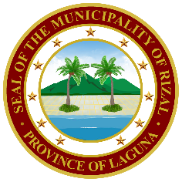**Republic of the Philippines**

**Province of Laguna**

**Municipality of Rizal**

**OFFICE OF THE MUNICIPAL HEALTH OFFICER**

[mho.rizallaguna@gmail.com](mailto:mho.rizallaguna@gmail.com)

**SANITARY PERMIT FORM**

{BUSINESS_NAME}

Registered Name

{BUSINESS_OWNER}

Owner

Type of Establishment: {Type_of_Establishment}

Address: {Address}

Registration No: **{Sanitary_Permit_No}**

Date Issued: {Date_Issued} Date of Expiration: {Exp_Date}

No. of Employees: **{No_of_Employees}**

*This permit is non-transferable and will be revoked for any violation of the Sanitary Rule, Laws and/or*

*Regulations of P.D. 856 and Local Ordinances.*

Recommending Approval:

Approved:

**DEAN CHAN KENNETH A. MONTEROLA**

Sanitation Officer (OIC) **DR. SAM JOSEPH C. CIRILO, Ll. B., MPM-HSD**

Municipal Health Officer