RENEWABLE ENERGY SYSTEMS I
LABORATORY RECORD
Experiment 3
Simulation of Voltage Controlled Solar Powered DC/DC Converter
MATLAB/Simulink R2025b Native Simscape Electrical Workflow

Student Name | Rhudhresh
Register Number | 212223050039
Department | Electrical and Electronics Engineering
Course / Lab | 19EE416 - Renewable Energy Systems I Laboratory

1. Aim
To simulate a solar powered DC/DC boost converter in MATLAB/Simulink for output-voltage control using a PI controller.
2. Manual Modelling Parameters
The following values are taken from the Experiment 3 page of the laboratory manual and are the design targets for the closed-loop model.
Category | Parameter | Value
Solar PV | Maximum voltage | 120 V
Solar PV | Irradiance | 1000 W/m²
Solar PV | Temperature at STC | 25 °C
Boost Converter | Inductor, L | 100 µH
Boost Converter | Capacitor, C | 1000 µF
Boost Converter | Switching frequency | 25 kHz
Boost Converter | Load resistance | 350 (manual sheet writes 350 W)
Boost Converter | Duty cycle range | 10% to 80%
Controller | Reference voltage | 100 V to 300 V
Controller | P constant | 0.01
Controller | I constant | 5
Controller | Time domain | Continuous
Controller | Controller switching frequency | 10 kHz
3. Theory
A boost converter raises the DC output voltage above the PV input voltage by storing energy in the inductor during the switch-ON interval and releasing that energy through the diode to the capacitor-load side during the switch-OFF interval.
In closed-loop operation, the actual output voltage Vo is measured and compared with a reference voltage Vref. The error e = Vref - Vo is sent to the PI controller.
The proportional term responds immediately to the error and improves the speed of correction. The integral term removes steady-state error and helps the output settle at the commanded value.
The PI output is converted into the PWM duty command. By varying duty cycle between the lower and upper limits, the converter keeps the output voltage close to the selected reference value.
4. Model Built
From the current screenshot, the following part of the Experiment 3 model is already present:
• Solar Cell block with constant irradiance input through a Simulink-PS Converter.
• Boost-converter power stage: inductor, MOSFET, diode, capacitor and resistive load.
• Input-side current sensor and voltage sensor.
• Output-side voltage sensor across the load side.
• Solver Configuration and Electrical Reference blocks for the native Simscape network.
• PWM Generator block with a fixed command value of 0.1.
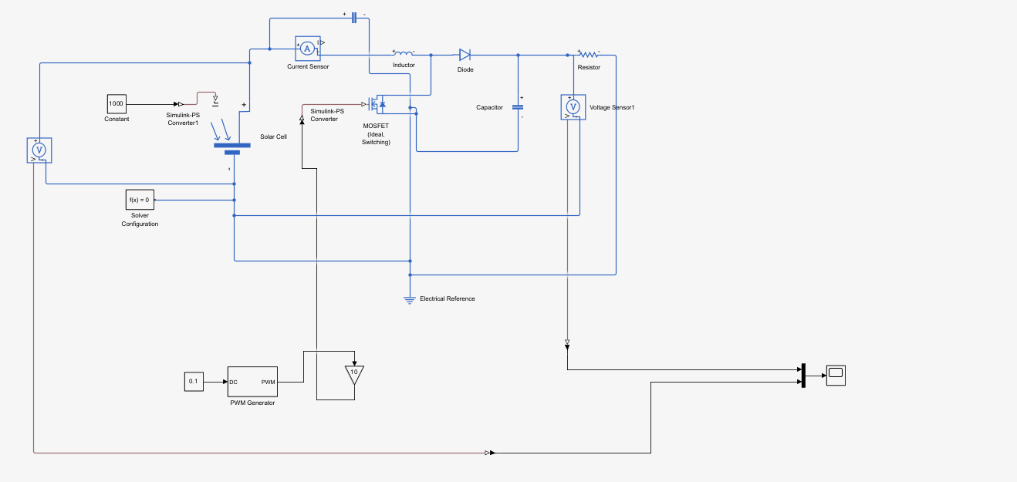
Figure 1. Current Exp 3 Simulink model as provided by the student.
5. What Is Still Missing for Full Experiment 3 Completion
The power circuit is close, but the screenshot still behaves like an open-loop duty-controlled model. To make it a true voltage-controlled closed-loop converter, the following control blocks must be added or rewired.
Required block / signal | Why it is needed | Action to take
Reference source (Vref) | Closed-loop control needs a commanded output target. | Add a Constant or Slider block with values such as 100 V, 150 V, 200 V, 250 V and 300 V.
Error block | The controller must work on the difference between desired and measured output voltage. | Use a Sum block and form e = Vref - Vo.
PI Controller | Experiment 3 specifically requires PI voltage control. | Insert a PI Controller block and set Kp = 0.01 and Ki = 5.
Duty limiter | Duty must stay within a valid PWM range. | Add a Saturation block and limit the controller output to 0.1 to 0.8.
Feedback path from output voltage | Vo must be fed back to the controller, not just viewed on a Scope. | Send output-voltage sensor -> PS-Simulink Converter -> Sum block negative input.
Output current path | The tabulation requires Io and Po. | Insert a Current Sensor in series with the load resistor branch; compute Po = Vo × Io.

6. Recommended Completed Block Flow
Closed-loop control chain: Vref -> Sum (Vref - Vo) -> PI Controller -> Saturation (0.1 to 0.8) -> PWM Generator -> MOSFET gate
Measurement chain: Vin, Iin, Vo and Io must come through PS-Simulink Converter blocks before going to Scope, Display or To Workspace blocks.
7. Step-by-Step Procedure for Finishing the Model in R2025b
1. Keep the already built boost-converter power stage without changing the inductor, diode, MOSFET, capacitor and resistor arrangement.
2. Disconnect the fixed 0.1 command from the PWM Generator duty/DC input.
3. Add a Constant or Slider block for Vref and test it over the range 100 V to 300 V.
4. Take the output-voltage sensor signal, pass it through a PS-Simulink Converter and label it as Vo.
5. Use a Sum block to form the control error: e = Vref - Vo.
6. Feed the error to a PI Controller block and set P = 0.01, I = 5 and time domain = continuous.
7. Place a Saturation block after the PI controller and keep the duty range between 0.1 and 0.8.
8. Connect the saturated duty signal to the PWM Generator duty/DC input.
9. Insert an output Current Sensor in series with the resistor branch to obtain Io.
10. Create Product blocks for Ppv = Vin × Iin and Po = Vo × Io.
11. Log Vref, Vin, Iin, Ppv, Vo, Io and Po using separate To Workspace blocks for clean tabulation.
12. Show Vref and Vo on the same Scope to verify that the closed loop is tracking the reference value.
8. Signal-Logging Plan
Signal | Taken from | Block type | Workspace name
Vref | Reference Constant / Slider | Simulink signal | vref
Vin | Input voltage sensor | PS-Simulink Converter | vin
Iin | Input current sensor | PS-Simulink Converter | iin
Ppv | Product(Vin, Iin) | Simulink Product | ppv
Vo | Output voltage sensor | PS-Simulink Converter | vo
Io | Output current sensor | PS-Simulink Converter | io
Po | Product(Vo, Io) | Simulink Product | po
9. Observation Table Format
Use the following table directly in the record after simulation for different reference voltages.
S.No. | Vref (V) | Vin (V) | Iin (A) | Ppv (W) | Vo (V) | Io (A) | Po (W)
1 | 100
2 | 150
3 | 200
4 | 250
5 | 300
10. Expected Scope / Waveform
The main scope for Experiment 3 should compare Vref and Vo on the same display. In a correct closed-loop run, Vo should rise and settle close to the selected reference voltage with acceptable transient error.
11. Result
Thus, the voltage-controlled solar powered DC/DC converter model for Experiment 3 was organized in MATLAB/Simulink R2025b, and the exact additional blocks required to convert the present boost-converter model into a full PI-controlled closed-loop system were identified and documented.

