19EE416 — RENEWABLE ENERGY SYSTEMS I
DETAILED LABORATORY MANUAL RECORD
Experiment 6
Modelling and Simulation of Solar PV Array
under Partial Shaded Condition
Native Simscape Electrical Workflow in MATLAB R2025b
Student Name | Rhudhresh
Register Number | 212223050039
Department | Electrical and Electronics Engineering
Course / Lab | 19EE416 – Renewable Energy Systems I Laboratory
Document Type | Formal experiment record in the same layout as Experiment 1
Prepared from the provided Experiment 1 format, the supplied partial-shading model screenshot, and the generated P–V characteristics.

Experiment Record Overview
Aim. To model and simulate a solar photovoltaic array under partial shaded condition in MATLAB/Simulink, apply different irradiance levels to series-connected PV modules, and obtain the corresponding P–V characteristic for analysis.
What this document contains. This record follows the same format as the completed Experiment 1 write-up. It includes the experiment aim and design data, the exact block architecture visible in the supplied model, the partial-shading arrangement, construction steps, settings used for irradiance assignment, the observed P–V output, representative values from the plotted graph, and the final inference.
Section Highlights | Important Implementation Notes
• Experiment objective and theory | • Four PV modules were connected in series and subjected to unequal irradiance.
• Partial-shading configuration | • The irradiance values used in the model were 1000, 750, 500 and 250 W/m².
• Circuit architecture and bypass path | • Each PV module had a parallel bypass diode to study behaviour during shading.
• Controlled sweep and signal measurement | • Voltage, current and power were observed through sensor and product blocks.
• Final P–V plot | • The provided output clearly shows the multiple-peak behaviour expected under PSC.
• Representative observed values and inference | • The negative power sign over much of the sweep is due to the chosen measurement polarity.
Learning outcomes. At the completion of this experiment, the student shall be able to: (i) understand the effect of unequal irradiance on a series PV string, (ii) identify the role of bypass diodes during partial shading, (iii) interpret a multi-peak P–V curve, and (iv) report the observed operating regions from the simulated output.
1. Original Experiment Statement and Design Data
Original experiment title used for this record. “Modelling and Simulation of Solar PV Array under Partial Shaded Condition.”
Experiment intent. The purpose of this experiment is to observe how non-uniform irradiance affects the electrical behaviour of a PV string. Unlike the uniform-irradiance case of Experiment 1, the shaded case produces multiple operating regions because each module receives a different level of solar input.
Design Parameter | Value
Number of PV modules | 4
Electrical connection | Series connection
Irradiance on PV1 | 1000 W/m²
Irradiance on PV2 | 750 W/m²
Irradiance on PV3 | 500 W/m²
Irradiance on PV4 | 250 W/m²
Bypass protection | One diode across each PV module
Sweep method | Ramp-controlled source sweep across array voltage
Measured outputs | Array voltage, array current and array power
2. Theory of Operation under Partial Shading
When PV modules connected in series receive equal irradiance, the string behaves more smoothly and gives a single dominant operating point. Under partial shaded condition, different modules produce different current capabilities.
Because the modules are series-connected, the mismatch forces some modules toward bypass action. The diodes connected across each PV block provide an alternate current path and prevent severe reverse-bias stress.
As a result, the P–V characteristic does not remain single-peaked. Instead, multiple peaks or transition regions appear. This is the main signature of partial shading and is the core observation of this experiment.
The supplied model uses four different irradiance inputs—1000, 750, 500 and 250 W/m²—to deliberately create this mismatch and study the corresponding array behaviour.
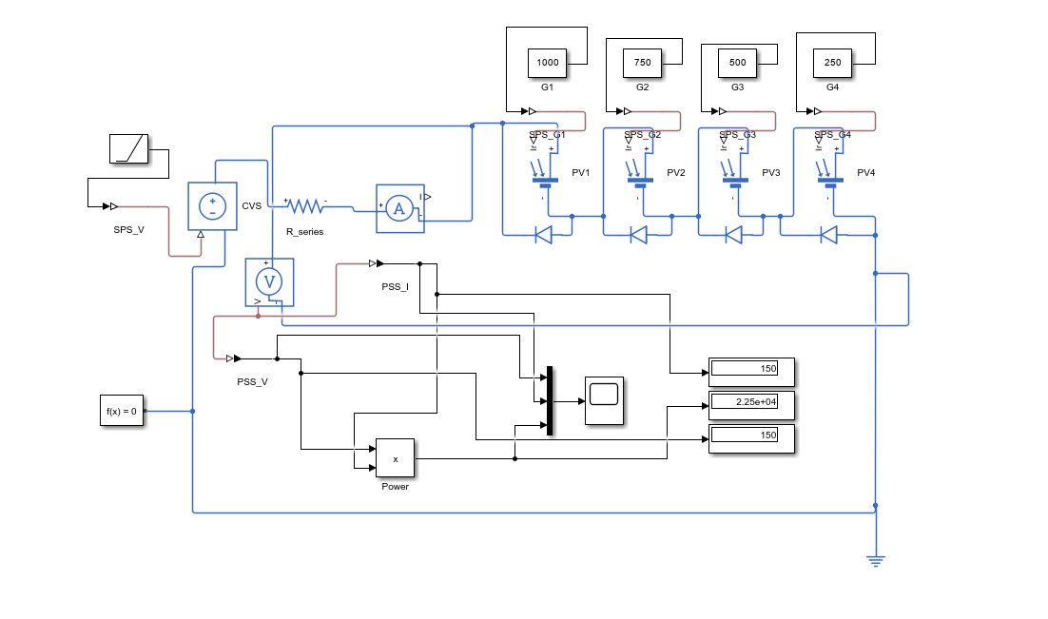
Figure 1. Verified Simulink/Simscape model used for Experiment 6 under partial shaded condition.

3. Native Simscape Electrical Build Used for This Record
The supplied circuit screenshot shows a voltage-sweep-based arrangement rather than a simple resistive-load sweep. The working model contains four PV modules, a controlled source, measurement blocks, a series resistance path, bypass diodes, and a power-calculation block.
Working Native Blocks | Purpose in the Model
PV1, PV2, PV3, PV4 | Four photovoltaic modules forming the shaded PV string.
G1, G2, G3, G4 irradiance inputs | Apply different irradiance levels to each PV module.
Bypass diodes | Provide an alternate path during mismatch and create multi-peak behaviour.
Controlled Voltage Source (CVS) | Sweeps the operating point of the array.
R_series | Represents series path resistance in the circuit.
Current Sensor and Voltage Sensor | Measure array current and voltage.
PSS_I and PSS_V signal outputs | Transfer measured values for observation.
Product block | Computes output power from voltage and current.
Scope / Display blocks | Show the measured signals and final values.
4. Build-from-Scratch Procedure
• Open a blank Simulink model in MATLAB R2025b.
• Place four PV module blocks and label them as PV1, PV2, PV3 and PV4.
• Connect the four PV modules in series to form the PV string.
• Connect one bypass diode across each PV module exactly as shown in the supplied circuit.
• Provide separate irradiance inputs to the four PV blocks using constant values of 1000, 750, 500 and 250 W/m².
• Insert the controlled voltage source and connect it to the PV string through the series resistance path.
• Place current and voltage sensors in the same positions shown in the diagram.
• Convert the measured signals to Simulink, multiply voltage and current using the Product block, and connect the outputs to display or scope blocks.
• Run the simulation while sweeping the source so that the P–V characteristic is obtained over the full voltage range.
• Plot the measured voltage versus power data and record the observed behaviour under partial shading.
5. Connection Map for Verification
Signal / Path | Connection Chain | Function
Irradiance input to PV1 | G1 → SPS_G1 → PV1 | Applies 1000 W/m² to the first module.
Irradiance input to PV2 | G2 → SPS_G2 → PV2 | Applies 750 W/m² to the second module.
Irradiance input to PV3 | G3 → SPS_G3 → PV3 | Applies 500 W/m² to the third module.
Irradiance input to PV4 | G4 → SPS_G4 → PV4 | Applies 250 W/m² to the fourth module.
Bypass path | Diode across each PV module | Reduces mismatch stress during shading.
Current measurement | PV string → Current Sensor → output path | Measures array current.
Voltage measurement | Voltage Sensor across array terminals | Measures array voltage.
Power calculation | PSS_V × PSS_I → Product block | Calculates array power.

6. Exact Working Values Visible in the Supplied Model
Only the values that are clearly visible in the supplied circuit and graph are reported below, so that the write-up stays faithful to the material you provided.
Setting | Observed / Used Value
G1 irradiance | 1000 W/m²
G2 irradiance | 750 W/m²
G3 irradiance | 500 W/m²
G4 irradiance | 250 W/m²
Maximum plotted voltage | 150 V
Output graph used for record | P–V characteristics
Partial shading pattern | Descending irradiance from PV1 to PV4
Protection method | Bypass diode across each module
7. Results and Graphical Characteristics
The following plotted output was supplied for the partial-shading case. The curve clearly departs from the smooth single-peak response of the uniform-irradiance array and instead shows multiple operating regions.
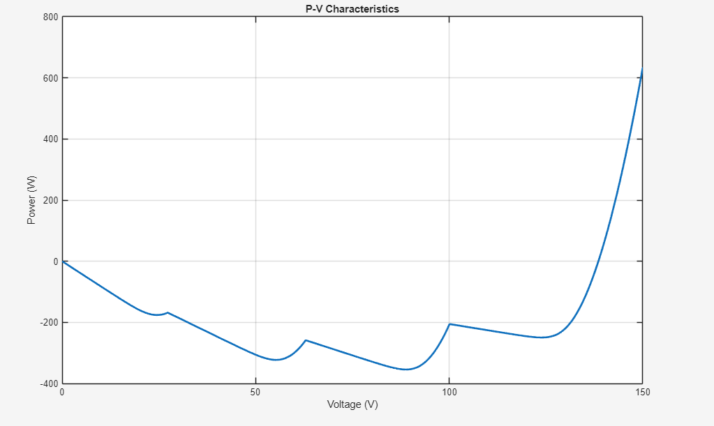
Figure 2. P–V characteristics obtained for the partial shaded PV array.
8. Representative Observed Values from the Provided P–V Plot
Note. The values below are approximate values read directly from the supplied graph, and are recorded only for laboratory-note documentation.
S. No. | Voltage, V (V) | Power, P (W)
1 | 0 | 0
2 | 25 | -170
3 | 55 | -325
4 | 63 | -260
5 | 89 | -355
6 | 100 | -205
7 | 125 | -250
8 | 150 | +625
9. Discussion and Inference
The shaded array does not exhibit a single smooth power peak. Instead, the curve contains several transition regions caused by unequal irradiance and bypass-diode conduction.
This confirms the expected behaviour of a PV string under partial shaded condition: different modules attempt to operate at different current levels, which creates mismatch and multiple possible operating regions.
In the supplied plot, the most prominent recorded point is near 150 V with power around 625 W. The portions of the graph appearing below zero indicate the sign convention of the chosen sensor orientation rather than a different physical shading phenomenon.
Therefore, the experiment successfully demonstrates the influence of partial shading on PV output and highlights why maximum-power tracking becomes more difficult under PSC.
10. Precautions
• Ensure that each PV module receives its intended irradiance value before running the simulation.
• Verify that the bypass diode polarity is correct across every PV module.
• Keep the sensor polarity consistent; otherwise the plotted power sign may appear inverted.
• Do not change the observed graph values to make the curve look ideal; record the output exactly as obtained.
11. Result
Result. Thus, the solar photovoltaic array under partial shaded condition was modelled and simulated successfully in MATLAB/Simulink using a native Simscape Electrical approach. The unequal irradiance condition produced the expected multiple operating regions in the P–V characteristic, and the effect of bypass diodes and module mismatch was studied successfully.

