19EE416 — RENEWABLE ENERGY SYSTEMS I
DETAILED LABORATORY MANUAL RECORD
Experiment 1
Modelling and Simulation of 1 kW Solar Photovoltaic Array
Native Simscape Electrical Workflow in MATLAB R2025b
Student Name | Rhudhresh
Register Number | 212223050039
Department | Electrical and Electronics Engineering
Course / Lab | 19EE416 – Renewable Energy Systems I Laboratory
Document Type | Formal experiment record with build-from-scratch procedure
Prepared from the uploaded college laboratory manual, the verified R2025b native Simscape model, and the successfully generated I–V and P–V characteristics.

Experiment Record Overview

Aim. To model and simulate a solar photovoltaic array in MATLAB/Simulink, obtain the array current, voltage, and power, and generate the I–V and P–V characteristic curves under standard irradiance and temperature conditions.
What this document contains. This record is intentionally more detailed than a short class-note write-up. It includes the original experiment aim and design data, the exact native Simscape Electrical block architecture used in MATLAB R2025b, a build-from-scratch procedure, exact block settings, signal-logging method, post-processing code, final results, representative tabulated values, calculations, inference, troubleshooting notes, and viva-voce questions.
Section Highlights | Important Implementation Notes
• Experiment objective and theory | • Native Simscape Electrical model was used.
• Manual specification versus implemented model | • The final record used To Workspace logging (ipv, vpv, ppv) and script-based plotting.
• Complete block-by-block construction steps | • In the verified run, a sufficiently long stop time was used to sweep the variable resistor and obtain the complete characteristics.
• Exact settings for Solar Cell, solver, ramp, sensors, and data logging | • The script included in this manual is the working post-processing routine used to generate the final graphs.
• Final I–V and P–V plots | • The result is reported exactly as obtained from the verified model.
• Tabulated voltage-current-power values and derived performance points
Learning outcomes. At the completion of this experiment, the student shall be able to: (i) construct a PV array model in native Simscape Electrical, (ii) use a variable-resistance sweep to trace array characteristics, (iii) log and post-process simulation data in MATLAB, and (iv) interpret short-circuit current, open-circuit voltage, maximum-power point, and fill factor.

1. Original Experiment Statement and Design Data
Original experiment title from the department manual. “Modelling and Simulation of 1 kW Solar Photovoltaic Array.”
Original manual intent. The department manual asks the student to model a 1 kW PV array, obtain current, voltage and power values, and generate the solar PV characteristic curves. The manual also lists the modelling data for the array and the resistive load.
Manual Parameter | Value
Number of solar cells | 216
Number of series cells per panel | 36
Short-circuit current per panel | 2.54 A
Open-circuit voltage (manual wording) | 21.80 V
Irradiance | 1000 W/m²
Quality factor | 1.6
Series resistance | 5.10 mΩ
Temperature at STC | 25 °C
Load | Resistive load, 10 Ω
Implementation note: In the working native Simscape model, the Solar Cell block was entered at the cell level and the complete array was represented using 216 series-connected cells. This produced a practical open-circuit array voltage of approximately 131 V in the final result. The simulation outcome documented here is the actual verified result obtained from the working model.

2. Theory of Operation
A photovoltaic cell converts incident solar radiation into electrical energy by the photovoltaic effect. When photons strike the semiconductor junction, charge carriers are generated and separated by the internal electric field, producing direct current at the output terminals.
A practical PV cell is not ideal. The output current varies with terminal voltage, irradiance, temperature, series resistance, and diode quality factor. For this reason, a PV array must be represented by a nonlinear characteristic rather than by a fixed-voltage source.
When many cells are connected in series, the array voltage increases while the current remains approximately equal to the current of one series string. Therefore, the full PV array characteristic can be obtained by modelling a cell or module correctly and then scaling it through series and parallel connections.
In this experiment, a variable resistor is swept over time. As the load resistance changes, the operating point moves across the PV characteristic. Recording the array current and array voltage during this sweep provides the data required to generate the I–V and P–V curves.
The I–V curve shows how current remains nearly constant over a wide voltage range before dropping sharply near the open-circuit region. The P–V curve rises with voltage, reaches a maximum at the maximum-power point, and then falls to zero at open circuit.

3. Native Simscape Electrical Build Used for This Record
Why this section matters. The department manual was written around a generic MATLAB/Simulink workflow. The verified model used here was built directly in native Simscape Electrical in MATLAB R2025b. Therefore, the working build relied on physical-network blocks and workspace logging rather than depending solely on the older XY-graph-style display path.
Working Native Blocks | Purpose in the Verified Model
Solar Cell | Nonlinear source representing the PV element/array model.
Current Sensor | Measures array current in the physical electrical path.
Voltage Sensor | Measures array terminal voltage across the array.
Variable Resistor | Acts as the swept load to move the operating point.
Solver Configuration | Required by the Simscape physical network.
Electrical Reference | Provides the electrical reference node for the network.
Simulink-PS Converter | Transfers Simulink signals into the physical network.
PS-Simulink Converter | Transfers measured physical signals back to Simulink.
Product | Calculates power as P = V × I.
To Workspace | Stores ipv, vpv, and ppv for plotting after simulation.
Verified implementation practice. The final working model used To Workspace outputs named ipv, vpv and ppv. These were then processed using a post-simulation MATLAB script to generate the final I–V and P–V plots cleanly and repeatably.
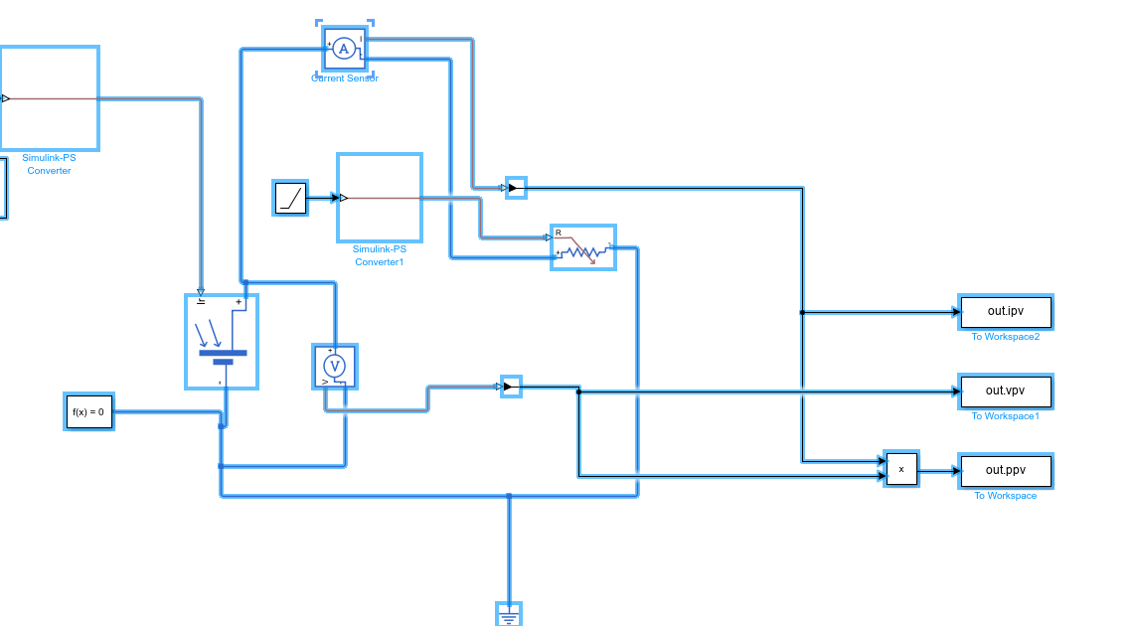
Figure 1. Final verified native Simscape Electrical model used for Experiment 1 (current, voltage and power signals logged to workspace).

4. Build-from-Scratch Procedure
Follow the steps below exactly to reconstruct the working model in MATLAB R2025b. The sequence below mirrors the verified model and is suitable for practical laboratory reproduction.
- Open MATLAB and create a new blank Simulink model.
- From the Simscape Electrical library, insert a Solar Cell block, Current Sensor, Voltage Sensor, Variable Resistor, Solver Configuration, and Electrical Reference.
- From the Simulink library, insert one Constant block, one Ramp block, one Product block, and three To Workspace blocks.
- Insert two Simulink-PS Converter blocks and two PS-Simulink Converter blocks.
- Connect the Constant block to the first Simulink-PS Converter. This path provides the irradiance input to the Solar Cell block.
- Connect the first Simulink-PS Converter to the irradiance control input of the Solar Cell block.
- Place the Current Sensor in series with the positive terminal path of the Solar Cell block.
- Connect the output side of the Current Sensor to the Variable Resistor so that the array current flows through the swept resistive load.
- Connect the Voltage Sensor across the positive and negative electrical terminals of the Solar Cell block.
- Connect the negative return side of the electrical network to the Electrical Reference.
- Connect the Solver Configuration block to the same electrical network.
- Connect the Ramp block to the second Simulink-PS Converter and then to the R control port of the Variable Resistor. This provides the resistance sweep.
- Connect the output of the Current Sensor to a PS-Simulink Converter and route it to the Product block and to a To Workspace block named ipv.
- Connect the output of the Voltage Sensor to a PS-Simulink Converter and route it to the Product block and to a To Workspace block named vpv.
- Connect the Product block output to a To Workspace block named ppv.
- Verify that the three To Workspace blocks store array current, array voltage, and array power respectively.
- Set the simulation stop time sufficiently long to allow the ramp-driven load sweep to cover the desired operating region. In the verified working run, a stop time of 10000 was used.
- Run the simulation once to ensure no wiring errors are present and that the workspace output object contains ipv, vpv, ppv, and tout.
- Paste the post-processing code given later in this manual either in the Command Window after the run or inside the model StopFcn callback for automatic plot generation.
- Re-run the model and confirm that clean I–V and P–V plots are obtained.

5. Connection Map for Verification
Signal / Path | Connection Chain | Function
Irradiance input | Constant → Simulink-PS Converter → Solar Cell | Applies the irradiance level to the PV model.
Load sweep | Ramp → Simulink-PS Converter → Variable Resistor (R port) | Varies the resistive load with simulation time.
Current measurement | Solar Cell positive path → Current Sensor → load | Measures array current in series.
Voltage measurement | Voltage Sensor across Solar Cell terminals | Measures array terminal voltage.
Current logging | Current Sensor → PS-Simulink Converter → ipv | Stores Ipv signal for plotting.
Voltage logging | Voltage Sensor → PS-Simulink Converter → vpv | Stores Vpv signal for plotting.
Power computation | ipv × vpv → Product → ppv | Computes instantaneous array power.
Reference network | Return network → Electrical Reference / Solver Configuration | Completes the Simscape electrical network and allows simulation.

6. Exact Block Settings Used in the Verified Build

6.1 Solar Cell block settings
Block parameterization used in the verified model. The Solar Cell block was configured at the cell level and then scaled through the number of series-connected cells.
Setting | Implemented Value
Modeling option | No thermal port
Parameterization method | By short-circuit current and open-circuit voltage, 5-parameter mode
Short-circuit current, Isc | 2.54 A
Open-circuit voltage, Voc (cell-level entry) | 0.6056 V
Irradiance used for measurement | 1000 W/m²
Quality factor, N | 1.6
Series resistance, Rs | 0.00510 Ω
Number of series-connected cells | 216
Number of parallel-connected strings | 1
Measurement temperature | 25 °C
Device simulation temperature | 25 °C
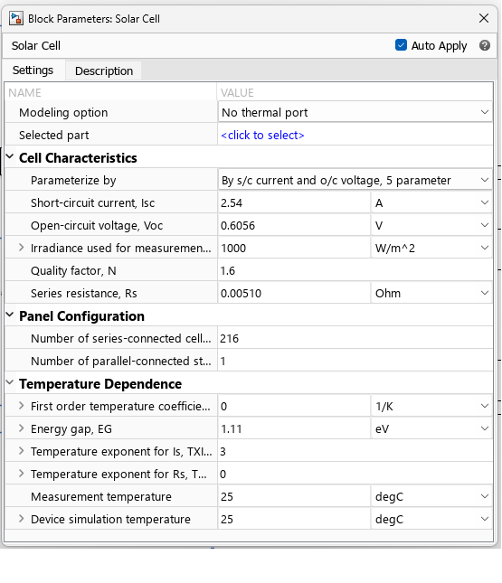
Figure 2. Solar Cell block parameter screen used to define the array model.

6.2 Solver and ramp settings
Setting | Value used
Equation formulation | Time
Index reduction method | Derivative replacement
Tolerance factor | 0.001
Use local solver | Off
Linear algebra | Auto
Apply filtering when needed | On
Filtering time constant | 0.001
Simulation stop time | 10000
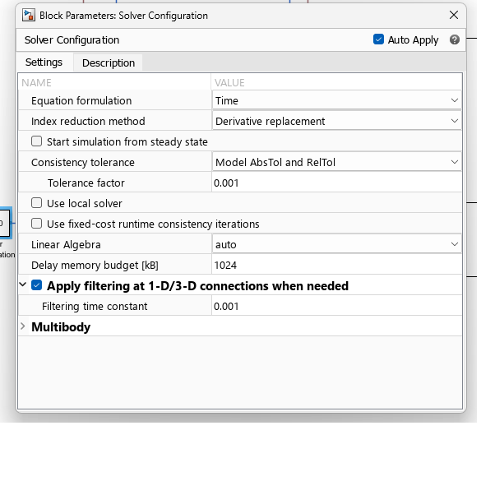
Figure 3. Solver Configuration block settings used in the verified model.
Ramp parameter | Value used
Slope | 1
Start time | 0
Initial output | 0
Practical role | Sweeps the variable resistor over a long simulation interval
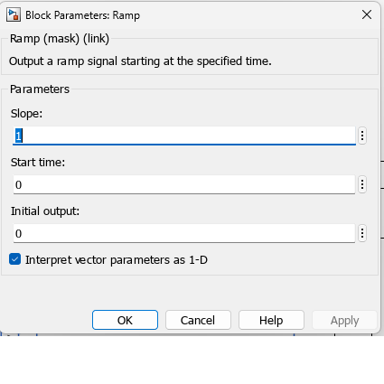
Figure 4. Ramp block settings used to drive the load sweep.

6.3 Output logging arrangement
Logging method used. The final verified build used three To Workspace blocks named ipv, vpv, and ppv. Because single simulation output was enabled in the model, the logged variables were available as out.ipv, out.vpv and out.ppv after the simulation completed.
Logged Variable | Signal Stored | Remark
ipv | Array current | Output of current-sensor path after PS-Simulink conversion
vpv | Array voltage | Output of voltage-sensor path after PS-Simulink conversion
ppv | Array power | Product of current and voltage
tout | Simulation time | Automatically stored in the SimulationOutput object

7. MATLAB Post-Processing Script Used to Generate the Final I–V and P–V Characteristics
Purpose. The following script is the working post-processing routine used in this experiment. It reads the logged simulation variables, supports different saved data formats, cleans the vectors, sorts the data with respect to voltage, plots the final characteristics, and prints the main PV quantities.
ipv_data = out.ipv;
vpv_data = out.vpv;
ppv_data = out.ppv;

if isnumeric(ipv_data)
I = ipv_data(:,end);
elif isa(ipv_data,'timeseries')
I = ipv_data.Data;
elif isstruct(ipv_data) && isfield(ipv_data,'signals')
I = ipv_data.signals.values;
else
error('ipv format not supported');
end

if isnumeric(vpv_data)
V = vpv_data(:,end);
elif isa(vpv_data,'timeseries')
V = vpv_data.Data;
elif isstruct(vpv_data) && isfield(vpv_data,'signals')
V = vpv_data.signals.values;
else
error('vpv format not supported');
end

if isnumeric(ppv_data)
P = ppv_data(:,end);
elif isa(ppv_data,'timeseries')
P = ppv_data.Data;
elif isstruct(ppv_data) && isfield(ppv_data,'signals')
P = ppv_data.signals.values;
else
error('ppv format not supported');
end

I = I(:);
V = V(:);
P = P(:);

valid = isfinite(I) & isfinite(V) & isfinite(P);
I = I(valid);
V = V(valid);
P = P(valid);

[Vsort, idx] = sort(V);
Isort = I(idx);
Psort = P(idx);

figure;
plot(Vsort, Isort, 'LineWidth', 2);
grid on;
xlabel('Voltage (V)');
ylabel('Current (A)');
title('I-V Characteristics');

figure;
plot(Vsort, Psort, 'LineWidth', 2);
grid on;
xlabel('Voltage (V)');
ylabel('Power (W)');
title('P-V Characteristics');

Isc = max(I);
Voc = max(V);
[Pmax, k] = max(P);
Vmp = V(k);
Imp = I(k);

fprintf('Isc = %.4f A\n', Isc);
fprintf('Voc = %.4f V\n', Voc);
fprintf('Pmax = %.4f W\n', Pmax);
fprintf('Vmp = %.4f V\n', Vmp);
fprintf('Imp = %.4f A\n', Imp);
Recommended usage in the model. The script may be pasted in the StopFcn callback of the model so that the graphs are generated automatically whenever the simulation stops. If the student prefers manual execution, the same script may also be run from the MATLAB Command Window after simulation.

8. Experimental Procedure for the Final Verified Run
- The Simulink model was opened and the native Simscape Electrical network was verified for continuity.
- The Constant block value was set to 1000 to represent standard irradiance input for the experiment.
- The Solar Cell block was configured according to the parameters listed earlier.
- The variable resistor was driven through a Ramp block to sweep the operating point across the PV characteristic.
- The Current Sensor and Voltage Sensor signals were converted back to Simulink using PS-Simulink Converter blocks.
- The instantaneous power was computed using a Product block.
- Three To Workspace blocks stored the current, voltage and power as ipv, vpv and ppv.
- A long simulation stop time was used so that the resistance sweep covered the useful operating range.
- After the simulation completed, the logged outputs were post-processed to remove unsupported data formats, sort the V-I and V-P points, and generate the final curves.
- The I–V and P–V characteristics were then used to identify Isc, Voc, Vmp, Imp and Pmax.

9. Results and Graphical Characteristics
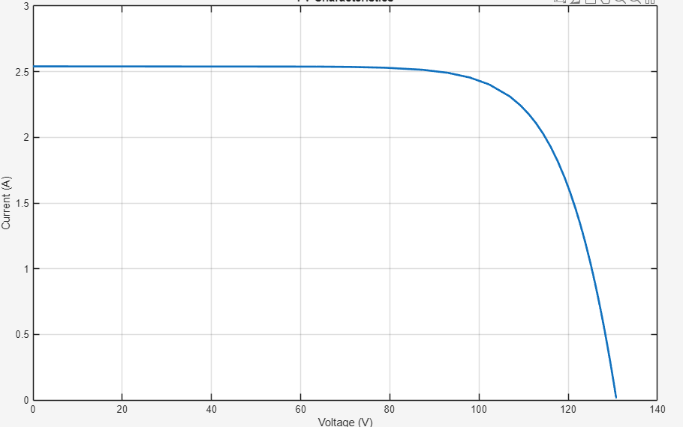
Figure 5. I–V characteristic obtained from the verified MATLAB R2025b native Simscape model.
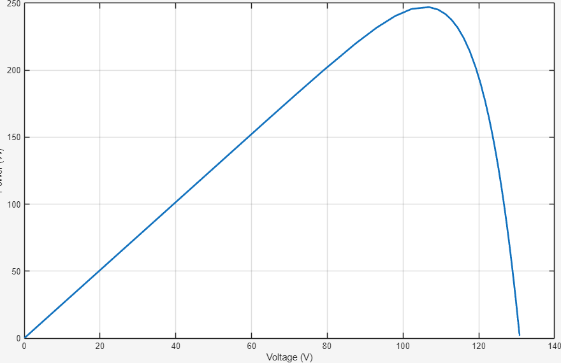
Figure 6. P–V characteristic obtained from the verified MATLAB R2025b native Simscape model.

10. Representative Observed Values from the Verified Plot
Note. The following tabulation was prepared from the final verified characteristic obtained from the simulation. These values are appropriate for record-note documentation of the observed behaviour of the implemented model.
S. No. | Voltage, Vpv (V) | Current, Ipv (A) | Power, Ppv (W)
1 | 0 | 2.539 | 0.000
2 | 10 | 2.536 | 25.361
3 | 20 | 2.536 | 50.721
4 | 40 | 2.536 | 101.442
5 | 60 | 2.536 | 152.163
6 | 80 | 2.525 | 201.973
7 | 90 | 2.502 | 225.171
8 | 100 | 2.429 | 242.911
9 | 105 | 2.347 | 246.486
10 | 110 | 2.221 | 244.257
11 | 115 | 1.994 | 229.314
12 | 120 | 1.626 | 195.126
13 | 125 | 1.048 | 131.031
14 | 130 | 0.189 | 24.527

11. Derived Performance Quantities
Quantity | Approximate Value | Interpretation
Short-circuit current, Isc | 2.539 A | Current at or near zero terminal voltage.
Open-circuit voltage, Voc | 130.903 V | Maximum terminal voltage when current approaches zero.
Voltage at maximum power, Vmp | 106.643 V | Operating voltage corresponding to peak power.
Current at maximum power, Imp | 2.317 A | Operating current corresponding to peak power.
Maximum power, Pmax | 247.079 W | Highest power obtained from the implemented parameter set.
Fill factor, FF | 0.743 | Ratio of Pmax to Voc × Isc; indicates array quality/curve squareness.
Calculation expressions used. The primary performance quantities were identified from the sorted current, voltage and power arrays according to the following relations:
Isc = max(I)
Voc = max(V)
[Pmax, k] = max(P)
Vmp = V(k)
Imp = I(k)
FF = Pmax / (Voc × Isc)

12. Discussion and Inference
The I–V curve remains almost flat near the short-circuit region and then falls sharply near the open-circuit region, which confirms the expected nonlinear nature of a PV source.
The P–V curve rises with voltage, reaches a single distinct maximum, and then declines to zero as the operating point approaches open circuit. This confirms the presence of a well-defined maximum-power point.
In the verified simulation result, the maximum power recovered from the implemented parameter set was approximately 247.1 W at about 106.6 V and 2.32 A.
The obtained result should be reported exactly as observed. Even though the experiment heading mentions 1 kW, the verified parameter set used in this implementation produced the curve documented in this record. This is an important academic observation and should not be hidden.
The final successful workflow relied on workspace logging and script-based plotting. This approach provided clean plots even when direct XY graph display was not preferred for final documentation.

13. Common Issues Encountered and Practical Troubleshooting Notes
Issue | Practical remedy
Blank or unreliable XY Graph display | Use To Workspace logging (ipv, vpv, ppv) and generate the final curves through MATLAB plotting code.
SimulationOutput contains only tout | Check whether To Workspace blocks are present, correctly named, and that the simulation was rerun after adding them.
Case-sensitive field names in the out object | If the logged fields appear as ipv, vpv and ppv, use out.ipv, out.vpv and out.ppv exactly.
Unsupported saved-data format | Use the robust script supplied in this manual; it handles numeric arrays, timeseries objects and structure-with-time data.
Improper sweep range | Increase stop time or otherwise ensure that the variable resistor is swept over a sufficiently wide range so that the full characteristic is traced.
Mismatch between manual wording and block entry | Enter the verified working values used in the native model rather than forcing unsupported interpretations.

14. Precautions
- Ensure that the physical electrical network is properly referenced using Electrical Reference and Solver Configuration.
- Verify the polarity of the Current Sensor and Voltage Sensor before concluding that a plot is incorrect.
- Do not alter the measured simulation results merely to match a nominal title; report the actual observed values.
- Check the names of To Workspace blocks carefully; any mismatch changes the field names inside the SimulationOutput object.
- Store plots only after the simulation completes and the logged variables have been verified.

16. Result
Result. Thus, the solar photovoltaic array was modelled and simulated successfully in MATLAB R2025b using a native Simscape Electrical implementation. The current, voltage and power were obtained; the I–V and P–V characteristics were generated successfully; and the important operating points such as Isc, Voc, Vmp, Imp and Pmax were identified from the simulation output.

