19EE416 — RENEWABLE ENERGY SYSTEMS I

DETAILED LABORATORY MANUAL RECORD
Experiment 2
Simulation of 1 kW Solar PV Powered DC/DC Boost Converter under Open Loop Condition
Open-Loop Boost Converter Workflow in MATLAB R2025b
Student Name | Rhudhresh
Register Number | 212223050039
Department | Electrical and Electronics Engineering
Course / Lab | 19EE416 – Renewable Energy Systems I Laboratory

Prepared from the uploaded college laboratory manual, the verified open-loop boost-converter circuit diagram, and the obtained output I–V and P–V characteristics.
Experiment Record Overview

Aim. To simulate a solar PV powered DC/DC boost converter under open-loop condition in MATLAB/Simulink and obtain the converter characteristics using the measured input and output signals.
What this document contains. This record follows the same overall presentation style as the Experiment 1 write-up and includes the experiment title, design data, theory, verified circuit description, signal logging arrangement, output characteristics, representative observed values, discussion, precautions, and result.
Section Highlights | Important Implementation Notes
Experiment objective and modelling parameters | The circuit is a solar-PV-fed boost converter operated in open loop through a PWM generator.
Verified circuit diagram | The logged outputs are vin, iin, pin, vo, io, po, and duty.
Open-loop operation and duty-cycle control | The duty signal is a Simulink signal; sensor outputs require PS-Simulink conversion before logging.
Output I–V and P–V characteristics | The obtained output voltage and power appear negative because of the measurement polarity in the verified model.
Learning outcomes. At the completion of this experiment, the student shall be able to: (i) identify the power-stage elements of a boost converter, (ii) understand open-loop duty-cycle control, (iii) log input and output electrical quantities to the workspace, and (iv) interpret the obtained output I–V and P–V characteristics.

1. Original Experiment Statement and Design Data
Original experiment title from the department manual. “Simulation of 1 kW Solar PV Powered DC/DC Boost Converter under Open Loop Condition.”
Original manual intent. The department manual asks the student to simulate a solar-powered DC/DC boost converter in MATLAB, vary the duty cycle, and observe the corresponding input and output parameters. The manual tabulation records Duty Cycle, Iin, Vin, Pin, Io, Vo, and Po.
Manual Parameter | Value
Maximum PV voltage | 120 V
Irradiance | 1000 W/m²
Temperature at STC | 25 °C
Inductor, L | 100 µH
Capacitor, C | 1000 µF
Switching frequency | 25 kHz
Load resistance (manual wording) | 350 W
Duty-cycle range | 10% to 80%
Implementation note. The verified student model uses the exact open-loop boost-converter structure shown in the uploaded circuit diagram and logs vin, iin, pin, vo, io, po, and duty through To Workspace blocks for post-processing.

2. Theory of Operation
A DC/DC boost converter is a step-up converter that produces an output voltage greater than the input voltage. In a solar-energy application, it is used to process the photovoltaic output and raise the DC voltage to the level required by the load or subsequent stage.
The boost converter mainly consists of an input source, an inductor, a controlled switch, a diode, an output capacitor, and a load resistor. When the switch is ON, the inductor stores energy from the source. When the switch is OFF, the inductor releases its stored energy through the diode to the output side, thereby increasing the output voltage level.
In open-loop operation, the switch is not controlled by feedback from the output. Instead, the PWM duty cycle is applied directly. Therefore, the output depends on the chosen duty cycle, the input voltage, and the power-stage components. This is why the manual specifically asks the student to vary duty cycle and observe the resulting quantities.
The I–V characteristic represents the relation between output current and output voltage, while the P–V characteristic represents output power versus output voltage. In the present verified result, the sign of the output voltage and power is negative because of the sensor polarity and reference direction used in the model; the converter behaviour is still interpreted from the magnitude and trend of the curve.

3. Verified Open-Loop Simulink Build Used for This Record
Why this section matters. The present record is based on the verified student model shown in the uploaded circuit image. The model contains a solar input, open-loop PWM control, boost-converter power stage, measurement blocks on the input and output sides, product blocks for power calculation, and To Workspace outputs for each required signal.
Working Verified Blocks | Purpose in the Verified Model
Solar source / PV side input | Provides the DC input to the boost-converter stage.
Input current sensor | Measures the source-side current iin.
Input voltage sensor | Measures the source-side voltage vin.
Inductor and diode | Store and transfer energy in the boost-converter power stage.
Controlled switch / MOSFET | Provides switching action based on the PWM command.
PWM Generator | Generates the open-loop gating signal from the chosen duty input.
Output capacitor and resistive load | Filter and receive the boosted output.
Output current and voltage sensors | Measure io and vo on the load side.
Product + To Workspace blocks | Compute pin and po, and log vin, iin, pin, vo, io, po, and duty.
Verified implementation practice. In this model, the voltage and current sensors output physical signals. These are passed through PS-Simulink Converter blocks before being sent to Product and To Workspace blocks. The duty signal is already a Simulink signal and can be logged directly.

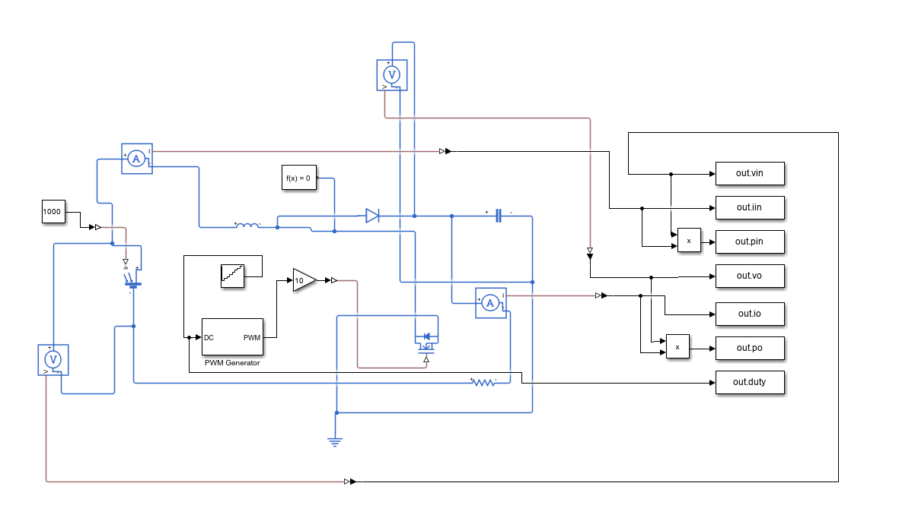
Figure 1. Verified open-loop solar PV boost-converter model with logged outputs vin, iin, pin, vo, io, po, and duty.

4. Build-from-Scratch Procedure
Follow the steps below to reconstruct the verified open-loop circuit in MATLAB/Simulink.
- Open MATLAB and create a new blank Simulink model.
- Place the solar input source at the left side of the model and apply the irradiance value of 1000 through the input arrangement used in the verified circuit.
- Insert an input current sensor in series with the PV positive path and place an input voltage sensor across the PV terminals.
- Connect the inductor in series with the input path and connect the diode from the switching node to the output node to form the boost-converter power stage.
- Place the controlled switch from the switching node to ground, matching the open-loop power-stage connection used in the verified circuit.
- Place the output capacitor across the output terminals and connect the resistive load branch at the output side.
- Insert an output current sensor in series with the load branch and an output voltage sensor across the output terminals.
- Insert the PWM Generator block and connect its pulse output to the gate-drive path of the switch through the gain/conditioning path used in the model.
- Bring the voltage and current sensor outputs to PS-Simulink Converter blocks.
- Use one Product block to compute input power as vin × iin and another Product block to compute output power as vo × io.
- Connect To Workspace blocks for vin, iin, pin, vo, io, po, and duty exactly as labeled in the verified model.
- Run the simulation and post-process the logged outputs to obtain the output I–V and P–V characteristics.

5. Connection Map for Verification
Signal / Path | Connection Chain | Function
Input current measurement | PV source → input current sensor → inductor | Measures iin on the source side.
Input voltage measurement | Voltage sensor across PV input terminals | Measures vin.
Gate-drive path | Duty command → PWM Generator → switch gate | Provides open-loop switching pulses.
Output voltage measurement | Voltage sensor across output capacitor / load terminals | Measures vo.
Output current measurement | Load branch → output current sensor | Measures io.
Power and logging path | vin×iin → pin, vo×io → po, direct log of duty | Stores all required experiment variables.

6. Exact Block Settings and Output Logging Arrangement
Setting | Value used
Irradiance input | 1000
Converter mode | Open loop
Inductor value | 100 µH
Capacitor value | 1000 µF
PWM switching frequency | 25 kHz
Duty logging | Logged directly as out.duty
Sensor logging | vin, iin, vo, io through PS-Simulink conversion
Logged Variable | Signal Stored
vin | Input voltage
iin | Input current
pin | Input power
vo | Output voltage
io | Output current
po | Output power
duty | Applied duty signal
MATLAB post-processing note. The following simple workspace routine is sufficient to plot the final output characteristics from the logged variables.
vo_data = out.vo;
io_data = out.io;
po_data = out.po;

V = vo_data(:);
I = io_data(:);
P = po_data(:);

valid = isfinite(V) & isfinite(I) & isfinite(P);
V = V(valid); I = I(valid); P = P(valid);

[Vsort, idx] = sort(V);
Isort = I(idx);
Psort = P(idx);

figure; plot(Vsort, Isort, 'LineWidth', 2); grid on;
xlabel('Output Voltage Vo (V)'); ylabel('Output Current Io (A)');
title('Output I-V Characteristics');

figure; plot(Vsort, Psort, 'LineWidth', 2); grid on;
xlabel('Output Voltage Vo (V)'); ylabel('Output Power Po (W)');
title('Output P-V Characteristics');

7. Results and Graphical Characteristics

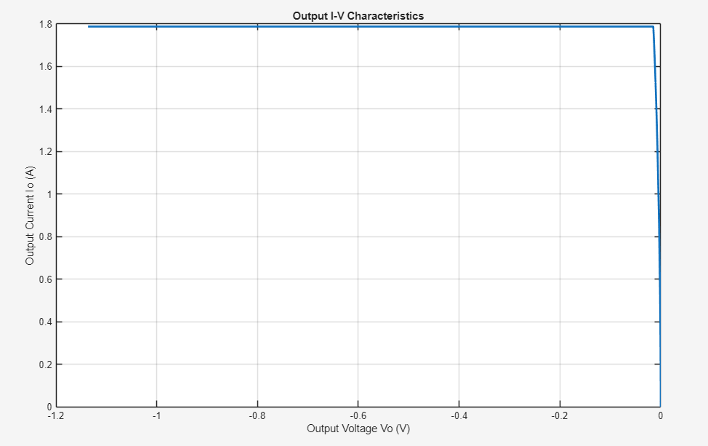
Figure 2. Output I–V characteristic obtained from the verified open-loop boost-converter model.

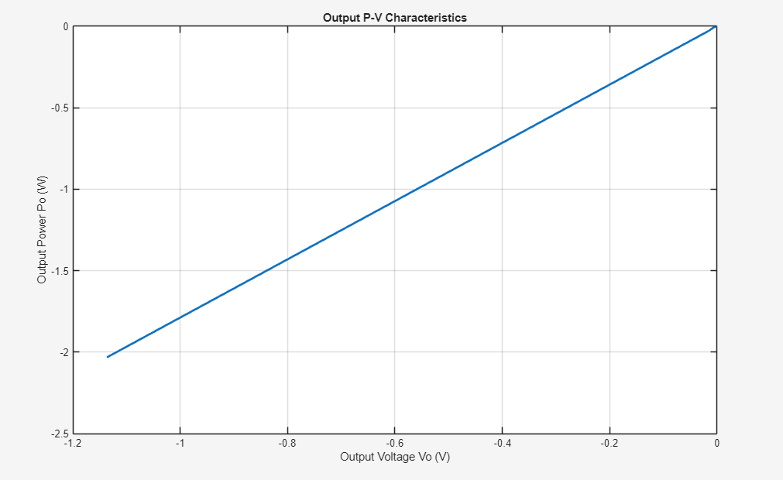
Figure 3. Output P–V characteristic obtained from the verified open-loop boost-converter model.

8. Representative Observed Values from the Verified Output
Note. The following values are representative readings approximated from the obtained output curves. The sign follows the sensor polarity used in the verified model.
S. No. | Output Voltage Vo (V) | Output Current Io (A) | Output Power Po (W)
1 | 0.00 | 0.00 | 0.00
2 | -0.20 | 1.79 | -0.36
3 | -0.40 | 1.79 | -0.72
4 | -0.60 | 1.79 | -1.07
5 | -0.80 | 1.79 | -1.43
6 | -1.00 | 1.79 | -1.79
7 | -1.13 | 1.79 | -2.02
Quantity |  | Approximate Value
Current plateau, Io |  | 1.79 A
Maximum magnitude of output voltage, |Vo| |  | 1.13 V
Maximum magnitude of output power, |Po| |  | 2.02 W
Sign convention observed |  | Vo and Po are negative because of measurement polarity

9. Discussion and Inference
The obtained output I–V plot shows that the output current remains almost constant at about 1.79 A over most of the voltage span and falls sharply near the zero-voltage end. This is the dominant behaviour visible in the verified output graph.
The output P–V curve is nearly linear in the obtained result because the current remains almost constant while the output voltage changes. Since the voltage is logged with negative polarity, the power also appears negative in the plotted graph.
The negative sign of Vo and Po should therefore be interpreted as a reference-direction issue of the measurement blocks rather than as a failure of the boost converter model itself. In practical record writing, this sign observation must be reported honestly instead of being silently altered.
The verified circuit also satisfies the laboratory requirement of logging duty cycle, input quantities, and output quantities to the workspace through named outputs such as out.vin, out.iin, out.pin, out.vo, out.io, out.po, and out.duty.

10. Precautions
- Ensure that the current sensors are connected in series and the voltage sensors are connected in parallel at the required measurement points.
- Route all physical-signal outputs through PS-Simulink Converter blocks before sending them to To Workspace blocks.
- Keep the duty input within the valid range expected by the PWM Generator block.
- Check polarity of the input and output sensors before interpreting the sign of the plotted quantities.
- Do not modify the obtained graph signs manually; report the observed output exactly as generated by the model.

11. Result
Result. Thus, the solar-PV-powered DC/DC boost converter under open-loop condition was simulated successfully in MATLAB/Simulink. The required signals vin, iin, pin, vo, io, po, and duty were obtained through the verified model, and the output I–V and P–V characteristics were plotted successfully.

