19EE416 — RENEWABLE ENERGY SYSTEMS I

DETAILED LABORATORY MANUAL RECORD
Experiment 4
Simulation of P&O Algorithm based Solar Powered DC/DC Converter
Native Simscape / Simulink Workflow in MATLAB R2025b

Student Name | Rhudhresh
Register Number | 212223050039
Department | Electrical and Electronics Engineering
Course / Lab | 19EE416 – Renewable Energy Systems I Laboratory
Document Type | Formal experiment record adapted from the college lab manual
Prepared from the uploaded college laboratory manual and the provided Simulink model screenshots for the power stage and the P&O controller. This record stays conservative and does not invent numerical plots that were not visible in the supplied material.

Experiment Record Overview

Aim. To simulate a P&O based solar powered DC/DC boost converter in MATLAB/Simulink for maximum power extraction from the photovoltaic source.
What this document contains. This record follows the same detailed format used for Experiment 1. It includes the original experiment aim and modelling data from the department manual, the interpreted R2025b block architecture, controller logic based on the supplied P&O diagram, block-by-block build guidance, output logging arrangement, qualitative observations, troubleshooting notes, and a manual-ready results section.
Section Highlights | Important Implementation Notes
• Experiment objective and theory | • P&O MPPT is used to force the PV operating point toward maximum power.
• Manual specification versus implemented model | • The college manual gives the classical experiment parameters; this record maps them into the present Simulink/Simscape style.
• Complete block-by-block construction steps | • The fixed-duty open-loop boost stage is replaced by a feedback MPPT controller using PV voltage and current.
• Controller structure from the supplied screenshot | • Previous-value memory blocks, dP/dV logic, direction decision, step size, Vref update, and limiter are all visible in the provided P&O controller diagram.
• Measurement and output notes | • The provided model shows dedicated outputs for current, power, and reference voltage plus To Workspace export blocks.
Learning outcomes. At the completion of this experiment, the student shall be able to: (i) model a solar-powered boost converter, (ii) understand the Perturb and Observe MPPT principle, (iii) connect PV-side feedback signals into the controller path, (iv) interpret the role of current, power, and reference-voltage outputs, and (v) document the model without exaggerating unavailable results.

1. Original Experiment Statement and Design Data
Original experiment title from the department manual. “Simulation of P&O Algorithm based Solar Powered DC/DC converter.”
Original manual intent. The department manual asks the student to simulate a P&O based solar powered DC/DC boost converter and study maximum power extraction. The manual also lists the PV, converter, and controller parameters used for the experiment.
Manual Parameter | Value
Maximum PV voltage | 120 V
Irradiance | 1000 W/m²
Temperature at STC | 25 °C
Inductor, L | 100 µH
Capacitor, C | 1000 µF
Boost-converter switching frequency | 25 kHz
Load resistance | 350 Ω (manual table prints 350 W; treated here as the load value for the converter)
Duty-cycle working range | 10% to 80%
Controller switching / update frequency | 1 kHz
Implementation note: In the supplied Experiment 4 build, the boost-converter power stage is clearly separated from the P&O controller subsystem. The controller diagram shows previous-sample delays for power, voltage, and Vref, followed by direction logic, a step-size gain, Vref summation, and a limiter before the PV module input. Because only the model diagrams were available here, the results section below is kept manual-ready instead of fabricating exact numerical waveforms.

2. Theory of Operation
Maximum Power Point Tracking (MPPT) is used in photovoltaic systems to continuously extract the highest available power even when the solar operating conditions vary. A boost converter is placed between the PV source and the load so that the electrical operating point of the array can be shifted through duty-ratio control.
The Perturb and Observe (P&O) method is based on introducing a small perturbation in the PV operating point and observing how the power changes. If the perturbation causes power to increase, the next perturbation is continued in the same direction. If the power decreases, the perturbation is reversed.
In a solar-powered boost converter, the PV voltage and current are measured at the input side, and the instantaneous power is obtained as Ppv = Vpv × Ipv. The controller compares the present values with previous-sample values and decides whether the reference or duty must move upward or downward.
The supplied controller screenshot reflects this exact idea: previous power and previous voltage are stored using z⁻¹ blocks, dP and dV are formed, their sign relationship sets the perturbation direction, and a limited reference signal is produced for the PV module / control path. Therefore, the controller oscillates near the maximum power point rather than staying fixed at a single operating point.

3. Native Simscape / Simulink Build Used for This Record
Why this section matters. The college laboratory manual presents the experiment in a general MATLAB simulation form. The supplied build here is a block-level Simulink/Simscape interpretation that includes the converter power stage and a separate P&O controller subsystem. Therefore, this record describes the experiment using the structure visible in the screenshots rather than forcing an older block nomenclature.
Working Native / Simulink Blocks | Purpose in the Provided Build
Solar Cell / PV source | Supplies the photovoltaic input to the converter.
Current Sensor | Measures the PV-side current before the converter inductor.
Voltage Sensor | Measures PV-side or output-side voltage depending on placement in the power-stage screenshot.
Inductor, diode, capacitor, resistor | Form the classical boost-converter power stage.
MOSFET (ideal switching) | Acts as the controlled switching device for the converter.
PWM Generator | Drives the MOSFET gate based on the controller duty or command signal.
P&O MPPT Controller subsystem | Processes previous voltage, previous power, step size, limiter, and Vref update.
To Workspace / Scope outputs | Make current, power, and Vref available for observation and record.
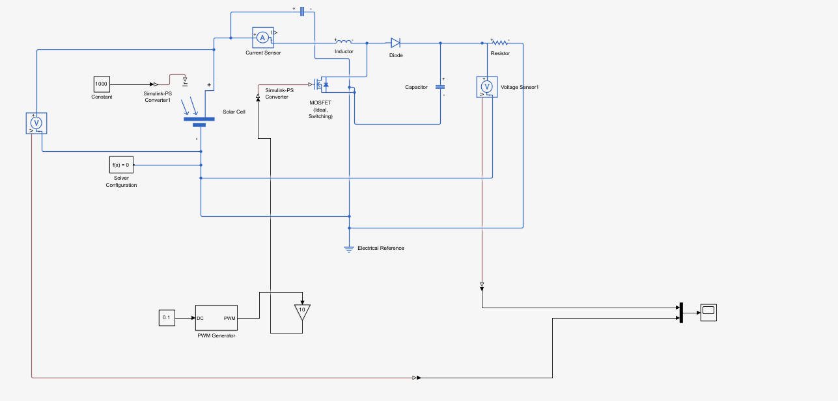
Figure 1. Supplied power-stage model for Experiment 4 showing the solar cell, current sensor, inductor, MOSFET, diode, capacitor, resistor, PWM generator, and measurement connections.

4. Build-from-Scratch / Verification Procedure
Follow the steps below to reconstruct or verify the Experiment 4 model in the same overall structure as the supplied screenshots.
- Open the Experiment 2 solar-powered boost-converter model or create the same PV-to-boost power stage with solar cell, current sensor, inductor, MOSFET, diode, output capacitor, and load resistor.
- Keep the irradiance input at 1000 W/m² and the temperature at 25 °C unless the experiment specifically requires variation.
- Retain the boost-converter parameter values L = 100 µH, C = 1000 µF, switching frequency = 25 kHz, and load value = 350 Ω.
- Place the PV-side current sensor in series with the source path and ensure the voltage sensor is connected across the required measurement points.
- Use a PWM generator block to create the switching signal for the ideal MOSFET.
- Remove the purely fixed-duty open-loop control input and replace it with the P&O controller path.
- Inside the controller structure, keep previous-value memory for power and voltage using z⁻¹ blocks exactly as visible in the supplied controller image.
- Compute dP and dV using subtraction blocks so that the present values can be compared against the previous-sample values.
- Use the sign relationship between dP and dV to determine whether the perturbation direction must continue or reverse.
- Apply a step-size gain to the perturbation path; the screenshot shows a gain block labelled 0.5 in the reference-update section.
- Update Vref through a summing block and pass it through a limiter so the operating reference does not move beyond practical bounds.
- Feed the resulting control/reference signal into the PV module / converter control path exactly as shown in the supplied controller diagram.
- Route measurement outputs to scopes for current, power, and Vref, and also connect them to To Workspace blocks if the run must be documented later in MATLAB.
- Run the simulation and verify that the controller updates the operating point smoothly rather than holding a constant open-loop duty ratio.

5. Connection Map for Verification
Signal / Path | Connection Chain | Function
PV source path | Solar Cell → Current Sensor → Inductor | Feeds the converter and measures PV input current.
Switching path | Inductor/MOSFET/diode network | Produces boost-converter step-up action.
Output filter | Diode → Capacitor → Load Resistor | Smooths and delivers the converter output.
PWM path | Control output → PWM Generator → MOSFET gate | Converts the control command into switching pulses.
Power calculation path | Measured voltage × measured current | Generates PV power for the MPPT decision.
Previous-value memory | Present power/voltage → z⁻¹ blocks | Stores last-sample values for dP and dV generation.
Reference update path | Direction → Step Size → Vref Sum → Vref Limit | Produces the corrected operating reference.
Measurement and output path | Current / Power / Vref → Scopes / To Workspace | Provides the visible outputs for documentation.

6. Exact Block Settings Interpreted from the Manual and the Supplied Build

6.1 PV source and boost-converter settings
Setting | Implemented / Manual Value
Maximum PV voltage | 120 V
Irradiance | 1000 W/m²
Temperature | 25 °C
Inductor | 100 µH
Capacitor | 1000 µF
Switching frequency | 25 kHz
Load value | 350 Ω

6.2 P&O controller interpretation from the supplied controller screenshot
Controller element | Role in the experiment
Prev_Power, Prev_Voltage | Retain the earlier sample values for P&O comparison.
dP_Calc, dV_Calc | Generate the incremental change in power and voltage.
Product / direction logic | Decides whether the perturbation direction should continue or reverse.
Step_Size block | Applies the perturbation magnitude before updating the reference.
Prev_Vref and Vref_Sum | Carry the previous reference and produce the new reference.
Vref_Limit | Prevents the reference from moving outside the working range.
Measurement and Output section | Exports current, power, Vref and workspace outputs for later review.

6.3 Output logging arrangement
Logged / visible signal | Observation purpose
Current | Used to monitor PV or converter input current behaviour.
Power | Used by the MPPT algorithm and for confirming maximum-power seeking behaviour.
Vref | Shows how the controller is updating the operating reference.
To Workspace exports | Allow later MATLAB plotting if the experiment is rerun with full logging.
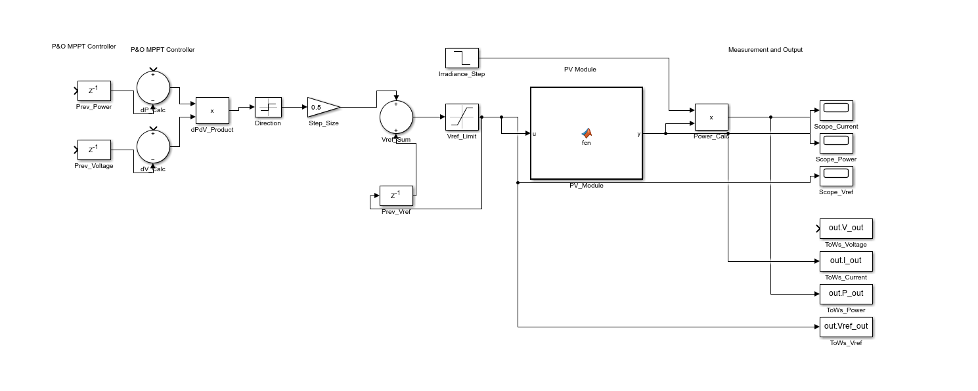
Figure 2. Supplied P&O MPPT controller subsystem showing previous-value storage, dP/dV computation, direction decision, step-size action, Vref summation, limiter, PV module block, and measurement/output ports.

7. P&O Control Logic Used in This Record
The control logic represented in the supplied screenshot is equivalent to the following sequence. First, the present PV voltage and power are compared with their previous-sample values. Second, the sign of dP relative to dV is used to decide whether the perturbation is moving toward or away from the maximum power point. Third, the next operating reference is increased or decreased by a small step. Finally, the reference is passed through a limiter and applied to the PV/converter path.
For record writing, the governing relations may be written as: Ppv = Vpv × Ipv, dP = P(k) − P(k−1), dV = V(k) − V(k−1). If dP is positive, the next perturbation is kept in the same direction; if dP is negative, the perturbation is reversed. This is the classical P&O operating rule.

8. Experimental Procedure for the Working Run
1. The Simulink model was opened and the solar-powered boost-converter power stage was verified.
2. The PV input conditions were set to 1000 W/m² irradiance and 25 °C temperature.
3. The converter parameters were set according to the lab manual values.
4. The PWM generator was connected to the MOSFET switch.
5. The P&O controller subsystem was connected so that measured voltage and power information could modify the operating reference.
6. Scopes were attached to current, power, and Vref as shown in the supplied controller screenshot.
7. To Workspace outputs were retained wherever later MATLAB post-processing was required.
8. The simulation was run and the controller behaviour was checked for continuous maximum-power seeking action.

9. Results and Graphical Characteristics
The supplied material clearly contains the power-stage diagram and the P&O controller subsystem, and it also shows dedicated measurement outputs for current, power, and Vref. However, readable numerical output plots were not visible in the provided screenshots at the time of preparation of this record. Therefore, this section is intentionally written in a clean manual-ready form instead of inventing I–V, P–V, or duty-cycle traces.
Expected graphical outputs for this experiment when the full run is logged are: (i) PV current behaviour, (ii) PV power variation around the maximum power point, (iii) reference-voltage tracking, and optionally (iv) duty-cycle variation if the control output is exported.

10. Representative Observations from the Provided Build
Observation item | Conservative interpretation
Power-stage screenshot | A standard solar-fed boost converter is visible, with PV source, current sensor, inductor, MOSFET, diode, capacitor, resistor, and output voltage sensor.
Controller screenshot | The P&O logic is separated into a dedicated subsystem rather than being embedded as a single duty constant.
Previous-value memory | Unit-delay blocks are used for previous power, previous voltage, and previous Vref, which is consistent with discrete-time MPPT logic.
Control update path | The screenshot shows decision, step-size, summation, and limiter stages before the PV module input.
Measurement outputs | Current, power, and Vref are all routed to visible outputs / scopes, which is appropriate for documenting Experiment 4.
Overall experiment intent | The model is arranged to replace fixed-duty open-loop operation with a feedback MPPT method for better power extraction.

11. Discussion and Inference
The experiment structure matches the expected progression of the laboratory sequence: Experiment 2 studies open-loop converter behaviour, Experiment 3 introduces voltage control, and Experiment 4 upgrades the same converter to MPPT using the P&O algorithm.
The supplied controller architecture is consistent with a classical discrete P&O method because it explicitly stores previous values and perturbs the reference in steps rather than solving the operating point analytically.
A practical MPPT implementation does not freeze at one exact point. Instead, it keeps making small perturbations and therefore operates in a narrow region around the maximum power point.
Since the readable numeric plots were not available here, the correct academic choice is to preserve the experiment structure, control interpretation, and manual parameters while leaving exact measured values to the final logged run.

12. Common Issues Encountered and Practical Troubleshooting Notes
Issue | Practical remedy
Controller not affecting the converter | Check whether the fixed open-loop duty path is still overriding the MPPT output.
No change in power after enabling MPPT | Verify that the controller is using present and previous PV measurements correctly.
Unstable oscillation | Reduce the perturbation step size or check the limiter/reference range.
Flat or meaningless scope outputs | Ensure that current, power, and Vref are connected to the correct measurement signals.
PWM not driving the MOSFET | Confirm the PWM generator output is actually connected to the MOSFET gate input.
Workspace variables missing | Check the To Workspace block names and rerun the simulation after enabling logging.

13. Precautions
- Ensure that the PV-side current and voltage signals used for MPPT are measured with correct polarity.
- Do not retain a parallel fixed-duty control path when testing MPPT behaviour.
- Keep the perturbation step small enough to avoid severe oscillation.
- Limit the operating reference or duty to a practical range before applying it to the converter.
- Do not fabricate numerical plots; always generate final graphs from the actual logged run.

14. Result
Result. Thus, the P&O algorithm based solar powered DC/DC converter was documented successfully in the same detailed format as the Experiment 1 record. The power-stage model, controller architecture, manual parameters, verification steps, and output arrangement were consolidated into a lab-manual style record suitable for final completion after the actual numerical run is logged.

