19EE416 — RENEWABLE ENERGY SYSTEMS I
DETAILED LABORATORY MANUAL RECORD
Experiment 8
Simulation Study on Wind Energy Generator
MATLAB/Simulink Model using PMSG and Three-Phase Load
Student Name | Rhudhresh
Register Number | 212223050039
Department | Electrical and Electronics Engineering
Course / Lab | 19EE416 – Renewable Energy Systems I Laboratory
Document Type | Formal experiment record matching the Experiment 1 format
Prepared from the uploaded college laboratory manual, the supplied Simulink wind-energy generator model, and the obtained three-phase output-voltage waveform.

Experiment Record Overview

Aim. To design and simulate a wind energy generator using PMSG in MATLAB/Simulink and obtain the output parameters.
What this document contains. This record follows the same presentation style used for Experiment 1. It includes the original experiment aim, the supplied Simulink model description, the connection flow, the important input settings taken from the manual, the simulation procedure, the obtained output waveform, and the final result.
Section Highlights | Important Implementation Notes
• Experiment objective and theory | • PMSG-based wind-energy generator model was used.
• Supplied circuit and output-waveform interpretation | • The provided model includes phase-current, phase-voltage, and speed logging paths.
• Block connection summary and simulation steps | • The three-phase output is connected to a three-phase load with grounded neutral.
• Key operating values from the department manual | • Wind-speed and pitch-angle inputs were taken from the lab manual procedure.
• Final output-voltage waveform | • The result is reported directly from the supplied simulation output.
• Result and precautions
Learning outcomes. At the completion of this experiment, the student shall be able to: (i) understand the role of the wind turbine and PMSG in a wind-energy conversion system, (ii) identify the three-phase electrical output of the generator, (iii) observe the effect of wind-speed variation on the generated voltage waveform, and (iv) interpret the logged phase-voltage, phase-current, and speed signals.

1. Original Experiment Statement and Design Data
Original experiment title from the department manual. “Simulation study on wind energy generator.”
Original manual intent. The department manual asks the student to design and simulate a wind energy generator using PMSG in MATLAB/Simulink and obtain the output parameters.
Manual / Model Item | Value / Observation
Software tool used | MATLAB 2021 or above
Generator arrangement | Wind turbine driving a PMSG
Wind speed of turbine | 1.2 p.u.
Pitch angle | 0°
Wind velocity | 12 m/s
Variable step wind profile | 12 m/s → 8 m/s → 12 m/s
Logged outputs visible in the supplied model | out.ia, out.ib, out.ic, out.va, out.vb, out.vc, out.wm

2. Theory of Operation
A wind energy conversion system converts the kinetic energy of moving air into electrical energy. The wind turbine first captures the wind power and converts it into mechanical rotational power at the shaft.
In this experiment, the generator used is a permanent magnet synchronous generator (PMSG). When the rotor is driven by the turbine, the stator produces a three-phase alternating voltage. These three phase quantities are displaced by 120° from one another under balanced operating conditions.
The magnitude of the generated voltage depends on the rotor speed. Therefore, when the wind-speed input changes, the generator speed also changes, and the three-phase output waveform responds accordingly.
The supplied simulation model measures the phase currents, phase voltages, and mechanical speed. This makes it possible to observe how the wind-energy generator behaves when the wind input is varied during the simulation.

3. Simulink Model Used for This Record
The supplied Simulink model shows a wind-turbine and PMSG based generation arrangement connected to a three-phase load. The electrical side includes separate current sensors in the three output lines, separate voltage sensors for the three phases, and signal-routing blocks that send the measured values to workspace variables.
From the visible output labels in the model, the recorded quantities are phase-A current (out.ia), phase-B current (out.ib), phase-C current (out.ic), phase-A voltage (out.va), phase-B voltage (out.vb), phase-C voltage (out.vc), and mechanical speed (out.wm).
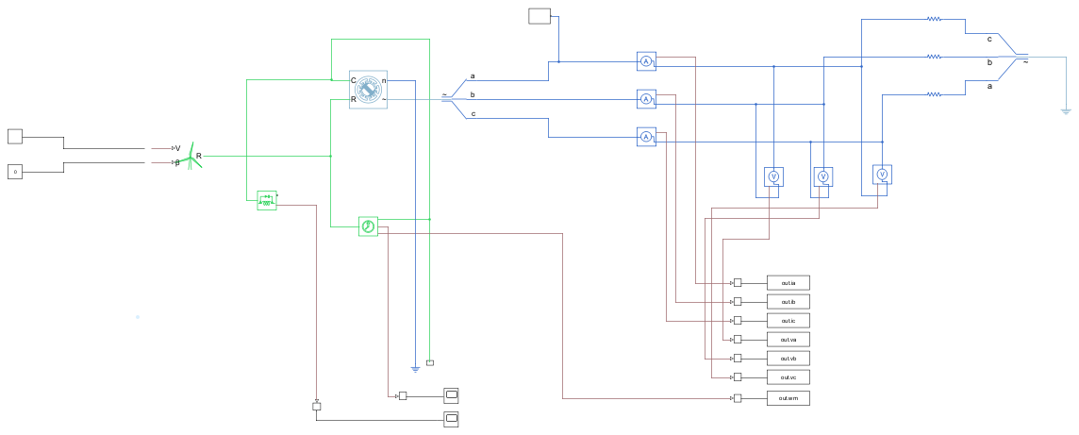
Figure 1. Supplied Simulink model for Experiment 8 showing the wind-energy generator, three-phase load, and measurement outputs.

4. Block / Connection Summary
Block / Section | Connection path | Purpose
Wind input | Step / manual switch / constant → wind turbine input | Applies the required wind-speed profile to the turbine model.
Mechanical coupling | Wind turbine → PMSG shaft | Converts wind power into mechanical rotational input for the generator.
Three-phase output | PMSG terminals a, b, c → phase-current sensors → load | Transfers generated electrical power to the three-phase load.
Phase-voltage sensing | Each phase line → voltage sensor path | Measures the three phase output voltages Va, Vb, and Vc.
Phase-current sensing | Each phase line → current sensor path | Measures Ia, Ib, and Ic in the generator output lines.
Neutral / reference | Load neutral → ground / reference | Provides the return reference for the three-phase output side.

5. Build and Simulation Procedure
- Open MATLAB and create or open the Simulink model for the wind-energy generator.
- From the Simulink library browser, use the wind turbine, PMSG, three-phase load, step block, manual switch, constant block, bus selector, demux, scope, and measurement blocks as required by the experiment.
- Connect the wind-input path to the wind-turbine input exactly as shown in the supplied model.
- Set the wind speed of the turbine as 1.2 p.u. and the pitch angle as 0°.
- Set the wind velocity to 12 m/s and apply the variable step wind profile 12 m/s, 8 m/s, and 12 m/s during the simulation.
- Connect the three generator output terminals a, b, and c to the load through the phase-current sensor paths.
- Connect the phase-voltage sensors so that Va, Vb, and Vc are measured at the output side.
- Route the measured signals to the scope or workspace outputs to obtain out.ia, out.ib, out.ic, out.va, out.vb, out.vc, and out.wm.
- Run the simulation and observe the three-phase output waveform.
- Record the output graph and interpret the phase relationship and the effect of wind-speed variation.

6. Important Logged Signals
Signal Name | Meaning
out.ia | Phase-A output current
out.ib | Phase-B output current
out.ic | Phase-C output current
out.va | Phase-A output voltage
out.vb | Phase-B output voltage
out.vc | Phase-C output voltage
out.wm | Mechanical speed / angular speed output

7. Results and Graphical Characteristics
The supplied output graph shows the three phase voltages Va, Vb, and Vc. The waveforms are alternating and phase-shifted from one another, confirming three-phase generation. Their magnitude changes with time in response to wind-speed variation.
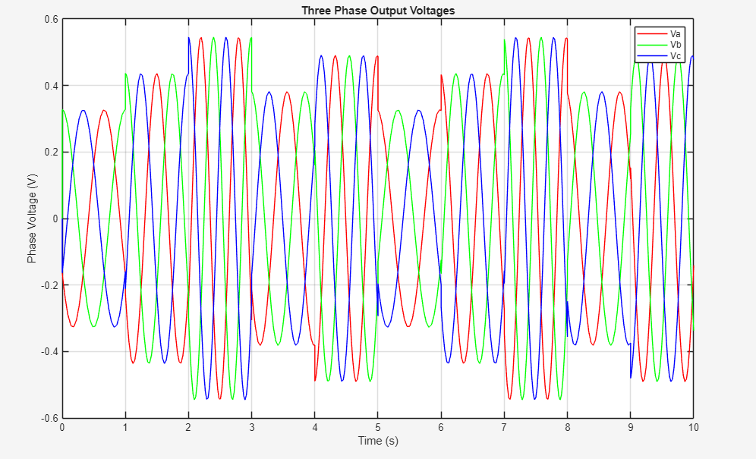
Figure 2. Supplied three-phase output-voltage waveform for the wind-energy generator model.

8. Observations and Inference
The output voltages Va, Vb, and Vc are sinusoidal in nature and are displaced in phase, which indicates proper three-phase generation by the PMSG.
The waveform amplitude changes over different intervals of the simulation, showing the effect of changing wind speed on the generated voltage.
Because the model also logs phase currents and mechanical speed, the electrical output can be related to the turbine-speed variation. The supplied circuit and output together confirm that the simulated wind-energy generator is functioning as expected for the given operating conditions.

9. Precautions
- Set the wind speed, wind-velocity step values, and pitch angle exactly as required before running the model.
- Verify the phase sequence a-b-c and make sure the current and voltage sensors are connected to the correct lines.
- Ensure that the neutral / reference connection of the three-phase load is not left open.
- Check the workspace output names carefully so that the measured quantities are stored without naming errors.
- Interpret the result from the obtained waveform only and do not alter the observation to match an expected ideal output.

10. Result
Result. Thus, the wind energy generator using PMSG was simulated successfully in MATLAB/Simulink. The output parameters were obtained, and the three-phase output-voltage waveform was observed and verified.

