Caching, Redis/Memcache, Eviction Strategies & LRU Cache Design
A structured reference covering caching fundamentals through a full LRU cache implementation

1. What is Caching?
Caching is the practice of storing a copy of data in a location that can be accessed faster than the original source, so that repeated requests for that data can be served quickly instead of repeating the expensive work of computing, fetching, or transferring it every time.
A cache trades memory (a limited, fast resource) for time (avoiding a slow operation). It is effective because of the principle of locality:
- Temporal locality — data accessed recently is likely to be accessed again soon.
- Spatial locality — data near recently accessed data is likely to be accessed soon.

1.1 Caching in Computer Organization
At the hardware level, caching bridges the speed gap between the CPU and main memory (RAM). CPUs can execute billions of instructions per second, but fetching data from RAM takes far longer in relative terms. To avoid stalling on every memory access, processors use a hierarchy of caches:
- L1 Cache — smallest and fastest, private to each core, split into instruction and data caches.
- L2 Cache — larger, slightly slower, often private to each core or shared between a pair of cores.
- L3 Cache — shared across all cores on the chip, larger still, closer to RAM in latency.
When the CPU needs data, it checks L1 first, then L2, then L3, and only goes to RAM on a full miss (this is called walking the cache hierarchy). Because of spatial locality, caches load data in fixed-size blocks called cache lines (commonly 64 bytes) rather than single bytes, so nearby memory is preloaded speculatively.
Other computer-organization examples include the Translation Lookaside Buffer (TLB), which caches virtual-to-physical address translations, and disk caches, which keep recently read disk blocks in RAM.

1.2 Caching in Web Applications
In web systems, caching appears at almost every layer of the request path:
- Browser cache — stores static assets (images, CSS, JS) locally so repeat visits skip the network entirely.
- CDN (edge) cache — caches responses geographically close to users, reducing latency and origin server load.
- Reverse proxy / gateway cache — tools like Varnish or Nginx cache full HTTP responses in front of application servers.
- Application-level cache — an in-memory store (e.g., Redis, Memcached, or an in-process LRU map) that holds computed results, session data, or frequently read database rows.
- Database cache — the database engine's own buffer pool caches recently used pages/rows in memory.
A concrete example: an e-commerce product page might query the database on the very first request, then store the rendered result in Redis with a short expiry. Every subsequent request for that page is served straight from Redis until the entry expires or the underlying product data changes — cutting database load dramatically for popular pages.

2. Introduction to Redis and Memcached
Redis and Memcached are the two most widely used in-memory data stores for application-level caching. Both keep data in RAM for very low-latency access, but they differ meaningfully in capability.

2.1 Memcached
Memcached is a simple, high-performance, distributed in-memory key-value store designed purely for caching.
- Data model: plain key-value pairs only; values are typically byte strings (often serialized objects), with a size limit per item (1 MB by default).
- Multithreaded: can use multiple CPU cores within a single instance, which helps under very high, simple read/write load.
- No persistence: data lives only in memory — a restart wipes the cache completely.
- No built-in replication or advanced data structures — scaling and high availability are typically handled at the application or infrastructure layer (e.g., consistent hashing across nodes).
- Best suited for: simple, high-throughput caching of small blobs — HTML fragments, session tokens, database query results — where losing the cache on restart is acceptable.

2.2 Redis
Redis (REmote DIctionary Server) is an in-memory data structure store that can be used as a cache, database, message broker, and more.
- Rich data structures: strings, hashes, lists, sets, sorted sets, bitmaps, hyperloglogs, streams, and geospatial indexes — not just plain key-value pairs.
- Persistence options: RDB snapshots and/or an AOF (append-only file) log allow data to survive a restart, unlike Memcached.
- Replication and clustering: supports primary-replica replication and Redis Cluster for horizontal scaling and high availability.
- Additional features: pub/sub messaging, Lua scripting, transactions, and native key expiry (TTL) for cache eviction.
- Mostly single-threaded core (per shard): extremely fast for typical workloads because it avoids locking overhead, though very large values or heavy scripting can block other operations.
- Best suited for: caching plus anything that benefits from structure — leaderboards (sorted sets), rate limiting (counters with TTL), session stores, queues, and pub/sub notifications.

2.3 Redis vs Memcached — When to Choose Which
Aspect | Memcached | Redis
Data types | Strings/blobs only | Strings, hashes, lists, sets, sorted sets, streams
Persistence | None | RDB / AOF options
Threading | Multithreaded | Mostly single-threaded per shard
Replication/HA | Not built-in | Built-in replication and clustering
Typical use | Simple, pure caching at high throughput | Caching plus structures, queues, pub/sub, leaderboards

3. Cache Eviction Strategies
A cache has finite capacity, so once it fills up, an eviction strategy decides which item to remove to make room for a new one. Choosing the right policy directly affects the cache hit ratio, which is the real measure of how effective a cache is.

3.1 Why Eviction Is Needed
Memory is expensive and limited, so a cache cannot simply grow forever. Without an eviction policy, the cache would either run out of memory or need to be cleared entirely, defeating its purpose. A good eviction policy tries to keep the items most likely to be reused, while discarding items unlikely to be accessed again soon.

3.2 Common Eviction Strategies
LRU (Least Recently Used): evicts the item that has not been accessed for the longest time. Assumes recently used items are likely to be used again soon. Good general-purpose default; used in this document's implementation.
LFU (Least Frequently Used): evicts the item with the lowest access count. Favors items that are accessed often, even if not recently. Useful when popularity is a better predictor than recency (e.g., trending content), but needs extra bookkeeping for frequency counts and can be slow to adapt when access patterns shift.
FIFO (First In, First Out): evicts the oldest inserted item regardless of how often or recently it was used. Simple to implement but ignores usage patterns entirely, so it can evict hot items.
MRU (Most Recently Used): evicts the most recently used item. Counter-intuitive for general caching, but useful in specific scenarios such as looping/sequential scans where the most recently accessed item is the least likely to be accessed again soon (e.g., scanning a large file once).
Random Replacement (RR): evicts a randomly chosen item. Very cheap to implement (no bookkeeping) and surprisingly effective under uniform access patterns, though unpredictable for skewed workloads.
TTL-based expiry: items are evicted once a fixed time-to-live elapses, regardless of usage. Common in Redis/Memcached for data that becomes stale after a known period (e.g., an API rate-limit counter, a session token).

3.3 When to Use Which
- Use LRU when recent access is a strong predictor of future access — most general-purpose application caches (this is the default choice in most systems, including Redis's approximated LRU and Linux's page cache).
- Use LFU when certain items are consistently popular over long periods and recency alone would evict them unfairly — e.g., caching the most-viewed articles on a news site.
- Use FIFO when simplicity matters more than hit ratio, or access patterns are close to uniform, so the extra bookkeeping of LRU/LFU isn't worth it.
- Use TTL-based expiry when data has a natural staleness window (auth tokens, rate limits, computed reports) rather than an intrinsic 'usefulness' pattern.
- Use Random Replacement in resource-constrained environments (e.g., embedded systems) where even LRU's bookkeeping overhead is too costly.

4. UML Class Diagram — LRU Cache (Circular DLL + HashMap)
The diagram below models an LRU cache built from two cooperating structures: a HashMap for O(1) key lookup, and a circular doubly linked list (DLL) of Node objects that tracks usage order. The HashMap maps each key directly to its Node, so a lookup never has to walk the list; the list itself is only walked implicitly (moving a node to the front, or evicting the node just before the sentinel).
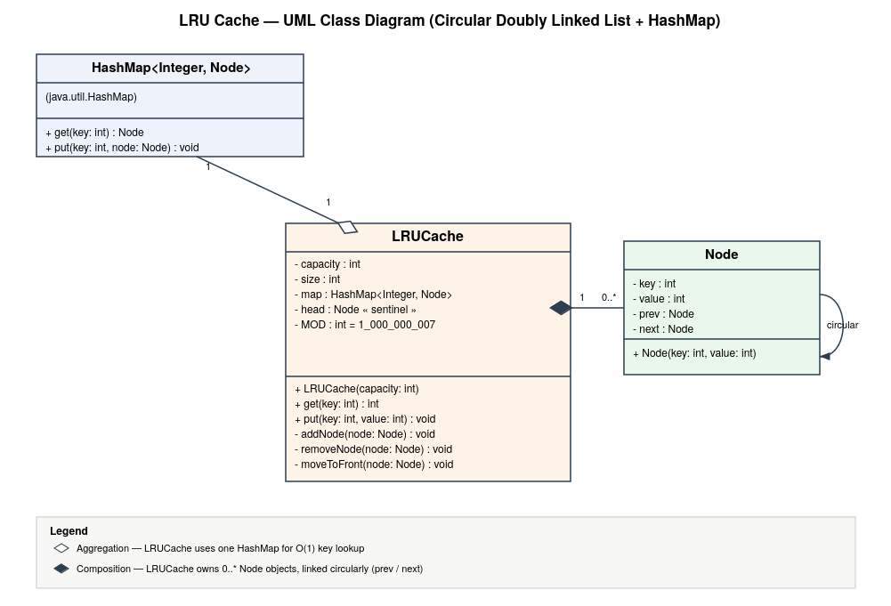
Design notes:
- head is a sentinel (dummy) node. Its own next points to the most-recently-used real node, and its own prev points to the least-recently-used real node — this is what makes the list circular and avoids null checks at the boundaries.
- Every Node lives in exactly two structures at once: as a value in the HashMap (for lookup by key) and as a link in the DLL (for tracking order) — the two structures share the same Node objects rather than duplicating data.
- get and put are both O(1): map lookup is O(1), and unlinking/relinking a node in a doubly linked list is O(1) regardless of list size.

5. Why Circular Doubly Linked List Is Preferred
An LRU cache needs two operations to be fast: (a) move an arbitrary node to the 'most recently used' end, and (b) remove the node at the 'least recently used' end. The data structure choice is driven entirely by how cheaply it supports these two operations.

5.1 Circular DLL vs Arrays
- Arrays require shifting elements to move an item to the front or to remove one from the middle — O(n) per operation, which defeats the purpose of an O(1) cache.
- A DLL only needs to relink a constant number of pointers (prev/next of the neighbors) to move or remove any node — O(1) regardless of where the node is.
- Arrays have a fixed size (or require costly resizing/copying); a linked list grows and shrinks node-by-node with no copying.

5.2 Circular DLL vs Singly Linked List
- To remove a node from a singly linked list, you must know its predecessor (since only next pointers exist), which normally means walking the list from the head — O(n). A doubly linked list stores prev directly on the node, so removal is O(1) with a direct node reference (which the HashMap provides).
- Moving a node to the front in a singly linked list still requires finding its predecessor first for the same reason; a DLL avoids this entirely.

5.3 Why Make It Circular Specifically
- A circular structure with a sentinel node removes all null-pointer special cases: the head/tail boundaries do not need separate 'if node is head' or 'if node is tail' checks, because the sentinel is always both neighbors of the boundary nodes.
- Insertion (add as most-recently-used) and eviction (remove least-recently-used, found at sentinel.prev) become two uniform, symmetric operations instead of edge-case-laden logic.
- Net result: every LRU operation — get, put, evict — is O(1) time and the code has no special-cased branches for empty list, single-element list, or boundary nodes.

6. Implementation with Comments
Java implementation using a HashMap for O(1) lookup and a circular doubly linked list (with a sentinel node) for O(1) recency tracking.
import java.util.HashMap;
public class LRUCache {
// Node of the circular doubly linked list.
// Holds a key/value pair plus links to its neighbors in usage order.
private static class Node {
int key, value;
Node prev, next;
Node(int key, int value) {
this.key = key;
this.value = value;
}
}
private final int capacity;
private int size;
private final HashMap<Integer, Node> map; // key -> Node, for O(1) lookup
private final Node head; // sentinel: head.next = MRU, head.prev = LRU
public LRUCache(int capacity) {
this.capacity = capacity;
this.size = 0;
this.map = new HashMap<>();
this.head = new Node(-1, -1);
// Sentinel points to itself initially -> empty circular list
head.next = head;
head.prev = head;
}
// Removes a node from the circular list by relinking its neighbors.
// O(1): touches only the two adjacent nodes, regardless of list size.
private void removeNode(Node node) {
node.prev.next = node.next;
node.next.prev = node.prev;
}
// Inserts a node right after the sentinel head, marking it as
// most-recently-used. O(1).
private void addNode(Node node) {
node.next = head.next;
node.prev = head;
head.next.prev = node;
head.next = node;
}
// Moves an existing node to the MRU position.
// Used whenever a key is read or re-written.
private void moveToFront(Node node) {
removeNode(node);
addNode(node);
}
public int get(int key) {
Node node = map.get(key);
if (node == null) {
return -1; // cache miss
}
moveToFront(node); // accessing a key refreshes its recency
return node.value;
}
public void put(int key, int value) {
Node existing = map.get(key);
if (existing != null) {
// Key already present: update value and refresh recency
existing.value = value;
moveToFront(existing);
return;
}
if (size == capacity) {
// Cache full: evict the least-recently-used node,
// which always sits right before the sentinel (head.prev).
Node lru = head.prev;
removeNode(lru);
map.remove(lru.key);
size--;
}
// Insert the new key as the most-recently-used node
Node fresh = new Node(key, value);
addNode(fresh);
map.put(key, fresh);
size++;
}
}
Complexity: both get and put run in O(1) time — a HashMap lookup plus a constant number of pointer updates — and O(capacity) space for the map and the list nodes combined.

