Name: Ryan Hartman Date: 10/4/19
Pledge: I pledge my honor that I have abided by the Stevens Honor System.
For each of the graphs below, list the order in which the vertices are visited in a breadth-first search, starting with vertex 1. If there are multiple vertices adjacent to a given vertex, visit the adjacent vertex with the lowest value first. Then repeat the process for depth-first search.
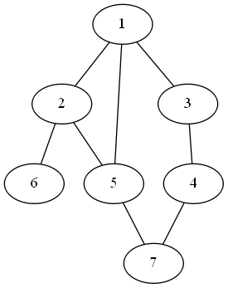

BFS: 1, 2, 3, 5, 6, 4, 7
DFS: 1, 2, 5, 7, 4, 3, 6
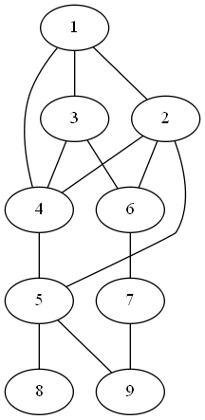

BFS: 1, 2, 3, 4, 5, 6, 8, 9, 7
DFS: 1, 2, 4, 3, 6, 7, 9, 5, 8
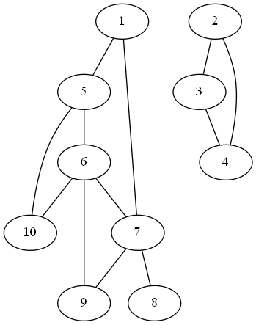

BFS: 1, 5, 7, 6, 10, 8, 9, 2, 3, 4
DFS: 1, 5, 6, 7, 8, 9, 10, 2, 3, 4
For each of the graphs below, list the order in which the vertices are visited in a topological sort, starting with vertex 1. If there are multiple vertices adjacent to a given vertex, visit the adjacent vertex with the lowest value first.
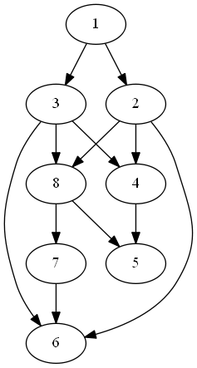

Topological sort: 1, 2, 3, 4, 8, 5, 7, 6
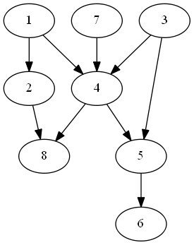

Topological sort: 1, 2, 3, 7, 4, 5, 6, 8

Visit smallest not already visited from current node. If all have bene visited, backtrack until you can.

