Name: Ryan Hartman Date: 9/17/19
Point values are assigned for each question. Points earned: ____ / 100, = ____ %
- Find an upper bound for $f\left(n\right)= n^{4}+10n^{2}+5$. Write your answer here: 2n⁴ , or O(n⁴)) (4 points)

Prove your answer by giving values for the constants $c$ and $n_{0}$. Choose the smallest integral value possible for $c$. (4 points)

$$n^{4}+10n^{2}+2≤cn^{2} ∀ n≥n_{o}$$

$$n^{4}+10n^{2}+2≤2n^{4} ∀ n≥4$$

$∴ C=2$, $n_{o}=4$

- Find an asymptotically tight bound for $f\left(n\right)= {3n}^{3}-2n$. Write your answer here: $θ$(n³) (4 points)

Prove your answer by giving values for the constants $c$ and $n_{0}$. Choose the smallest integral value possible for $c$. (4 points)

Check Lower bound:
$$3n^{3}-2n≥cn^{3} ∀ n≥n_{o}$$

$$3n^{3}-2n≥2n^{3} ∀ n≥2$$

$$∴ C_{1}=2$$

Check upper bound:

$$3n^{3}-2n≤cn^{3} ∀ n≥n_{o}$$

$$3n^{3}-2n≤3n^{3} ∀ n≥1$$

$∴ C_{2}=3 C_{1}=2 n_{o}=2$

- Is $3n-4 ϵ Ω\left(n^{2}\right)?$ No.

If yes, prove your answer by giving values for the constants $c$ and $n_{0}$. Choose the smallest integral value possible for $c$. If no, derive a contradiction. (4 points)

For $3n-4 ϵ Ω\left(n^{2}\right)$, there must exist positive constants n_{o} and C such that:
$3n-4≥Cn^{2} ∀n≥n_{o}$
Well, if we simply solve this expression for n:
$$-4≥Cn^{2}-3n$$
$$n\left(n-3\right)≤ -\frac{4}{C}$$
It becomes clear that the constants n_{o} and C cannot exist. A quantity of n cannot be less than or equal to some constant, because n must be able to grow indefinitely. This inequality implies that n must be restricted to be below a constant, which means no n_{o} can be chosen, and proves by contradiction that this is not of the order $Ω\left(n^{2}\right)$.

- Write the following asymptotic efficiency classes in increasing order of magnitude.
$O(n^{2})$, $O(2^{n})$, $O\left(1\right)$, $O\left(n\lg{n}\right)$, $O(n)$, $O\left(n!\right)$, $O(n^{3})$, $O\left(\lg{n}\right)$, $O\left(n^{n}\right),$ $O\left(n^{2}\lg{n}\right)$ (2 points each)

$O\left(1\right)$, $O\left(lg n\right)$, $O\left(n\right)$, $O\left(nlg n\right)$, $O\left(n^{2}\right)$, $O\left(n^{2}lg n\right)$, $O\left(n^{3}\right)$, $O\left(2^{n}\right)$, $O\left(n!\right)$, $O\left(n^{n}\right)$

- Determine the largest size n of a problem that can be solved in time t, assuming that the algorithm takes f(n) milliseconds. n must be an integer. (2 points each)

- f(n) = $n$, t = 1 second 1E³

- f(n) = $n\lg{n}$, t = 1 hour 204,094

I wrote a python script to continually multiply n times lg(n) until it reached above 3.6E^6 (one minute in ms) then subtract 1 to get max integer. Got me close enough to the answer, which I just continually played with until I found the max number to be 204,094 in a calculator.

- f(n) = $n^{2}$, t = 1 hour 1897

- f(n) = $n^{3}$, t = 1 day 442

- f(n) = $n!$, t = 1 minute 8

- Suppose we are comparing two sorting algorithms and that for all inputs of size $n$ the first algorithm runs in $4n^{3}$ seconds, while the second algorithm runs in $64n lg n$ seconds. For which integral values of $n$ does the first algorithm beat the second algorithm? $1≤n≤6**$ (4 points)

**Technically, it may be $2≤n≤6$, since by some calculators the intersection is actually 1.049, making 1 not included in this domain. But, I think the problem simply expects 1, because 1.049 is very close to 1 and Desmos may be off on its estimation.

Explain how you got your answer or paste code that solves the problem (2 point):

By graphing $y={4x}^{3}$ and $y=64xlg(x)$, we get two points of intersection:

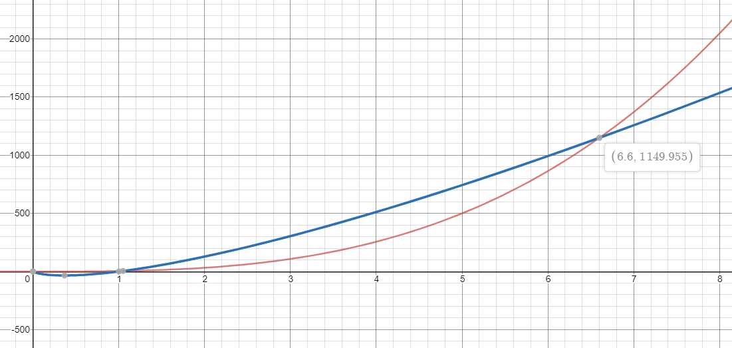

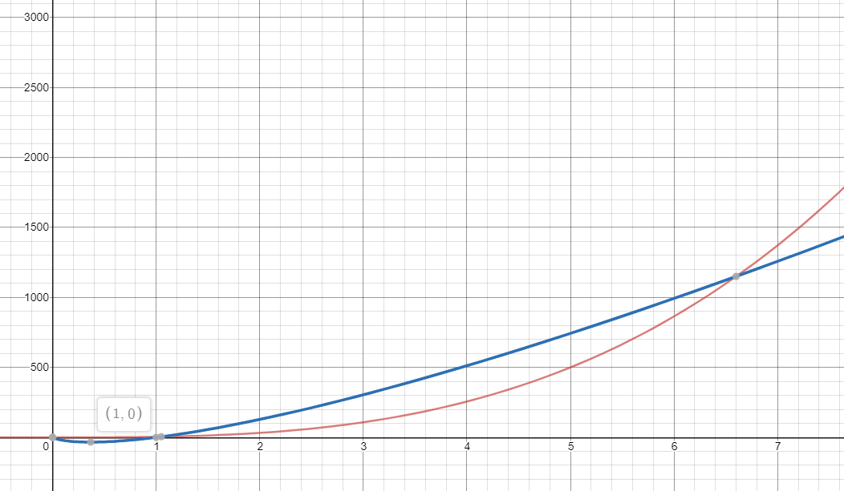

These two points of intersection denote where the blue function ($y=64xlg(x)$) takes a longer time to process the input, or in other words, where $y=4x^{3}$ is faster. These two points of intersection are (1,0) and (6.6, 1150), making the integer domain where the first algorithm (4n³) is faster $1≤n≤6$.

PLEASE NOTE: Technically, the domain may be $2≤n≤6$, since by some calculators the intersection is actually 1.049, making 1 not included in this domain. But, I think the problem simply expects 1, because 1.049 is very close to 1 and Desmos may be off on its estimation, and even shows (1, 0) as a point of intersection.

- Give the complexity of the following methods. Choose the most appropriate notation from among $Ο$, $Θ$, and $Ω$. (8 points each)

int function1(int n) {
int count = 0;
for (int i = n / 2; i <= n; i++) {
for (int j = 1; j <= n; j *= 2) {
count++;
}
}
return count;
}
Answer: $θ$(n lg(n))

int function2(int n) {
int count = 0;
for (int i = 1; i * i * i <= n; i++) {
count++;
}
return count;
}
Answer: $θ(\sqrt[3]{n})$

int function3(int n) {
int count = 0;
for (int i = 1; i <= n; i++) {
for (int j = 1; j <= n; j++) {
for (int k = 1; k <= n; k++) {
count++;
}
}
}
return count;
}
Answer: $θ$(n³)

int function4(int n) {
int count = 0;
for (int i = 1; i <= n; i++) {
for (int j = 1; j <= n; j++) {
count++;
break;
}
}
return count;
}
Answer: $θ$(n)

int function5(int n) {
int count = 0;
for (int i = 1; i <= n; i++) {
count++;
}
for (int j = 1; j <= n; j++) {
count++;
}
return count;
}
Answer:$θ$(n)

I pledge my honor that I have abided by the Stevens Honor System.
Ryan J. Hartman

