WEBSITE PROJECT PROPOSALS
Part 1 — Building the Foundation
MODULE | STUDENT
Web Development (Introduction)  WEDE5020 | Rhema Muthurwana  ST10527385
Assessment: POE — Part 1 | Academic year: 2026

Two hypothetical South African organisations
Savanna Flame Kitchen • FreshBasket Neighbourhood Grocer

Table of Contents
Section | Content
1 | Proposal A: Savanna Flame Kitchen
2 | Proposal B: FreshBasket Neighbourhood Grocer
3 | Proposal Comparison and Recommendation
4 | References

Note: Both organisations are fictional. Their descriptions, needs and budgets are realistic scenarios developed for this assessment. Lecturer approval is required before one concept is taken forward into the website build.

1. Proposal A: Savanna Flame Kitchen
Proposal type: Small business — restaurant | Proposed location: Thohoyandou, Limpopo

1.1 Organisation overview
Savanna Flame Kitchen is a proposed independent restaurant in Thohoyandou. It will sell both traditional South African meals and popular fast-food options. Its mission is to meet customers’ needs by making food easy to access at any time of day. The restaurant will operate 24 hours a day and offer collection and delivery. Its main customers will include students, working people, families, senior citizens and visitors in Thohoyandou.

1.2 Website goals, objectives and KPIs
The website will help customers view the menu, check student specials and senior-citizen discounts, and place collection or delivery orders. It will also provide the address, contact details and 24-hour operating information. Success will be measured during the first three months after launch.
Objective | Key performance indicator
Increase awareness | At least 500 website visits per month by month three
Generate orders | At least 30 valid collection or delivery orders per month
Promote discounts | At least 20% of visitors view student or senior specials
Support usability | All five pages and navigation links pass manual testing

1.3 Current website analysis
As a hypothetical start-up, the restaurant has no existing website. This permits consistent branding and structure, but it also means no search authority, online proof or content library. The first release will therefore prioritise original photography, visible contact details and clear calls to action. False reviews or claims will not be used.

1.4 Proposed features and functionality
- Homepage with hero image, short value proposition, featured meals and calls to view the menu or enquire.
- About page covering the origin, mission, vision, values and kitchen approach.
- Menu/Services page grouping traditional meals, fast food, drinks, student specials and senior discounts.
- Enquiry page supporting collection and delivery order requests during the later functional stage.
- Contact page with operating hours, telephone/email details, two location references and a contact form.

1.5 Design and user experience
The palette combines terracotta (#A84A2A), charcoal (#252525), cream (#FFF7E8) and herb green (#557A46). Bold sans-serif headings, legible Aptos body text, food imagery, generous spacing and prominent buttons will create a warm, uncluttered identity. Consistent navigation, semantic HTML, alternative text, labels and logical headings will support usability and accessibility (Mozilla, 2026; W3C, 2024).
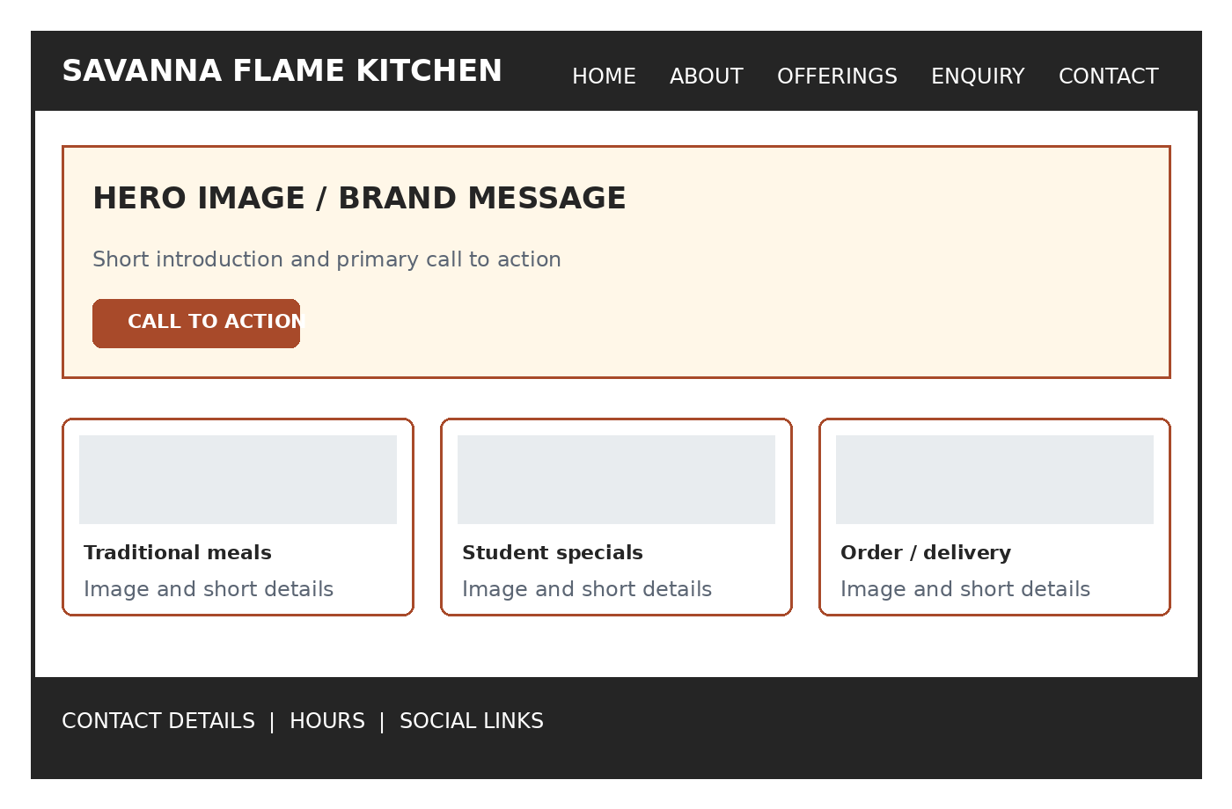
Figure 1: Low-fidelity homepage wireframe — Savanna Flame Kitchen (author-created, 2026).

1.6 Technical requirements
The site will use HTML5 in Visual Studio Code, with CSS and JavaScript added in later POE parts. Git and the private GitHub repository will control versions. A possible domain is savannaflame.co.za, subject to availability. Entry hosting begins near R99 monthly and may include SSL and backups (xneelo, 2026a). Testing will cover Chrome, Edge and Firefox.

1.7 Timeline and milestones
Week | Milestone
1 | Confirm content, audience, brand direction and lecturer approval
2 | Organise research assets; finalise sitemap and wireframes
3 | Create five semantic HTML pages and shared navigation
4 | Test links/content; complete README, references and submission

1.8 Estimated budget
Item | Estimated cost (ZAR)
.co.za domain (first year estimate) | R105
Entry web hosting (12 × R99) | R1,188
Original food photography allowance | R1,500
Maintenance allowance (12 × R250) | R3,000
Development for this student project | R0
Estimated first-year total | R5,793

Budget note: Hosting and domain figures are planning estimates based on advertised entry pricing and must be confirmed before purchase (xneelo, 2026a).

2. Proposal B: FreshBasket Neighbourhood Grocer
Proposal type: Retail store — grocery | Proposed location: Thohoyandou, Limpopo

2.1 Organisation overview
FreshBasket Neighbourhood Grocer is a proposed community-owned store in Thohoyandou. Community members will be able to hold shares, and the business will employ local youth. It will sell fresh produce, groceries and household essentials, with stock purchased directly from local farmers where possible. Its mission is to make food more affordable and accessible while supporting the local economy. Its customers will include households, students, senior citizens and small local traders.

2.2 Website goals, objectives and KPIs
The website will display products, affordable prices, selected-item specials and information about local suppliers. Customers will eventually be able to order for collection or delivery and earn coupons when buying selected products. Coupons can be redeemed on later purchases. In Part 1, these functions will be planned and represented through the HTML page structure.
Objective | Key performance indicator
Promote current offers | Update selected-item specials at least once per week
Increase customer action | At least 50 calls, map selections or enquiries per month
Build local reach | At least 700 visits and 40 coupon redemptions by month three
Maintain information quality | 100% of displayed store details checked monthly

2.3 Current website analysis
FreshBasket has no existing website. This gives the community a chance to create a clear brand from the beginning, but the store will initially have no online visibility or digital product catalogue. The website must build trust by explaining its community share model, local youth employment and direct relationships with farmers. Accurate prices, dated specials and regular updates will prevent misleading information.

2.4 Proposed features and functionality
- Homepage with store promise, featured categories, weekly specials and a clear enquiry action.
- About page describing community ownership, youth employment, mission, vision and local sourcing.
- Products page organised into produce, pantry, beverages, household items and selected-item specials.
- Enquiry page for stock checks, online orders, supplier interest and collection or delivery questions.
- Contact page containing hours, telephone/email details, two location references and a general contact form.

2.5 Design and user experience
The website will use dark green (#1F4D3A) and cream (#FFF4D6). Dark green represents farming, freshness and growth, while cream keeps the pages warm and easy to read. Product cards, clear prices, coupon labels and dated special badges will help customers scan information. Compressed images will reduce data use (xneelo, 2026b). Semantic sections, meaningful links, alternative text and form labels will support accessibility (Mozilla, 2026; W3C, 2024).
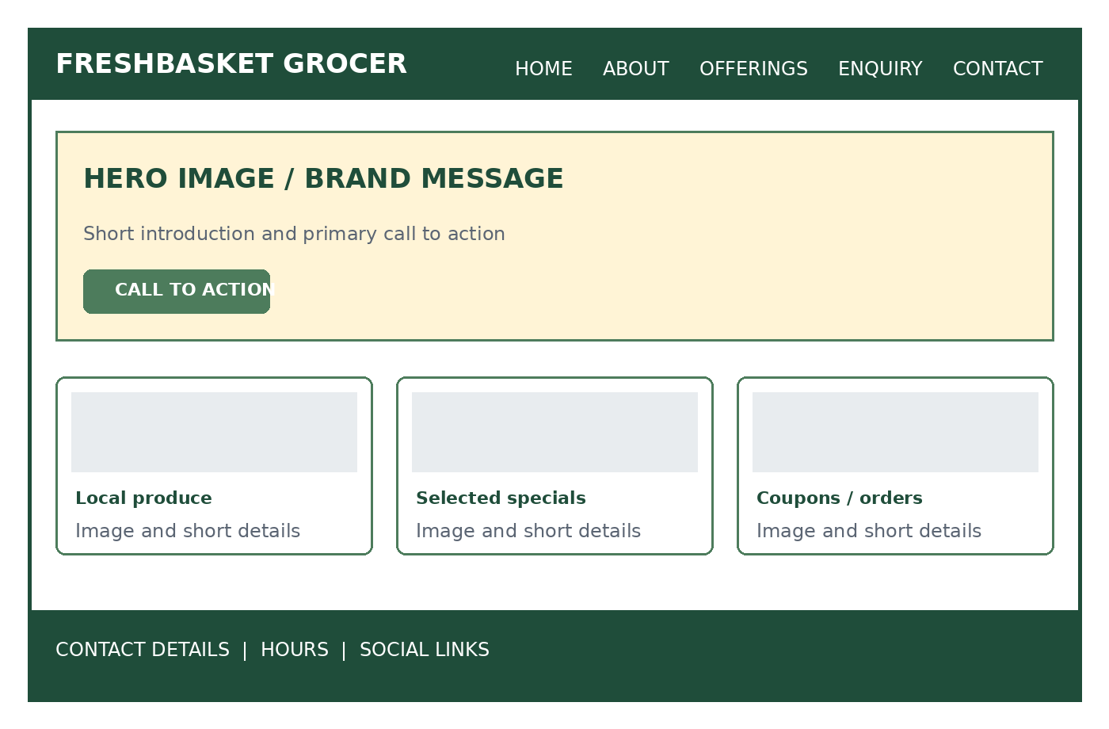
Figure 2: Low-fidelity homepage wireframe — FreshBasket Neighbourhood Grocer (author-created, 2026).

2.6 Technical requirements
The site will use HTML5 in Visual Studio Code, with CSS and JavaScript added later. Git and the private GitHub repository will record development. A possible domain is freshbasketgrocer.co.za, subject to availability. Entry hosting from about R99 monthly suits the information catalogue and may include SSL and backups (xneelo, 2026a). Testing will cover Chrome, Edge and Firefox.

2.7 Timeline and milestones
Week | Milestone
1 | Confirm store categories, content needs and lecturer approval
2 | Collect product content; finalise sitemap and wireframes
3 | Build five semantic HTML pages with working navigation
4 | Test content and links; finish README, references and submission

2.8 Estimated budget
Item | Estimated cost (ZAR)
.co.za domain (first year estimate) | R105
Entry web hosting (12 × R99) | R1,188
Original store/product photography allowance | R1,200
Maintenance allowance (12 × R300) | R3,600
Development for this student project | R0
Estimated first-year total | R6,093

Budget note: Costs are realistic planning estimates. Actual domain availability, promotional rates and renewal pricing must be checked before registration (xneelo, 2026a).

3. Proposal Comparison and Recommendation
Criterion | Savanna Flame Kitchen | FreshBasket Grocer
Primary conversion | Booking or catering enquiry | Stock or delivery enquiry
Content emphasis | Menu, experience and food imagery | Categories, specials and practical information
Update frequency | Moderate | High — weekly specials
Part 1 suitability | Strong visual storytelling and clear five-page scope | Strong information architecture and retail content

Recommended concept: FreshBasket Neighbourhood Grocer. I prefer this proposal because I see a need for a community-owned grocery store in Thohoyandou. It can support local farmers, create work for local youth and help customers access affordable food. The community share model, coupons and selected-item specials also make it clearly different from Savanna Flame Kitchen. Final selection remains subject to lecturer approval.

4. References
Mozilla (2026) ‘Semantic HTML’, MDN Web Docs. Available at: https://developer.mozilla.org/en-US/curriculum/core/semantic-html/ (Accessed: 14 August 2026).
W3C (2024) Web Content Accessibility Guidelines (WCAG) 2.2. Available at: https://www.w3.org/TR/WCAG22/ (Accessed: 14 August 2026).
xneelo (2026a) ‘Trusted in Hosting’. Available at: https://xneelo.co.za/ (Accessed: 14 August 2026).
xneelo (2026b) ‘Understanding Web Hosting in South Africa’. Available at: https://xneelo.co.za/web-hosting/understanding-web-hosting-in-south-africa/ (Accessed: 14 August 2026).
OpenAI (2026) ChatGPT [Large language model]. Available at: https://chatgpt.com/ (Accessed: 14 August 2026).

Submission note
Submit both proposals to the lecturer before the Part 1 due date and obtain approval for one organisation. If neither is approved, revise and resubmit the proposal before continuing with the final website.

Annexure A: Declaration of AI Assistance
I used OpenAI ChatGPT as a support tool while revising this proposal. I provided the original business ideas, including the Thohoyandou location, community ownership of FreshBasket, employment of local youth, purchasing from local farmers, selected-item coupons, dark green and cream branding, and Savanna Flame Kitchen’s 24-hour service, student specials and senior-citizen discounts. ChatGPT helped me organise these ideas, correct grammar, create the document layout, develop wireframe diagrams and format references. I reviewed the content and remain responsible for checking its accuracy and explaining my decisions (OpenAI, 2026).

AI interaction evidence
Insert clear screenshots of the relevant ChatGPT conversation below before submission. The screenshots should show the prompts, the ideas supplied by the student and the assistance received.
PLACE SCREENSHOT 1 HERE

PLACE SCREENSHOT 2 HERE

PLACE SCREENSHOT 3 HERE

