**COMPANY PROFILE**

TATA Technologies Ltd. (TTL), found in 1989, is a global leader in engineering services outsourcing (ESO) and product development I.T. services. It delivers best-in-class solutions for the product life cycle management (PLM) and enterprise resource management to the world's leading automotive and aerospace manufacturers and their suppliers.

The company has a combined global work force of more than 4000 professionals serving clients worldwide from facilities in North America, Europe and Asia-Pacific region.

**LOCATION**

TTL’s international headquarter is in Singapore, with the key regional headquarters in India (Pune), USA (Novi, Michigan) and the UK (Luton). The company has global development centres in Germany, India, Thailand, the UK, and the USA and also has offices in Canada, China, France, Germany, Ireland, Japan, Korea, Mexico and the Netherlands.

# **AREAS OF BUSINESS**

The TTL group offers solutions and services in:

* **ENGINEERING AND DESIGN: Working with the world's leading automotive and aerospace organization leveraging global resources to provide engineering services wherever their clients need them to be.**
* **PRODUCT LIFECYCLE MANAGEMENT: Helping companies build better product, define better processes and reduce costs along the way. Includes branded products from Autodesk, Siemens, Assault Systems as well as training and support.**
* **PRODUCT DEVELOPMENT IT: Implementing best practice enterprise solutions that coordinate people, technology, information and processes specific to product to development organizations. Includes CRM, ERP, Application Lifecycle management, Information Lifecycle Management.**
* **MANUFACTURING: Delivering a power combination of cutting-edge digital manufacturing, manufacturing automation and control systems, and comprehensive manufacturing domain expertise.**
* **KNOWLEDGE LIFECYCLE DEVELOPMENT: Helping to harvest institutional knowledge, especially with i GET IT®, the comprehensive engineering internet-based training system.** Joint Ventures, Subsidiaries, Associates
* Tata HAL Technologies: Tata Technologies and Hindustan Aeronautics Ltd. (HAL), Asia's premier aerospace manufacturer, merge their formidable engineering, design and manufacturing resources and market reach to provide clients with comprehensive "design through build" aerospace solutions. This joint venture in India only dedicated aero structure provider that offers access top HAL's design and manufacturing facilities and TTL's global delivery centre.

**INTRODUCTION**

Safely using your laptop will help ensure that your laptop works properly and you don’t get hurt. Improper use or not being aware of safety issues can cause your laptop irreparable damage. The general safety tips should be added to your weekly laptop maintenance routine which will help you stay productive and safe, no matter where you are working.

A helpdesk is an information and assistance resource and troubleshoots problems with computers or similar products. Corporations often provide help desk support to their customers via a toll-free number, a website or e-mail. There are also in-house help desks geared towards providing the same kind of help to a company's employees. Some schools offer classes in which they perform similar tasks as a help desk. In the Information Technology Infrastructure Library, within companies adhering to ISO/IEC 20000 or seeking to implement IT Service Management best practice, a help desk may offer a wider range of user centric services and be part of a larger Service Desk.

Help desk management software offers numerous benefits to system admins and IT pros. Company employees always appreciate a resource for their potential issues and queries. When employees submit a report, they are assured that their problems are forwarded to the correct member of the support staff. One a report has been submitted to the system, the employee will have the ability to log in and track the progress of their ticket.

**What does a help desk management system do?**

Help desk management software acts as a web-based system, which means it can help with managing inquires as well as other types of support processes. The software also ranks inquiries and classifies them all by priority. At the same time, the software transfers them to the appropriate department for issue resolution.

This type of software can also help reduce the amount of training that is needed for the support staff. As a result, your support staff can become experts in just short amount of time. Such an advantage allows for a much speedier solution of employee networking issues, which in turn frees up your support staff to support an even higher volume of employees.

Support staff can also benefit from help desk management software as their jobs become easier. In addition, employees will receive service in a more efficient manner and wait times are dramatically reduced. Because ticket history is stored, the support staff is better able to accurately assess issues and takes appropriate action.

Another benefit to leveraging help desk management software is that managers have the ability to keep track of members and their performance in the company. Since the typical help desk management solution has resolution and tracking tools, reports are easily completed.

Our website offers extraordinary services for laptops. Our service centre is well equipped with expert technicians and service equipment to handle any queries and repairs you may have with your laptops/notebooks.

We provide Broken Laptop service, Chip level service, Laptop Data Recovery, Laptop Anti-Virus Protection Service, Laptop hard disk failure service, memory upgrading such as RAM extension, Battery and Laptop Screen Replacement Service, extend laptop hard drive to increase laptop space, CPU cleaning, Laptop performance tuning etc.

Our technicians are well-qualified to diagnose, troubleshoot and repair almost all laptop problems including malfunctioning keyboard, power surges, dim or flickering LCD screen, failed power jack and booting problems.

**SYSTEM REQUIREMENTS**

**FUNCTIONAL REQUIREMENTS:**

The purpose of this section is to obtain agreement regarding what the system will need to do when interacting with other parties such as user or administrator.

* The web page (e.g. the dashboard) will be generated automatically according to the data in the database.
* The customer here does not create any account rather registers his/her complaint which is stored in the database of the system and the admin log in to his account to see the customers’ complain and fix their problems
* The admin get logged in to his account to see the customers’ complain and fix their problems.
* The administrator can use the system to update the data to the database.
* This website is compatible with XAMPP version 1.8.2 and works efficiently with Google chrome web browser.
* When working on website please ensure that you have an internet connection.

**NON FUNCTIONAL REQUIREMENTS:**

It consists of the following parameters:

* Reliability: The system will consistently perform its intended function. For e.g. the important information must be validated.
* Efficiency: Unnecessary data will not be transmitted on the network and database server will be properly connected.
* Reusability: The system can be reused in any organization or site of the same group, by defining the organization master definition under software licence agreement.
* Integrity: Only system administrator has rights to access the database, not every user can access all the information. Each user will be having rights to access the modules. Admin cannot delete the head admin account.

**TECHNICAL REQUIREMENTS:**

The purpose of this section is to obtain agreement regarding the platforms to be used for deploying and developing the working system. As with all software, the better the machine, the better it performs. We use Xampp server as a localhost and MySQL as a database, so you need to make sure that your server data is stored, has the best resources to run queries of data held in it.

If you have any questions about these specifications, please speak with anyone in our team, who are happy to help.

**OPERATIONAL REQUIREMENT:**

To run the project a web browser, web server, a database server and one operating system is needed.

**CASE STUDY**

A Help Desk for all problems and queries related to laptops including hardware and software solutions and queries regarding warranty. The customer if has any complaint registers the complaint on our site. These complaints are stored in the database of the system. The admin log and record the complaints of the customers through our complaint page by seeing to the new notifications that contains the complaints and problems of the customers. And then complaints are diverted to experts who work on them accordingly and notify the users by sending an email to them. Warranty users get free software help while non-warranty users are charged for any service they avail. Hardware problems are charged on their severity.

There are three types of problems that our help desk can cater to software problems, hardware problems and other miscellaneous problems.

Software problems that our help desk can register and their respective priorities:

1. Software crash problems

2. Installation/uninstallation problems

3. Updating problems

4. Booting problems

5. Wi-Fi not working

6. OS corrupted

7. Virus & spyware removal

8. Password recovery

9. Updates crashed

Hardware problems that our helpdesk can register are:

1. Battery-related problems

2. charger-related problems

3. screen-related problems

4. Camera related problems

5. Hard Disk failure

6. Motherboard repair/replacement

Other problems that our helpdesk can register are:

1. Insurance related issues

- Replacement insurance

-accidental damage insurance

-theft insurance

2. Warranty issues

-check warranty

-warranty renewal

The experts will handle the problems based on pre-defined system priorities. The help desk system has four groups of experts each handling their respective areas of problems.

1. Software experts

2. Hardware experts

3. Software-Hardware experts

4. Other experts

Software-hardware problems include those problems which require attention of both software and hardware experts.

The experts can resolve, reject or park the problems submitted by the customers.

First the system identifies which category the problem belongs to. The problem is assigned to the respective experts. The expert handles multiple problems one by one according to the system-defined priorities. In case of multiple problems having same priority, the time of arrival of these problems is checked and higher preference is given to the problem that has arrived first. If the stated problem is not identified in the lists of problems of a particular group then the problem is passed on to the other group where it can be resolved or further passed on to other group. If no groups accept the problem then the problem is ultimately rejected and the customer is notified accordingly. If the experts are busy solving other problems they can park the requests until one of them is free.

The actual bill is generated by the experts and is forwarded to the customers.

For   
Our outputs are:   
1.Hardware and Software related solutions  
2.Warranty related information  
3.Bills of services provided

4. The total number of problems received and solved in a time period.  
  
Our approach:   
1.Identify the entities and attributes and then arrange them accordingly.  
2. Create ENTITY-RELATIONSHIP DIAGRAM.

3. Create SYSTEM-FLOW-DIAGRAM to understand the flow of logic.  
4. Write an efficient code for the above logic.

**ENTITY-RELATIONSHIP DIAGRAM**

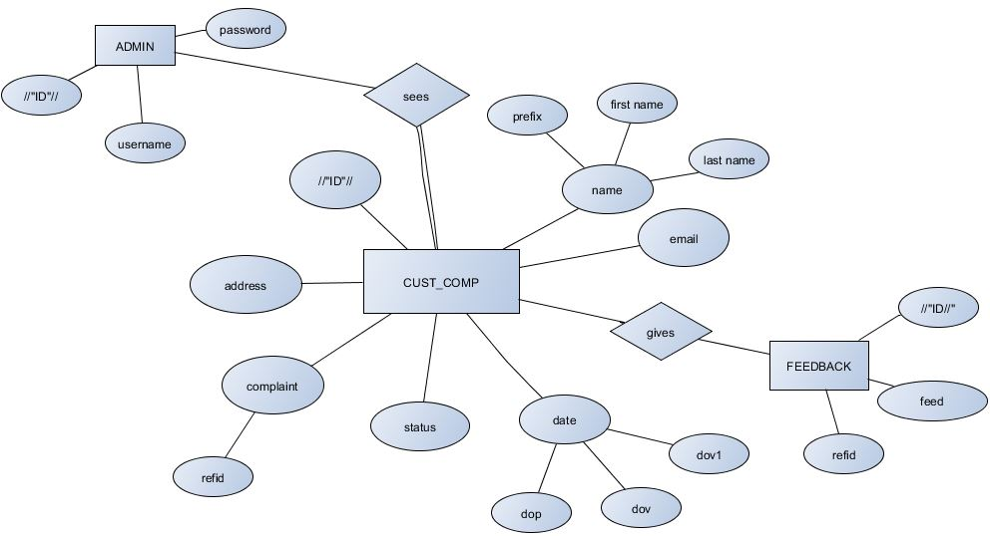

Entities and Attributes:

1. Complaint page (ID, name (prefix, first name, last name), email, date (dop,dov,dov1), complaint (ref.id), address, status)
2. Admin (ID, password, username)
3. Feedback (ID, refid, feed)

**SYSTEM-FLOW DIAGRAM**

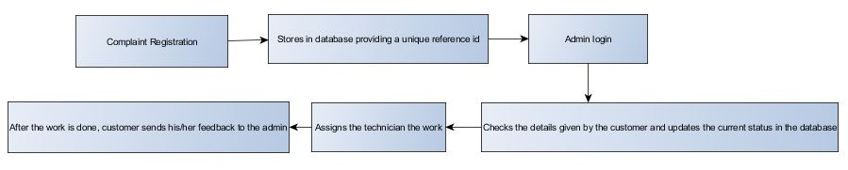

**DATA-FLOW DIAGRAM**

* **LEVEL 0**

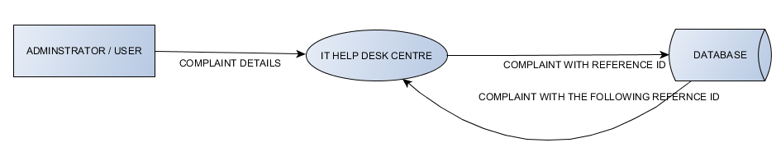

* **LEVEL 1**

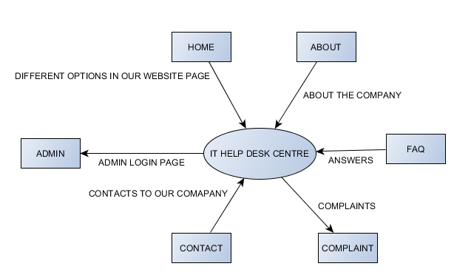

* **LEVEL 2**

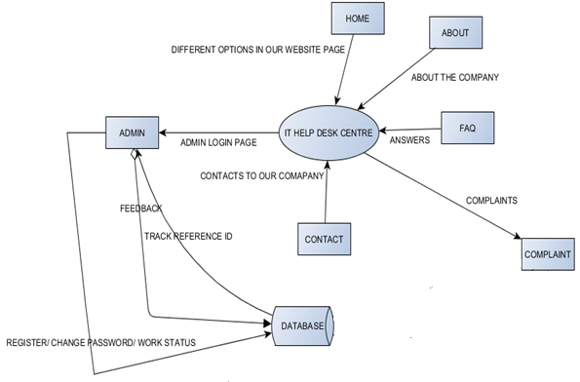

**TOOLS AND PLATFORM USED**

## **SOFTWARE SPECIFICATION:**

## FRONT-END TOOL: HTML, CSS, JQUERY, JAVASCRIPT, BOOTSTRAP

* BACK-END TOOL: PHP, MYSQL
* Security
* Portability
* Quality
* PLATFORM: XAMP SERVER
* LANGUAGE USED: PHP, HTML, CSS, JAVASCRIPT.
* EDITORS: NOTEPAD++, ADOBE DREAMWEAVER CS6, SUBLIME TEXT 3

**FRONT-END TOOLS**

* **HTML:**

**Hypertext Markup Language** (**HTML**) is the standard [markup language](https://en.wikipedia.org/wiki/Markup_language) for creating [web pages](https://en.wikipedia.org/wiki/Web_page) and [web applications](https://en.wikipedia.org/wiki/Web_application). With [Cascading Style Sheets](https://en.wikipedia.org/wiki/Cascading_Style_Sheets) (CSS) and [JavaScript](https://en.wikipedia.org/wiki/JavaScript) it forms a triad of cornerstone technologies for the [World Wide Web](https://en.wikipedia.org/wiki/World_Wide_Web). Browsers receive HTML documents from a [webserver](https://en.wikipedia.org/wiki/Webserver) or from local storage and render them into multimedia web pages. HTML describes the structure of a web page [semantically](https://en.wikipedia.org/wiki/Semantic) and originally included cues for the appearance of the document.

[HTML elements](https://en.wikipedia.org/wiki/HTML_element) are the building blocks of HTML pages. With HTML constructs, [images](https://en.wikipedia.org/wiki/Img_(HTML_element)) and other objects, such as forms, may be embedded into the rendered page. It provides a means to create [structured documents](https://en.wikipedia.org/wiki/Structured_document) by denoting structural [semantics](https://en.wikipedia.org/wiki/Semantics) for text such as headings, paragraphs, lists, [links](https://en.wikipedia.org/wiki/Hyperlink), quotes and other items. HTML elements are delineated by *tags*, written using [angle brackets](https://en.wikipedia.org/wiki/Bracket#Angle_brackets). Tags such as <img /> and <input /> introduce content into the page directly. Others such as <p>...</p> surround and provide information about document text and may include other tags as sub-elements. Browsers do not display the HTML tags, but use them to interpret the content of the page.

HTML can embed programs written in a [scripting language](https://en.wikipedia.org/wiki/Scripting_language) such as [JavaScript](https://en.wikipedia.org/wiki/JavaScript) which affect the behaviour and content of web pages. Inclusion of CSS defines the look and layout of content. The [World Wide Web Consortium](https://en.wikipedia.org/wiki/World_Wide_Web_Consortium) (W3C), maintainer of both the HTML and the CSS standards, has encouraged the use of CSS over explicit presentational HTML since 1997.

* **CSS:**

**Cascading Style Sheets** (**CSS**) is a [style sheet language](https://en.wikipedia.org/wiki/Style_sheet_language) used for describing the [presentation](https://en.wikipedia.org/wiki/Presentation_semantics) of a document written in a [markup language](https://en.wikipedia.org/wiki/Markup_language). Although most often used to set the visual style of [web pages](https://en.wikipedia.org/wiki/Web_page) and user interfaces written in [HTML](https://en.wikipedia.org/wiki/HTML) and [XHTML](https://en.wikipedia.org/wiki/XHTML), the language can be applied to any [XML](https://en.wikipedia.org/wiki/XML) document, including [plain XML](https://en.wikipedia.org/wiki/Plain_Old_XML), [SVG](https://en.wikipedia.org/wiki/Scalable_Vector_Graphics) and [XUL](https://en.wikipedia.org/wiki/XUL), and is applicable to rendering in [speech](https://en.wikipedia.org/wiki/Speech_synthesis), or on other media. Along with HTML and [JavaScript](https://en.wikipedia.org/wiki/JavaScript), CSS is a cornerstone technology used by most websites to create visually engaging webpages, user interfaces for [web applications](https://en.wikipedia.org/wiki/Web_applications), and user interfaces for many mobile applications.

CSS is designed primarily to enable the separation of presentation and content, including aspects such as the [layout](https://en.wikipedia.org/wiki/Page_layout), [colors](https://en.wikipedia.org/wiki/Color) and [fonts](https://en.wikipedia.org/wiki/Typeface). This separation can improve content [accessibility](https://en.wikipedia.org/wiki/Accessibility), provide more flexibility and control in the specification of presentation characteristics, enable multiple HTML pages to share formatting by specifying the relevant CSS in a separate .css file, and reduce complexity and repetition in the structural content.

Separation of formatting and content makes it possible to present the same markup page in different styles for different rendering methods, such as on-screen, in print, by voice (via speech-based browser or [screen reader](https://en.wikipedia.org/wiki/Screen_reader)), and on [Braille-based](https://en.wikipedia.org/wiki/Braille_display) tactile devices. It can also display the web page differently depending on the screen size or viewing device. Readers can also specify a different style sheet, such as a CSS file stored on their own computer, to override the one the author specified.

Changes to the [graphic design](https://en.wikipedia.org/wiki/Graphic_design) of a document (or hundreds of documents) can be applied quickly and easily, by editing a few lines in the CSS file they use, rather than by changing markup in the documents.

The CSS specification describes a priority scheme to determine which style rules apply if more than one rule matches against a particular element. In this so-called *cascade*, priorities (or *weights*) are calculated and assigned to rules, so that the results are predictable.

* **JQUERY:**

**JQuery** is a [cross-platform](https://en.wikipedia.org/wiki/Cross-platform) [JavaScript library](https://en.wikipedia.org/wiki/JavaScript_library) designed to simplify the [client-side scripting](https://en.wikipedia.org/wiki/Client-side_scripting) of [HTML](https://en.wikipedia.org/wiki/HTML). It is [free, open-source software](https://en.wikipedia.org/wiki/Free_and_open_source_software) using the permissive [MIT license](https://en.wikipedia.org/wiki/MIT_license). [Web](https://en.wikipedia.org/wiki/World_Wide_Web) analysis indicates that it is the most widely deployed JavaScript library by a large margin.

JQuery’s syntax is designed to make it easier to navigate a document, select [DOM](https://en.wikipedia.org/wiki/Document_Object_Model) elements, create [animations](https://en.wikipedia.org/wiki/Animation), handle [events](https://en.wikipedia.org/wiki/Event_(computing)), and develop [Ajax](https://en.wikipedia.org/wiki/Ajax_(programming)) applications. JQuery also provides capabilities for developers to create [plug-ins](https://en.wikipedia.org/wiki/Plug-in_(computing)) on top of the JavaScript library. This enables developers to create [abstractions](https://en.wikipedia.org/wiki/Abstraction_(computer_science)) for low-level interaction and animation, advanced effects and high-level, theme-able widgets. The modular approach to the jQuery library allows the creation of powerful [dynamic web pages](https://en.wikipedia.org/wiki/Dynamic_web_page) and Web applications.

The set of [jQuery core features](https://en.wikipedia.org/wiki/JQuery#Features)—DOM element selections, traversal and manipulation—enabled by its *selector engine*, created a new "programming style", fusing algorithms and DOM data structures. This style influenced the architecture of other [JavaScript frameworks](https://en.wikipedia.org/wiki/Comparison_of_JavaScript_frameworks) like [YUI v3](https://en.wikipedia.org/wiki/YUI_Library) and [Dojo](https://en.wikipedia.org/wiki/Dojo_Toolkit), later stimulating the creation of the standard *Selectors API*.

[Microsoft](https://en.wikipedia.org/wiki/Microsoft) and [Nokia](https://en.wikipedia.org/wiki/Nokia) bundle jQuery on their platforms. Microsoft includes it with [Visual Studio](https://en.wikipedia.org/wiki/Microsoft_Visual_Studio) for use within Microsoft's[ASP.NET AJAX](https://en.wikipedia.org/wiki/ASP.NET_AJAX) and [ASP.NET MVC](https://en.wikipedia.org/wiki/ASP.NET_MVC) frameworks while Nokia has integrated it into the Web Run-Time widget development platform.

* **BOOTSTRAP:**

In general, **bootstrapping** usually refers to a self-starting process that is supposed to proceed without external input. In [computer technology](https://en.wikipedia.org/wiki/Computer_technology) the term (usually shortened to **booting**) usually refers to the process of loading the basic software into the memory of a computer after power-on or general reset, especially the [operating system](https://en.wikipedia.org/wiki/Operating_system) which will then take care of loading other software as needed. Bootstrapping can also refer to the development of successively more complex, faster programming environments. The simplest environment will be, perhaps, a very basic text editor and an [assembler](https://en.wikipedia.org/wiki/Assembly_language#Assembler) program. Using these tools, one can write a more complex text editor, and a simple compiler for a higher-level language and so on, until one can have a [graphical](https://en.wikipedia.org/wiki/Graphical_user_interface) [IDE](https://en.wikipedia.org/wiki/Integrated_development_environment) and an extremely [high-level programming language](https://en.wikipedia.org/wiki/High-level_programming_language).

* **JAVA SCRIPT:**

**JavaScript** often abbreviated as "JS", is a [high-level](https://en.wikipedia.org/wiki/High-level_programming_language), [dynamic](https://en.wikipedia.org/wiki/Dynamic_programming_language), [un-typed](https://en.wikipedia.org/wiki/Untyped_language), [interpreted](https://en.wikipedia.org/wiki/Interpreted_language) [run-time](https://en.wikipedia.org/wiki/Runtime_system) [language](https://en.wikipedia.org/wiki/Programming_language). It has been standardized in the [ECMA Script](https://en.wikipedia.org/wiki/ECMAScript) language specification. Alongside [HTML](https://en.wikipedia.org/wiki/HTML) and [CSS](https://en.wikipedia.org/wiki/CSS), JavaScript is one of the three core technologies of [World Wide Web](https://en.wikipedia.org/wiki/World_Wide_Web) [content production](https://en.wikipedia.org/wiki/Content_engineering); the majority of [websites](https://en.wikipedia.org/wiki/Website) employ it, and all modern [Web browsers](https://en.wikipedia.org/wiki/Web_browser) support it without the need for [plug-ins](https://en.wikipedia.org/wiki/Browser_extension). JavaScript is a [multi-paradigm](https://en.wikipedia.org/wiki/Multi-paradigm) language, since it supports [prototype-based](https://en.wikipedia.org/wiki/Prototype-based_programming) with [first-class functions](https://en.wikipedia.org/wiki/First-class_function), [imperative](https://en.wikipedia.org/wiki/Imperative_programming), and [functional](https://en.wikipedia.org/wiki/Functional_programming) [programming paradigms](https://en.wikipedia.org/wiki/Programming_paradigm). It has an [API](https://en.wikipedia.org/wiki/Application_programming_interface) for working with text, [arrays](https://en.wikipedia.org/wiki/Array_data_type), dates, [regular expressions](https://en.wikipedia.org/wiki/Regular_expression), and basic manipulation of the [DOM](https://en.wikipedia.org/wiki/Document_Object_Model), but does not include network, storage, or sophisticated graphics APIs, relying instead upon APIs made available by its host environment.

**BACK-END TOOLS:**

* **PHP:**

**PHP** is a [server-side scripting](https://en.wikipedia.org/wiki/Server-side_scripting) language designed primarily for [web development](https://en.wikipedia.org/wiki/Web_development) but also used as a [general-purpose programming language](https://en.wikipedia.org/wiki/General-purpose_programming_language). PHP originally stood for *Personal Home Page*, but it now stands for the [recursive acronym](https://en.wikipedia.org/wiki/Recursive_acronym) *PHP: Hypertext Pre-processor*.

PHP code may be embedded into [HTML](https://en.wikipedia.org/wiki/HTML) or HTML5 [markup](https://en.wikipedia.org/wiki/Markup_language), or it can be used in combination with various [web template systems](https://en.wikipedia.org/wiki/Web_template_system), [web content management systems](https://en.wikipedia.org/wiki/Web_content_management_system) and [web frameworks](https://en.wikipedia.org/wiki/Web_framework). PHP code is usually processed by a PHP [interpreter](https://en.wikipedia.org/wiki/Interpreter_(computing)) implemented as a [module](https://en.wikipedia.org/wiki/Plugin_(computing)) in the web server or as a [Common Gateway Interface](https://en.wikipedia.org/wiki/Common_Gateway_Interface) (CGI) [executable](https://en.wikipedia.org/wiki/Executable). The [web server](https://en.wikipedia.org/wiki/Web_server) software combines the results of the interpreted and executed PHP code, which may be any type of data, including images, with the generated [web page](https://en.wikipedia.org/wiki/Web_page). PHP code may also be executed with a [command-line interface](https://en.wikipedia.org/wiki/Command-line_interface) (CLI) and can be used to implement [standalone](https://en.wikipedia.org/wiki/Computer_software) [graphical applications](https://en.wikipedia.org/wiki/Graphical_user_interface).

The standard PHP interpreter is [free software](https://en.wikipedia.org/wiki/Free_software) released under the [PHP License](https://en.wikipedia.org/wiki/PHP_License). PHP has been widely ported and can be deployed on most web servers on almost every [operating system](https://en.wikipedia.org/wiki/Operating_system) and [platform](https://en.wikipedia.org/wiki/Computing_platform), free of charge.

The PHP language evolved without a written [formal specification](https://en.wikipedia.org/wiki/Formal_specification) or standard until 2014, leaving the canonical PHP interpreter as a [*de facto*](https://en.wikipedia.org/wiki/De_facto) standard. Since 2014 work has gone on to create a formal PHP specification.

* **MYSQL**:

**MySQL** is an [open-source](https://en.wikipedia.org/wiki/Open-source) [relational database management system](https://en.wikipedia.org/wiki/Relational_database_management_system) (RDBMS). Its name is a combination of "My", the name of co-founder [Michael Widenius](https://en.wikipedia.org/wiki/Michael_Widenius)' daughter, and "[SQL](https://en.wikipedia.org/wiki/SQL)", the abbreviation for [Structured Query Language](https://en.wikipedia.org/wiki/Structured_Query_Language). The MySQL development project has made its [source code](https://en.wikipedia.org/wiki/Source_code) available under the terms of the [GNU General Public License](https://en.wikipedia.org/wiki/GNU_General_Public_License), as well as under a variety of [proprietary](https://en.wikipedia.org/wiki/Proprietary_software) agreements. MySQL was owned and sponsored by a single [for-profit](https://en.wikipedia.org/wiki/Business) firm, the [Swedish](https://en.wikipedia.org/wiki/Sweden) company [MySQL AB](https://en.wikipedia.org/wiki/MySQL_AB), now owned by [Oracle Corporation](https://en.wikipedia.org/wiki/Oracle_Corporation). For proprietary use, several paid editions are available, and offer additional functionality.

MySQL is a central component of the [LAMP](https://en.wikipedia.org/wiki/LAMP_(software_bundle)) open-source web application software stack (and other "[AMP](https://en.wikipedia.org/wiki/List_of_AMP_packages)" stacks). LAMP is an acronym for "[Linux](https://en.wikipedia.org/wiki/Linux), [Apache](https://en.wikipedia.org/wiki/Apache_HTTP_Server), MySQL, [Perl](https://en.wikipedia.org/wiki/Perl)/[PHP](https://en.wikipedia.org/wiki/PHP)/[Python](https://en.wikipedia.org/wiki/Python_(programming_language))". Applications that use the MySQL database include: [TYPO3](https://en.wikipedia.org/wiki/TYPO3),[MODx](https://en.wikipedia.org/wiki/MODx), [Joomla](https://en.wikipedia.org/wiki/Joomla), [WordPress](https://en.wikipedia.org/wiki/WordPress), [phpBB](https://en.wikipedia.org/wiki/PhpBB), [MyBB](https://en.wikipedia.org/wiki/MyBB), and [Drupal](https://en.wikipedia.org/wiki/Drupal). MySQL is also used in many high-profile, large-scale [websites](https://en.wikipedia.org/wiki/Website), including [Google](https://en.wikipedia.org/wiki/Google).

**PLATFORM TOOL**

* **XAMPP:**

**XAMPP** is a [free and open source](https://en.wikipedia.org/wiki/Free_software) [cross-platform](https://en.wikipedia.org/wiki/Cross-platform) [web server](https://en.wikipedia.org/wiki/Web_server) [solution stack](https://en.wikipedia.org/wiki/Solution_stack) package developed by Apache Friends, consisting mainly of the [Apache HTTP Server](https://en.wikipedia.org/wiki/Apache_HTTP_Server), [Maria DB](https://en.wikipedia.org/wiki/MariaDB) [database](https://en.wikipedia.org/wiki/Database), and [interpreters](https://en.wikipedia.org/wiki/Interpreter_(computing)) for scripts written in the [PHP](https://en.wikipedia.org/wiki/PHP) and [Perl](https://en.wikipedia.org/wiki/Perl) [programming languages](https://en.wikipedia.org/wiki/Programming_language). XAMPP stands for Cross-Platform (X), Apache (A), Maria DB (M), PHP (P) and Perl (P). It is a simple, lightweight Apache distribution that makes it extremely easy for developers to create a local web server for testing and deployment purposes. Everything needed to set up a web server – server application (Apache), database (Maria DB), and scripting language (PHP) – is included in an extractable file. XAMPP is also cross-platform, which means it works equally well on Linux, Mac and Windows. Since most actual web server deployments use the same components as XAMPP, it makes transitioning from a local test server to a live server extremely easy as well.

**SCREEN-SHOTS**

* 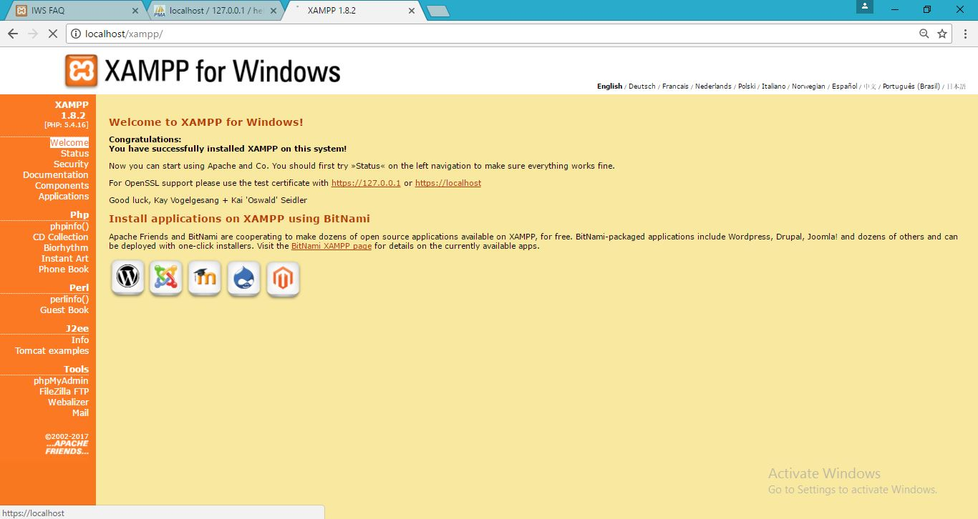**XAMPP:**
* 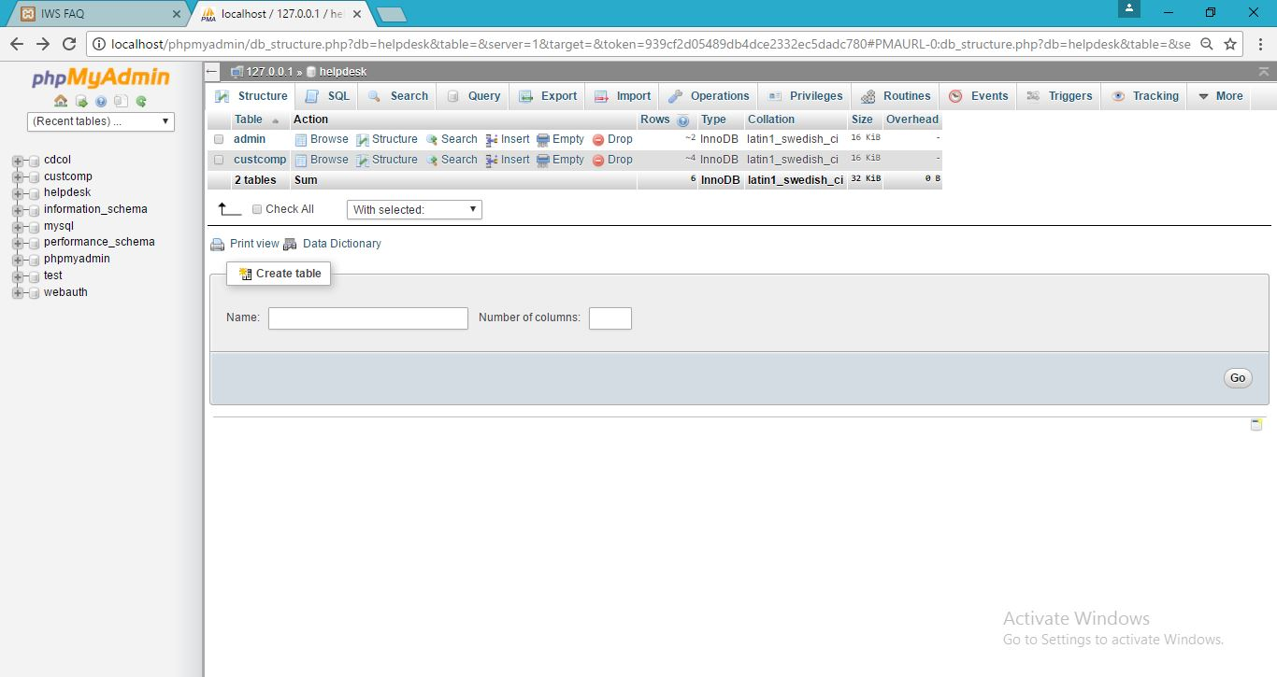**PHPMYADMIN:**
* **CUSTOMER TABLE:**

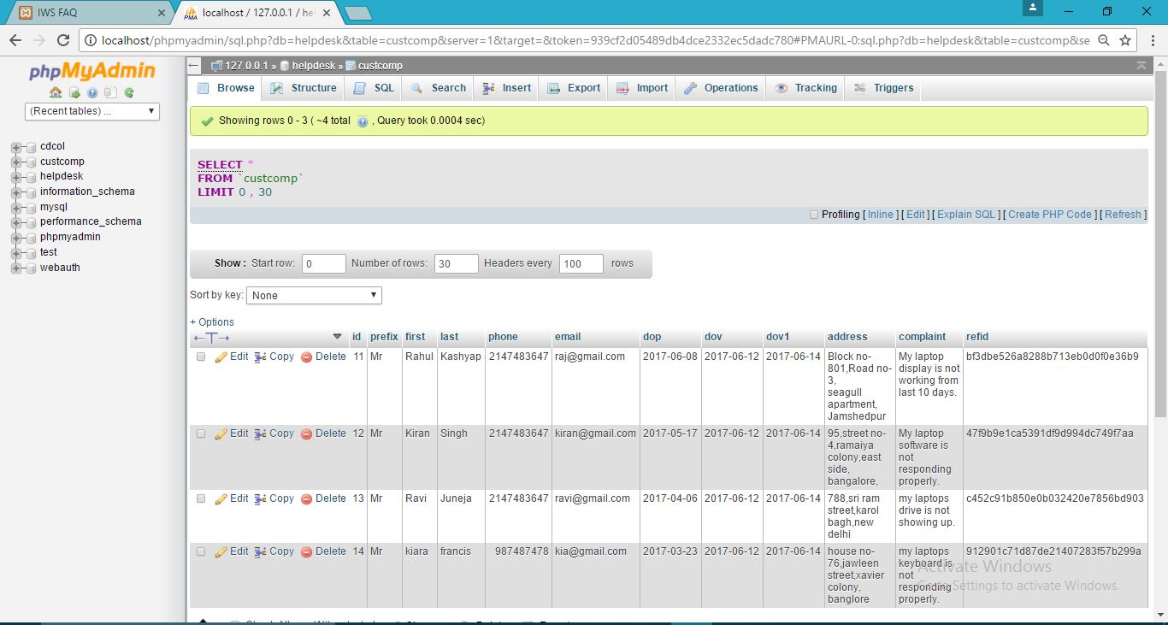

* **HOME PAGE:**

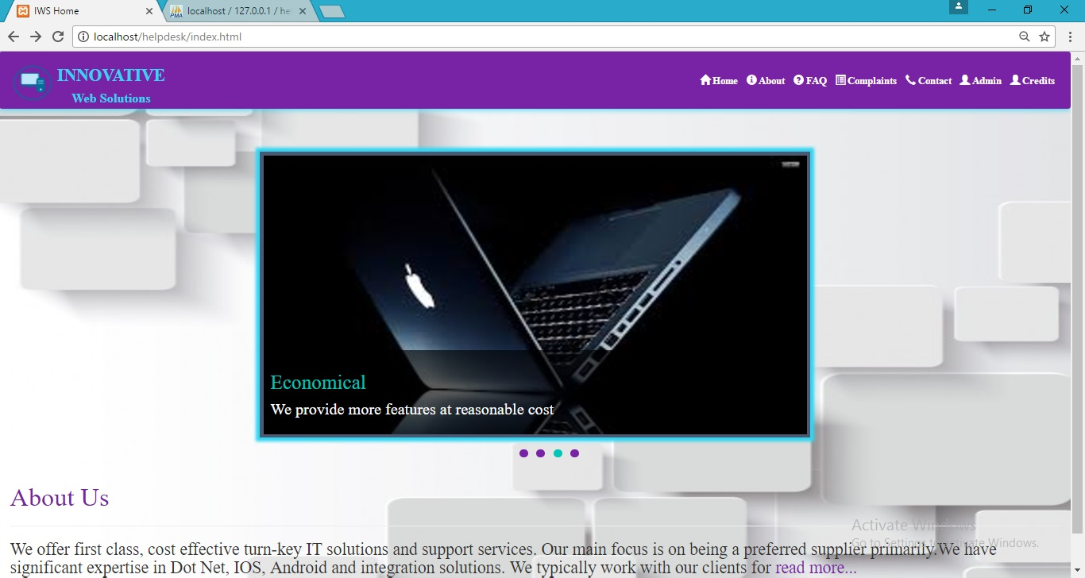

* **FAQ:**

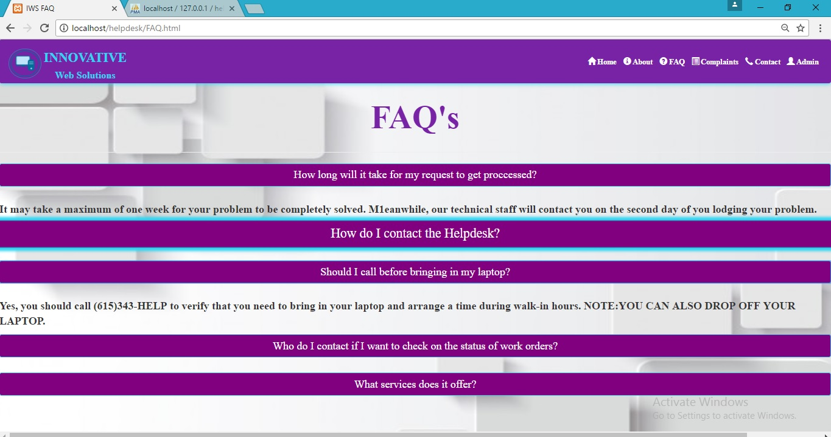

* 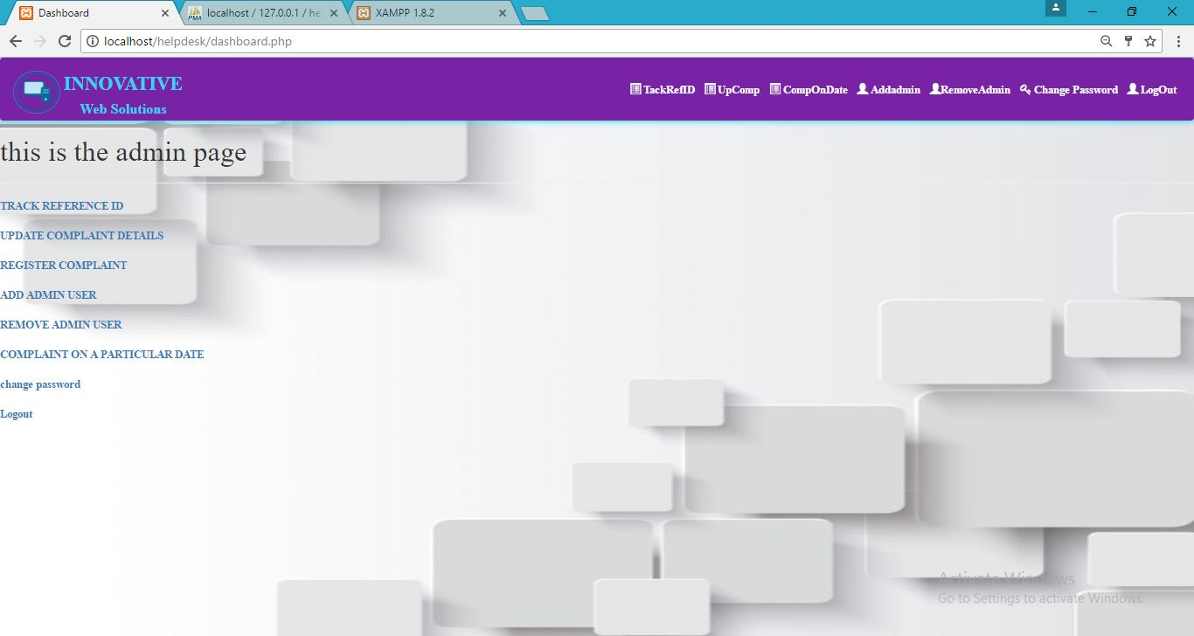**DASHBOARD:**
* **TRACK REF ID:**

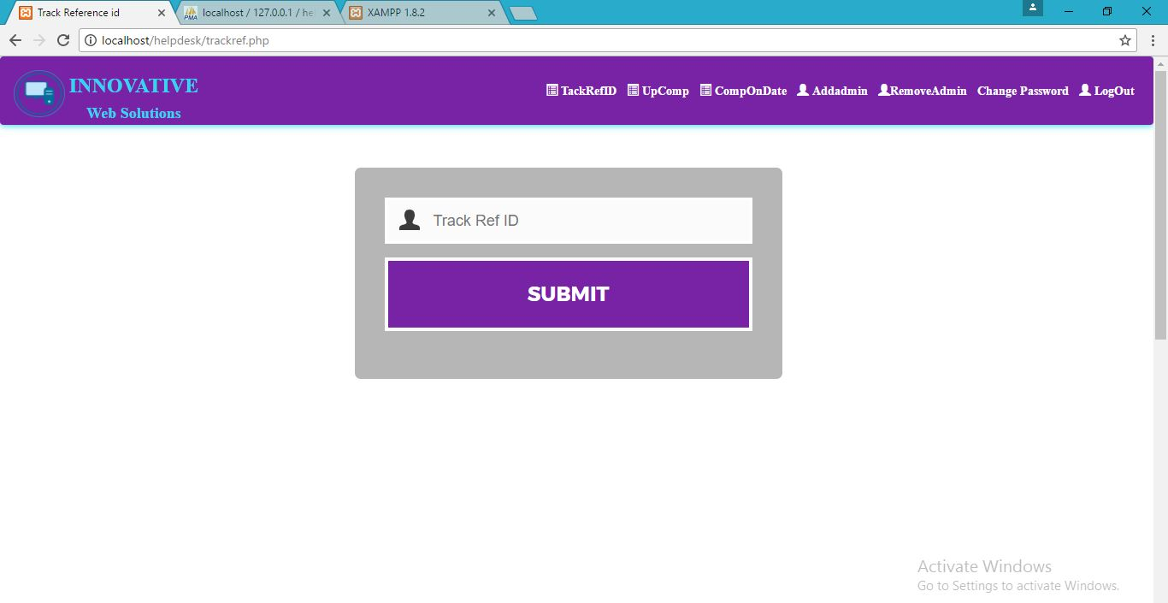

* **ADMIN LOGIN:**

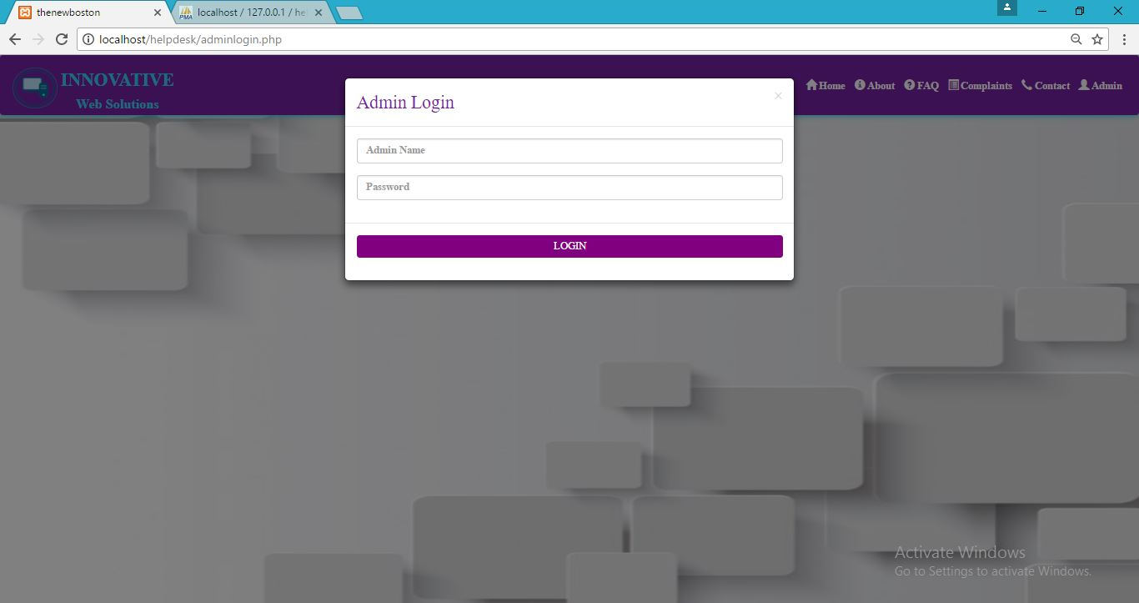

* 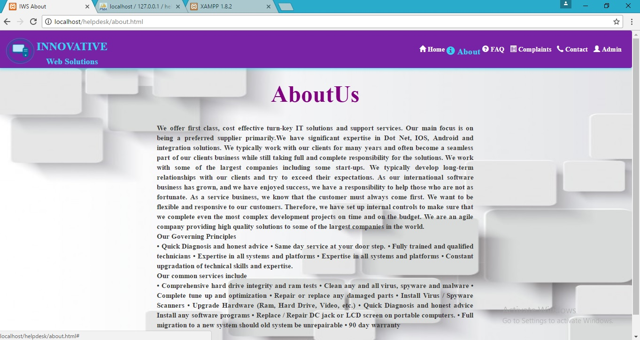**ABOUT US:**
* 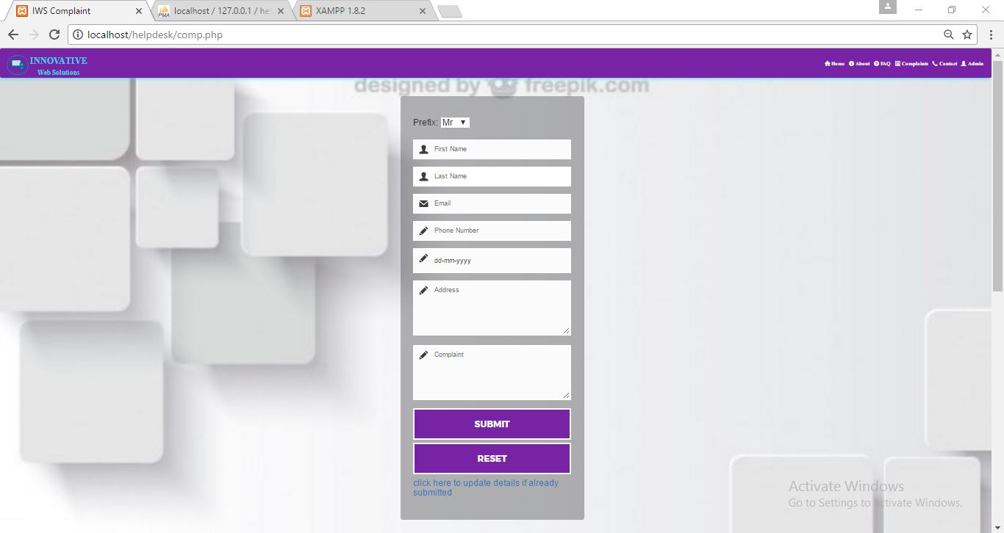**COMPLAINT PAGE:**
* 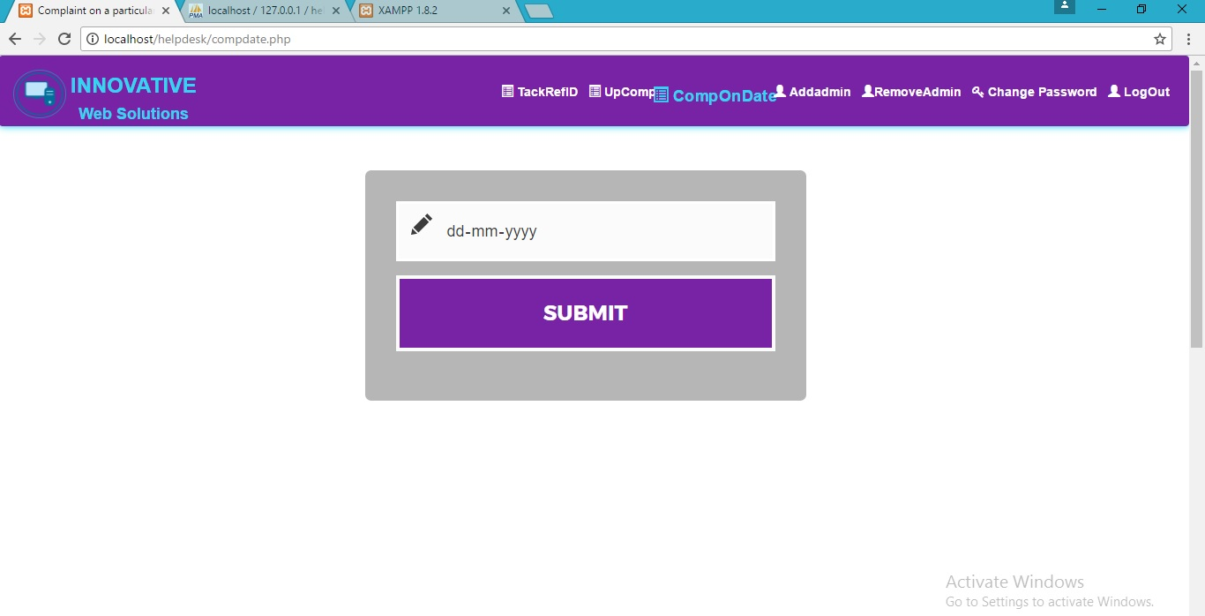**COMPLAINT DATE PAGE:**
* 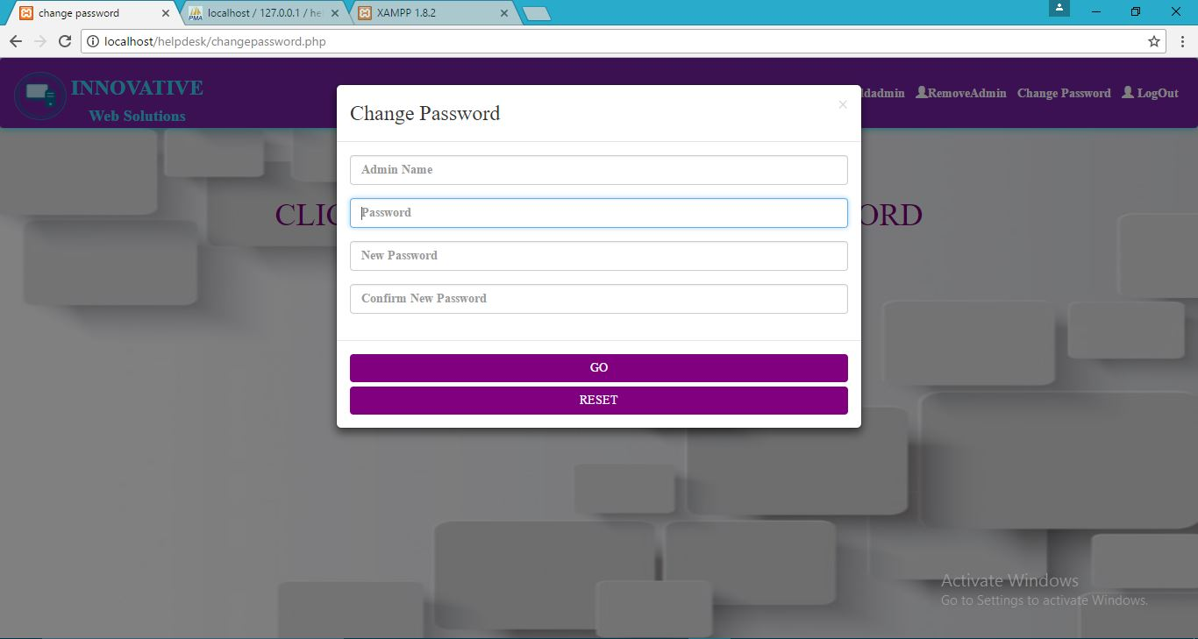**CHANGE PASSWORD:**
* 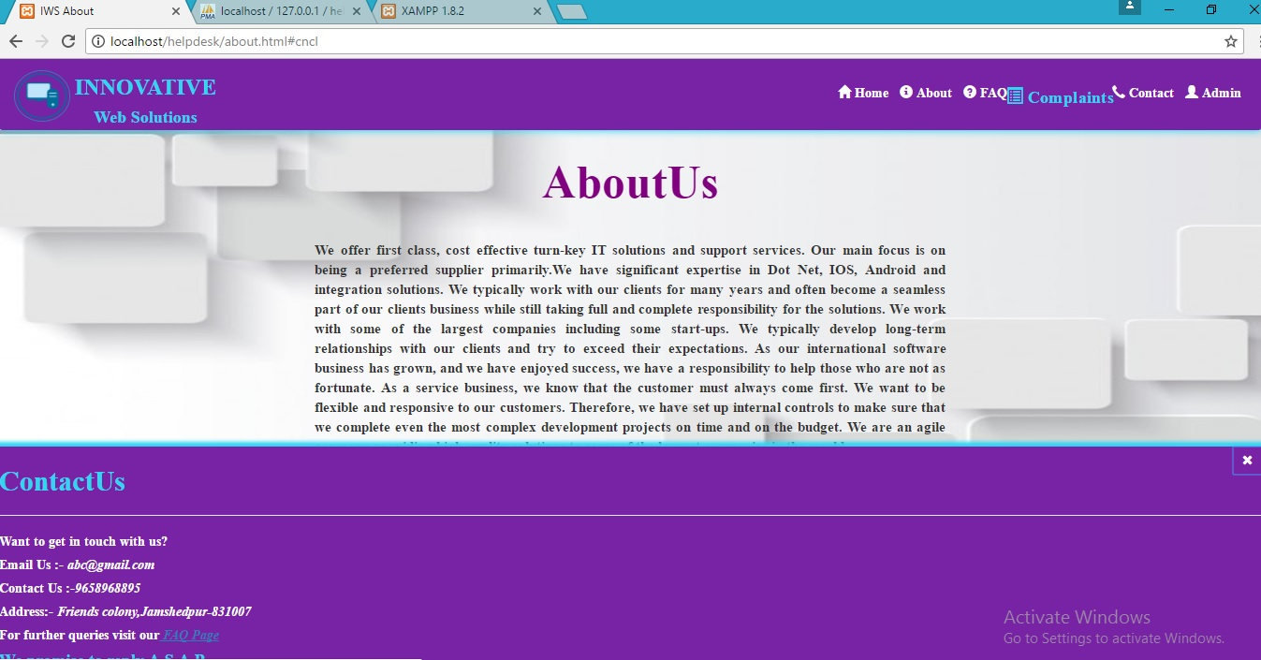**CONTACT US:**
* **EDITOR:**

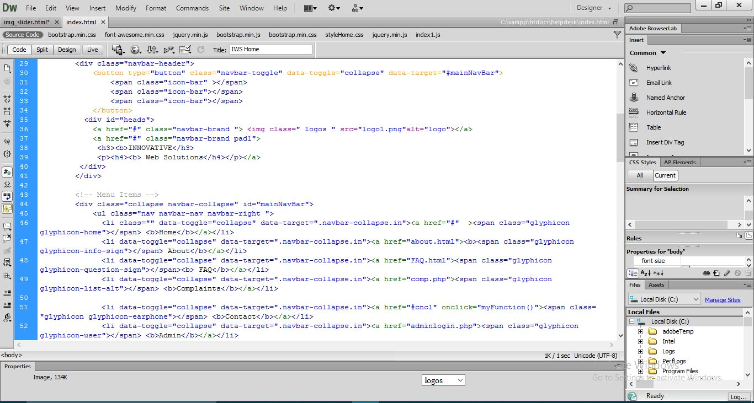

**FUTURE SCOPE**

* **Time savings:**

The staff doesn’t need to talk to customers which can be quite time consuming rather customer can go to the website and register his/her problem and get proper solution for the same.

* **Monetary savings:**

The time savings experienced by a facility can translate into monetary savings, as both staff time and services translate into expenses and revenue, respectively. As staff resources can now be directed at other tasks, a help desk system can eliminate the need for a staff member to work overtime or for management to hire new staff members to handle the work overload.

* **24-Hour Convenience:**

Customer service over the phone usually requires an individual to phone in during office hours, as few facilities offer round-the-clock phone booking. This is an inconvenience for most customers, as they too are working at this time. Additionally, many individuals prefer to solve their queries online rather than over the phone. An online help desk system allows for 24-hour scheduling, not just during normal facility or office hours.

* **Customer support:**

24-hour, live support should be a requirement when researching an online help desk software provider. The ability to immediately reach a dedicated contact or support representative is imperative for a scheduling application that needs to be functional at all times and one that reaches across multiple locations.

**RESULTS AND ADVANTAGES**

* Customers support has changed a lot since the arrival of cloud based help-desk. The help-desk solution resides on third-party servers for easy access and use by agents. These are maintained professionally with data being secured highly.
* Time management and productivity enables the customers and agents to manage their helpdesk in an efficient way.
* The application will prove very beneficial to customers.
* The application is a freeware, user friendly and easily accessible.
* Also it will save timer, reduce the effort and paperwork of both admin as well as customers.

**CONCLUSION**

The repairing process of the system, generally viewed as a burden in various repair and service centres, can be completely automated by the admin through admin login. There are many benefits of implementing this technology, as administrators and staff can conduct their tasks more efficiently and accurately, while customers and clients have the ability to book their appointments for the repair of the laptop more conveniently in one single click through our complaint page providing the necessary details.

**BIBLIOGRAPHY**

We convey special thanks to our department and to our college. The following websites and software’s have helped us complete this project:

* Wikipedia
* w3schools.com
* stackoverflow.com
* tutorialpoint.com
* php.net
* www.theart-ofweb.com