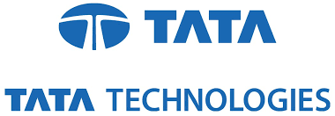

Submitted By:

RAJSHREE

INFORMATION TECHNOLOGY

G.H RAISONI COLLEGE OF ENGINEERING

10th May 2017– 09th June 2017

Under The Guidance Of:

Mr. RAJEEV KUMAR

TEAM LEAD – CEIT

TATA TECHNOLOGIES LIMITED

Mr. KUNTAL CHOWDHURY

HR, TRAINING COORDINATOR

TATA TECHNOLOGIES LIMITED