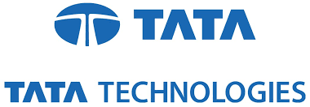

Submitted By:

MIRZA GULAM SARWAR BAIG

COMPUTER SCIENCE AND ENGINEERING

PARALA MAHARAJA ENGINEERING COLLEGE

29th May 2017– 28th June 2017

Under The Guidance Of:

Mr. RAJEEV KUMAR

TEAM LEAD – CEIT

TATA TECHNOLOGIES LIMITED

Mr. KUNTAL CHOWDHURY

HR, TRAINING COORDINATOR

TATA TECHNOLOGIES LIMITED