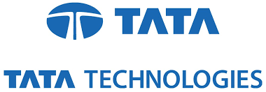

Submitted By:

SUBHOJEET CHAKRABORTY

COMPUTER SCIENCE AND ENGINEERING

SINHGAD COLLEGE OF ENGINEERING

29th May 2017– 31th June 2017

Under The Guidance Of:

Mr. RAJEEV KUMAR

TEAM LEAD – CEIT

TATA TECHNOLOGIES LIMITED

Mr. KUNTAL CHOWDHURY

HR, TRAINING COORDINATOR

TATA TECHNOLOGIES LIMITED