◆ Phase 2 · System Planning

Software Development
Life Cycle
PLMun Inventory Nexus

Agile (Scrum-based) · 4 Sprints · Feb – Apr 2026 · 6 Members

Bachelor of Science in Computer Science — BSCS 3D
Software Engineering 1 — Prof. Mr. Melchor Paz
Pamantasan ng Lungsod ng Muntinlupa (PLMun)
Academic Year 2025–2026

Methodology Overview

PLMun Nexus follows an Agile iterative SDLC with Scrum-based sprints. Each phase is revisited across iterations — requirements evolve, design is refined, code is implemented, and testing is continuous. This approach accommodates changing academic deadlines, enables early delivery of core features, and allows the team to respond to usability feedback throughout development.

Attribute | Value
Methodology | Agile — Scrum-based iterative sprints
Total Phases | 6 (Requirements → Maintenance)
Total Sprints | 4 sprints across Feb – Apr 2026
Team Size | 6 members
Timeline | February 3 – April 7, 2026
Key Principle | Iterative delivery with continuous feedback and improvement

SDLC Circular Diagram

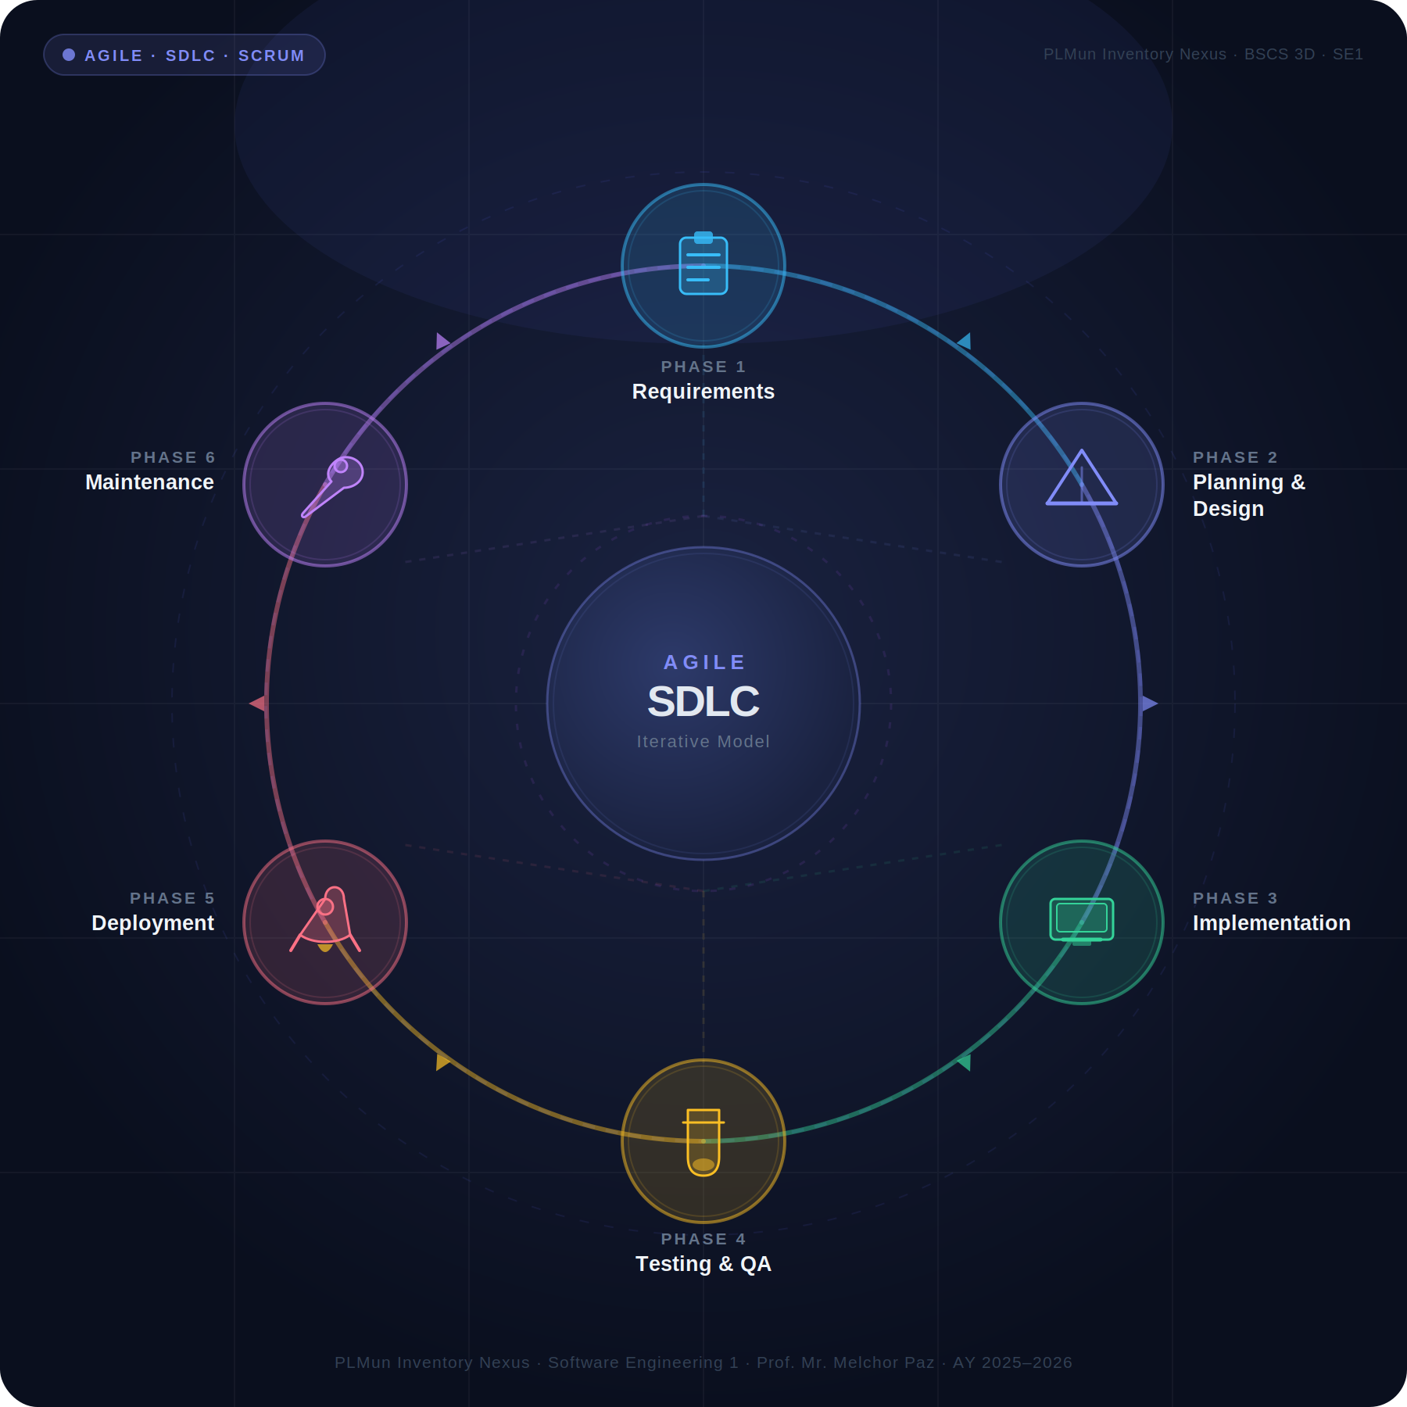
Figure 1 — Agile SDLC Iterative Model (6 Phases, 4 Sprints)
SDLC Phases Overview

Phase | Name | Duration | Key Focus
Phase 1 | Requirements Gathering | Feb 3–7, 2026 · 1 week | Stakeholder interviews, scope definition, requirements matrix
Phase 2 | System Planning & Design | Feb 7–14, 2026 · 1 week | Architecture, ERD, DFD, API spec, feasibility study
Phase 3 | Implementation & Coding | Feb 14 – Mar 21, 2026 · 5 weeks | Full-stack development — Django backend + React frontend
Phase 4 | Testing & Quality Assurance | Mar 21–27, 2026 · 1 week | RBAC validation, security tests, bug fixes, build verification
Phase 5 | Deployment & Release | Mar 27–29, 2026 · 3 days | Railway + Vercel production deployment, SSL, CORS, env vars
Phase 6 | Maintenance & Iteration | Mar 29 – Apr 7, 2026 · Ongoing | Post-release fixes, planned enhancements, feedback loop

Phase 1 — Requirements Gathering

Phase 1 — Requirements Gathering
📅 Feb 3 – Feb 7, 2026 · 1 week
Objectives  Identify all functional and non-functional requirements through stakeholder engagement. Document the current manual process, its pain points, and define the scope of the digital solution.  Deliverables  - Phase 1 Requirements Document (docx)  - Stakeholder interview notes  - Hardware & software requirements tables  - System features matrix (6 modules)  - RBAC permission model definition  - Problem statement & impact analysis | Methods Used  - Structured interviews with faculty & supply staff  - Document review of existing manual forms  - Direct observation of supply office operations  - Questionnaires distributed to faculty & staff  - Benchmarking against similar institutional systems  Team Assigned  · Mendoza, John Erick — Lead · Loterina, Justine — Analysis · Peneverde, Salvador — Documentation

Phase 2 — System Planning & Design

Phase 2 — System Planning & Design
📅 Feb 7 – Feb 14, 2026 · 1 week
Objectives  Translate requirements into a concrete system architecture. Define the database schema, API contracts, UI wireframes, and the technology stack. Produce the feasibility study confirming project viability.  Deliverables  - Phase 2 System Planning Document (docx)  - Feasibility study (operational, technical, economic, legal)  - Entity-Relationship Diagram (ERD)  - Data Flow Diagrams (Level 0 & Level 1)  - UI wireframes and mockups  - REST API endpoint specification  - Project Charter with milestones | Design Artifacts  - Django models: User, Item, Request, Notification, Comment, AuditLog  - 4-tier RBAC matrix: Student → Faculty → Staff → Admin  - Request state machine: PENDING → APPROVED → COMPLETED/RETURNED  - JWT authentication flow (access + refresh tokens)  - Vercel (frontend) + Railway (backend) deployment architecture  Team Assigned  · Mendoza, John Erick — Architecture · Olazo, Charl Stephen — UI/UX Wireframes · Loterina, Justine — DFD & UML

Phase 3 — Implementation & Coding

Phase 3 — Implementation & Coding
📅 Feb 14 – Mar 21, 2026 · 5 weeks
Objectives  Build the complete system across frontend and backend following the Phase 2 architecture. Implement all 6 modules with role-based access, atomic stock management, and real-time notifications.  Backend Implementation  - Django 6.0 project with 4 apps (auth, inventory, requests, users)  - Custom User model with role hierarchy (0–3)  - JWT auth via SimpleJWT (1-hour access, 1-day refresh)  - Inventory CRUD with category filtering & access-level gates  - Request workflow with F() atomic stock deduction  - Notification system (COMMENT, STATUS_CHANGE, REMINDER, OVERDUE)  - Audit logging with IP address recording (17 action types)  - Rate limiting on auth endpoints (django-ratelimit) | Frontend Implementation  - React 18 SPA with Vite 5 build tooling  - React Router v6 with role-protected routes  - Zustand state management with localStorage persistence  - Axios HTTP client with JWT interceptor (auto-refresh)  - Dashboard with real-time stats, charts, and activity feed  - Inventory page with search, filters, QR codes, CRUD modals  - PDF export (jsPDF + AutoTable) and CSV export (file-saver)  - Responsive design — mobile, tablet, desktop  Team Assigned  · Mendoza, John Erick — Full-Stack Lead · Castillo, Kimar — Backend APIs · Palma, Dave — Frontend UI · Olazo, Charl Stephen — Styling & UX

Phase 4 — Testing & Quality Assurance

Phase 4 — Testing & Quality Assurance
📅 Mar 21 – Mar 27, 2026 · 1 week
Objectives  Verify correctness, security, and usability across all modules. Validate RBAC enforcement and confirm the request workflow state machine operates correctly under all scenarios.  Testing Performed  - Functional testing: all CRUD operations across 4 roles  - RBAC validation: role gates on every API endpoint  - Request workflow: PENDING → APPROVED → COMPLETED/RETURNED  - Self-approval prevention: backend blocks own-request approval  - Atomic stock: concurrent approval race condition testing  - JWT lifecycle: token expiry, refresh rotation, blacklisting  - Rate limiting: brute-force login attempt throttling  - Responsive UI: mobile, tablet, desktop breakpoint testing | Bugs Found & Fixed  - Duplicate import in Settings.jsx caused build failure  - Missing SettingsIcon/exportPDF imports caused runtime crash  - Password visibility toggle missing in SecurityTab  - Backend accepted quantity=0 (fixed: minimum 1)  - Overdue logic had redundant +1 increment per user  - Mobile layout missing flash message toast  - Select dropdowns unstyled in dark mode  Build Verification  Production build (npx vite build) verified passing with exit code 0. All ESLint checks pass. No console errors in production mode.  Team Assigned  · Peneverde, Salvador — QA Lead · Mendoza, John Erick — Bug Fixes · All Members — UAT

Phase 5 — Deployment & Release

Phase 5 — Deployment & Release
📅 Mar 27 – Mar 29, 2026 · 3 days
Objectives  Deploy the complete system to production, configure environment variables, verify end-to-end connectivity, and confirm the system is accessible to all stakeholders.  Deployment Architecture  - Frontend: Vercel static hosting (CDN-distributed)  - Backend: Railway cloud (Django + Gunicorn)  - Database: Railway PostgreSQL 18 (managed)  - Static files: WhiteNoise middleware  - SSL: HTTPS enforced via HSTS (1-year) | Configuration  - Environment variables set via Railway/Vercel dashboards  - CORS whitelist configured for production frontend domain  - ALLOWED_HOSTS updated with production hostnames  - DEBUG=False enforced in production  - SECRET_KEY rotated for production  - CSP headers enabled for XSS defense-in-depth  - Auto-deploy on git push to main branch  Team Assigned  · Mendoza, John Erick — DevOps & Deploy · Castillo, Kimar — Backend Config

Phase 6 — Maintenance & Iteration

Phase 6 — Maintenance & Iteration
📅 Mar 29 – Apr 7, 2026 · Ongoing
Objectives  Monitor system performance, collect user feedback, fix post-deployment issues, and iterate on features. This phase feeds back into Phase 1 for continuous improvement.  Completed Iterations  - Password visibility toggle added to SecurityTab  - Dark mode select dropdown fix in InventoryFormModal  - Backend quantity validation hardened (>= 1)  - Overdue counting logic refactored for accuracy  - Mobile toast notification added to Settings  - Login page team section finalized with member names | Planned Enhancements  - Loading skeletons for Dashboard data fetching  - Configurable low-stock threshold (currently hardcoded at 5)  - Add 'condition' field to the Item model  - Add student_year field to the User model  - Pagination for inventory views (performance at scale)  - Email notifications for critical events  Team Assigned  · All Members — Ongoing Support

Sprint-to-Phase Mapping

Sprint | Duration | Phase Focus | Key Deliverables
Sprint 1 | Feb 3 – Feb 14  (2 weeks) | Phase 1 & 2 | Requirements gathering, system planning, Django project setup, JWT auth, React scaffold & routing
Sprint 2 | Feb 14 – Mar 7  (3 weeks) | Phase 3 (core) | Inventory CRUD, form validations, request workflow engine, approval/rejection flow, dashboard, notifications
Sprint 3 | Mar 7 – Mar 21  (2 weeks) | Phase 3 (advanced) | Security hardening (CSP, CORS), comment threads, audit logging, dark mode, reports, PDF/CSV export
Sprint 4 | Mar 21 – Apr 7  (2.5 weeks) | Phase 4, 5 & 6 | Bug fixes, code quality, deployment, production release, UAT, documentation, final submission

Agile Feedback Loop

Each sprint concludes with a review that feeds improvements back into the next iteration. This ensures the system evolves based on real usage and stakeholder feedback — not just initial assumptions.

1 | Sprint Review | Team reviews completed work and evaluates what was delivered vs. planned.
2 | Identify Gaps | Gaps between expected and actual functionality are documented as actionable items.
3 | Refine Backlog | The product backlog is updated and reprioritized based on feedback.
4 | Update Requirements | Requirements are revised to reflect evolved understanding of user needs.
5 | Implement Fix | Developers work on the refined backlog items in the next sprint cycle.
6 | Test & Deploy | Changes are tested, verified, and deployed — completing the loop back to Sprint Review.

PLMun Inventory Nexus — Software Development Life Cycle Documentation
BSCS 3D · Software Engineering 1 · Prof. Mr. Melchor Paz · AY 2025–2026

