SentinelTransfer – Secure File Transfer Monitoring System

5.1 Project Setup
5.1.1 Environment Preparation
The development environment for the SentinelTransfer system was configured on a Windows 10/11 machine. Before initiating development, the necessary runtime environments, package managers, and supporting tools were verified and installed. The primary language chosen for this project was Python, owing to its rich ecosystem of libraries for networking, cryptography, file system monitoring, and web development.
A structured development workflow was followed, beginning with the installation of Python, followed by the creation of an isolated virtual environment, and then the sequential installation of all required third-party dependencies. This approach ensured that the project dependencies remained self-contained and did not conflict with any system-level Python packages.
5.1.2 Python Installation
Python version 3.10 (or later) was downloaded from the official Python website (https://www.python.org) and installed on the development machine. During installation, the option "Add Python to PATH" was enabled to allow Python commands to be executed directly from the system terminal without specifying the full executable path. After installation, the following command was used to verify the setup:
bash
python --version
The package manager pip, which is bundled with Python, was also verified and updated to its latest version using:
bash
pip install --upgrade pip
5.1.3 Virtual Environment Creation
To maintain project-level dependency isolation, a Python virtual environment was created within the project directory using the following commands:
bash
python -m venv venv
venv\Scripts\activate # Windows
Activating the virtual environment ensures that all subsequent package installations are scoped to the project and do not affect the global Python installation. The active environment is indicated by a (venv) prefix in the terminal prompt.
5.1.4 Dependency Installation
All required Python libraries were installed using pip. The full list of dependencies was maintained in a requirements.txt file for reproducibility. The primary packages installed include:
Package | Purpose
Flask | Web application framework
Flask-Login | Session and authentication management
Werkzeug | Password hashing and security utilities
watchdog | Real-time file system event monitoring
pycryptodome | AES-256 database encryption
fpdf2 | PDF report generation
psutil | USB/removable drive detection
smtplib (stdlib) | SMTP-based email alerts
hashlib (stdlib) | SHA-256 file integrity hashing
sqlite3 (stdlib) | Embedded relational database
csv (stdlib) | CSV report generation
All dependencies were installed using:
bash
pip install -r requirements.txt
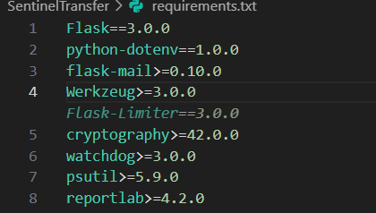

[Figure 5.1: Terminal output showing successful package installation]

5.1.5 Flask Configuration
Flask was configured as the core web framework for the SentinelTransfer application. A central application factory pattern was adopted, where the Flask application object is initialized inside app.py. Key configuration parameters included:
- SECRET_KEY — A randomly generated string used for session cookie signing and CSRF protection.
- DATABASE URI — Configured to point to the SQLite database file located in the instance/ folder.
- DEBUG mode — Enabled during development to display detailed error messages; disabled in production.
- Upload folder path — Defined to point to the monitored directory.
The configuration was managed using a separate config.py file, which was imported into app.py to keep the application logic clean and configurable.
5.1.6 SQLite Database Initialization
SQLite was selected as the embedded database engine due to its simplicity, zero-configuration nature, and suitability for single-user and small-scale applications. The database file sentinel.db was stored inside the instance/ folder, which Flask automatically treats as a private, non-versioned directory.
The database schema was defined using raw SQL CREATE TABLE statements executed at application startup via a dedicated init_db() function. This function was called once during the initial project setup using:
bash
python app.py init-db
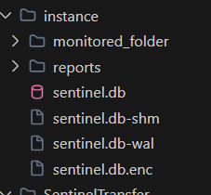
All tables, including those for users, file events, audit logs, alerts, and USB activity, were created during this step.
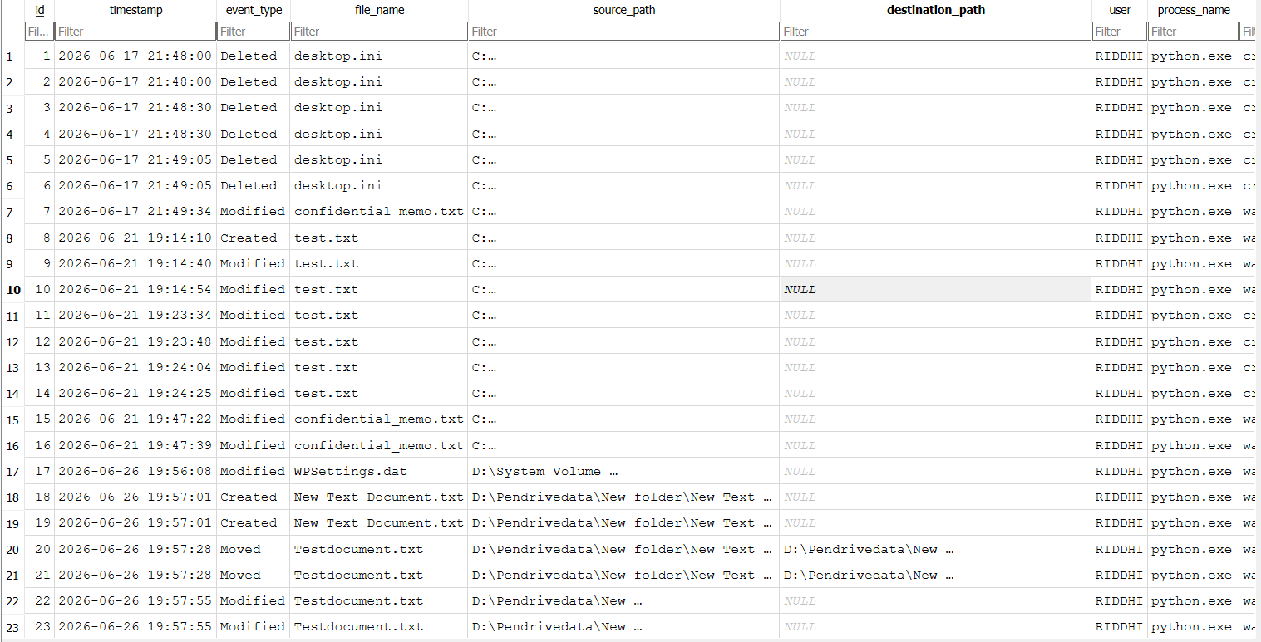
[Figure 5.2: SQLite database file created inside the instance/ folder]

5.1.7 Git Repository Creation
Version control for the project was managed using Git. A local Git repository was initialized within the project root directory using:
bash
git init
A .gitignore file was created to exclude sensitive and generated files from version tracking, including:
- venv/ — The virtual environment folder
- instance/ — The database directory
- *.pyc — Compiled Python bytecode
- reports/ — Auto-generated report outputs
- .env — Environment variable files containing secrets
Commits were made at each major development milestone to maintain a clear history of the implementation progress.

5.2 Project Folder Structure
The SentinelTransfer project follows a modular and organized folder structure inspired by Flask's application layout conventions. The directory tree is as follows:
SentinelTransfer/
│
├── app.py # Main application entry point
├── config.py # Application configuration settings
├── requirements.txt # Python dependency list
├── .gitignore # Git ignore rules
│
├── instance/
│ └── sentinel.db # SQLite database file
│
├── templates/ # HTML Jinja2 templates
│ ├── base.html
│ ├── login.html
│ ├── register.html
│ ├── dashboard.html
│ ├── logs.html
│ ├── alerts.html
│ ├── usb.html
│ └── reports.html
│
├── static/ # Static assets
│ ├── css/
│ │ └── style.css
│ ├── js/
│ │ └── dashboard.js
│ └── images/
│ └── logo.png
│
├── reports/ # Generated PDF and CSV reports
│ ├── report_<date>.pdf
│ └── report_<date>.csv
│
└── monitored_folder/ # Target directory for file monitoring
File and Folder Descriptions
app.py — This is the central entry point of the entire application. It initializes the Flask application object, registers all route handlers, configures extensions such as Flask-Login, starts the Watchdog file monitoring observer, and runs the development server. All major modules are imported and integrated here.
config.py — Contains all configurable constants used throughout the application, such as the secret key, database path, monitored directory path, SMTP credentials, and encryption key material. Separating configuration from logic makes the system easier to maintain and deploy in different environments.
requirements.txt — A plain text file listing all Python packages required by the project. This enables quick environment replication using pip install -r requirements.txt.
instance/sentinel.db — The SQLite database file that stores all persistent data for the application, including user accounts, file events, audit logs, USB activity records, and alert history. Flask's instance/ folder is not committed to version control, protecting sensitive data.
templates/ — Contains all HTML files rendered by Flask using the Jinja2 templating engine. Each page of the application corresponds to one HTML file. The base.html file defines the shared layout (navigation bar, footer, Bootstrap links), which all other templates extend via Jinja2's {% extends %} block system.
static/ — Holds all front-end assets that are served directly to the browser without any server-side processing. This includes the custom CSS stylesheet (style.css), JavaScript logic (dashboard.js), and image assets.
reports/ — The output directory where auto-generated PDF and CSV reports are saved. The filenames include timestamps to prevent overwriting and allow historical access.
monitored_folder/ — The target directory that the Watchdog observer watches at runtime. Any file creation, modification, deletion, or movement within this folder triggers an event handler, which logs the activity and checks for policy violations.

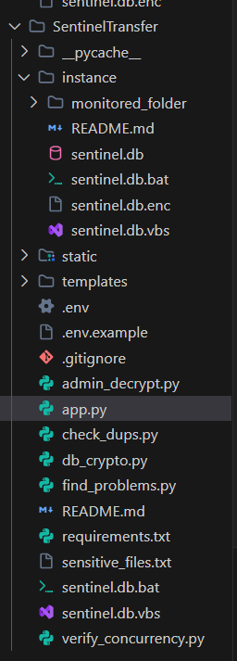

[Figure 5.3: Project folder structure as viewed in Visual Studio Code Explorer]

5.3 Database Design
The SentinelTransfer system uses an SQLite relational database with five interconnected tables. Each table is designed to store a specific category of operational data, and relationships between tables are enforced through foreign key references where applicable.
5.3.1 Table: users
This table stores the credentials and metadata of all registered users of the SentinelTransfer dashboard.
Column | Type | Description
id | INTEGER PRIMARY KEY | Auto-incremented unique identifier
username | TEXT NOT NULL UNIQUE | Login username chosen by the user
password_hash | TEXT NOT NULL | Bcrypt/Werkzeug hashed password string
email | TEXT | Email address for alert notifications
role | TEXT | User role (admin or viewer)
created_at | DATETIME | Account creation timestamp

5.3.2 Table: file_events
This is the primary data table that records every file system event detected by the Watchdog observer.
Column | Type | Description
id | INTEGER PRIMARY KEY | Auto-incremented unique identifier
event_type | TEXT | Type of event: created, modified, deleted, moved
file_path | TEXT | Absolute path of the affected file
file_name | TEXT | Name of the file
file_size | INTEGER | File size in bytes at event time
sha256_hash | TEXT | SHA-256 checksum of the file
is_sensitive | INTEGER | Boolean flag (1 = sensitive, 0 = normal)
sensitivity_reason | TEXT | Reason for classification (e.g., extension match)
timestamp | DATETIME | Date and time the event was recorded
user_id | INTEGER | Foreign key referencing users.id

5.3.3 Table: audit_logs
This table records all significant user actions performed within the application for accountability and traceability.
Column | Type | Description
id | INTEGER PRIMARY KEY | Auto-incremented unique identifier
user_id | INTEGER | Foreign key referencing users.id
action | TEXT | Description of the action performed
detail | TEXT | Additional context or metadata about the action
ip_address | TEXT | IP address of the client that initiated the action
timestamp | DATETIME | Timestamp of the logged action

5.3.4 Table: usb_events
This table stores records of USB and removable drive connection and disconnection events detected during monitoring.
Column | Type | Description
id | INTEGER PRIMARY KEY | Auto-incremented unique identifier
drive_label | TEXT | Label or name of the detected drive
drive_path | TEXT | Mount path of the detected drive
event_type | TEXT | connected or disconnected
timestamp | DATETIME | Timestamp of the USB event

5.3.5 Table: alerts
This table maintains a history of all security alerts generated by the system, including both sent and pending notifications.
Column | Type | Description
id | INTEGER PRIMARY KEY | Auto-incremented unique identifier
alert_type | TEXT | Type of alert (e.g., sensitive_file, usb_detected)
message | TEXT | Human-readable alert message
file_event_id | INTEGER | Foreign key referencing file_events.id (nullable)
sent | INTEGER | Boolean flag indicating if the email was sent
timestamp | DATETIME | Timestamp when the alert was created

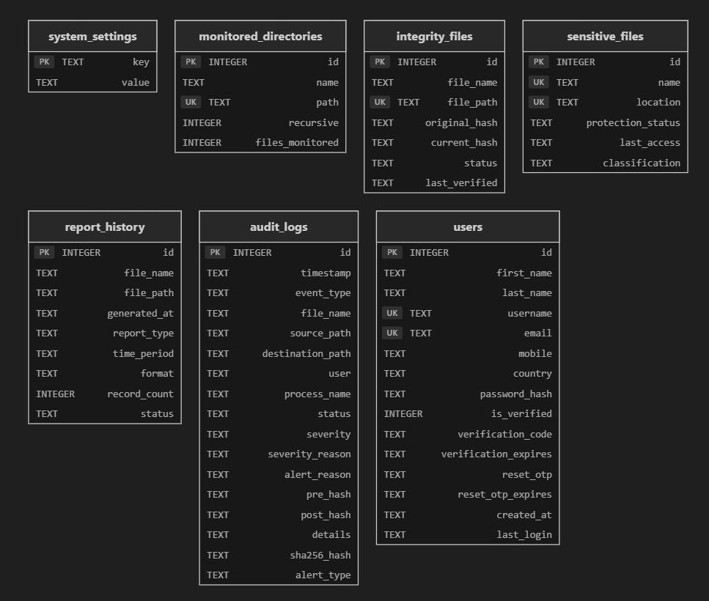
[Figure 5.4: Diagram showing database table relationships]

5.4 Authentication Module
5.4.1 User Registration
The registration module allows new users to create accounts within the SentinelTransfer system. The registration form collects the username, email address, and password. Upon form submission, the following validation steps are performed:
- The username is checked for uniqueness against the user’s table.
- The password is validated for minimum length requirements.
- If validation passes, the password is hashed using Werkzeug's generate_password_hash() function, which applies the PBKDF2-SHA256 algorithm with a random salt.
- The hashed password and user details are inserted into the user’s table.
The raw password is never stored in the database at any point during this process.
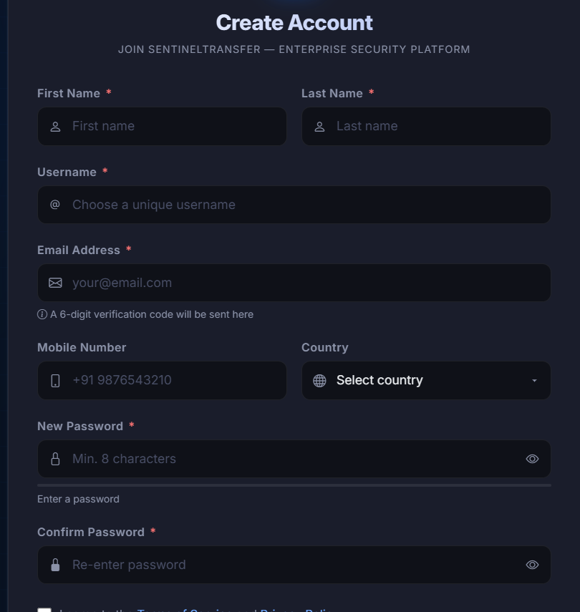

[Figure 5.5: User Registration Page]
5.4.2 Login
The login module authenticates users by comparing the submitted password against the stored hash. The following process is executed on a login request:
- The submitted username is looked up in the users table.
- If a matching record is found, Werkzeug's check_password_hash() function verifies the submitted password against the stored hash.
- If authentication succeeds, Flask-Login's login_user() function is called to create an authenticated session.
- The user is redirected to the dashboard.
- If authentication fails, an error message is displayed without revealing whether the username or password was incorrect (to prevent user enumeration).

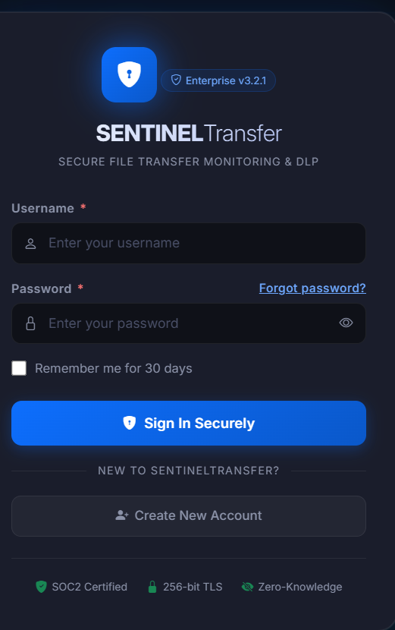

[Figure 5.6: User Login Page]
5.4.3 Session Management
Session management is handled by the Flask-Login extension. Once a user logs in, their user ID is stored in a signed and encrypted browser session cookie. All protected routes in the application are decorated with @login_required, which redirects unauthenticated requests to the login page. The UserMixin class is used to provide standard Flask-Login properties (is_authenticated, is_active, get_id()) to the User model.
Sessions are invalidated when the user clicks the logout button, which calls Flask-Login's logout_user() function and clears the session cookie.
5.4.4 Password Hashing
Passwords are hashed using Werkzeug Security utilities, which internally apply PBKDF2 with SHA-256 and a randomly generated salt. This one-way hashing approach ensures that even if the database is compromised, the original passwords cannot be retrieved. The hashing function is called at registration, and the verification function is called at login:
python
from werkzeug.security import generate_password_hash, check_password_hash
# At registration
password_hash = generate_password_hash(plain_password)
# At login
is_valid = check_password_hash(stored_hash, submitted_password)
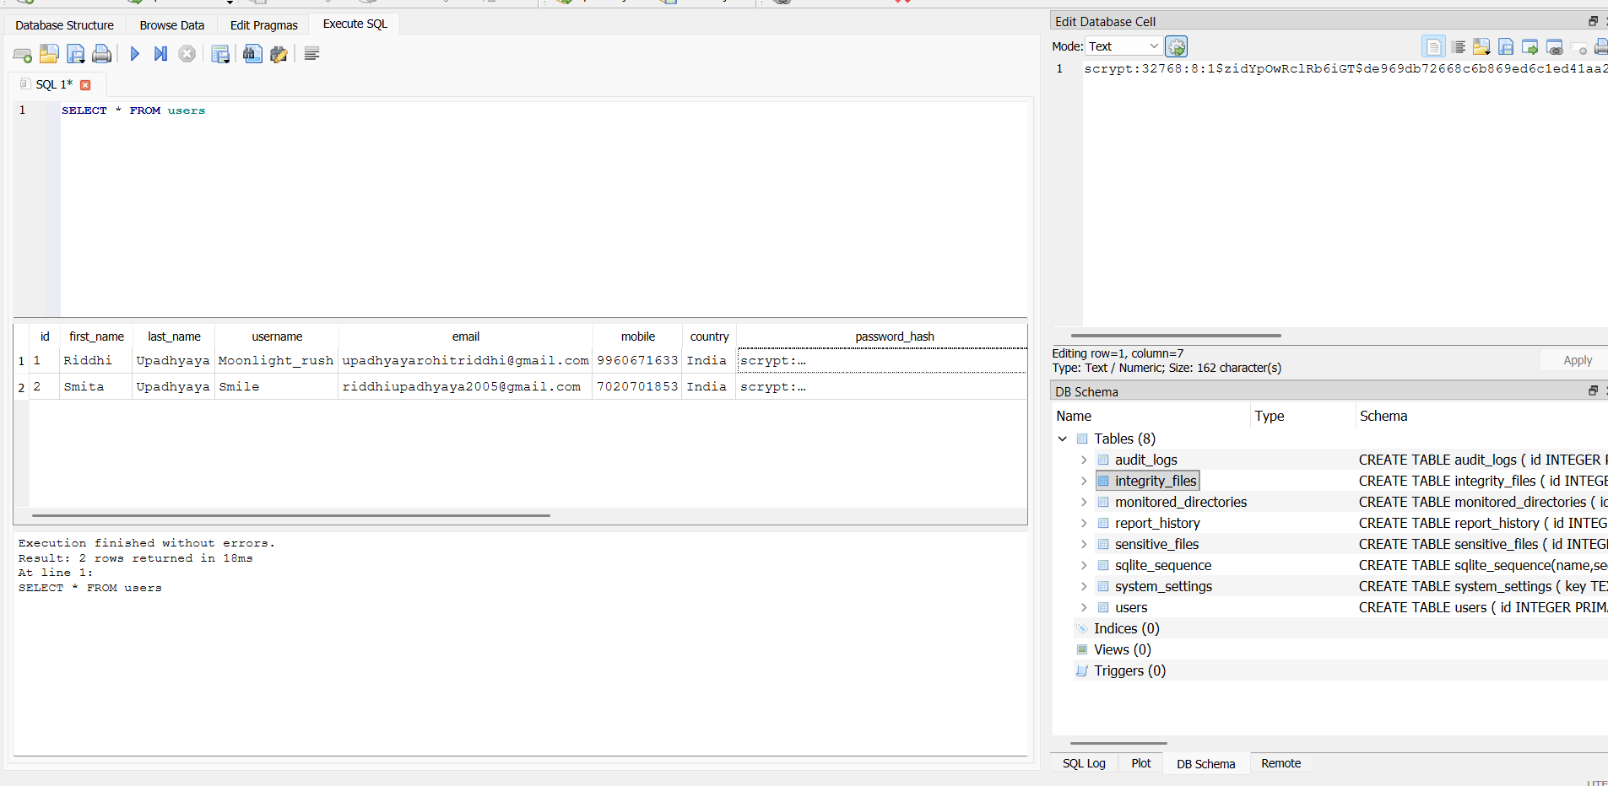
[Figure 5.7: Password stored as an irreversible hash in the database]

5.5 File Monitoring Engine
5.5.1 Watchdog Observer Setup
The file monitoring engine is built on the Watchdog library, which provides a cross-platform API for monitoring file system events. The observer is configured to watch a specified directory (the monitored_folder/) recursively, meaning all subdirectories within it are also monitored.
The observer is set up and started within a background daemon thread when the Flask application initializes, so that it operates concurrently with the web server without blocking request handling. The setup is as follows:
python
from watchdog.observers import Observer
from watchdog.events import FileSystemEventHandler
observer = Observer()
observer.schedule(SentinelEventHandler(), path='monitored_folder/', recursive=True)
observer.daemon = True
observer.start()
Running the observer in a daemon thread ensures it automatically terminates when the main application process exits, preventing resource leaks.

5.5.2 Monitoring Workflow
The overall monitoring workflow follows this sequence:
- The application starts and the observer thread begins watching the target directory.
- A file system change occurs (e.g., a file is created or modified).
- The operating system sends an event notification to the Watchdog observer.
- The observer dispatches the event to the registered SentinelEventHandler.
- The handler processes the event: computes the SHA-256 hash, classifies the file for sensitivity, and writes the record to the database.
- If the file is flagged as sensitive, an alert entry is created, and an email notification is optionally sent.

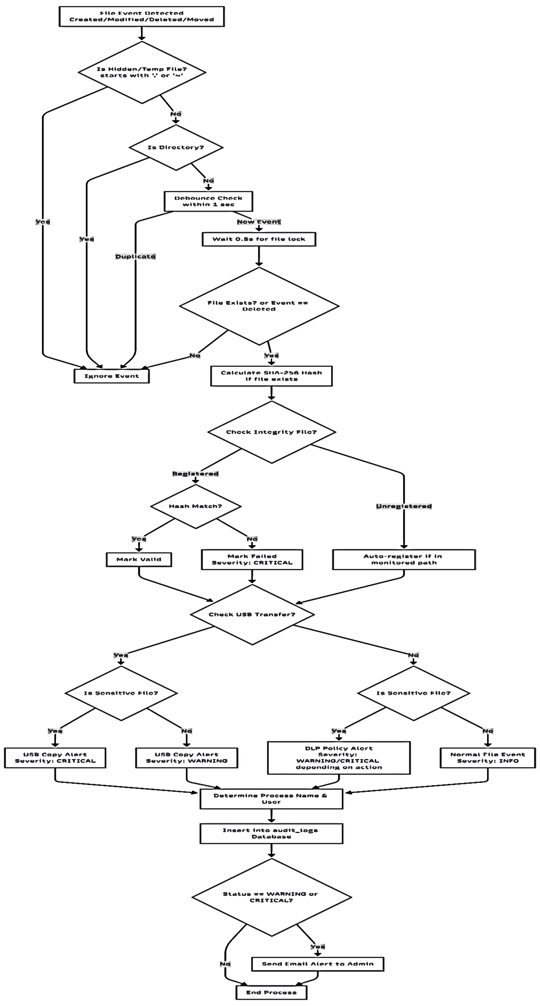
5.5.3 Event Handlers
The SentinelEventHandler class extends Watchdog's FileSystemEventHandler and overrides the following event methods:
- on_created(event) — Triggered when a new file or directory is created inside the monitored folder. The handler computes the file's SHA-256 hash and checks whether it matches any sensitive file classification criteria before logging the event.
- on_modified(event) — Triggered when an existing file is modified. The new SHA-256 hash is recomputed and compared against the previously stored hash for the same path to detect content changes.
- on_deleted(event) — Triggered when a file or directory is removed from the monitored folder. Since the file no longer exists, only the path and event type are recorded.
- on_moved(event) — Triggered when a file or directory is renamed or moved within the monitored folder. Both the source and destination paths are captured in the log entry.
All events are filtered to exclude directory-level events (checking event.is_directory) to focus monitoring on file-level activity only.

5.6 SHA-256 Integrity Verification
5.6.1 Hashing Process
SHA-256 (Secure Hash Algorithm 256-bit) is used to compute a unique cryptographic fingerprint of every monitored file. The hash is computed at the time of a file creation or modification event. Because even a single-bit change in the file produces a completely different hash (the avalanche effect), SHA-256 provides a reliable mechanism for detecting unauthorized modifications.
The hashing is performed using Python's built-in hashlib library:
python
import hashlib
def compute_sha256(file_path):
sha256 = hashlib.sha256()
try:
with open(file_path, 'rb') as f:
for chunk in iter(lambda: f.read(65536), b''):
sha256.update(chunk)
return sha256.hexdigest()
except (FileNotFoundError, PermissionError):
return None
The file is read in 64 KB chunks to handle large files efficiently without loading the entire content into memory at once.
5.6.2 Integrity Comparison
When a file is modified, the newly computed SHA-256 hash is compared against the hash stored in the database from the previous event for the same file path. If the hashes differ, it confirms that the file's contents have changed. This comparison is logged in the event record, and a flag is set if the change is unexpected or if the file belongs to a sensitive category.
The integrity check serves as a tamper-detection mechanism — even if a file's metadata (such as timestamp) is manually manipulated, the hash comparison will reveal whether the file's actual content was altered.
5.7 Sensitive File Detection
5.7.1 Classification Logic
The sensitive file detection module classifies files as sensitive based on a set of configurable rules. Classification is performed at the time a file event is processed by the event handler. The primary classification criteria include:
- File Extension Matching — Files with extensions associated with confidential data are flagged automatically. The monitored extension list includes, but is not limited to: .pdf, .docx, .xlsx, .csv, .db, .sql, .key, .pem, .p12, .pfx, .zip, .tar, .gz, .bak.
- Keyword Matching in Filename — Filenames containing sensitive keywords such as password, secret, credential, confidential, private, token, or backup are flagged regardless of extension.
- File Size Threshold — Files exceeding a configurable size threshold may be flagged for review if they are moved or transferred unexpectedly.
The classification function returns both a boolean flag and a human-readable reason string that is stored in the file_events table for reference.
5.7.2 Policy Enforcement
Upon detecting a sensitive file event, the system enforces the following response policy:
- The event is logged to the database with the is_sensitive flag set to 1.
- An entry is created in the alerts table with an appropriate message.
- An optional email notification is sent to the configured administrator address.
- The event is highlighted in the dashboard with a visual indicator (e.g., a red badge or warning icon) to draw the administrator's attention.
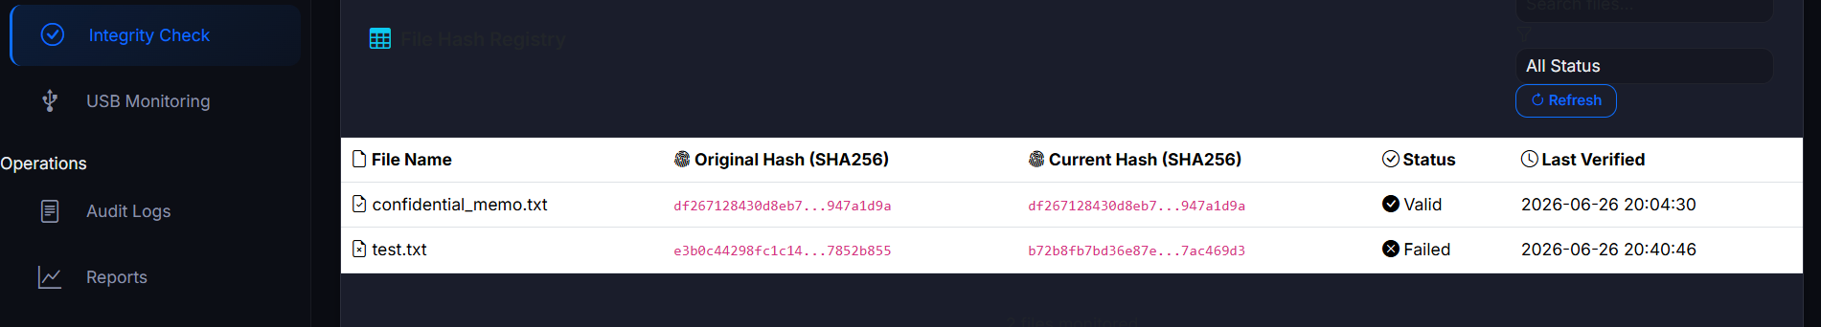
This policy framework ensures that sensitive data movements are not silently ignored and are always surfaced for review.
[Figure 5.8: Sensitive file event highlighted in red on the dashboard log view]
5.8 USB Monitoring
5.8.1 Removable Drive Detection
USB and removable drive monitoring is implemented using the psutil library, which provides a cross-platform interface for querying disk partitions and their attributes. The system polls the list of active disk partitions at regular intervals and compares the current list against a previously known snapshot to detect newly connected or disconnected removable drives.
A drive is identified as removable by checking the partition options for the removable flag or by checking its filesystem type on Windows.
5.8.2 Monitoring Logic
The USB monitoring function runs in a separate background thread that polls disk partitions every few seconds. The monitoring logic is as follows:
- At startup, the current set of removable drive mount points is captured as the baseline snapshot.
- At each polling interval, the current drive list is compared against the baseline.
- If a new drive is present that was not in the baseline, a connected USB event is logged to the usb_events table, and an alert is generated.
- If a drive in the baseline is no longer present, a disconnected event is logged.
- The baseline is updated after each comparison cycle.
This approach reliably detects USB insertions and removals without requiring elevated operating system privileges or kernel-level drivers.

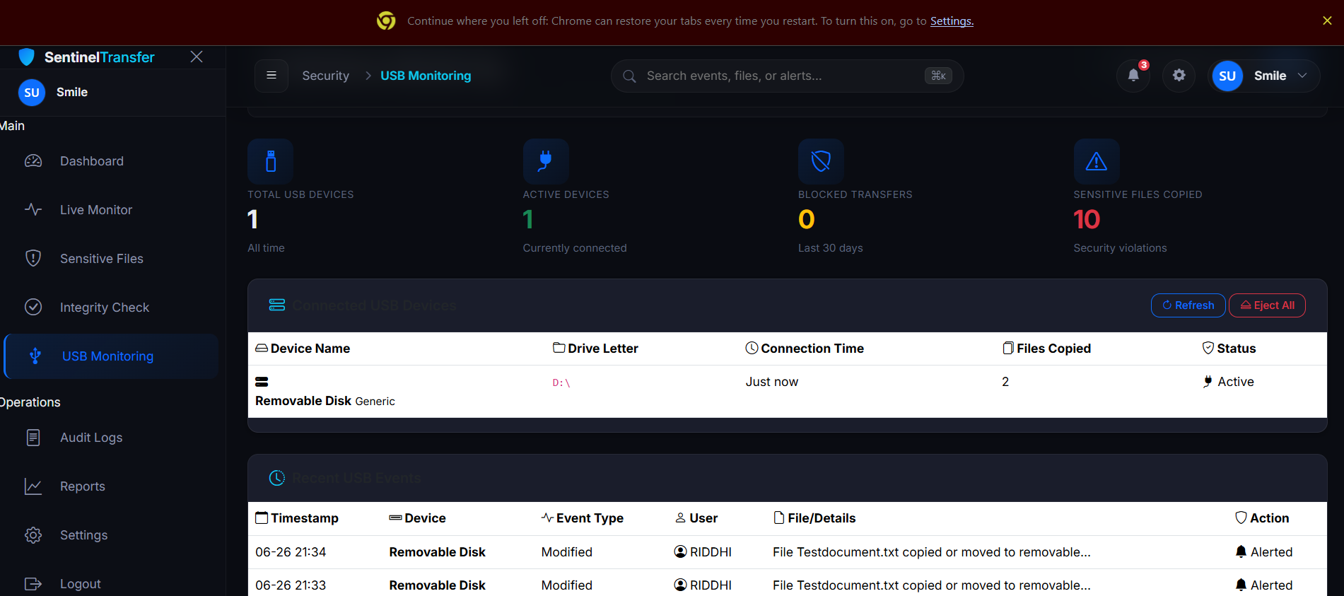
[Figure 5.9: USB Monitoring page displaying connected and disconnected drive history]
5.9 Audit Logging
5.9.1 Event Recording
The audit logging module provides an accountability trail by recording every significant action performed by users within the application. Logged events include:
- User login and logout activities
- Report generation requests
- Alert acknowledgement
- Configuration changes
- Manual file event queries
Each audit entry captures the user who performed the action, a textual description of the action, any relevant detail or context, the client's IP address, and a precise timestamp.
5.9.2 Database Logging
Audit events are written to the audit_logs table using a reusable helper function that can be called from any Flask route handler:
python
def log_audit(user_id, action, detail='', ip_address=''):
db = get_db()
db.execute(
'INSERT INTO audit_logs (user_id, action, detail, ip_address, timestamp) '
'VALUES (?, ?, ?, ?, ?)',
(user_id, action, detail, ip_address, datetime.utcnow())
)
db.commit()
The request.remote_addr Flask context variable is used to capture the client's IP address. This function is called before returning responses for any sensitive operations to ensure that even failed actions are recorded.
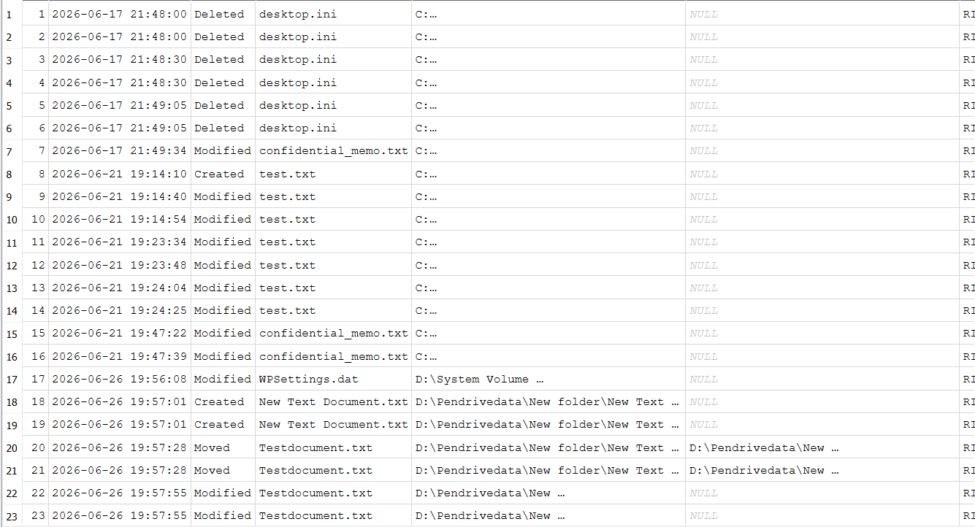
[Figure 5.10: Audit Logs page showing user action history with timestamps]

5.10 Dashboard Development
5.10.1 Flask Routes
The web dashboard is composed of multiple Flask routes, each serving a specific page or API endpoint. The primary routes defined in app.py include:
Route | Method | Description
/ | GET | Redirects to login or dashboard
/login | GET, POST | User authentication page
/register | GET, POST | New user registration page
/logout | GET | Logs out the current user
/dashboard | GET | Main monitoring dashboard
/logs | GET | Full file event log viewer
/alerts | GET | Security alerts listing
/usb | GET | USB event history
/reports | GET | Report generation page
/audit | GET | Audit log viewer (admin only)
All dashboard routes are protected with the @login_required decorator to ensure only authenticated users can access monitoring data.
5.10.2 API Endpoints
To support dynamic, real-time updates on the dashboard without full page reloads, a set of lightweight JSON API endpoints was implemented:
Endpoint | Method | Returns
/api/stats | GET | Summary counts of events, alerts, and USB activity
/api/events/recent | GET | The 10 most recent file events as JSON
/api/chart/events | GET | Hourly or daily event count data for Chart.js
/api/alerts/unread | GET | Count of unacknowledged alerts
These endpoints are called by the front-end JavaScript (dashboard.js) at defined intervals using the Fetch API to refresh the displayed data without requiring a full page reload.
5.10.3 Chart.js Integration
Data visualization on the dashboard is implemented using Chart.js, a JavaScript library for rendering interactive charts in an HTML <canvas> element. The following chart types are used:
- Line Chart — Displays the trend of file events over time (hourly or daily).
- Doughnut/Pie Chart — Shows the distribution of event types (created, modified, deleted, moved).
- Bar Chart — Compares the count of sensitive versus non-sensitive events.
Chart data is fetched from the /api/chart/events endpoint and rendered dynamically each time the dashboard page loads or refreshes.
javascript
fetch('/api/chart/events')
.then(response => response.json())
.then(data => {
const ctx = document.getElementById('eventChart').getContext('2d');
new Chart(ctx, {
type: 'line',
data: {
labels: data.labels,
datasets: [{
label: 'File Events',
data: data.values,
borderColor: '#4e73df',
fill: true
}]
}
});
});
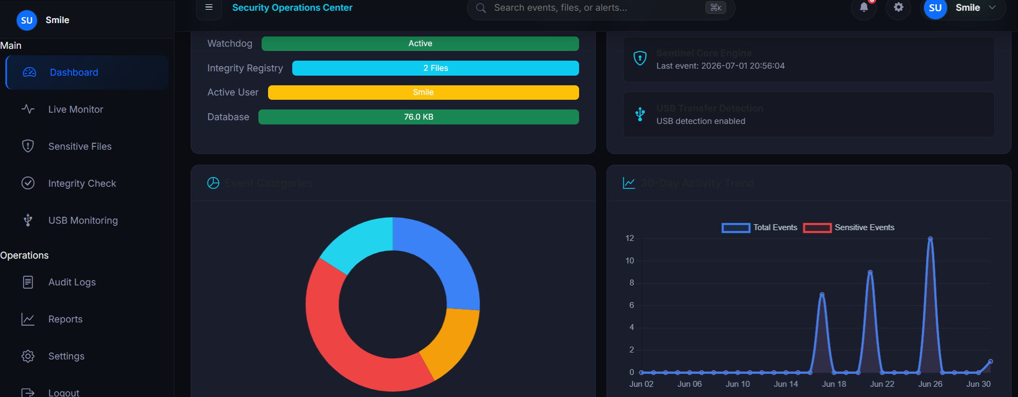
[Figure 5.11: Dashboard with Chart.js line chart showing file event trends]

5.10.4 Dynamic Updates
The dashboard is designed to reflect near-real-time activity without manual page refreshes. This is achieved through a polling mechanism implemented in dashboard.js, where the front-end JavaScript calls the /api/stats and /api/events/recent endpoints at a fixed interval (e.g., every 10 seconds) using setInterval().
Upon receiving a response, the JavaScript updates the summary statistic cards (total events, sensitive files, active alerts, USB detections) and refreshes the recent events table by re-rendering the table rows. If new alert counts are detected, a browser notification badge is updated to alert the user.

5.11 Report Generation
5.11.1 CSV Report Generation
CSV (Comma-Separated Values) reports are generated by querying the file_events table and writing the results row by row using Python's built-in csv module. The generated CSV file is saved to the reports/ directory with a timestamp-based filename and then offered to the user as a file download via Flask's send_file() function.
The CSV report includes the following columns: Event ID, Event Type, File Name, File Path, File Size, SHA-256 Hash, Sensitive Flag, Sensitivity Reason, and Timestamp.
python
import csv, io
from flask import make_response
def generate_csv(events):
output = io.StringIO()
writer = csv.writer(output)
writer.writerow(['ID', 'Type', 'File Name', 'Path', 'Size', 'SHA256', 'Sensitive', 'Reason', 'Timestamp'])
for event in events:
writer.writerow([event['id'], event['event_type'], ...])
response = make_response(output.getvalue())
response.headers['Content-Disposition'] = 'attachment; filename=report.csv'
response.headers['Content-type'] = 'text/csv'
return response
5.11.2 PDF Report Generation
PDF reports are generated using the fpdf2 library, which allows programmatic construction of PDF documents within Python. The PDF report includes a formatted header with the system name and generation timestamp, followed by a summary statistics section and a data table listing all file events within the selected date range.
The PDF generation workflow is:
- Instantiate the FPDF object and add a page.
- Define the header with the report title and timestamp using set_font() and cell().
- Iterate over the queried event records and render each as a row in a multi-column table using cell() with appropriate column widths.
- Save the output to the reports/ directory.
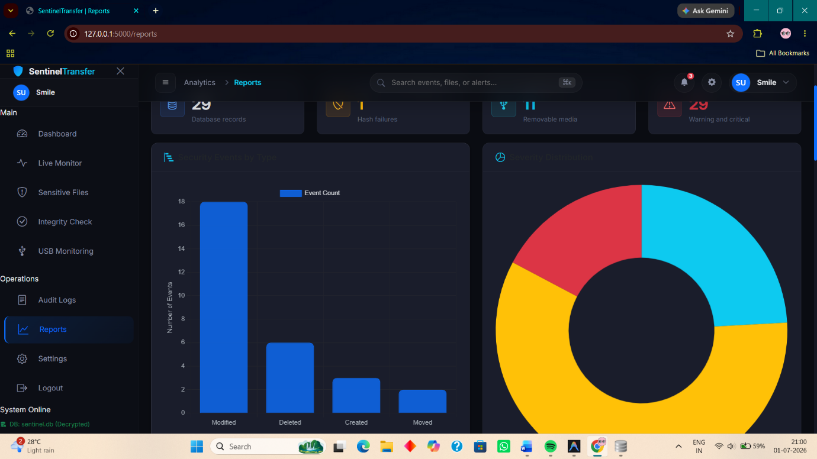
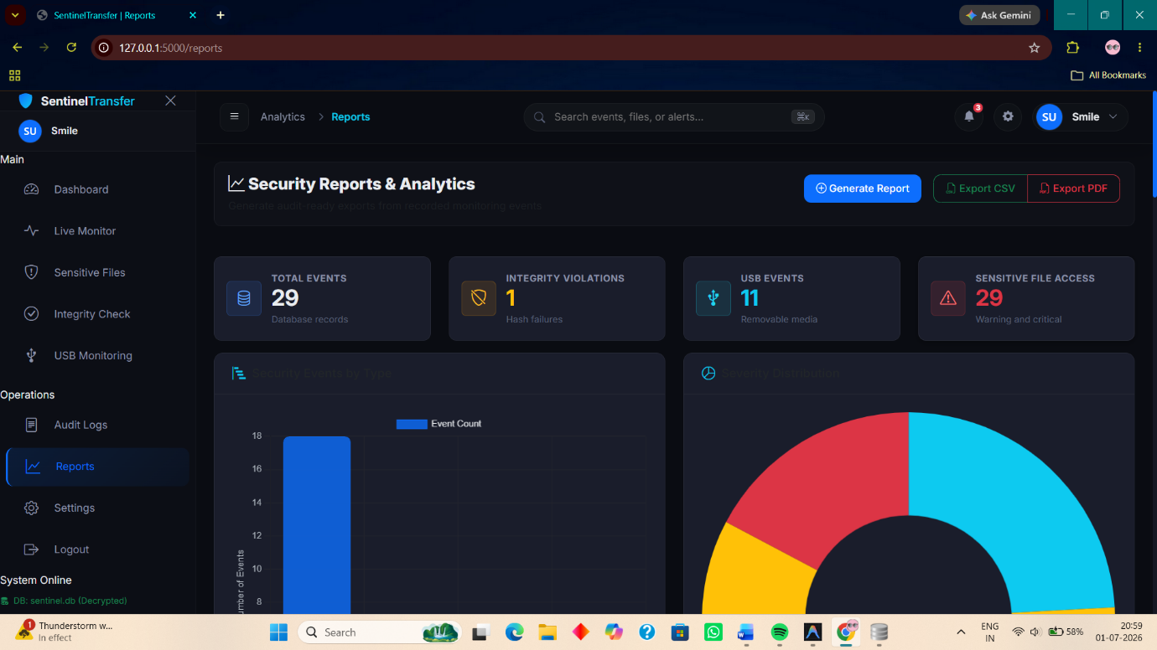
- Serve the file to the browser using Flask's send_file() with as_attachment=True.

[Figure 5.12: PDF Report generation page with date filter and download button]

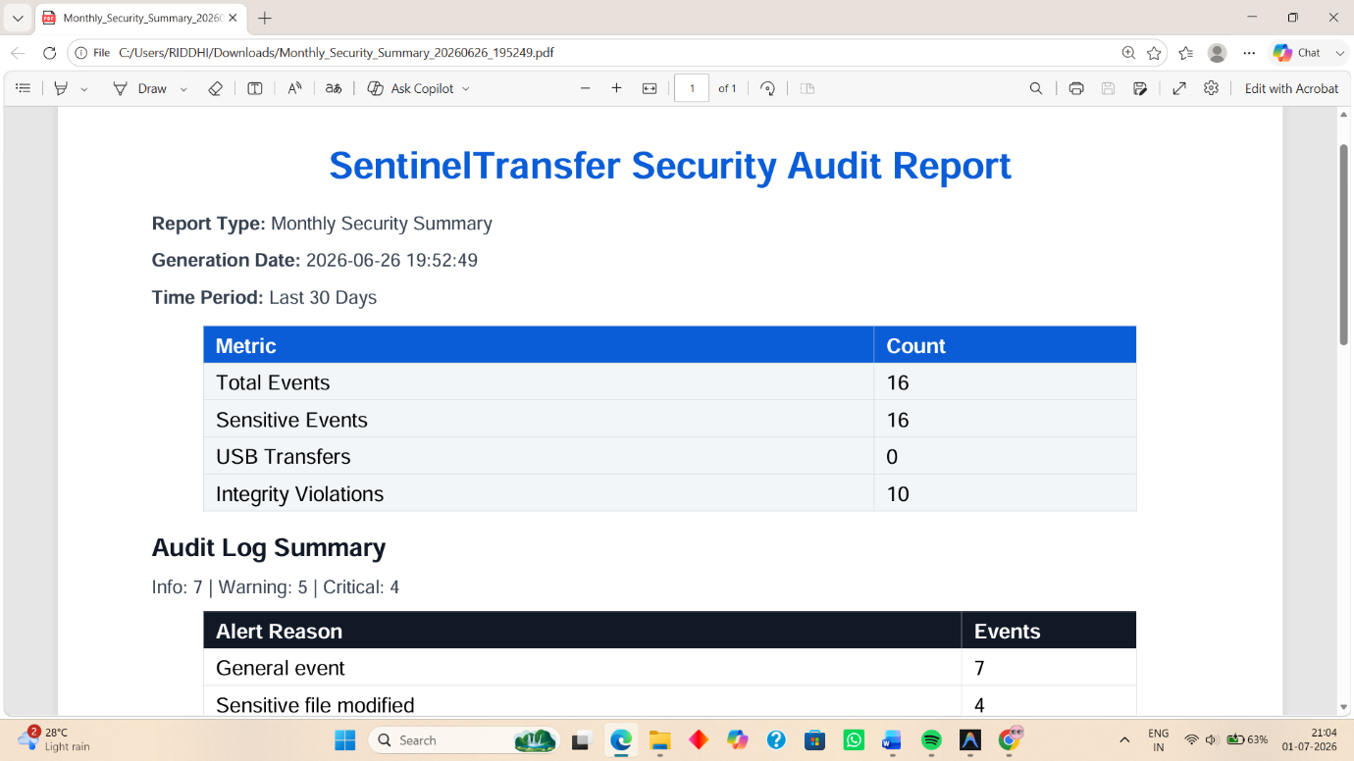
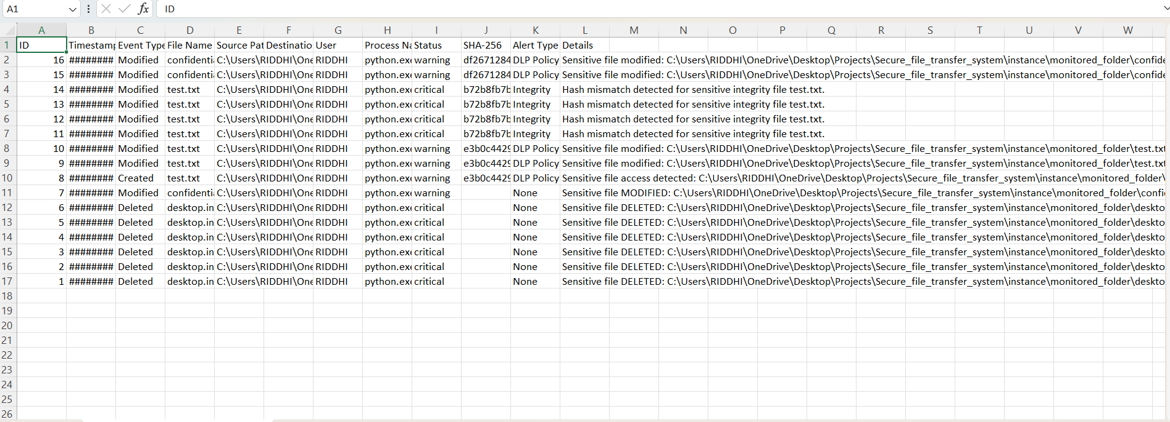
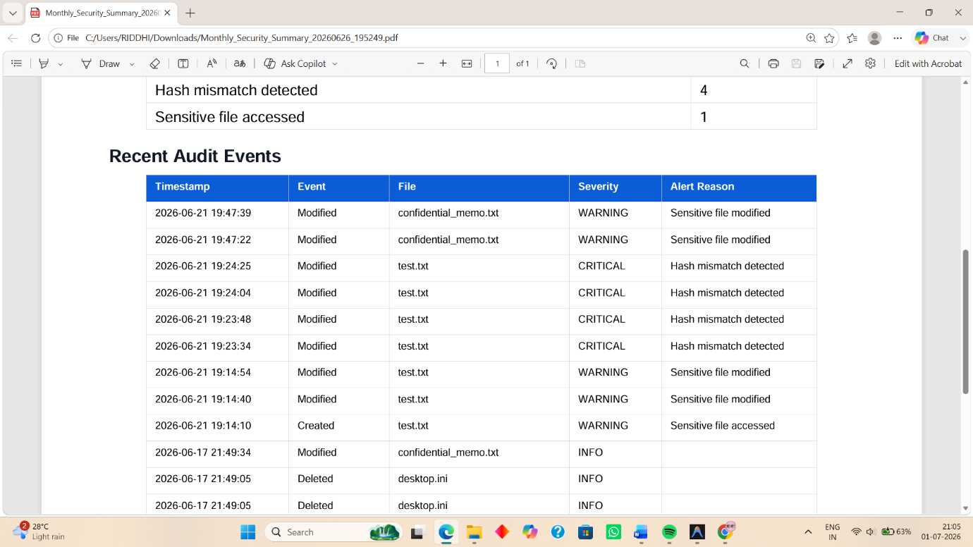
[Figure 5.13: Sample generated PDF report showing file event table]
5.12 Database Encryption
5.12.1 AES-256 Encryption
To protect the contents of the SQLite database file at rest, an optional database encryption module was implemented using the AES-256 (Advanced Encryption Standard with a 256-bit key) symmetric encryption algorithm in CBC (Cipher Block Chaining) mode, provided by the PyCryptodome library.
The encryption module operates at the file level — it reads the entire SQLite database binary file and encrypts it into a ciphertext output file. The original database file can be replaced with the encrypted version for secure storage, and decryption is performed on demand before the application accesses the data.
5.12.2 PBKDF2 Key Derivation
Rather than using a raw password as the AES key directly, the PBKDF2 (Password-Based Key Derivation Function 2) algorithm is used to derive a strong, fixed-length 256-bit key from a user-supplied passphrase. PBKDF2 applies a pseudorandom function (HMAC-SHA256) iteratively (e.g., 200,000 iterations) with a randomly generated 16-byte salt, making brute-force and dictionary attacks computationally expensive.
python
from Crypto.Protocol.KDF import PBKDF2
from Crypto.Hash import SHA256
salt = os.urandom(16)
key = PBKDF2(passphrase, salt, dkLen=32, count=200000, prf=lambda p, s: HMAC.new(p, s, SHA256).digest())
The salt is prepended to the encrypted output so that it can be recovered during decryption.
5.12.3 Decryption Workflow
The decryption process reverses the encryption steps:
- Read the encrypted file and extract the first 16 bytes as the salt.
- Re-derive the AES key using PBKDF2 with the same passphrase and extracted salt.
- Extract the next 16 bytes as the Initialization Vector (IV).
- Decrypt the remaining ciphertext using AES-256-CBC.
- Remove PKCS7 padding from the decrypted output.
- Write the decrypted data back to the SQLite database file.
This workflow ensures that the database is only accessible to users who possess the correct passphrase, adding an additional layer of protection beyond the application's login system.

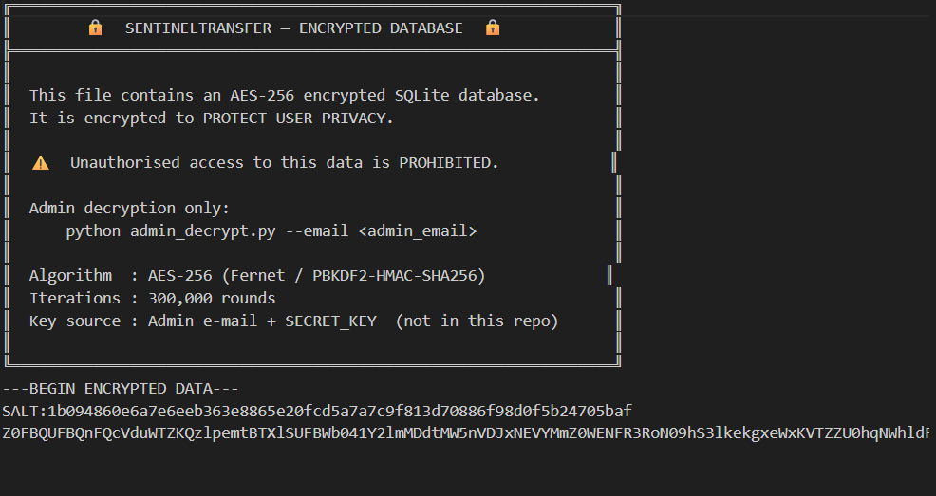
[Figure 5.14: Database Encryption utility interface showing encrypt and decrypt options]
5.13 User Interface
5.13.1 Bootstrap Layout
The front-end user interface is built using Bootstrap 5, a widely adopted CSS framework that provides a responsive grid system, pre-styled UI components, and utility classes. The layout follows a standard sidebar-based administrative dashboard pattern:
- A fixed left sidebar contains the navigation menu with links to all major sections (Dashboard, Logs, Alerts, USB Monitor, Reports, Audit Logs).
- A top navbar displays the application logo, the currently logged-in username, and a logout button.
- The main content area to the right of the sidebar renders page-specific content, including data tables, charts, and forms.
- Modals are used for confirmation dialogs (e.g., before generating or downloading reports).
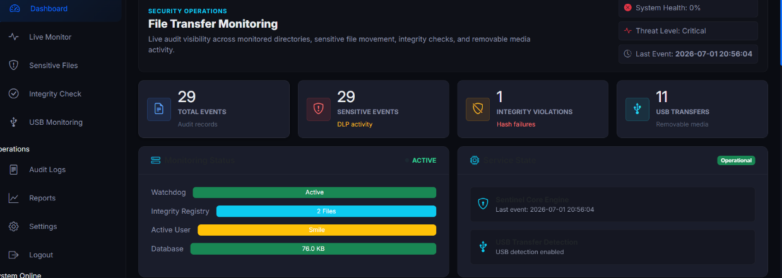
The base.html template defines this shared layout structure, and all other pages inject their unique content into the {% block content %} block.

[Figure 5.15: SentinelTransfer Dashboard main layout with sidebar navigation]
5.13.2 Responsive Design
The interface is designed to be responsive across common screen sizes. Bootstrap's 12-column grid system automatically reflows content based on viewport width. On smaller screens, the sidebar collapses into a hamburger menu toggled by a button in the top navbar. Stat cards on the dashboard stack vertically on narrow viewports. This ensures the application remains usable on laptop screens, tablet-sized displays, and standard desktop resolutions.
5.13.3 Dark Theme
A custom dark theme is applied across the entire interface through a combination of Bootstrap's dark mode utilities and a custom style.css stylesheet. The colour palette uses deep navy and dark grey backgrounds (#0d1117, #161b22), white and light grey foreground text, and accent colours in teal/cyan for interactive elements and chart highlights. This visual design choice reduces eye strain during extended monitoring sessions and presents a professional, security-tool aesthetic aligned with the project's purpose.
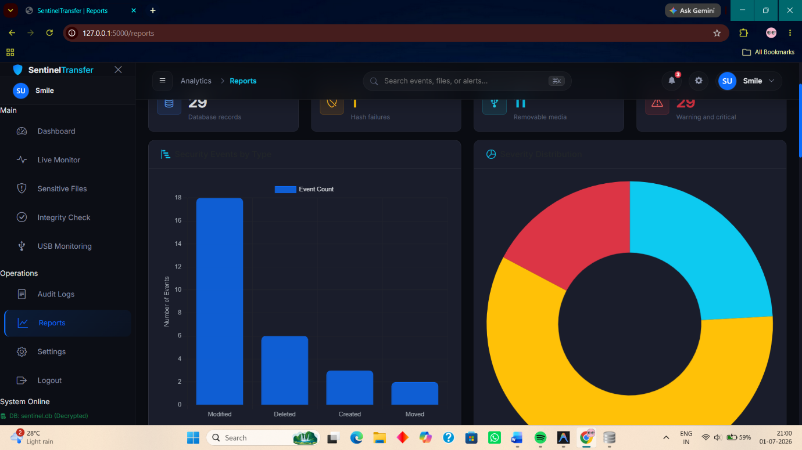
Custom CSS overrides Bootstrap defaults for components such as tables (alternating dark row shading), cards (dark glass-effect backgrounds with subtle borders), and form inputs (dark background with light placeholder text).
[Figure 5.16: Dark theme applied across the dashboard, log, and report pages]

5.15 Testing and Debugging
5.15.1 SQLite Database Locking
Issue: During early testing, concurrent write operations from both the Flask web server (handling HTTP requests) and the Watchdog background thread (logging file events) caused sqlite3.OperationalError: database is locked exceptions. This occurred because SQLite uses file-level locking and defaults to a short lock timeout.
Resolution: The issue was resolved by setting a longer timeout value in the SQLite connection configuration and switching the connection's isolation level to allow the write-ahead logging (WAL) mode:
python
conn = sqlite3.connect('sentinel.db', timeout=20, check_same_thread=False)
conn.execute("PRAGMA journal_mode=WAL;")
WAL mode allows concurrent reads alongside a single writer, significantly reducing lock contention in a multi-threaded Flask application.
5.15.2 Dashboard Synchronization
Issue: The dashboard stat cards and the recent events table initially displayed stale data that did not reflect newly logged file events until the page was manually refreshed.
Resolution: The synchronization issue was resolved by implementing the JavaScript polling mechanism described in Section 5.10.4. The setInterval() function calls the /api/stats and /api/events/recent endpoints every 10 seconds, and the JavaScript DOM manipulation logic updates only the relevant UI elements without re-rendering the entire page. This provided a near-real-time update experience without the complexity of WebSockets.
5.15.3 Dynamic Chart Updates
Issue: Chart.js charts, once rendered on page load, did not update when new data arrived from the polling API calls. Calling new Chart() repeatedly on the same canvas element caused a "Canvas is already in use" error.
Resolution: This was fixed by maintaining a reference to the Chart.js instance in a JavaScript variable and using the .update() method on the existing chart instance to refresh data, rather than recreating the chart:
javascript
if (eventChart) {
eventChart.data.labels = data.labels;
eventChart.data.datasets[0].data = data.values;
eventChart.update();
} else {
eventChart = new Chart(ctx, { ... });
}
5.15.4 PDF Generation Formatting
Issue: The initial implementation of the PDF report using fpdf2 produced overlapping text and table cell content that exceeded page boundaries for records with long file paths.
Resolution: The issue was resolved by applying text truncation to long path strings before writing them to PDF cells, and by using multi_cell() instead of cell() for content that might wrap across lines. Column widths were also carefully calibrated to fit within A4 page margins. A line height and font size reduction was applied to the table rows to maximize the number of records per page.
5.15.5 UI Refinement
Issue: During initial development, the navigation sidebar overlapped with the main content area on certain screen sizes, and the data tables overflowed their containers on narrow viewports.
Resolution: The layout was refined by wrapping tables inside <div class="table-responsive"> Bootstrap containers to enable horizontal scrolling on small screens. The sidebar was given a fixed width using CSS, and the main content area was assigned a responsive margin-left property that adjusted in CSS @media queries. Visual polish was added through Bootstrap utility classes, custom card styles, and consistent spacing between sections.
5.16 Final Working System
5.16.1 Completed Application Overview
Upon completion of development, the SentinelTransfer – Secure File Transfer Monitoring System represents a fully functional, web-based cybersecurity monitoring application. The system operates as a local Flask web application accessible from any browser on the host machine, providing a centralized dashboard for an administrator to monitor file activity, track security alerts, and manage system records in real time.
The completed system is launched using a single command: bash:-python app.py
This command initializes the Flask server, starts the Watchdog file monitoring observer in a background thread, and launches the USB monitoring poller in another background thread. The web interface becomes accessible at http://127.0.0.1:5000/.
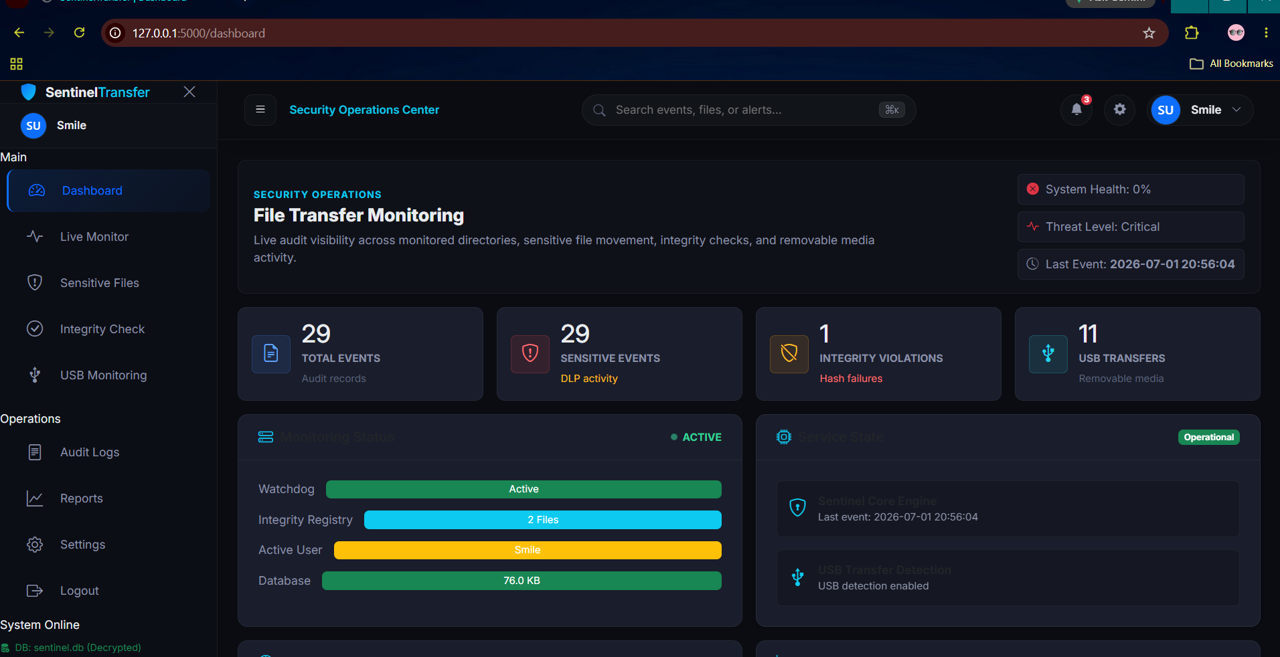
[Figure 5.27: SentinelTransfer application running in the browser with all modules active]

5.16.2 Module Integration
All the independently developed modules of the SentinelTransfer system are integrated through the central app.py file and the shared SQLite database. The integration points are as follows:
- The Authentication Module controls access to all other modules and routes.
- The File Monitoring Engine (Watchdog) feeds data into the SHA-256 Integrity Module and the Sensitive File Detector, whose combined output is written to the Audit Logging database.
- The USB Monitoring module independently writes to the database and triggers the Alert System.
- The Dashboard reads from the database via Flask API routes and visualizes the aggregated data using Chart.js.
- The Report Generation module queries the same database and outputs results in CSV or PDF format.
- The Database Encryption utility operates independently as an optional offline protection layer.
- The Email Alert System is invoked by both the File Monitor and USB Monitor whenever a security-relevant event is detected.
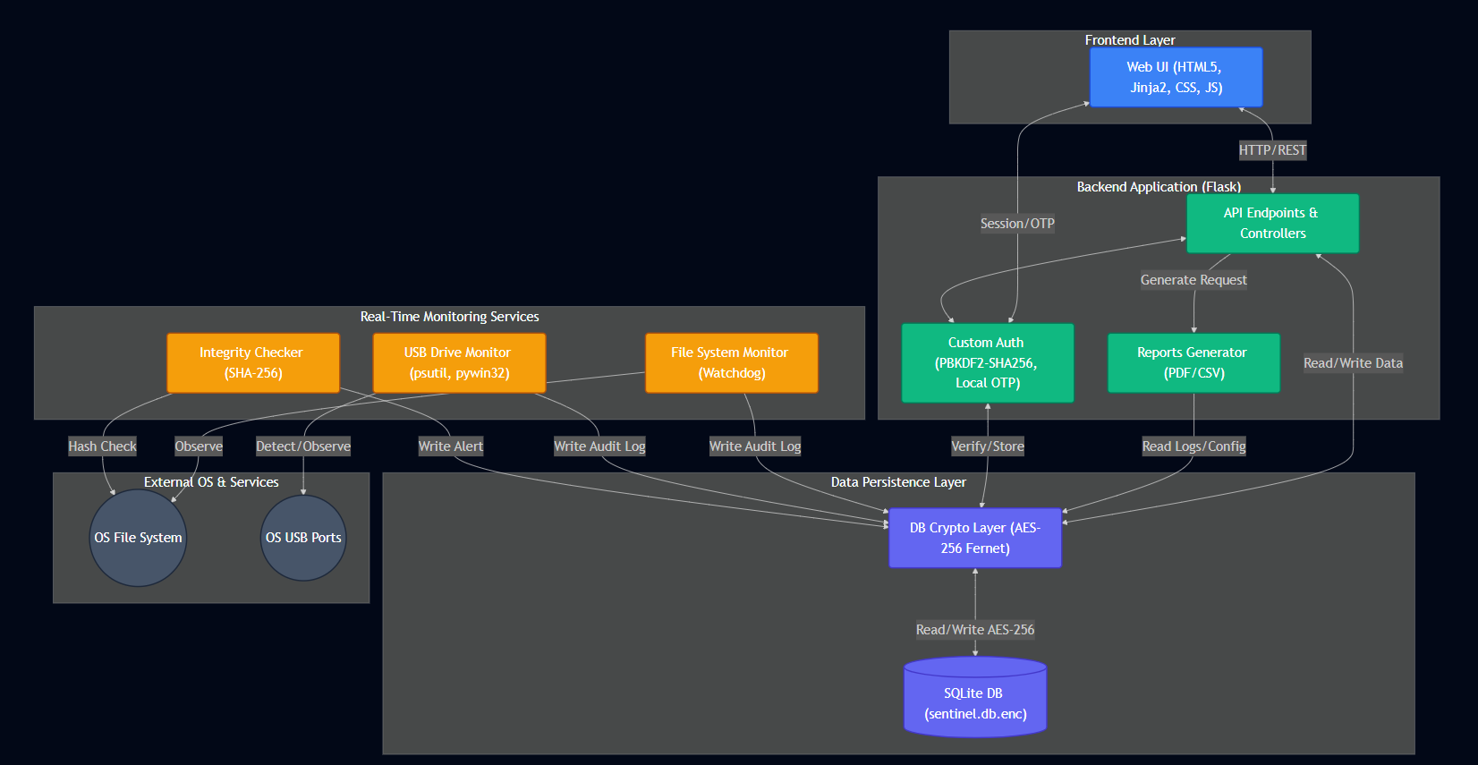
The following diagram illustrates the end-to-end data flow across all integrated modules:

[Figure 5.18: SentinelTransfer System Architecture and Module Integration Diagram]

5.16.3 Real-Time Monitoring and Dynamic Dashboard Updates
One of the distinguishing features of the final system is its ability to surface security-relevant file events in near real time. When a file is created, modified, deleted, or moved within the monitored directory, the following sequence occurs within seconds:
- The Watchdog observer detects the event and dispatches it to the handler.
- The handler computes the SHA-256 hash, classifies the file, and writes the event record to the database.
- If the file is sensitive, an alert record is created and an email is dispatched.
- Within the next polling interval (≤10 seconds), the dashboard's JavaScript fetches updated stats and events from the API.
- The dashboard UI updates the statistic cards, the recent events table, and the Chart.js visualizations without any page reload.
This real-time loop, from file system event to dashboard visualization, demonstrates the end-to-end capability of the SentinelTransfer system as a practical and effective tool for file transfer security monitoring.

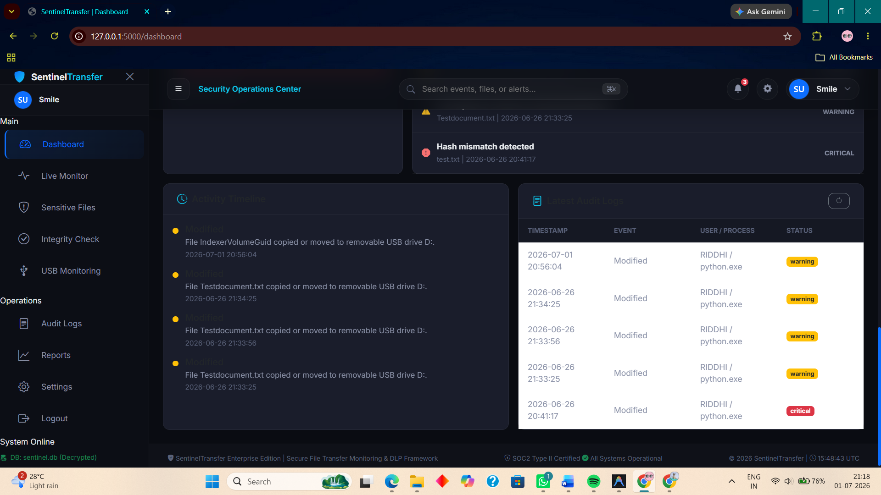
[Figure 5.19: Real-time event appearing in the dashboard within seconds of a file change]

