3 DevOps Lifecycle

DevOps looks at the complete Software Development Lifecycle, breaking it down into four phases which further spans to six areas for scope coverage

- Plan & Measure,
- Develop & Test,
- Release & Deploy, and
- Monitor & Optimize
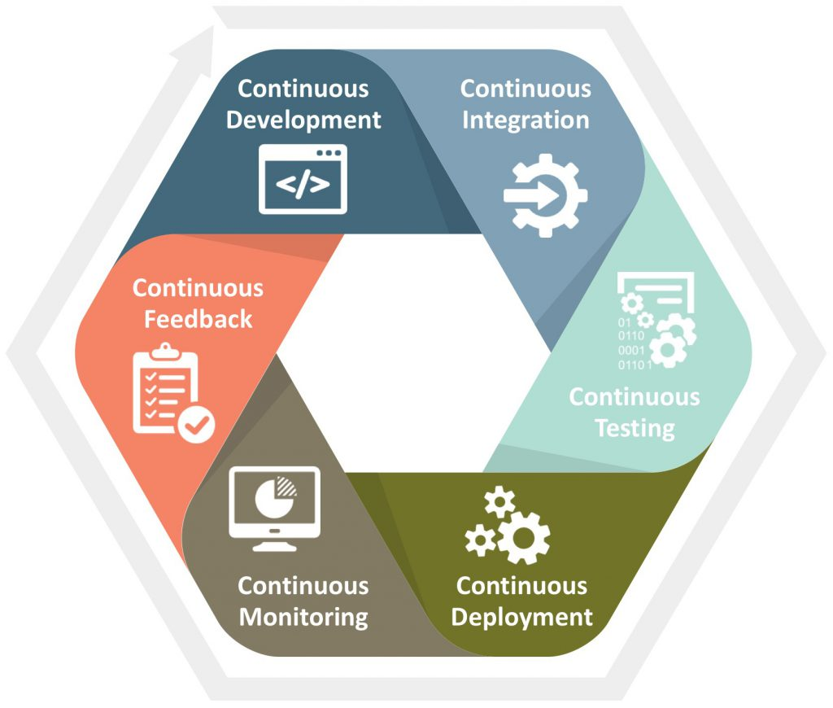

3.1 Continuous Business Planning

Continuously plan, measure and bring business strategy and customer feedback into the development lifecycle. Continuous Business Planning assures that the investment choices are aligned throughout their life cycle to your organization's needs. It employs lean principles to help teams start small, identifying the outcomes and resources needed to test the business vision and value. Adapt and adjust continually, measuring actual progress, and customer requirements so teams can shift direction with agility [9]. Product backlog is maintained and gets split into smaller releases and milestones based on the priority decided by the various stakeholders. Following are the major components in Continuous Businessplanning:
• Requirements Management
• Change Management
• Project Planning and Work
Management

• Iteration Planning
• Progress Monitoring and Reporting

3.2 Collaborative Development and Continuous Integration

Collaborative Development brings together business, development, and QA organizations to deliver innovative, quality customer experiences with speed. It dramatically transforms the way clients build their apps in order to drive real business outcomes. The technological enablers for DevOps establish DevOps capabilities by automating different trivial and non-trivial tasks [10]. Automation helps in achieving continuous delivery and deployment by providing a DevOps pipeline to production for all changes to a given software environment [11].

3.3 Continuous Testing

Utilizes highly automated approaches to dramatically reduce the time and effort in delivering quality results [12]. Eliminate testing bottlenecks through virtualized dependent services. It simplifies the creation of virtualized test environments. Continuous Testing also reduces the costs of provisioning and maintaining the various test environments.

3.4 Continuous Release & Deployment

There are various advantages of continuous release and deployment. Continuous deployment helps in receiving an early feedback from the customers and users. It enables frequent and reliable releases which improves customer satisfaction [15], trust and product quality [16]. It also enables teams to perform on-demand Dev/Test self-deploymentsto continuously integrate software driven innovation.
• Release Management
• Build Automation
• Deployment Automatio

3.5 Continuous Monitoring

Continuous Monitoring automates and optimizes the ability to monitor and manage the performance and availability of applications and infrastructure continuously. It tells how good my systems are performing and whether it needs any correction [17]. Choice of correct tool decides the level of correctness which can be brought into the system. Following are the main areas for monitoring in a DevOps implemented project:
• Application Performance Management
• IT Operations Analytics
• Operational Problem Management Logging needs to be used effectively to monitor application logs. Logging mechanism works at multiple levels and should be configured to analyse the logs by drilling down when needed [18].
The logs are analysed to provide quality feedback to the development teams and then perform a deeper problem analysis to go to the root of the issue. The results of the log analysis help the development and Operations team to prepare better for future.
3.6 Continuous Customer Feedback and Optimization

Continuously getting customer's feedback on their experience brings far better insights that form the basis for improved decision making and optimization. An early and rapid feedback from the systems help to save time and improve the end user experience on continuous basis [19]. The DevOps maturity model enables growth through continuous learning among development and operations teams as depicted by figure 6 below. The capabilities and skilldefined, guarantees enhanced ability to handle issues of scale and complexities. Information Technology Infrastructure Library, ITIL is a framework of best practices for IT service management which focuses on aligning IT services according to the needs of the business.The degree of DevOps implementation can also be measured by means of maturity models against various matrices [20].

