SPL1 Project Proposal Form, 2026
Institute of Information Technology (IIT)
University of Dhaka

Student’s Name: | Rifat Al Maruf
Student’s Roll: | BSSE–1705 | Phone: | +8801521772227
Project Description:
Proposed Title: IIT Search Engine - A Domain-Specific Information Retrieval System
Objective: Develop a Java-based search engine for a controlled collection of public or supervisor-authorized IIT PDF documents. PDFs will be parsed and, when necessary, OCR-processed to extract plain text; indexing and searching will operate on that extracted text. The system will build its own index, process queries, support exact and approximate matching, rank documents, and return relevant results efficiently.
Core Flow: IIT PDF corpus -> PDF text extraction/OCR -> normalized text -> tokenization -> inverted/positional index -> exact/partial/fuzzy query processing -> retrieval -> TF-IDF-style ranking -> Top-K results/snippets.
Planned Core Scope: PDF import and text extraction; OCR fallback for scanned PDFs; preprocessing; exact keyword, multi-word, AND/OR and phrase search; partial/substring and basic fuzzy matching; persistent index save/load/rebuild; relevance ranking; Top-K retrieval; snippets; and corpus/index/search statistics.
Evaluation: Compare indexed retrieval with a simple sequential scan using indexing time, query time, index size, number of documents/terms, and observed behavior for exact and approximate queries.
Scope and Constraints: Core IR logic will be implemented manually in Java without Lucene, Elasticsearch or Solr. External libraries/tools may be used for PDF parsing/OCR only, not for the core indexing, matching or ranking logic. The initial corpus will be English public/authorized IIT PDFs; exact dataset size and OCR coverage will be finalized with the supervisor. No web-scale crawling or semantic/LLM search is planned.
Four-Month Plan: Month 1 - corpus, PDF extraction/OCR pipeline, preprocessing and baseline exact search; Month 2 - inverted/positional indexing, Boolean and phrase queries; Month 3 - partial/fuzzy matching, ranking, Top-K and persistence; Month 4 - full-corpus testing, benchmarking, optimization, documentation and final presentation.
Languages or Tools to be used:
Java (core language); IntelliJ IDEA; Git/GitHub; Java File I/O; PDF text-extraction/OCR library or tool. Core indexing, matching and ranking algorithms/data structures will be implemented manually; no ready-made search-engine framework will be used.
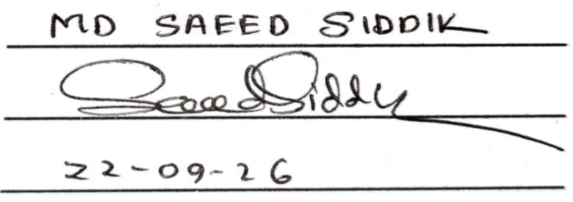
Supervisor’s Name : ________________________________
Signature of the supervisor : ________________________________
Date : ________________________________

Before the Midterm Presentation:
I confirm that the progress is satisfactory and I am forwarding it for midterm presentation.
Signature of the supervisor : _________________________
Date : _________________________

Midterm Presentation Feedback:

Before the Final Presentation:
I confirm that the project is complete and I am forwarding it for final presentation.
Signature of the supervisor : _________________________
Date : _________________________

